Photographer: Image with description

Button Name: Photography

Junior Photographer

1. FAISAL KARIM

TK.12,500/=

* 1 **Top** Photographer
* Event Duration:**4 Hours**
* Number of Pictures: Unlimited
* Specially Edited Photos: 100 copies
* Print: 4R (4”x6″) Matte Prints: 100 copies

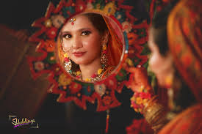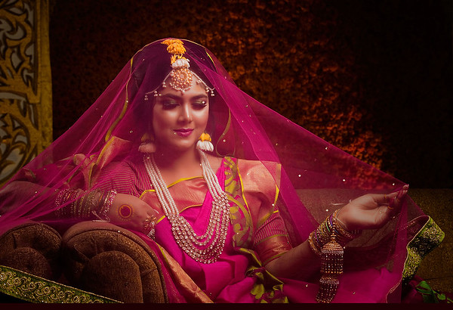

1. Hanif Sharif

TK.12,500/=

* 1 **Top** Photographer
* Event Duration:**4 Hours**
* Number of Pictures: Unlimited
* Specially Edited Photos: 100 copies
* Print: 4R (4”x6″) Matte Prints: 100 copies

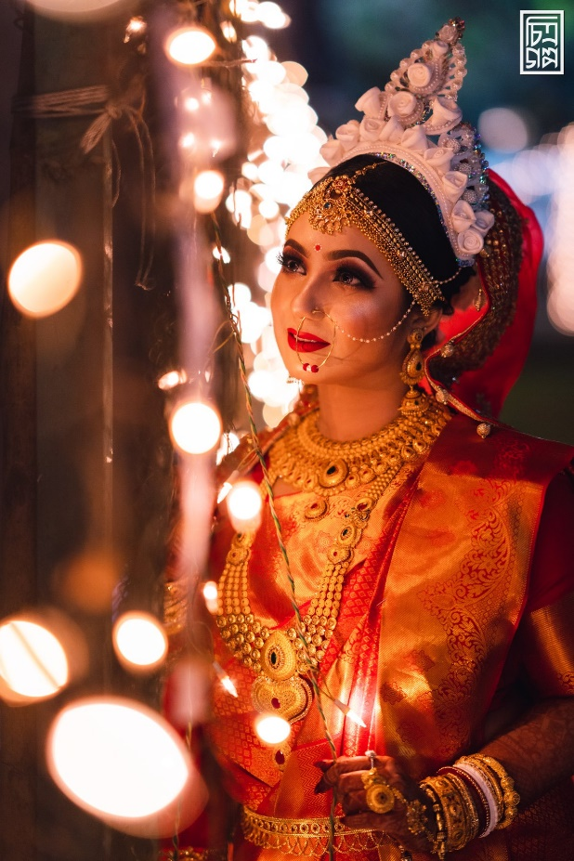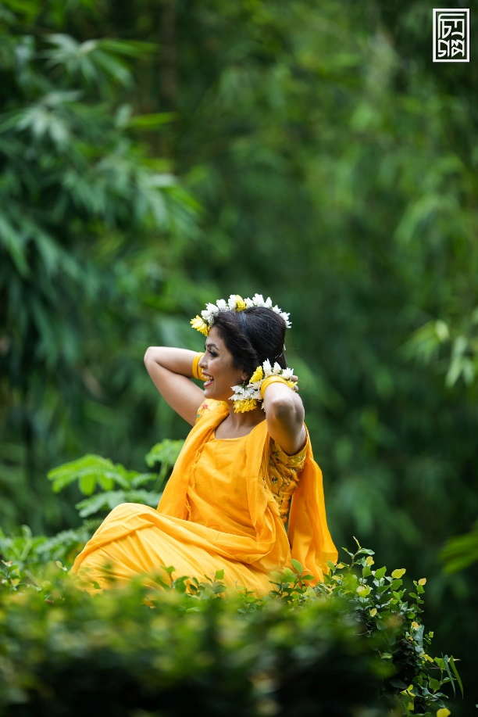

Professional Photographer

1. Iqbal Hosain

#### TK.15,000/=

* 1 **Top** Photographer + 1 Top Associate Photographer.
* Event Duration:**4 Hours**
* Number of Photos: Unlimited (All post processed)
* Specially Edited Photos: 100 copies
* Print: 4R (4”x6″) Matte Prints: 100 copies

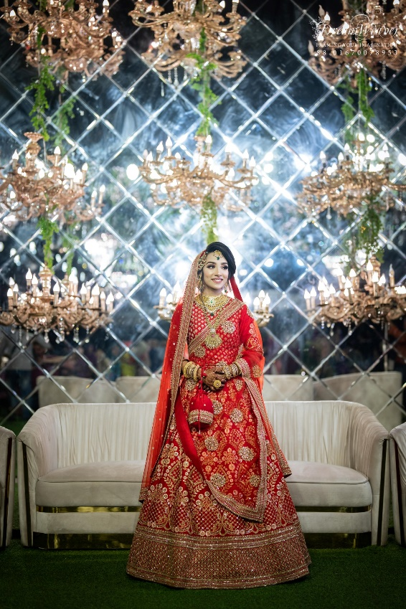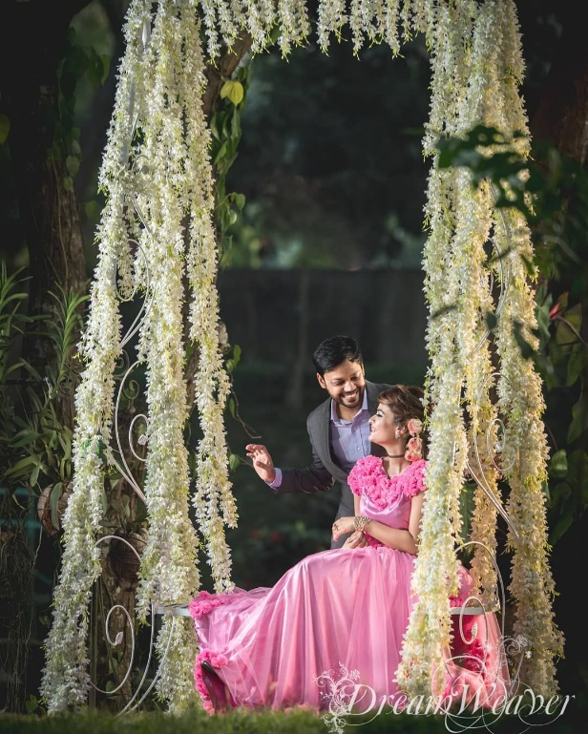

1. Amitro Saha

**TK.18,000/=**

* 1 **Senior** Photographer + 1 Top Associate Photographer.
* Event Duration:**4 Hours**
* Number of Pictures: Unlimited (All post processed)
* Specially Edited Photos: 100 copies
* Print: 5L (5”x7.5″) Matte Prints: 100 copies

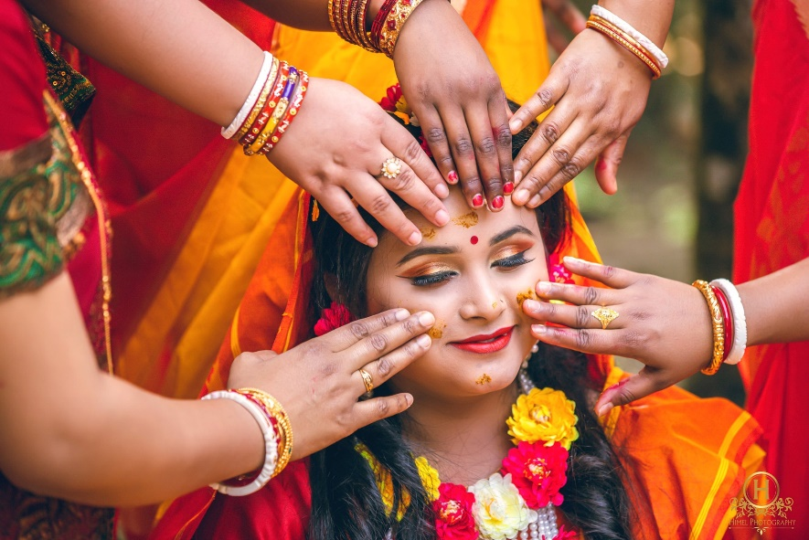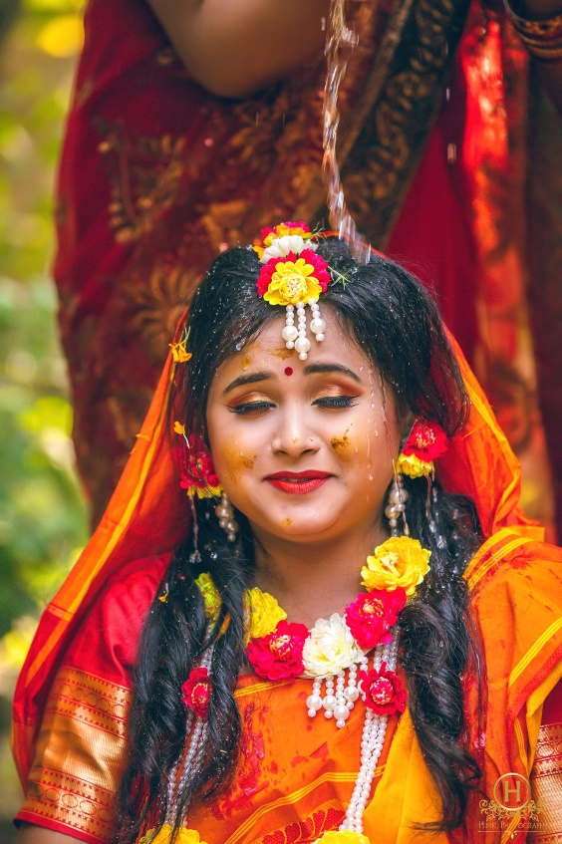

Cinematographer

* 1. **Rudro Ahsan**

#### TK.20, 000/=

* 1 Top Cinematographer
* 1 Camera Unit
* Video Quality: 1080P (1920×1080)
* Lighting setup
* Event Duration: 5 hours
* 2-3 minutes Promo with the best moments of the event
* 25 mins + edited video from entire event

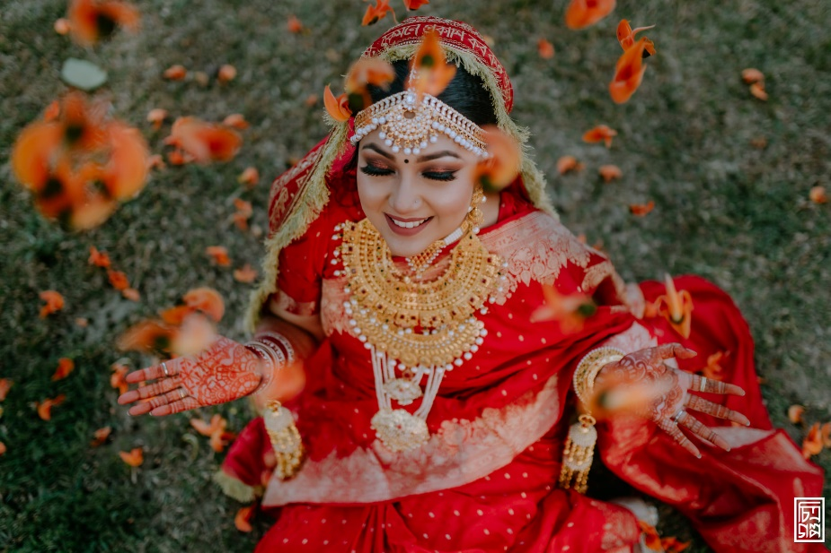

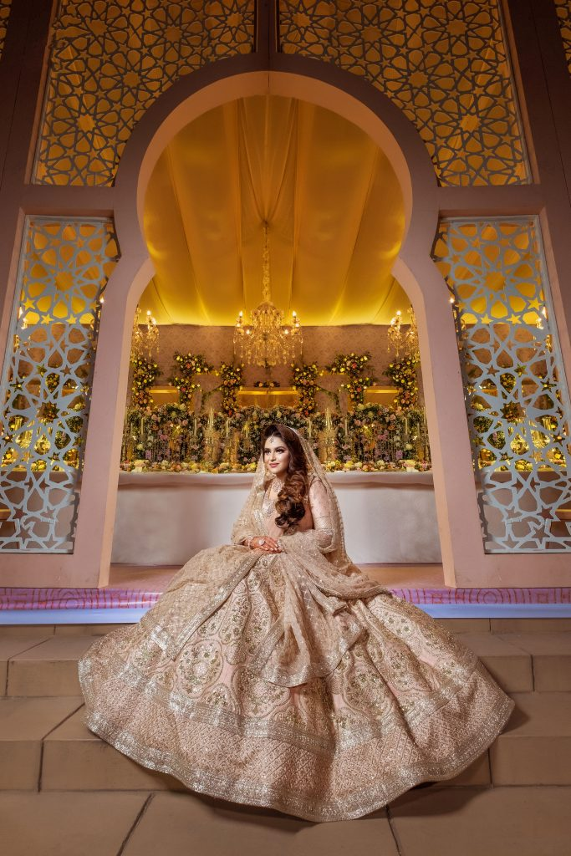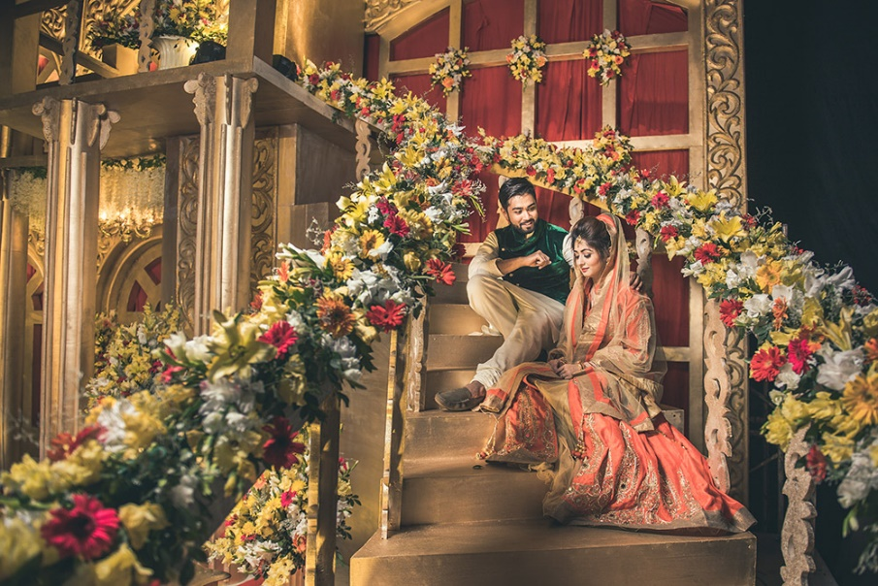

* 1. Partha Mandal

#### TK.25, 000/=

* 1 Top Cinematographer + 1 Top Associate Cinematographer
* 2 Camera Units
* Video Quality: 1080P (1920×1080)
* Lighting setup
* Duration: 5 hours
* Conceptual Cinematography.
* 2-3 minutes Promo with the best moments of the event
* 25 mins + edited video from entire event

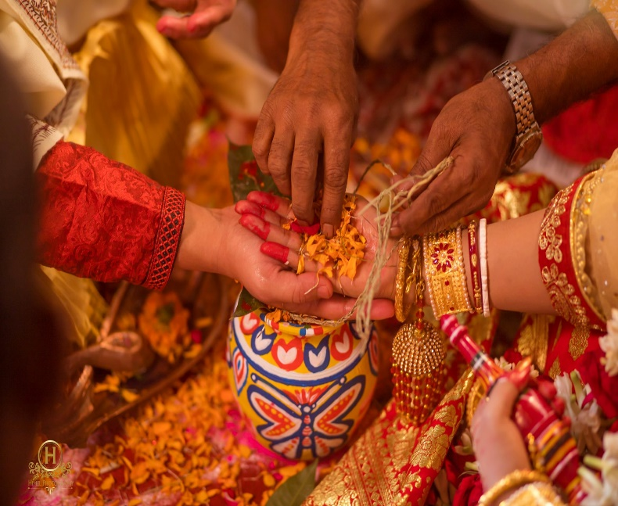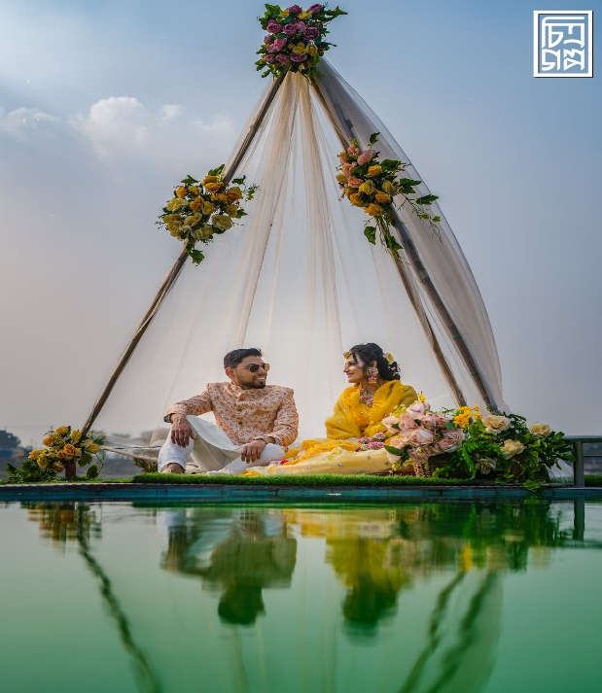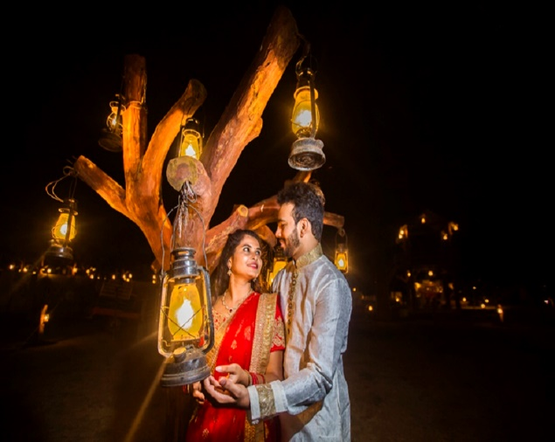

* 1. Himel Shahriar

#### TK.30,000/=

* 2 Top Cinematographers + 1 Top Associate Cinematographer
* 3 Camera Units
* Video Quality: 1080P (1920×1080)
* Lighting setup
* Duration: 5 Hours
* Conceptual Cinematography.
* 2-3 minutes Promo with the best moments of the event
* 30 mins + edited video from entire event

