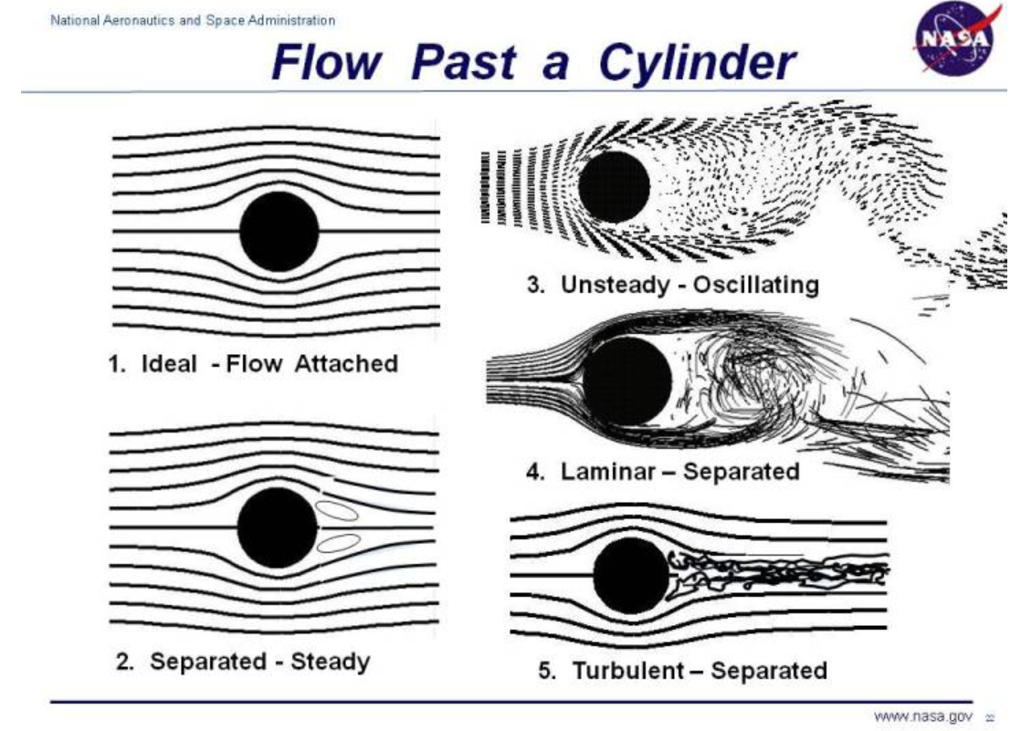

<https://www.grc.nasa.gov/www/k-12/airplane/dragsphere.html>

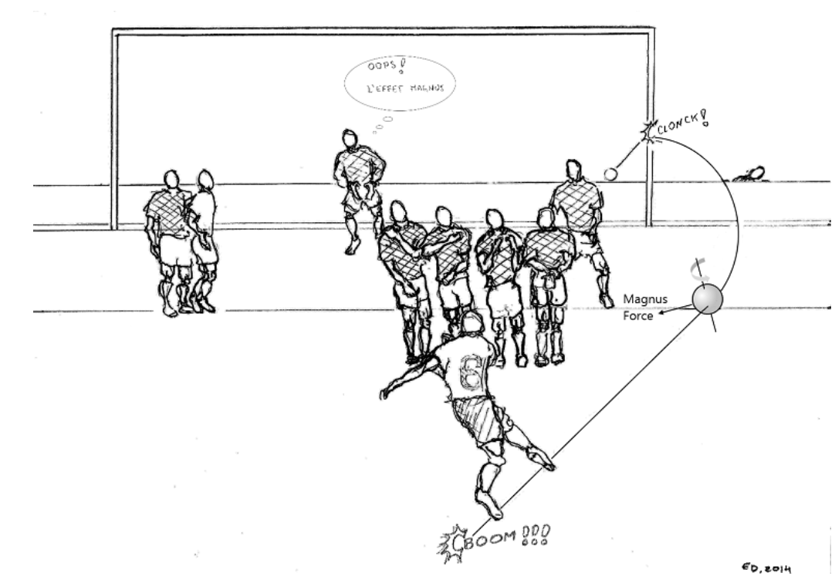

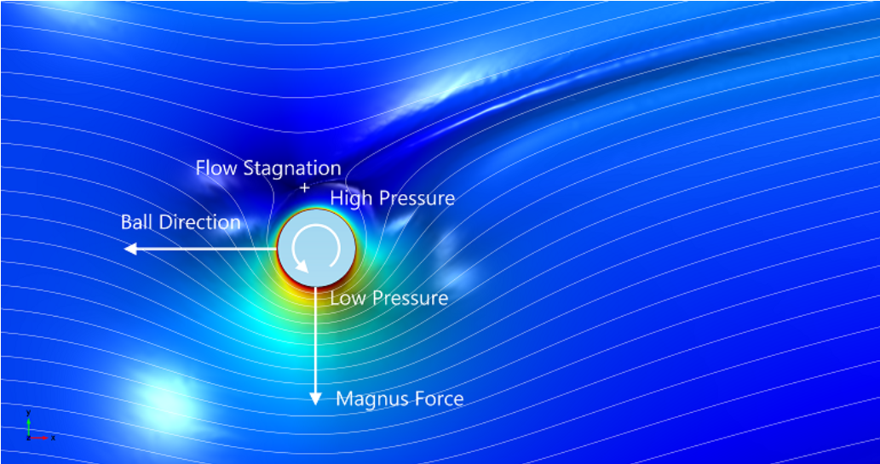

https://www.comsol.com/blogs/magnus-effect-world-cup-match-ball/