Surveys

Surveys will be used from time to time to learn about interest in going to the state fair as a group or t-shirt size or what people want for lunch.

In order to manage this, I have found that it is best to send an anonymous link. However, even with a space for name 2 or 3 times, people still will not include their name. To get around this we can change the survey flow.



To the left of the screen are several picture options. We want the second one.

Next, we will choose to add a new element: 

Choose Authenticator and then:

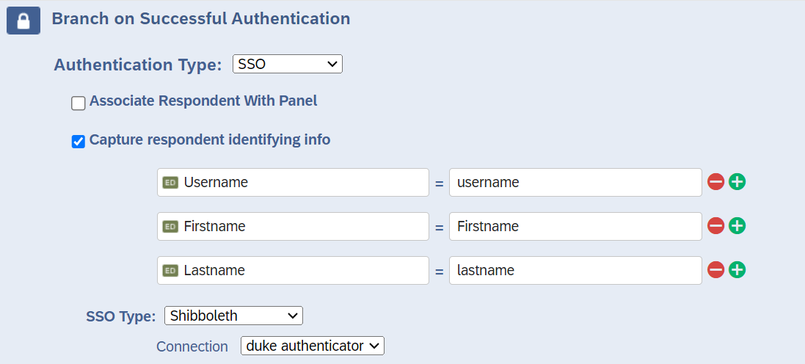

You will need to then move this to the top of the flow; ahead of “Show Block: Default Question Block” so that the first thing they do is sign in. I usually still leave a name input question on the actual survey.

Sign-up surveys: (Very Tricky!!!)

To do a sign-up survey we must first establish this very important idea: Multiple people can accidentally sign-up for the same slot. To mitigate this, it is best to send out the survey link at a random time. DO NOT HAVE THE COURSE INSTRUCTOR STAND AT THE FRONT AND TELL PEOPLE IT IS OPEN. If a time slot looks available when the survey is opened, they can select it. The best way to get around this is to make sure not everyone opens the survey at the same moment. Doesn’t really work that well for group projects, but works okay for programming interview final exam sign-ups.

To create the sign-up survey, have a multiple-choice question and allow one answer. 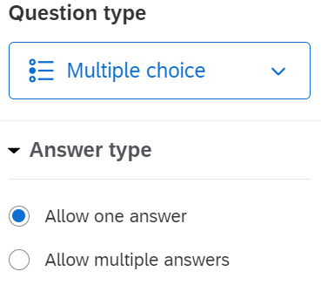

Put all of the available time slots.

For each time slot you will need to do the following: on the left-hand side find quotas:

Create a quota for each time slot. 

Use Question -> Choose Question -> Choose time slot -> Is selected

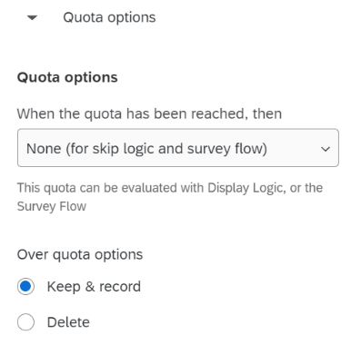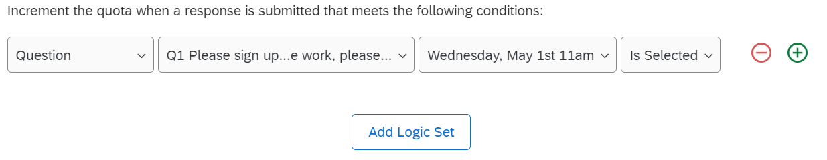

Quota Options below that:

Choose the quota count by clicking on the space under quota target.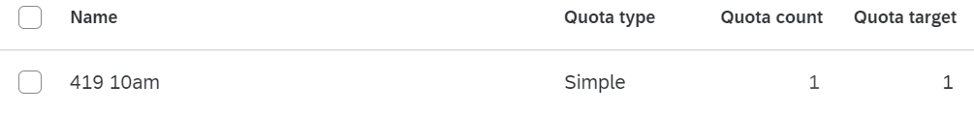

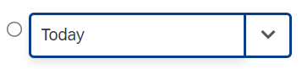Then return back to survey builder

Choose a time slot and click the down arrow

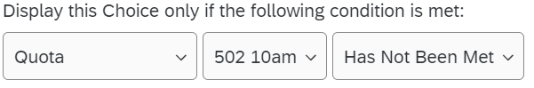Then choose the quota that matches

Check the results under Data & Analysis. If more people choose a time slot than should have, the spreadsheet will give a time stamp and you will need to contact the people who are over the limit after the others and let them know to choose a new time slot.

Course Evaluations

For course evaluations, it will be best to distribute them by email so that everyone can answer only once. You will need to do evaluations for BIOSTAT MB and CRTP. Not BIOSTAT PhD or CBB.

General Qualtrics:

Look & Feel:

Theme: Choose a theme that represents the survey. I usually go with a generic Duke University.

Layout: How do you want the questions to look?

General: Choose how buttons and progress bar looks. For the header: What title or explanation do you want to go with the survey? Some people create a question on the survey itself to have a header. That is only really necessary to do if there are different sections that need a different explanation. If there is only one header in the entire survey, you can do it here/ add a logo for the entire survey. FOR COURSE EVALUATIONS, PUT THE COURSE AT THE TOP (BIOSTAT 707, CRTP 241, etc.)

Style: Colors, Fonts, text size, any custom CSS you want to add to the survey.

Motion: Page and Question transition styles

Logo: To change the Duke University Logo. (Probably best not to)

Background: Total survey colors.

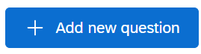

Add New Question to survey. Will pull up many options. Choose wisely.

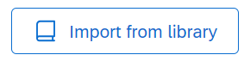

To copy a previous project. Choose this and then

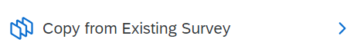

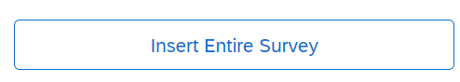If you want to use the entire survey again choose:

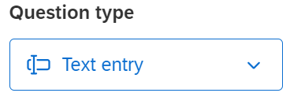

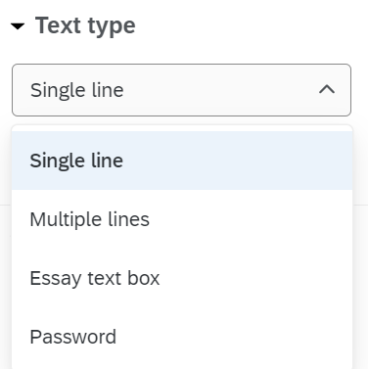For text entry you can choose from:

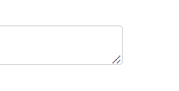If more than a few words are required, choose multiple lines. Then go back and increase the size of the box. Grab the corner and pull to re-size.

Distributions: Before you can distribute the survey, you must publish it. After you publish the survey, any changes to the survey do not become live until after you clock publish again. Anonymous link and emails are the standard options. If using anonymous link, probably best to use the authenticator.

To distribute through email (to ensure that respondents only answer one time) click compose email and from there you will need to create a contact list (This can be copy and pasted from excel), choose a time for the email to be sent out, and you will need to write the email. I also like to delete the opt out link at the bottom of the page, because generally I NEED a response from someone.

Data & Analysis:

This is where you can view the information gathered. Technically, you can do it under results…but that is annoying and bad.

Go to Data & Analysis at the top of the page and export the information into a CSV.

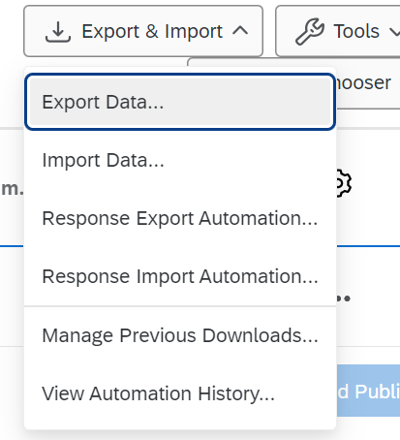

From there you can manipulate the data and easily copy and paste free response answers. This is very helpful for course evaluations.

Workflows:

Workflows are ways to get the program to do things for you automatically. This helps with sending follow up emails or sending a confirmation form to someone else.

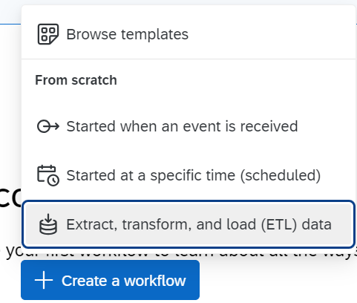To get started click on “+ Create a workflow”

If you are following this guide, browse templates.

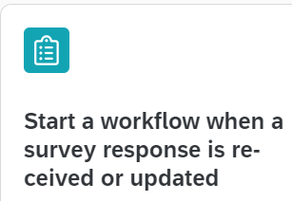

Click the plus and then add a task or a condition.

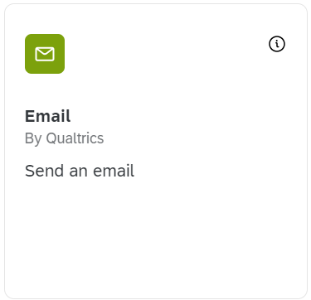Add a task:

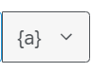

For automatic follow-up emails, you can choose

the response from a question in the survey. So, if an email is a response, that email address can be chosen. The same symbol can be used in the body of the automatic email to include information from the survey in the email.

To create an approval workflow please follow these instructions : <https://www.qualtrics.com/support/survey-platform/data-and-analysis-module/retake-survey-link/>