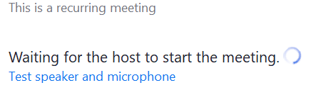All course directors have been set as meeting hosts. If you try to start a class meeting and there is a message :

**it is likely that are not logged in through Duke shibboleth**



In the top right-hand corner of the Zoom workplace client, find the profile symbol. Click that and sign out

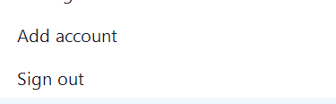

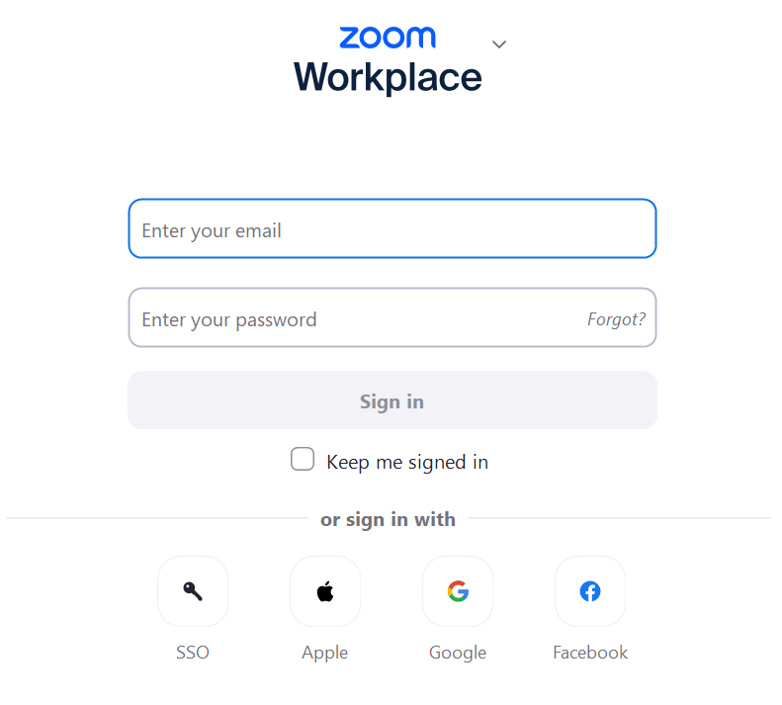You should come back to a sign-in screen:

**DO NOT ENTER YOUR EMAIL AND PASSWORD**

**Choose the SSO button at the bottom and click that. You may be asked for a domain; it will be “Duke”.**

**Log in through Shibboleth & try to start the meeting again.**

There is a chance that you are logged in through Shibboleth with other Duke programs. In that case it should just open the client again. In some cases, you may need to run through the SSO process a few times, but you should always choose “SSO”

Your profile should now be “NETID@duke.edu”