Pope Francis with Lamb

Pope Francis with Dove

Pope Francis with Dog

Pope Francis with Black Panther Cub

50th Anniversary of Earth Day

50th Anniversary of Earth Day

1750th Birthday Anniversary of St. Nicholas of Myra

Ascension of Christ, Alessia Babrow

100th Death Anniversary of St. Teresa of Jesus de los Andes
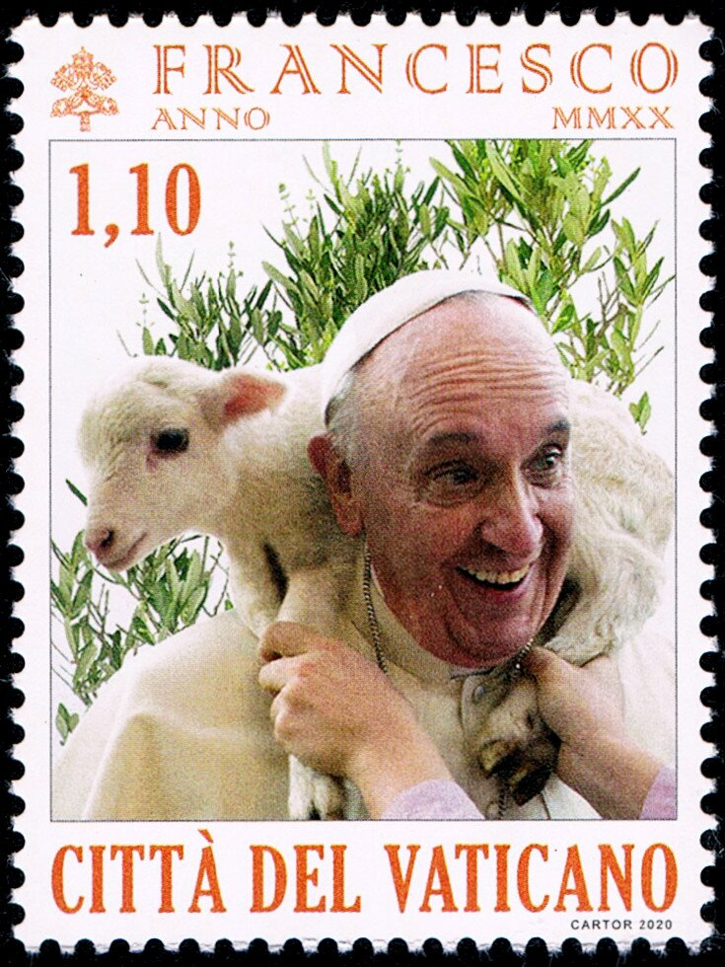
1838
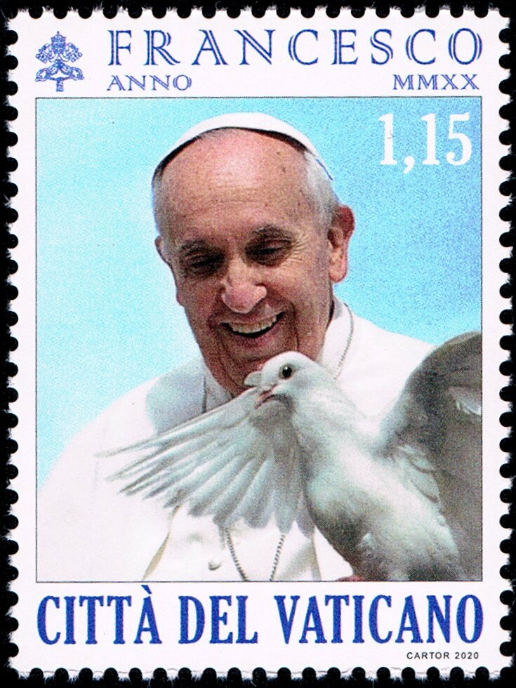
1839
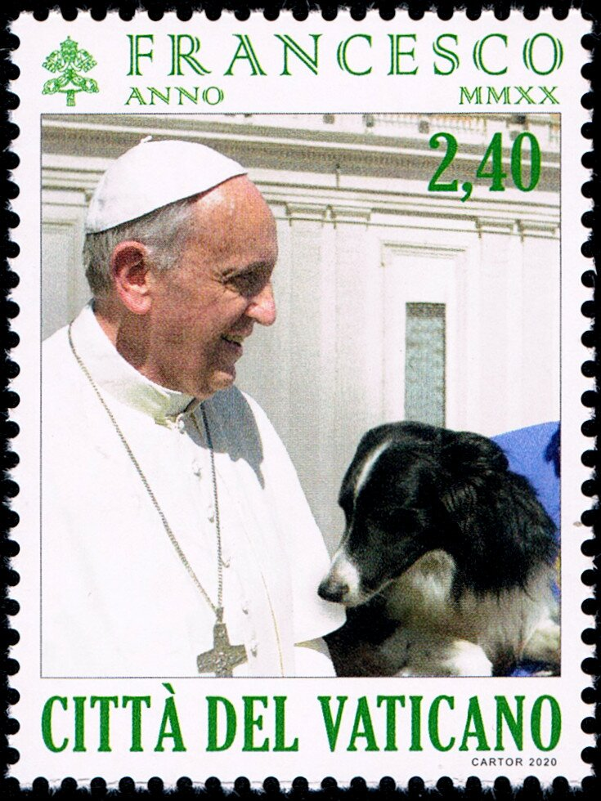
1840
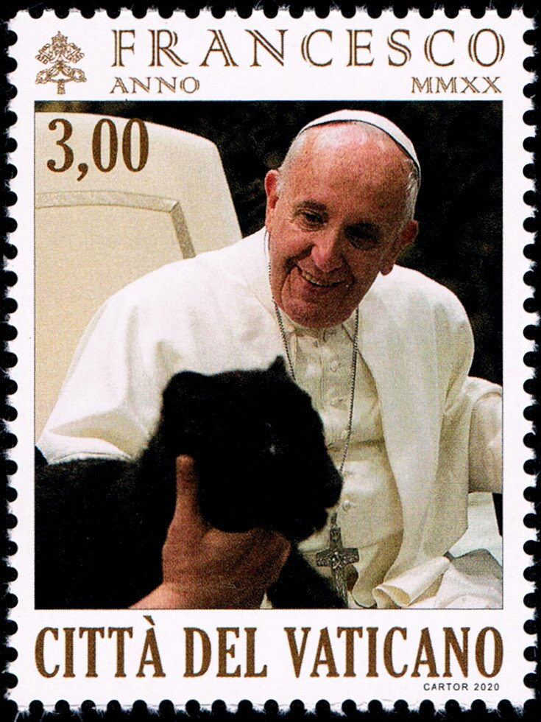
1841
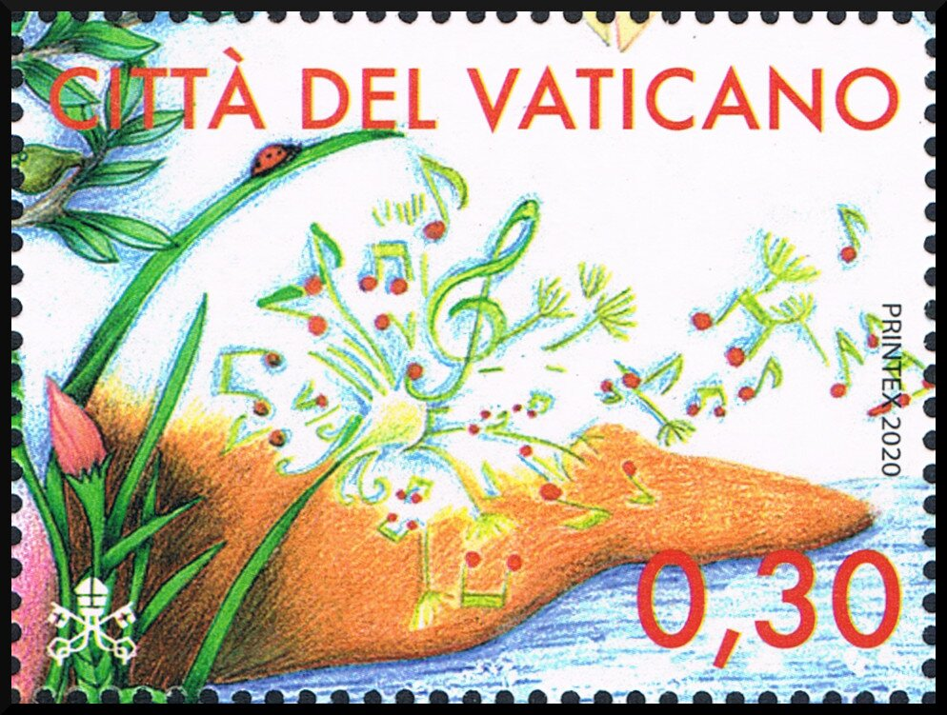
1845
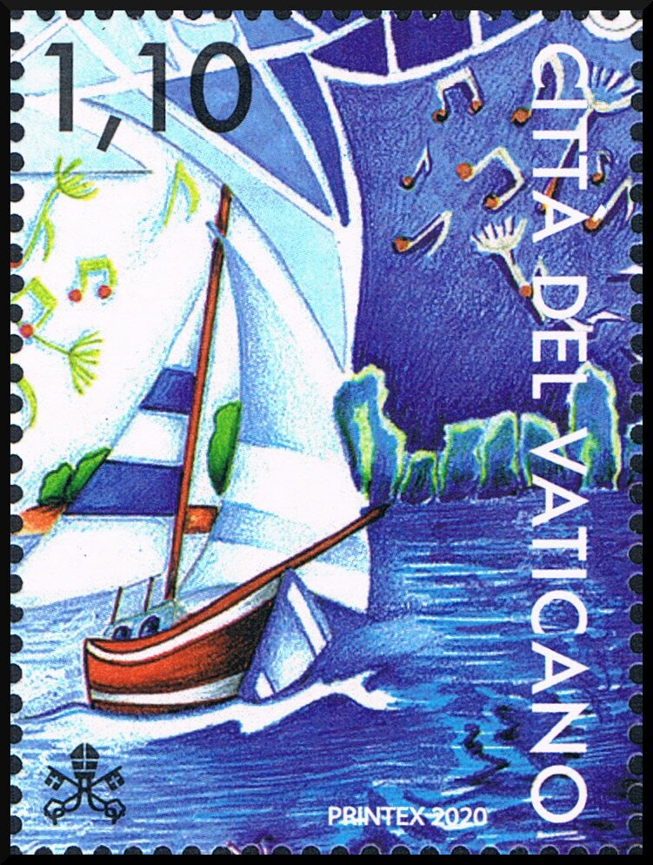
1846
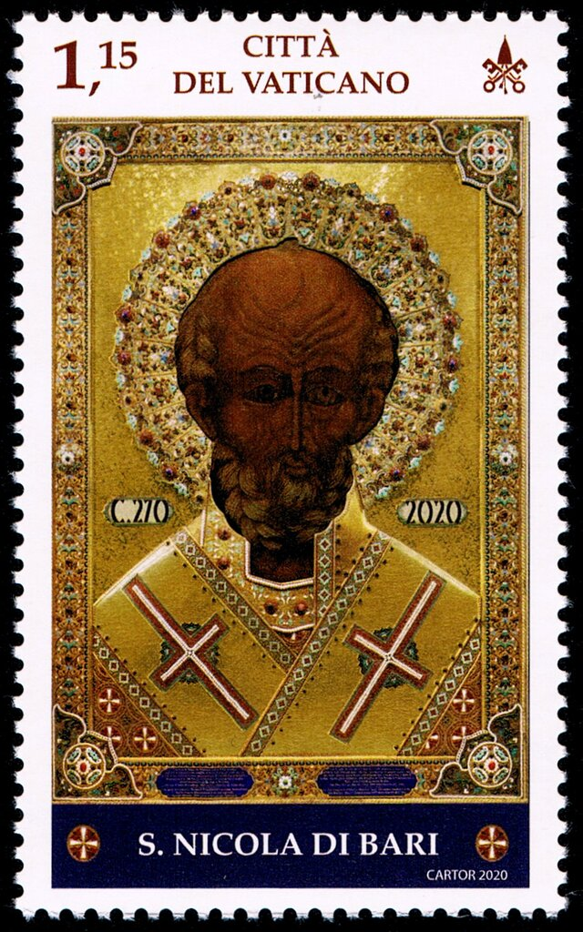
1843
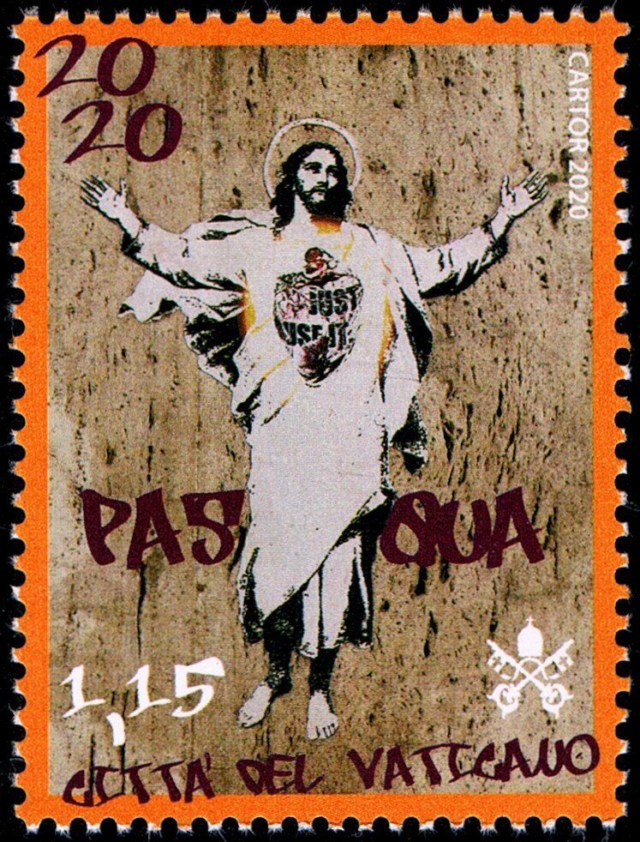
1842
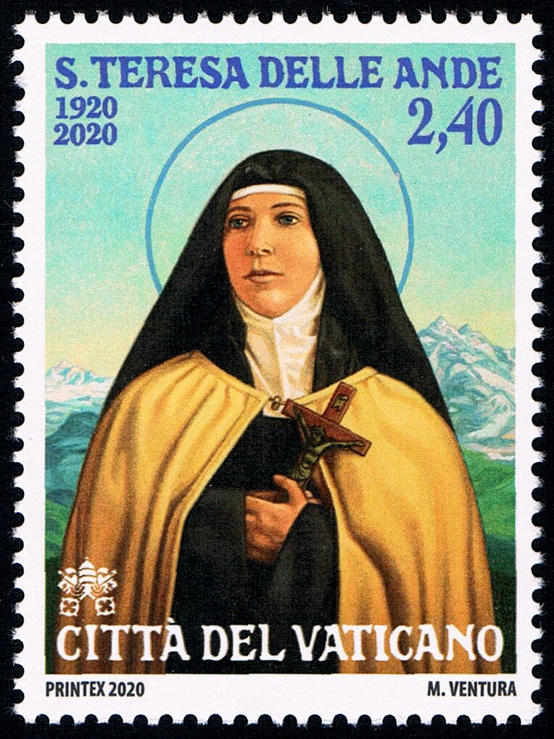
1847

