# FreeRTOS notes

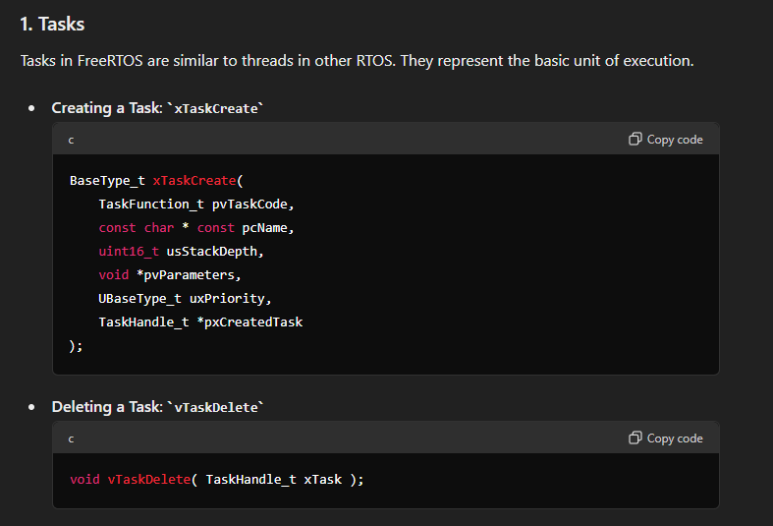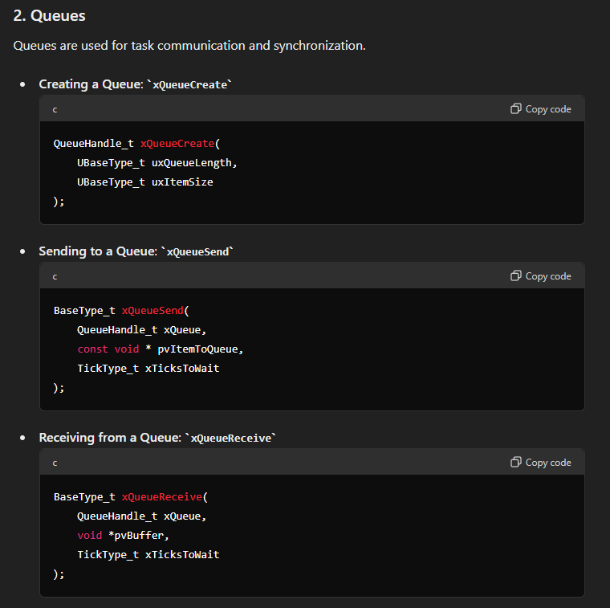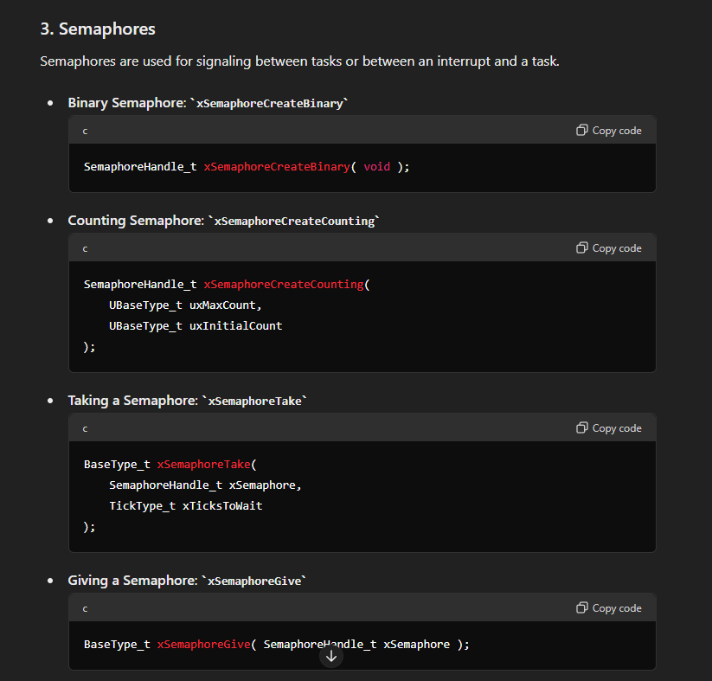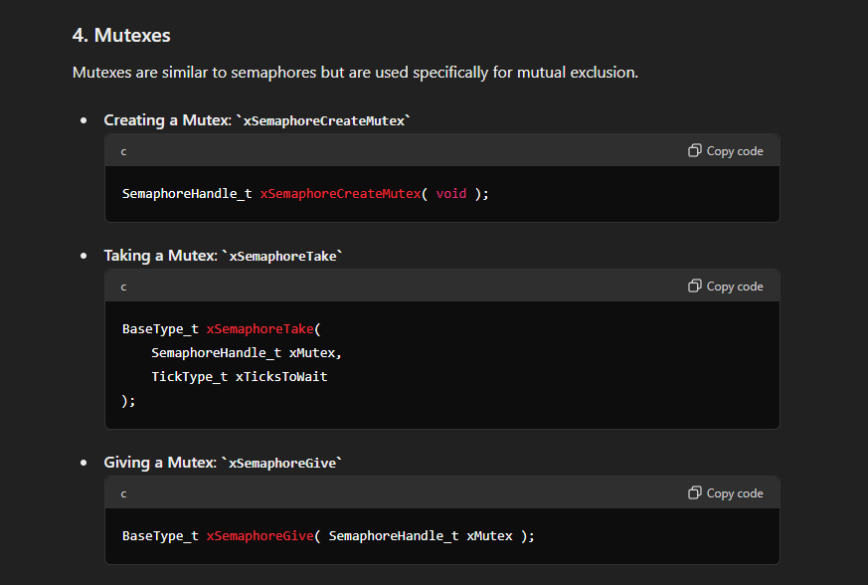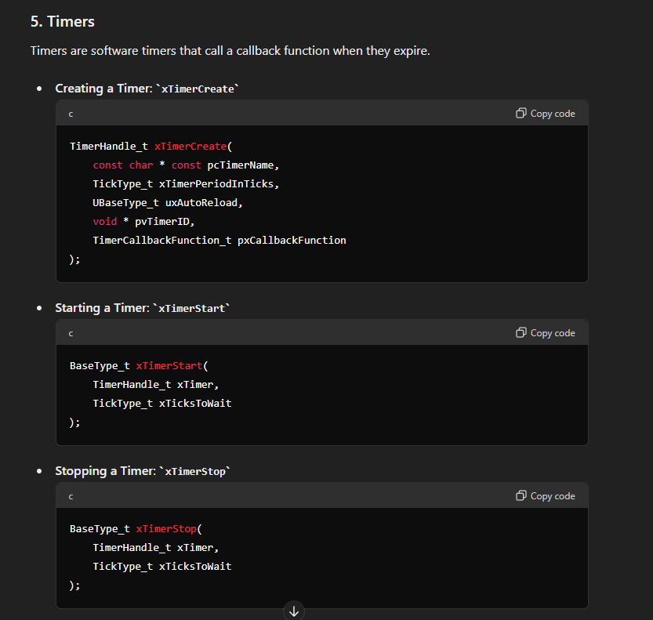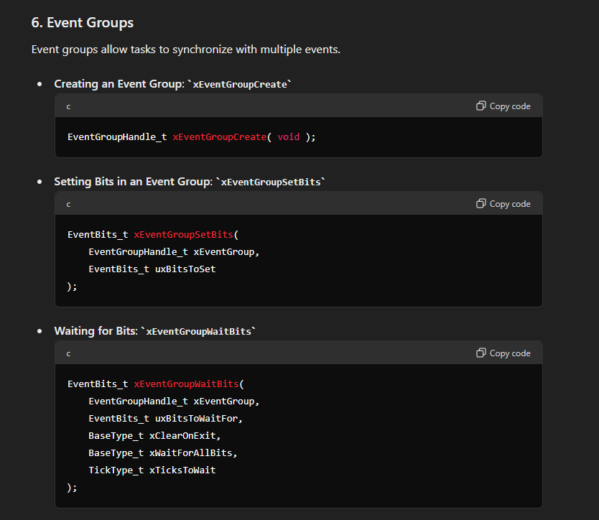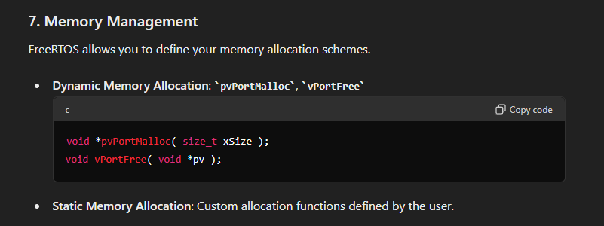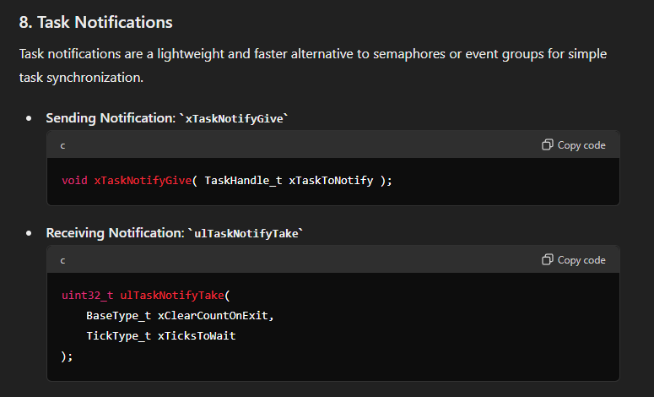

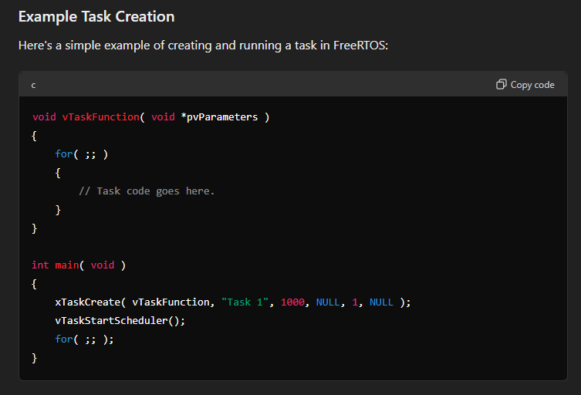

* xTaskCreate, xTaskDelete
* xQueueCreate, xQueueSend, xQueueReceive
* xSemaphoreCreateBinary, xSemaphoreCreateCounting, xSemaphoreTake, xSemaphoreReceive
* xSemaphoreCreateMutex, xSemaphoreTake, xSemaphoreGive
* xTimerCreate, xTimerStart, xTimerStop
* xEventGroupCreate, xEventGroupSetBits, xEventGroupWaitBits
* pvPortMalloc, vPortFree
* xTaskNotifyGive, ulTaskNotifyTake

# Setting up the ESP32 for flashing



After the ESP-IDF extension is installed, on the ESP-IDF setup tab, double check your PATHs.

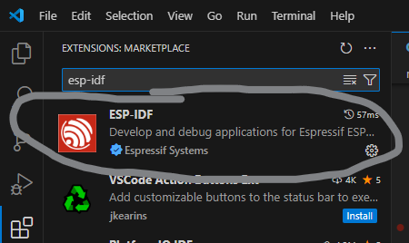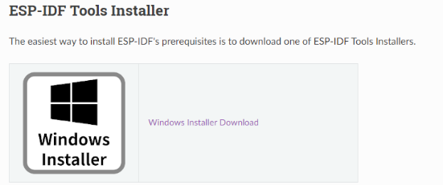

In order to get the ESP32 set up and functional, went to this website and installed ESP-IDF on vscode:

https://docs.espressif.com/projects/esp-idf/en/stable/esp32/get-started/windows-setup.html

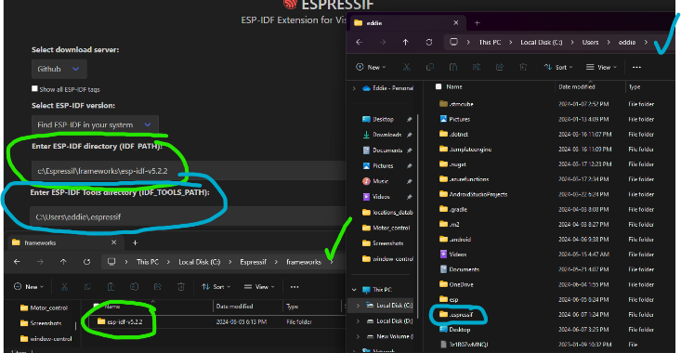



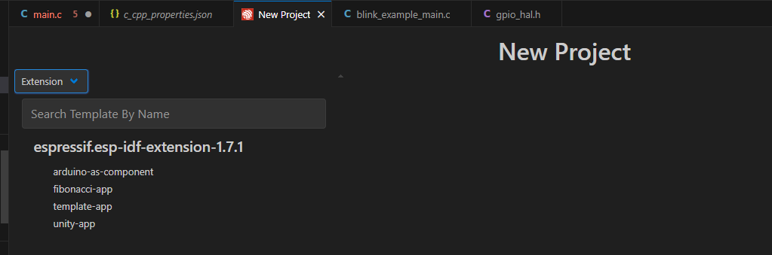

On VSCode when you press the “Install” button, it’ll ask what workspace you want to install to at the top of the screen, which in my case is the root project folder where my firmware, hardware, schematics etc. will be located.



After creating a new project and selecting the folder, I choose template-app on extension. This creates a blank project with no code other than app_main



# Getting it to blink

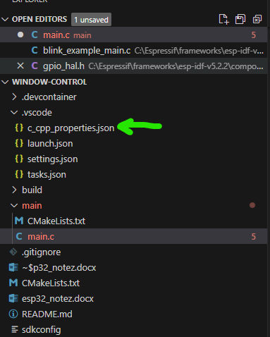I changed the code to this in c_cpp_properties.json

{

    "configurations": [

      {

        "name": "ESP-IDF",

        "cStandard": "c11",

        "cppStandard": "c++17",

        "includePath": [

          "${config:idf.espIdfPathWin}/components/**",

          "${workspaceFolder}/**"

        ],

        "browse": {

          "path": [

            "${config:idf.espIdfPathWin}/components",

            "${workspaceFolder}"

          ],

          "limitSymbolsToIncludedHeaders": false

        },

        "compilerPath": "${config:idf.toolsPathWin}\\tools\\xtensa-esp-elf\\esp-13.2.0_20230928\\xtensa-esp-elf\\bin\\xtensa-esp32-elf-gcc.exe"

      }

    ],

    "version": 4

  }

Getting ESP32 to work: LED0 on the board is connected to D2, or GPIO 2.

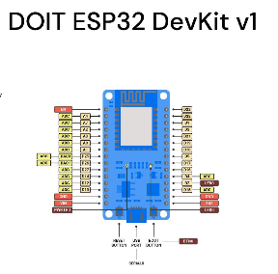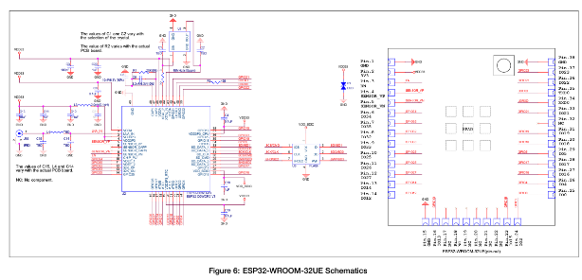

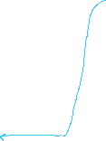

#include <stdio.h>

#include "freertos/FreeRTOS.h"

#include "freertos/task.h"

Note: this code is sort of based on their blink_example_main.c code. 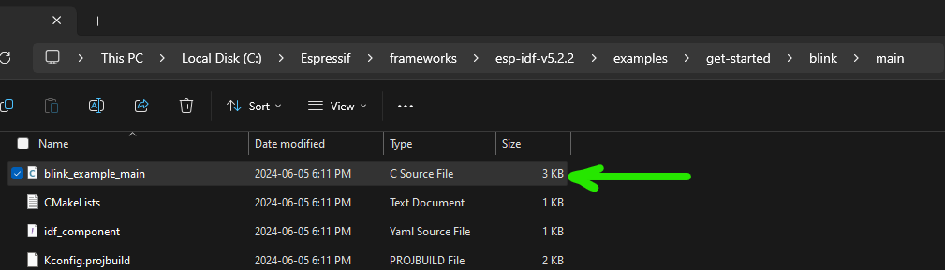

#include "driver/gpio.h"

#include "esp_log.h"

#define CONFIG_BLINK_PERIOD 1000

//ESP32 controls window linear actuator to open and close

static const char* TAG = "main";

static gpio_num_t LED_PIN = 2;

static uint32_t LED_state = 0;

void configure_led(void) {

    ESP_LOGI(TAG, "configuring LED...");

    gpio_reset_pin(LED_PIN);

    gpio_mode_t mode = GPIO_MODE_OUTPUT;

    gpio_set_direction(LED_PIN, mode);

}



static void blink_led(void) {

    gpio_set_level(LED_PIN, LED_state);



}

void app_main(void)

{

    configure_led();

    while(1) {

        ESP_LOGI(TAG, "Turning the LED %s", LED_state == true ? "ON": "OFF");

        blink_led();

        LED_state = !LED_state;

        vTaskDelay(CONFIG_BLINK_PERIOD / portTICK_PERIOD_MS);

    }

}

# Blinking as Task

void vBlinkTask(void *pvParameters) {

    while(1) {

        ESP_LOGI(TAG, "Turning the LED %s", LED_state == true ? "ON": "OFF");

        blink_led();

        LED_state = !LED_state;

        //vTaskDelay(CONFIG_BLINK_PERIOD / portTICK_PERIOD_MS);

        vTaskDelay(pdMS_TO_TICKS(CONFIG_BLINK_PERIOD));

    }

}

extern "C" void app_main(void)

{

    configure_led();

    // LED blinking task

Stack Overflow Error, change to 4096 for sufficient stack size

    xTaskCreate(

        vBlinkTask,

        "Blink Task",

        configMINIMAL_STACK_SIZE,



        NULL,

        tskIDLE_PRIORITY,

        NULL);

    while(1) {

    }

}

# Progress Notes

## WiFi

I (458) main: Turning the LED OFF

E (1078) mqtt_client: Error parse uri = 192.168.77.237:1883

E (1078) mqtt_client: Client was not initialized

I (1508) main: Turning the LED ON

I (2518) main: Turning the LED OFF

I (3088) main: Sending MQTT message...

I (3088) mqtt_functionality: [APP] Startup..



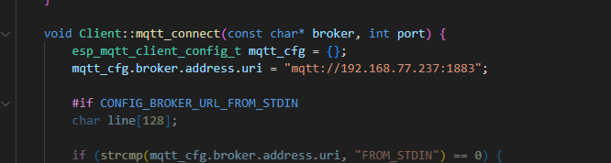I (3088) mqtt_functionality: [APP] Free memory: 281560 bytes



I (3088) mqtt_functionality: [APP] IDF version: v5.2.2-dirty



ESP_ERROR_CHECK failed: esp_err_t 0x103 (ESP_ERR_INVALID_STATE) at 0x400d74eb

0x400d74eb: MQTT::Client::Client() at D:/projects/smart_room/firmware/window/window-control/main/mqtt_network.cpp:105 (discriminator 1)

file: "./main/mqtt_network.cpp" line 105

func: MQTT::Client::Client()

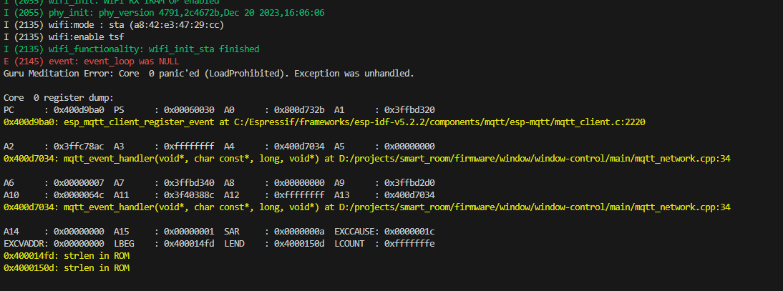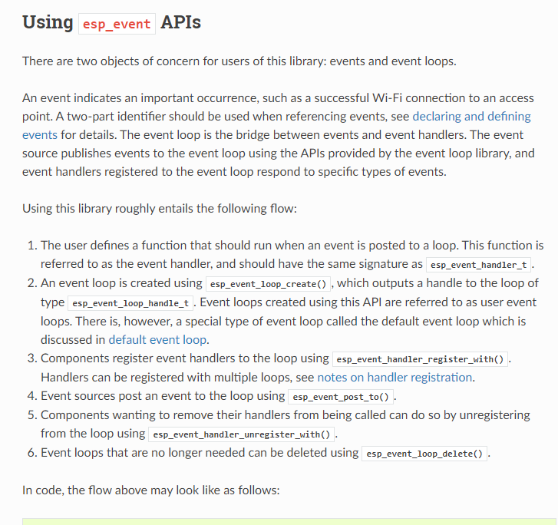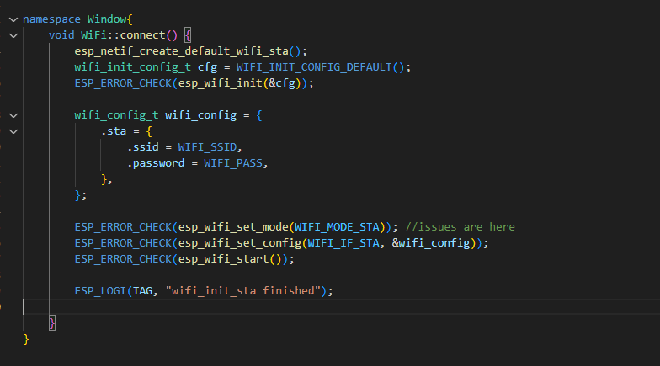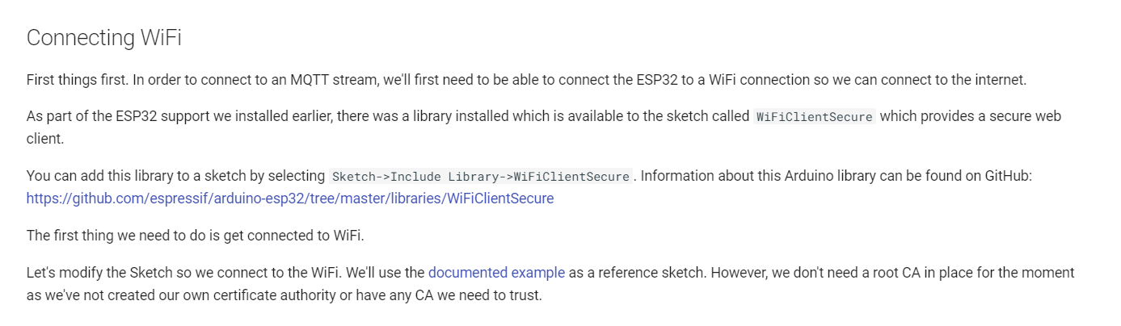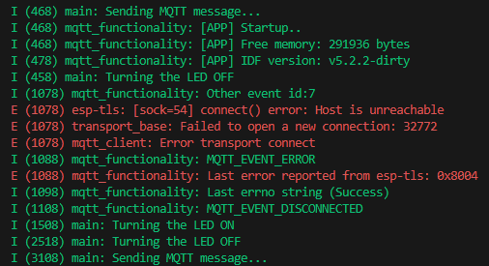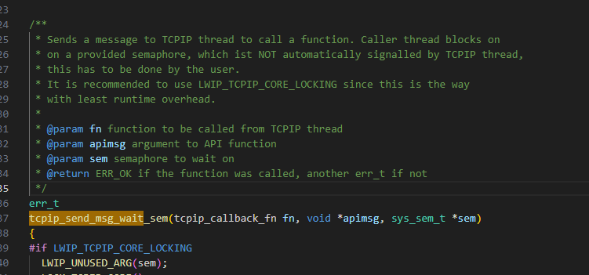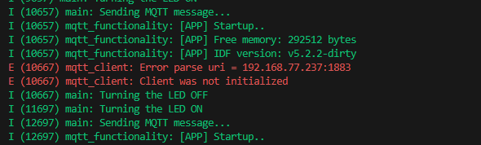expression: esp_event_loop_create_default()

Event_loop NULL means the event loop has not even been created.



I (468) main: Sending MQTT message...

I (468) mqtt_functionality: [APP] Startup..

I (468) mqtt_functionality: [APP] Free memory: 291936 bytes

I (478) mqtt_functionality: [APP] IDF version: v5.2.2-dirty

I (458) main: Turning the LED OFF

I (1078) mqtt_functionality: Other event id:7

E (1078) esp-tls: [sock=54] connect() error: Host is unreachable

E (1078) transport_base: Failed to open a new connection: 32772

E (1078) mqtt_client: Error transport connect

I (1088) mqtt_functionality: MQTT_EVENT_ERROR

E (1088) mqtt_functionality: Last error reported from esp-tls: 0x8004

I (1098) mqtt_functionality: Last errno string (Success)

I (1108) mqtt_functionality: MQTT_EVENT_DISCONNECTED

I (1508) main: Turning the LED ON

I (2518) main: Turning the LED OFF

I (3108) main: Sending MQTT message...

assert failed: tcpip_send_msg_wait_sem /IDF/components/lwip/lwip/src/api/tcpip.c:449 (Invalid mbox)

Tcpip.c below… possible hint?



# Key Things Learned