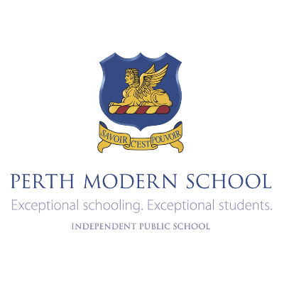Literature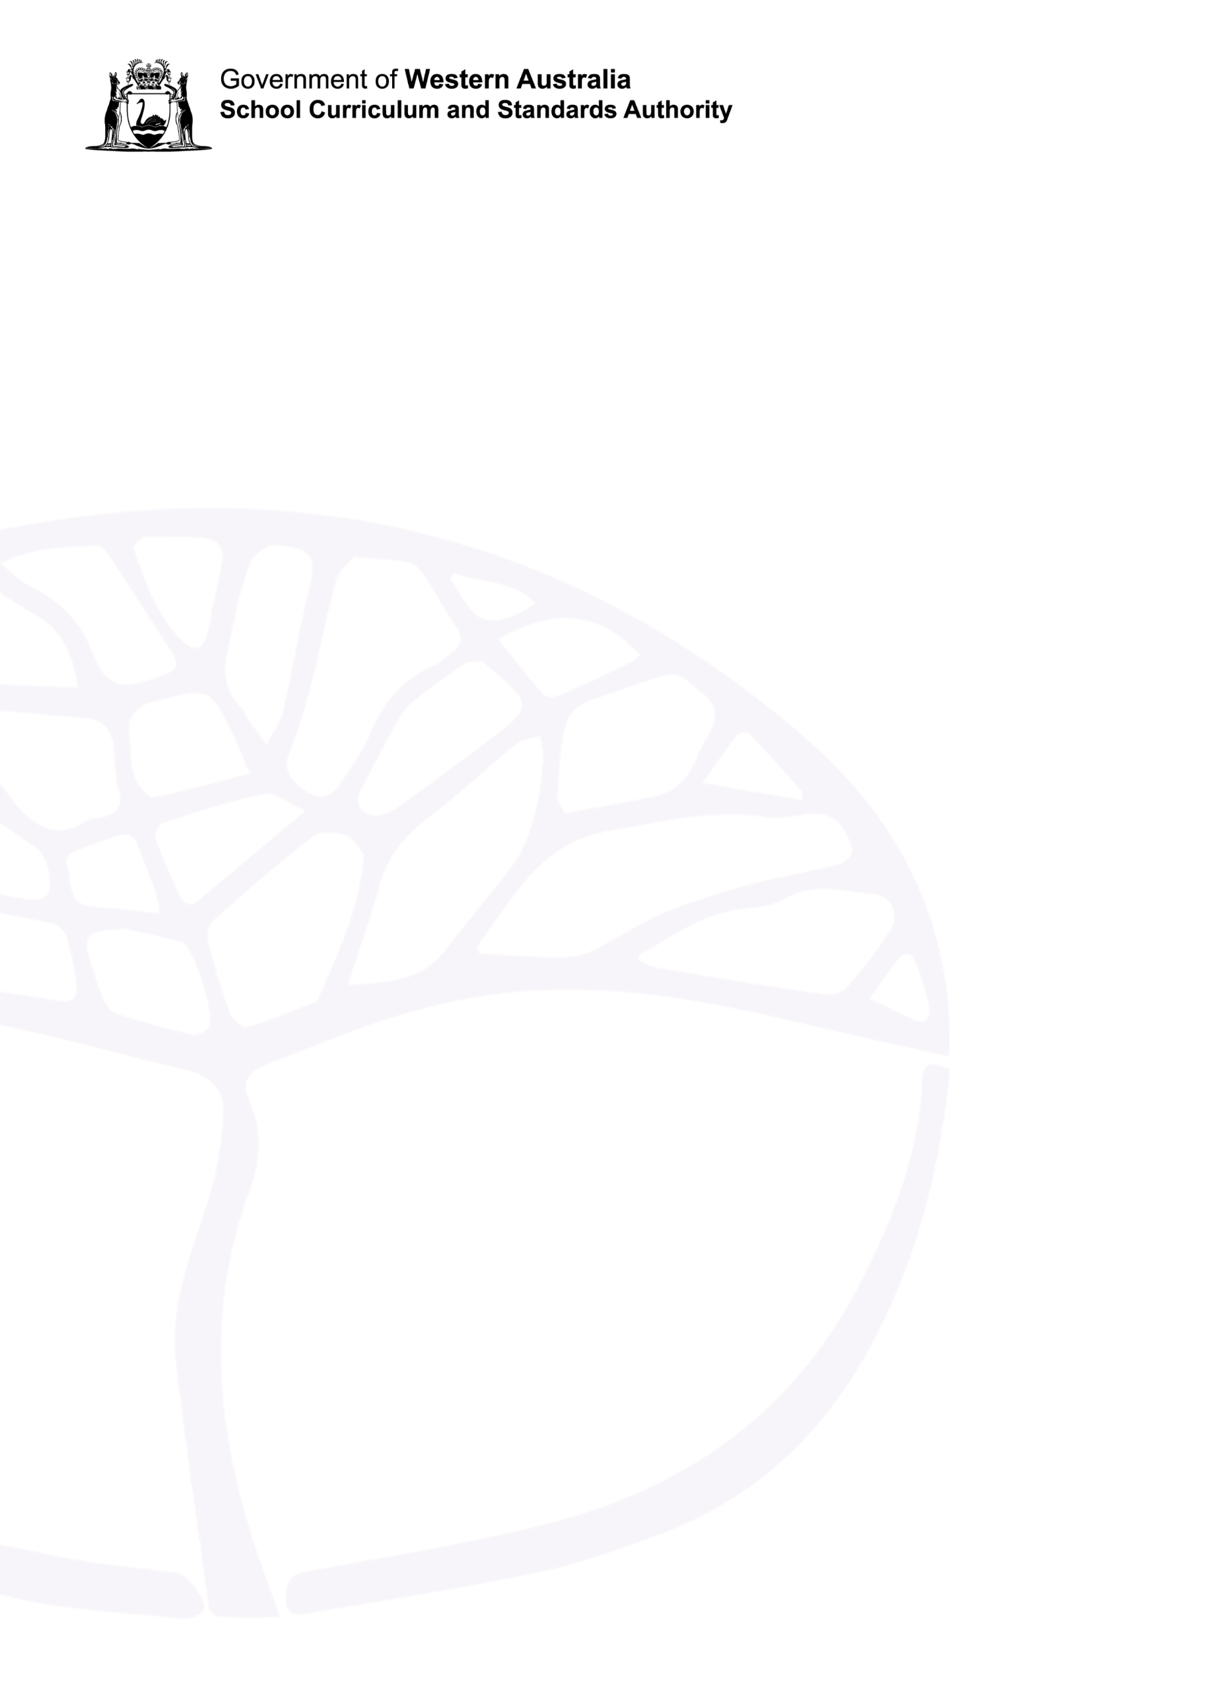

ATAR course

Year 12 syllabus

**Acknowledgement of Country**

Kaya. Perth Modern School acknowledges that our premises, and the offices of The School Curriculum and Standards Authority, are on Whadjuk Noongar boodjar and that we deliver our services on the country of many traditional custodians and language groups throughout Western Australia. We acknowledge that the traditional custodians as the first educators throughout Australia and we offer our respect to Elders past and present. May we continue their legacy and honour their sense of connection to community and the world around us.

**Contents**

Rationale 1

Aims 2

Organisation 3

Structure of the syllabus 3

Organisation of content 3

Representation of the general capabilities 4

Representation of the cross-curriculum priorities 6

Unit 3 7

Unit description 7

Learning outcomes 7

Unit content 7

Unit 4 9

Unit description 9

Learning outcomes 9

Unit content 9

School-based assessment 11

Grading 12

ATAR course examination 13

Examination design brief – Year 12 14

Appendix 1 – Grade descriptions Year 12 15

Appendix 2 – Glossary 17

# Rationale

The Literature ATAR course focuses on the study of literary texts and developing students as independent, innovative and creative learners and thinkers who appreciate the aesthetic use of language; evaluate perspectives and evidence; and challenge ideas and interpretations. The Literature ATAR course explores how literary texts construct representations, shape perceptions of the world and enable us to enter other worlds of the imagination. In this subject, students actively participate in the dialogue of literary analysis and the creation of imaginative and analytical texts in a range of modes, media and forms.

Students enjoy and respond creatively and critically to literary texts drawn from the past and present and from Australian and other cultures. They reflect on what these texts offer them as individuals, as members of Australian society and as world citizens.

Students establish and articulate their views through creative response and logical argument. They reflect on qualities of literary texts, appreciate the power of language and inquire into the relationships between texts, authors, readers, audiences and contexts as they explore ideas, concepts, attitudes and values.

# Organisation

This course is organised into a Year 11 syllabus and a Year 12 syllabus. The cognitive complexity of the syllabus content increases from Year 11 to Year 12.

## Structure of the syllabus

The Year 12 syllabus is divided into two units which are delivered as a pair. The notional time for the pair of units is 110 class contact hours.

# 

# Unit 3

## Unit description

Unit 3 develops students’ knowledge and understanding of the relationship between language, culture and identity in literary texts. Students inquire into the power of language to represent ideas, events and people, comparing these across a range of texts, contexts, modes and forms. Through critical analysis and evaluation, the values and attitudes represented in and through texts and their impact on the reader are examined. Throughout the unit, students create analytical responses that are characterised by a confident, engaging style and informed observation. In creating imaginative texts, students experiment with language, adapt forms, and challenge conventions and ideas.

## Learning outcomes

By the end of this unit, students:

* understand the relationship between language and representations of culture and identity
* develop their own analytical responses by synthesising and/or challenging other interpretations
* create oral and/or written and/or multimodal texts that experiment with literary style.

## 

# Unit 4

## Unit description

Unit 4 develops students’ appreciation of the significance of literary study through close critical analysis of literary texts drawn from a range of forms, genres and styles. Students reflect upon the creative use of language, and the structural and stylistic features that shape meaning and influence response. The unit focuses on the dynamic nature of literary interpretation and considers the insights texts offer, their use of literary conventions and aesthetic appeal. Students’ analytical responses demonstrate increasing independence in interpreting texts and synthesising a range of perspectives into critical and imaginative responses. In creating imaginative texts, students experiment with literary conventions and reflect on how the created text takes into account the expectations of audiences.

## Learning outcomes

By the end of this unit, students:

* understand the relationship between the representation of values and ideas in texts and how they are received by audiences
* justify their own critical interpretation or reading of a text
* create oral and/or written and/or multimodal texts blending and borrowing literary conventions.

## 

## Unit content

|  |  |  |  |  |  |  |
| --- | --- | --- | --- | --- | --- | --- |
|  | | | **PERTH MODERN SCHOOL**  **Course Outline: ATLIT 2024**  **Course: Literature – Unit 4** | |  | |
| **Task** | **Task Description and Content** | | **Syllabus Pointers**  **Note: The study of our various texts will not be confined to the pointers next to them but will also engage with other criteria listed besides other texts/assessments.** | | **Task Marks** |
| **% Weight** |
| 1 | **Creative production of literary texts**  Transition assessment. Creative writing.  Feminism. Reader. | | **Create imaginative texts, including:**   * experimenting with content, form, style, language and medium. Writers may manipulate grammatical and stylistic elements for ideological and/or aesthetic purposes * drawing on knowledge and experience of genre, literary devices and the interplay of the visual and verbal in creating new texts * adapting literary conventions for specific audiences, challenging conventions and reinterpreting ideas and perspectives * reflecting on the different ways in which form, personal style, language and content engage and position the audience. | | 10 |
| 2 | **Short written response**  CAP.  Top Girls | | **Evaluate the dynamic relationship between authors, texts, audiences and contexts, including:**   * how literature represents and/or reflects cultural change and difference * the ways in which the expectations and values of audiences shape readings of texts and perceptions of their significance; and how the social, cultural and historical spaces in which texts are produced and read mediate readings * how texts in different literary forms, media or traditions are similar or different * how interpretations of texts vary over time * the ways in which ideological perspectives are conveyed through texts drawn from other times and cultures, and how these perspectives may be reviewed by a contemporary Australian audience. | | 12 |
| 3 | **Oral**  Group run tutorial.  Modernist poetry | | **Evaluate and reflect on how representations of culture and identity vary in different texts and forms of texts, including:**   * the ways in which representations of the past allow a nation or culture to recognise itself * how representations vary according to the discourse. Different groups of people use different terms to represent their ideas about the world and these different discourses (ways of thinking and speaking) offer particular representations of the world * the impact of the use of literary conventions and stylistic techniques * the ways in which language, structural and stylistic choices communicate values and attitudes and shed new light on familiar ideas * how reading intertextually helps readers to understand and critique representations * the influence of the reader’s context, cultural assumptions, social position and gender. | | 10 |
| 4 | **Extended written response**  Blog.  Creative response to Yr 11 Aus Lit texts. | | **Create analytical texts, including:**   * developing independent interpretations of texts supported by informed observation and close textual analysis. In responding to a literary text, readers might consider the context of the writer, the society and culture in which the text was produced, the readers’ contexts and reading strategies or practices, their experiences of reading and their ways of thinking about the world * using appropriate linguistic, stylistic and critical terminology to analyse and evaluate texts * evaluating their own and others’ ideas and readings using logic and evidence * experimenting with different modes, media and forms. * **Evaluate** the ways in which authors represent Australian culture, place and identity both to Australians and the wider world. | | 7.5 |
| 5 | **Examination**  Sem 1 exam Prose close reading. Poetry/play essays. | | | | 12.5 |
| 6 | **Extended written response**  Research essay.  Steinbeck | | **Evaluate and reflect on how representations of culture and identity vary in different texts and forms of texts, including:**   * the ways in which representations of the past allow a nation or culture to recognise itself * how representations vary according to the discourse. Different groups of people use different terms to represent their ideas about the world and these different discourses (ways of thinking and speaking) offer particular representations of the world * the impact of the use of literary conventions and stylistic techniques * the ways in which language, structural and stylistic choices communicate values and attitudes and shed new light on familiar ideas * how reading intertextually helps readers to understand and critique representations * the influence of the reader’s context, cultural assumptions, social position and gender. | | 7.5 |
| 7 | **Short written response**  Journal submission 1.  Study notes and personal reflections | | **Evaluate and reflect on the ways in which literary texts can be interpreted, including:**   * how ideas, values and assumptions are conveyed, that is, how the ideas represented in a text are just one possible way of thinking about the world and may reflect a particular set of values and attitudes. Some literary texts reflect the system of attitudes, values, beliefs and assumptions (ideology) of powerful groups. In this way, literary texts may be used to ‘naturalise’ particular ways of thinking, to serve the purposes of these powerful groups, while marginalising the views of other less powerful groups * how specific literary elements and forms shape meaning and influence responses. Genres may have social, ideological and aesthetic functions. Writers may blend and borrow conventions from other genres to appeal to particular audiences * how genre, conventions and language contribute to interpretations of texts. Choice of language is related to ideological and aesthetic considerations * exploring a range of critical interpretations produced by adopting a variety of reading strategies. Multiple readings of a text are possible. | | 9 |
| 8 | **Short written response**  CAP.  M Butterfly | | **Evaluate the ways in which literary texts represent culture and identity, including:**   * how readers are influenced to respond to their own and others’ cultural experiences * the power of language to represent ideas, events and people in particular ways, understanding that language is a cultural medium and that its meanings may vary according to context * how representations of culture support or challenge various ideologies. Representations may reinforce habitual ways of thinking about the world or they may challenge popular ways of thinking, and in doing so, reshape values, attitudes and beliefs. | | 12 |
| 9 | **Short written response**  Journal submission 2.  Study notes and personal reflections | | | | 2 |
| 10 | **Examination**  Sem 2 exam | | | | 17.5 |

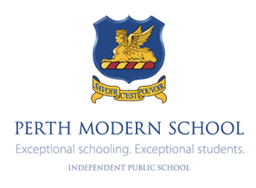

Reaching the pinnacle of your abilities is the **continuous process** of reflecting, ***goal setting***, *and* ***learning*** from ***feedback*** about your performance.

|  |  |  |  |  |  |
| --- | --- | --- | --- | --- | --- |
| **Goal for Lit in 2024:** | | | | | |
| **REALITY**  In relation to my goal what is currently working well and could be even better if?  Consider your results from Year 11 and the task you’ve just had returned to you. What are your current strengths and weaknesses? | | **OPTIONS**  What are some of the things I could do during the year to assist me in reaching my goal?  This column is just a brainstorm. Add anything. This list is totally non-committal. | **WILL**  What options do I like the most? What will I do next?  Look over the list in the previous column. What’s achievable? What’s most likely? | **TACTICS**  How and when exactly will I do this?  If you don’t plan it, you’ll never do it. Lit is just one of your subjects, how will you ensure you give it the focus it deserves. | **HABITS**  How can I ensure I am successful? What support do I need from my teacher?  What else can you do? Whose support will you need? What support will you need? |
| **WWW?** | **EBI…** |  |  |  |  |