Factors Affecting Resistance:

1. Nature of the materials (resistivity)
2. Cross section of conductor

* E.g.

1. Length of conductor

* Shorter (lower Resistance)
* Longer (higher resistance)

1. Temperature

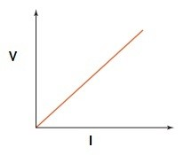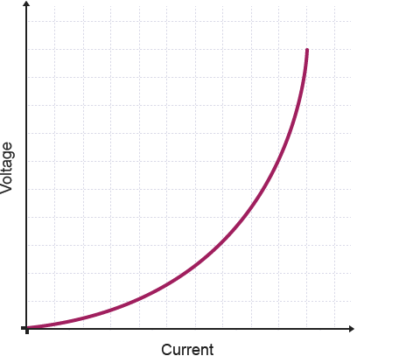

Ohmic

It is linear

Non-Ohmic

It is non-linear

Ohms Law :

V= Potential difference (Volts)

I= Current (amperes)

R= resistance (Ohms)

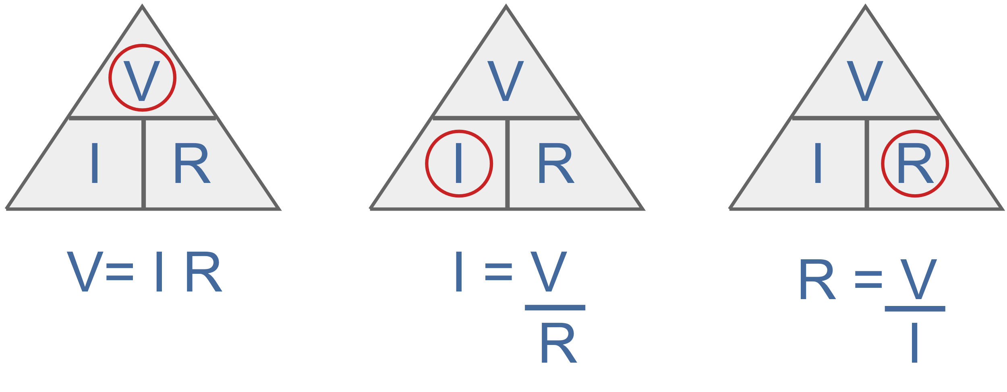

**If non-ohmic we do a specific point in the graph

e.g. A power line has a PD of 250V and a resistance of 1.0Kῼ

PD= 250V R=1000ῼ I=?

V=IR

250=1000xI

I= 250/1000

=0.25 A

Conventional Current:

as moving in the same direction as the positive charge flow. (positive -> negative)

Electron Current:

 is what actually happens and electrons flow out of the negative terminal, through the circuit and into the positive terminal of the source. (negative->positive)

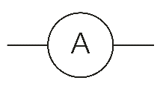Ammeter:

Use for **current**

* Place it anywhere in circuit
* Connect in series
* Internal resistance is very small

a circle with a 'V' in the centre. two horizontal lines come out from either side of the circle.**Why its connected in series**

Ammeter measures the electrons, therefor they need to go through it

**Why does it have a low resistance?**

Because you don’t want to block the charge flow

Voltmeter:

Use for **potential difference**

* Connect in parallel
* Internal resistance is very high

**Why are voltmeters connected in parallel across a resistor?**

Because we want to know the voltage across a certain element, so either side. Voltage is the electric potential difference between two points of space. There is no point of asking what the voltage through a circuit is

**Why do volt meters have a high resistance?**

We want to make sure minimal current is going through the Voltmeter. So, by having a high resistance it makes sure the current flows through the resistor.

**What is a rheostat and its function?**

It is a variable resistor. - you can change the resistance

*Function is to regulate/ identity the current flow, it also ensures the circuit doesn’t blow

**Why can a voltmeter and ammeters be connected one way, but it doesn’t matter with resistors?**

The meter can only go one way (polar). They both have a – and + positive terminal and the dial can go only one way. For resistors it doesn’t matter due to the current being able to go any direction.