****Semester 1 Year 11 Physics Exam Revision****

****Topics covered by exam:****

* **Scientific Method**
* **Thermal Physics**
* **Electrical Physics**
* **Introduction to Nuclear Physics**

****Resources:****

* **Attached worksheets**
* **Questions in topic booklets**
* **STAWA exercises**
* **Pearson chapter review questions**
* **WACE Study guide**

****Revision timeline****

|  |  |
| --- | --- |
| ****Date**** | ****Milestone**** |
| **Tuesday week 4** | **Electricity revision completed** |
| **Friday week 5** | **Thermal revision completed** |
| **Friday week 6** | **Nuclear and Scientific Method revision completed** |
| **Week 7** | **Exams commence** |

**TIME ALLOWED FOR THIS PAPER**

Reading time before commencing work: Ten (10) minutes

Working time for paper: Two and a half (2.5) hours

**MATERIALS REQUIRED/RECOMMENDED FOR THIS PAPER**

*TO BE PROVIDED BY THE SUPERVISOR*

This question/answer booklet.

Physics UNIT 1 and 2 Formulae and Constants Sheet

*TO BE PROVIDED BY THE CANDIDATE*

Standard Items: Pens, pencils, eraser or correction fluid, and ruler.

Special Items: **Scientific** calculators satisfying the conditions set by the Curriculum Council for this subject. **NO GRAPHICS CALCULATORS ALLOWED.**

**IMPORTANT NOTE TO CANDIDATES**

No other items may be taken into the examination room.

|  |  |  |  |  |  |  |
| --- | --- | --- | --- | --- | --- | --- |
| Section | Section | No. of questions | Time | % | Total | Mark |
| 1 | Short response | 13 | 55 min | 40 | 60 |  |
| 2 | Problem Solving | 5 | 60 min | 40 | 60 |  |
| 3 | Comprehension | 2 | 35 min | 20 | 30 |  |
|  |  |  | Total: |  | 150 |  |

****Electricity****

1. **A portable stereo runs off four 1.50 V cells connected in series. The total resistance of the stereo when used to play music is 18.0 Ω**
   1. **How much current does the stereo draw from the cells?**
   2. **If it is used for half an hour how much charge flows through the electric circuit of the stereo?**
2. **A particular sensor system is used to sample data at regular intervals. The data are then transmitted along metal cables before storage by a computer for future analysis. The average current carried by the sensor system is 35 mA and the effective sensor resistance is 22 kΩ.**
   1. **Calculate the heat energy dissipated in the system in a 24 hour period.**
   2. **In an attempt to increase the versatility of the sensor system, the diameter of the cables is reduced. Suggest a disadvantage of reducing the diameter of the cables.**
3. **A toaster is marked 240 V, 1250 W.**
   1. **What current does it draw from the mains?**
   2. **If the owner of the toaster uses it for 2 hours per week, how much would it cost to operate per week if electricity costs 15 cents per every 3.6 MJ?**
4. **A personal hand held fan had four 1.5 V cells connected in series which drive a small electric motor. The dan had two speed settings as controlled by adjusting the switches in the circuit.  
     
   Two resistors whose value is indicated are included in the circuit.**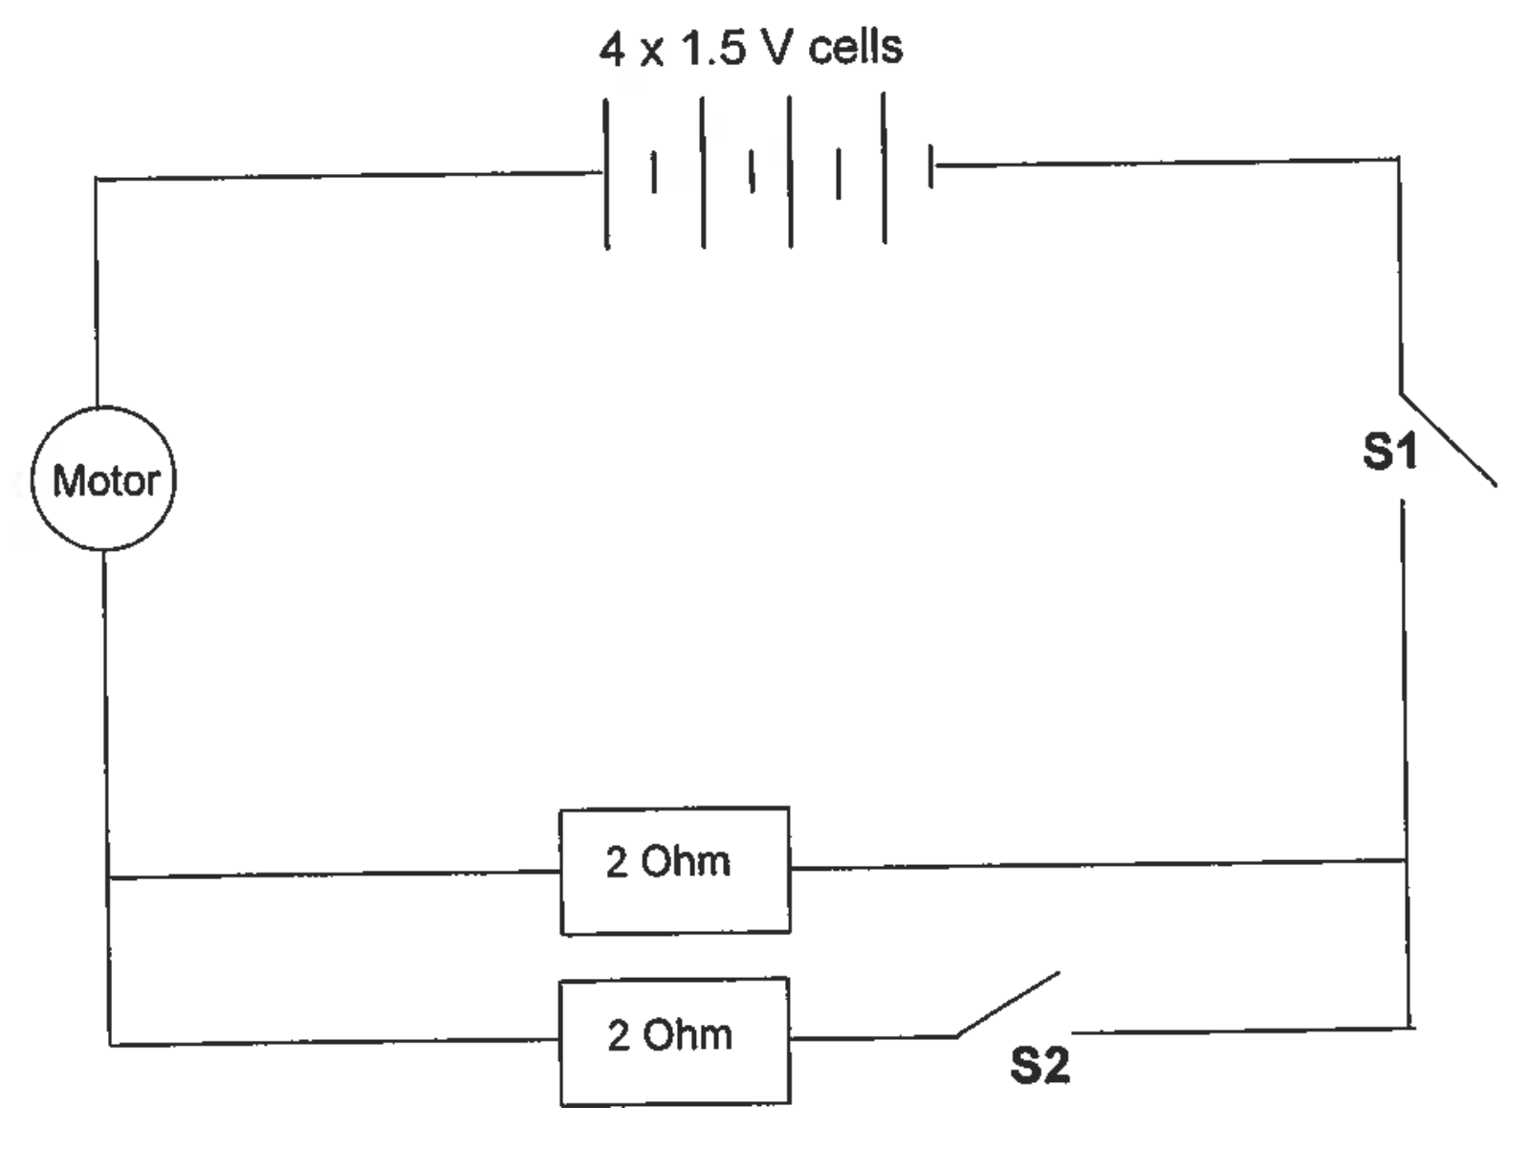
   1. **When all the switches are closed what is the total resistance of the circuit? The motor has a resistance of 3 Ω.**
   2. **With respect to the switches S1 and S2 which position should they be for maximum motor speed? Give your reason.**
   3. **Determine the current flowing through the 6 Ohm resistor in the diagram below.**

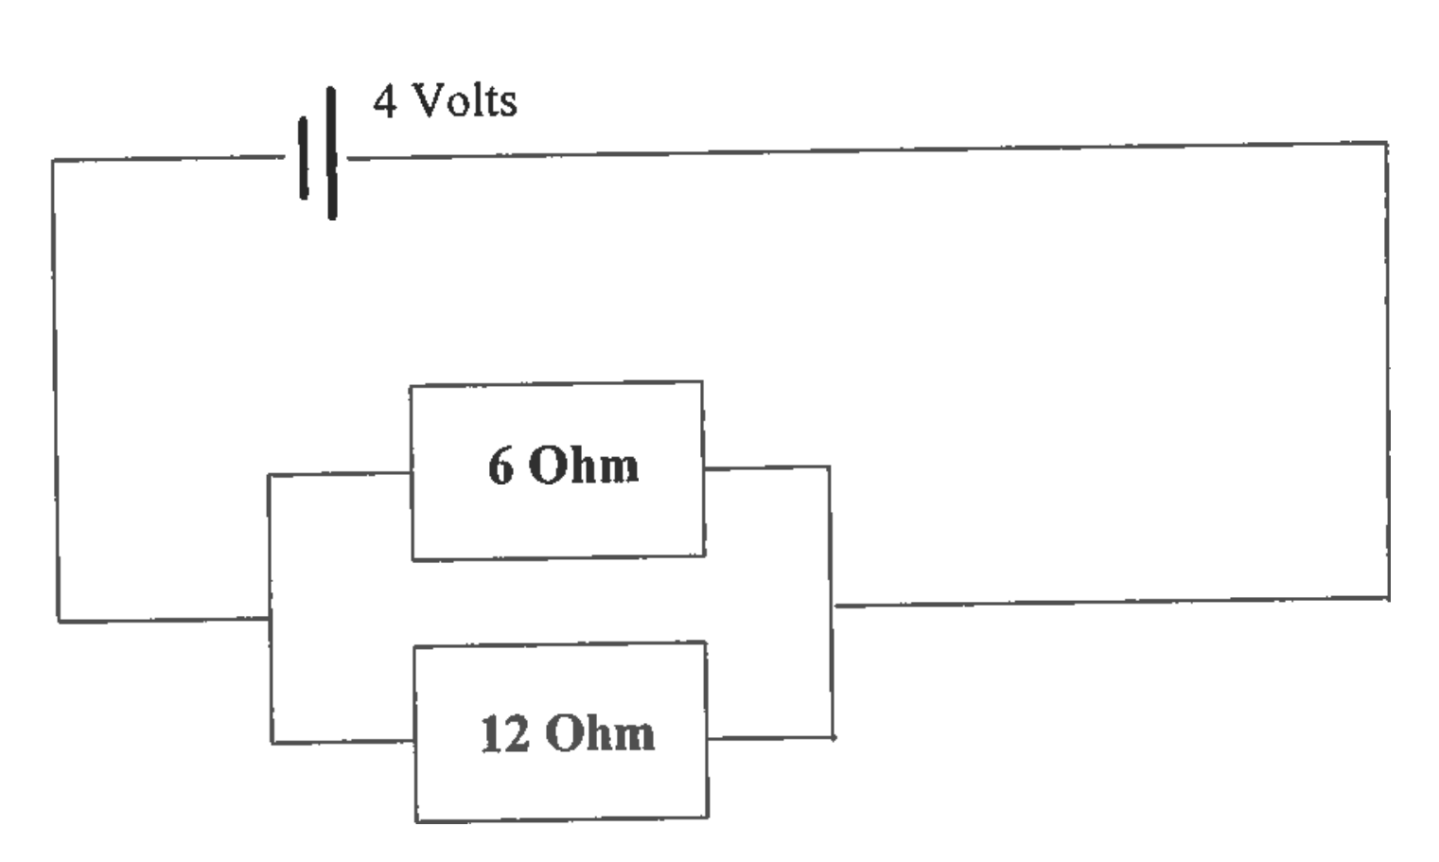

* 1. **How many electrons pass through the 6 Ohm resistor each second?**

1. **A group of physics students were asked to find the value of the resistance of a device in a circuit. The table below shows the generated results.**

|  |  |  |  |  |  |  |  |  |
| --- | --- | --- | --- | --- | --- | --- | --- | --- |
| **Potential difference (V)** | **1.2** | **1.8** | **2.2** | **3.0** | **3.4** | **3.7** | **4.2** | **4.8** |
| **Current (mA)** | **140** | **210** | **256** | **350** | **410** | **430** | **490** | **560** |

* 1. **Using correct symbols draw a circuit diagram to show a simple experimental setup the students were likely to have used to have attained the data above.**
  2. **Graph the data and comment on what information the shape of the graph provides.**
  3. **Show working to calculate the resistance of the device as determined in the experiment.**
  4. **Would it be safe to assume that the resistance of the circuit would remain constant above 5.0 V?**
  5. **If the battery stores 100.0 C of charge, how long will the circuit operate at 4.0 V?**

1. **An electric coffee maker has a resistance of 75.0 Ω and operates on a 240 V supply. 85% of the electrical energy is converted into heating 0.50 kg of water which is initially at 23°C.**
   1. **Calculate the heat energy required to just bring the water to its boiling point.**
   2. **Calculate the quantity of electrical energy required to boil the water.**
   3. **Calculate the time taken to boil the water.**
2. **Resistivity is a property of a material that determines the electrical resistance of that material. Other variables that determine the resistance are length and cross-sectional area. They are related by the formula:**

$$R=\frac{ρl}{A}$$

**A group of Year 11 students were given the task of finding the resistivity of graphite in a “lead” pencil. The diameter of the graphite in the pencil was 2.0 mm.  
  
The voltage was determined by connecting a voltmeter to the graphite via crocodile clips.**

**Their results are summarized below:**

|  |  |  |  |
| --- | --- | --- | --- |
| **Length of “lead” (x 10-2 m)** | **Current (A)** | **Voltage (V)** | **Resistance (Ω)** |
| **10.0** | **0.29** | **1.74** |  |
| **8.0** | **0.35** | **1.73** |  |
| **6.0** | **0.41** | **1.67** |  |
| **4.0** | **0.53** | **1.49** |  |
| **2.0** | **0.69** | **1.27** |  |

* 1. **Use the results table and complete the column headed “Resistance”.**
  2. **Plot a graph of Resistance (y axis) against Length (x axis) and draw a line of best fit.**
  3. **Use the gradient of the “line of best fit” and the cross-sectional area of the “lead” to determine the resistivity of the graphite.**
  4. **Why does the graph not pass through the origin (0,0)?**

1. **One tiny polystyrene ball carries a positive charge while another carries a negative charge. The two balls are hung vertically on 1cm strings from a rod. They are 5 cm apart.** 
   1. **Sketch how the balls would sit when undisturbed.**
   2. **If the balls were brought together and touched what would happen to the charges? Why?**
2. **A student sets up a circuit represented by the circuit diagram below.**

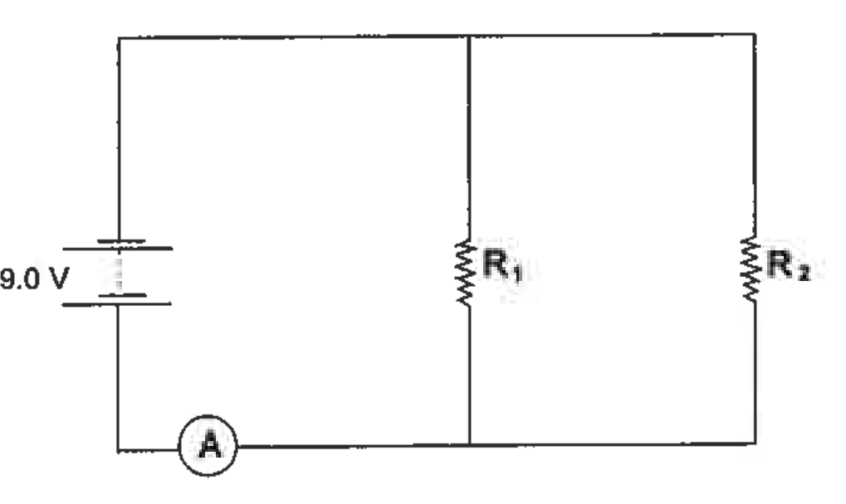 **The reading on the ammeter is 1.35 A. The resistance of R2 is 10.0 Ω but the resistance of R1 is unknown.**

* 1. **Calculate the current flowing through R2.**
  2. **Calculate the current flowing through R1.**
  3. **Calculate the resistance of R1.**
  4. **Calculate the effective resistance of the circuit.**

****Thermal Physics****

1. **A plastic insulated container contains 300 g of water at 20 °C. If 50 g ice at 0 °C is added to the water, calculate the final temperature of the water. (Ignore any heat transfer between the mixture and the container.)**
2. **Explain why steaming cooks faster than boiling.**
3. **On a warm sunny day, the sun’s radiation melts very little snow on the slopes of an alpine ski resort. Why?**
4. **585 kg of pyrex glass (specific heat 837 J kg-1 K-1) loses 8.65 x 106 J of heat. If the temperature of the glass is 95.8 °C before cooling, what is its final temperature?**
5. **What mass of water can be raised in temperature from 15°C to its boiling point when 2.93x106 J of heat is supplied?**
6. **A glass beaker of mass 215 g contains 145 g of water at 18.5 °C. If the specific heat of glass is 840 J kg-1 K-1, how much heat energy would need to be supplied to raise the temperature of the glass and water to 98.5°C?**
7. **Calculate the specific heat of a piece of steel if 5.53x107 J of heat is required to heat a 286 kg mass of the steel from 22 °C to 452 °C.**
8. **Why does a foot in a wet sock usually feel colder than a foot in a dry sock even if both socks have the same temperature?**
9. **In hot weather, it is not uncommon for pet dogs to stretch out on a tiled floor. Why do they choose a tiled floor rather than other surfaces?**
10. **How much heat energy must a fridge remove from an aluminium pot of mass 865 g to cool it from a temperature of 120 °C to 55 °C. (cAl= 900 J kg-1 K-1)**
11. **How much heat does 28.6 kg of ice at 0 °C absorb while it melts completely?**
12. **How much heat energy does 423 g of steam at 100 °C release when it condenses to water at the same temperature?**
13. **A student freezes a drink bottle containing 1.15 kg of tap water at 21.5 °C. How much heat energy must the freezer remove from the drink to turn it into ice at a temperature of -5 °C.**
14. **Using kinetic theory, explain why:**
    1. **The pressure increases when more air is put into a car tyre.**
    2. **It is dangerous to put an aerosol can on a fire.**
    3. **A lady’s perfume can be detected at some distance from her, even when there are no draughts.**
15. **Why do solids not increase in temperature while they are melting even though heat energy continues to be supplied?**
16. **Construct a cooling curve illustrating a gas cooling until it liquifies at 80 °C, the resulting liquid cooling until it solidifies at -10 °C and the solid cooling further to -20 °C.**
17. **What is wind chill?**
18. **Water is a good absorber of radiated heat energy. Why, then, does it not get hot very quickly?**
19. **Explain why**
    1. **Telephone wires are left slack when hung between poles.**
    2. **Concrete roads have bitumen-filled gaps across them.**
    3. **Steel can be used to reinforce concrete.**

|  |  |
| --- | --- |
| **Expansion of 1 metre bar, heated to 100 °C** | |
| **Pyrex** | **0.3 mm** |
| **Platinum alloy** | **0.9 mm** |
| **Glass** | **0.9 mm** |
| **Concrete** | **1.0 mm** |
| **Steel** | **1.0 mmm** |

1. **Explain why:**
   1. **An aluminium window frame feels cold when you touch it, but a wooden frame feels warmer.**
   2. **Aerated concrete is a better insulator than normal concrete.**
2. **Ibrahim feels a draught when the bonfire burns fiercely. Why?**
3. **Explain why:**
   1. **If you tip methylated spirits on the back of your hand, the methylated spirit vanishes and your hand feels cold.**
   2. **On a humid day, you feel hot and uncomfortable.**
4. **Explain how the breeze can cause a cooling effect on a person.**
5. **Draw a heating curve and give a detailed explanation on the curve as heat is applied.**
6. **Why does the brass handle of the door feel colder than the wooden door itself when you touch them even though they are the same temperature?**
7. **How much heat is required to melt 28.6 kg of ice at 0 °C?**
8. **How much heat energy is required to heat 1.15 kg of ice at 0 °C to water at 21.5 °C?**
9. **How many joules of energy are lost if 865 g of aluminium (cAl = 880 J kg-1 K-1) is cooled from 120 to 55 °C?**
10. **A glass beaker of mass 100 g contains 120 g of water 20 °C. If the specific heats of water and glass are 4200 J kg-1 K-1 and 840 J kg-1 K-1 respectively, how much heat energy would need to be supplied to raise the temperature of the glass and water to 90 °C?**
11. **Explain why steam gives a more severe burn than boiling water.**

****Nuclear****

1. As part of her medical degree at university, Cynthia is studying Nuclear Medicine. The two atoms she is studying both have mass number 60, but atom ONE has atomic number 28 while atom TWO has atomic number 27. Use this information to fill in the table below:

|  |  |  |  |
| --- | --- | --- | --- |
| atom | Nuclide of atom | Number of neutrons | Number of protons |
| ONE |  |  |  |
| TWO |  |  |  |

1. Identify “**X**” in each of the following equations and place its symbol in the brackets to the right of the equation. Name what is produce and if a type of radiation, name the radiation not the particle.   
   1.  [ ] __________________________
   2.  [ ] __________________________
   3.  [ ] __________________________  
        
      (note: m denotes in excited state)

**Working Scientifically**

1. Lezanne put a hot piece of toast on a cool, dry plate and then lifted it off. She saw drops of water on the plate in the area that had been covered by the toast. Jan thought that the water came from moisture, evaporated from the toast, which had condensed on the plate.  
     
   Which one of the following would help Lezanne by supporting or rejecting her hypothesis? Only one answer is correct.  
   1. Measuring the temperature of the plate before and after the toast was on it.
   2. Weighing the toast before and after it was on the plate.
   3. Measuring the temperature of the toast before and after it was on the plate.
   4. Weighing the plate before and after the toast was on it.
2. 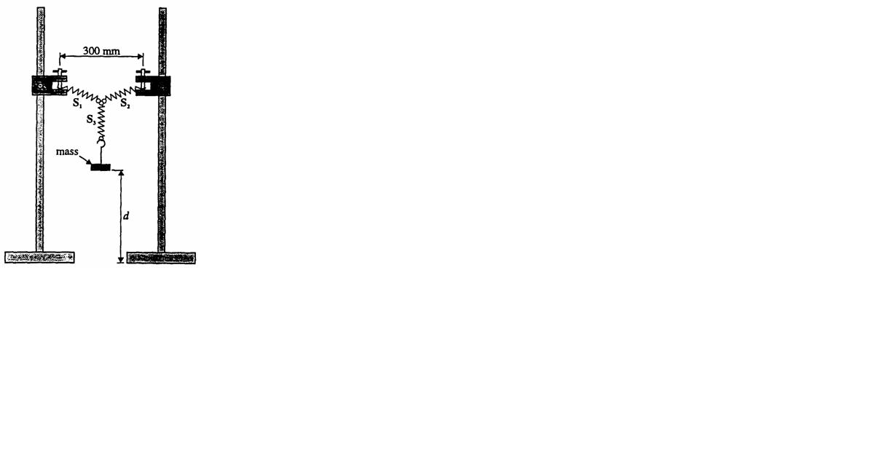You can calculate the spring constant for a spring in a school laboratory by placing a mass on a spring in a similar set-up to that shown.  
     
   The mass can then be oscillated and the time for 10 oscillations taken. After repeating the trial, more mass is added and then the experiment is repeated. The spring constant, ***k***, can then be calculated using the relationship:

  
  
A group of students completed the experiment using the equipment set up similar to that shown. They took the appropriate measurements, recorded them and produced the graph below:

* 1. **Complete the graph by drawing a line of best fit.**
  2. **What would be the period for a mass of 0.25 kg?**
  3. **Determine the gradient and value of k.**

**period squared (s2)**

1. In a Physics investigation, a group of students measures the time (t) for a trolley to roll down a 5.0 m incline starting the trolley from rest. The slope is determined by raising one end of the plank by distance H. After repeating the measurement four times, the students then increases the slope of the incline, and repeats the timing procedure for the trolley to cover the same distance. The students repeat the exercise for four other slopes, the results of which are recorded in the table below.

|  |  |  |  |  |  |
| --- | --- | --- | --- | --- | --- |
| **Height** | **Time for the trolley to roll down the slope**  **t (s)** | | | | |
| H (cm) | t1 | t2 | t3 | t4 | Average |
| 20 | 5.2 | 5.1 | 4.9 | 5.0 |  |
| 30 | 4.2 | 4.0 | 4.1 | 4.1 |  |
| 40 | 3.6 | 3.5 | 4.2 | 3.5 |  |
| 50 | 3.2 | 3.1 | 3.2 | 3.1 |  |
| 60 | 2.9 | 2.85 | 2.9 | 2.1 |  |

* 1. State the independent and dependent variables for this experiment.
  2. List two control variable to make it a valid test.
  3. Explain why the students repeated the trials four times before changing the height.
  4. Circle any data results you would disregard when finding the average of the results.
  5. Explain why you would disregard these results and if it is acceptable to do so.
  6. Complete the table by calculating averages.
  7. Plot a graph of H against t.
  8. Write a conclusion for this investigation based on the data collected and the graph.