1. A force of 100 N acts on two boxes in contact as shown at 30o to the horizontal.

a) Draw the free body diagram (showing all the forces acting) on box A.

***A (2kg)***

***B  
(1.5kg)***

***30o***

***100 N***

b) Calculate the total friction force acting on both boxes if the acceleration of both boxes was 2.05 m.s−2.

Answer: ____________________________

2. Consider the normal classroom door.

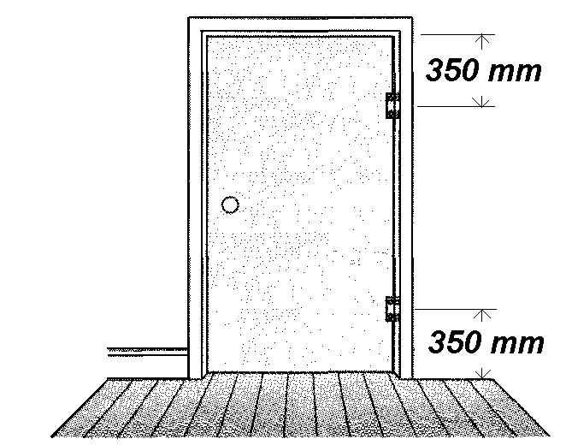a) Draw a free body diagram labelling all the forces acting on the door when it is stationary.

b) If the hinges are placed 350 mm from the top and bottom edge of the 10.0 kg door, **ESTIMATE** the magnitude of the force acting on the hinges. Each hinge carries half the weight of the door.

Answer: ____________________________

3. A bird with a mass of 1.35 kg is gliding at constant speed, *v*, in a horizontal circle of radius *r*, as shown schematically below. The bird's banking angle is 30°.

Assume that the lift, *L*, is provided by a force perpendicular to the wings.

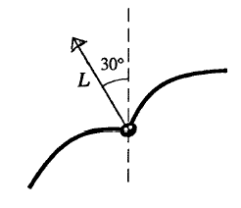

***r***

a) Explain how the bird can fly in a horizontal circle without flapping its wings.

b) What is the value of the lift force *L*?

Answer: ___________________

c) If the radius of the circle is 33 m, what is the speed of the bird?

Answer: ___________________

4. A beam of electrons is directed towards the centre of a screen with four quadrants A, B, C and D. When electric and magnetic fields are arranged as shown below, the electron beam is deflected.

a) Which quadrant of the screen is the beam most likely to strike?

**North Pole**

**South Pole**

**+++++**

**−−−−−**

**A**

**B**

**C**

**D**

Answer: ___________

b) A cosmic ray proton in interstellar space has an energy of 10.0 MeV and executes a circular orbit having a radius equal to that of Mercury’s orbit around the Sun, 5.80 × 10 10m. What is the magnetic field strength in that region of space?

Answer: ___________________

5. A horizontal wire can carry a current towards the East or West. It is located in an area where the earth’s horizontal component of magnetic field is 2.50 × 10−5 T at an angle of declination of 9.50o West of North as shown. A magnetic compass needle is placed just below this wire. A current to the West makes the compass needle point West. In which direction will a current to the East of the same magnitude make the needle point? Indicate your direction on the diagram. (Note: NO CALCULATIONS REQUIRED. NEAT VECTOR DIAGRAMS OF EACH SITUATION WILL SUFFICE)

.

***N***

***9.50o***

Answer: ___________________

6. One of Mars’ moons, Phobos revolves around Mars with an orbital radius of 9.35 × 103 km and with a period of 7 hours and 35 minutes. Use the given information to determine the mass of Mars.

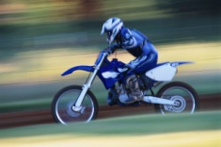7. Mass of rider = 60 kg  
 Motor bike mass = 120 kg  
 Radius of loop = 6.0 m

**B**

**A**

a) A motor bike stunt rider approaches a dare-devil loop-the-loop. At point A she has a constant speed of 18 m.s–1.

(i) What is her speed at point B if she does not increase her throttle setting and you ignore friction losses? [3]

Answer: ___________________

(ii) Is this speed sufficient for the rider and bike to maintain contact with the track at point B? Show your working. [3]

b) At the instant before the rider and the bike exit the loop-the-loop at point C (assuming a speed of 18 m.s–1),

(i) what is the force exerted by the track on the bike and rider? [3]

Answer: ___________________

(ii) If the normal acceleration due to gravity is taken to be one "g" then how many "g" does the stunt rider and bike experience at point C? [2]

Answer: ___________________

c) The rider now accelerates along a flat stretch of track and rides up a short ramp and launches the bike over the "Wall-of-Death", a gap of 20 metres with a flaming wall set in the middle of the gap. The stunt is shown in the following diagram.

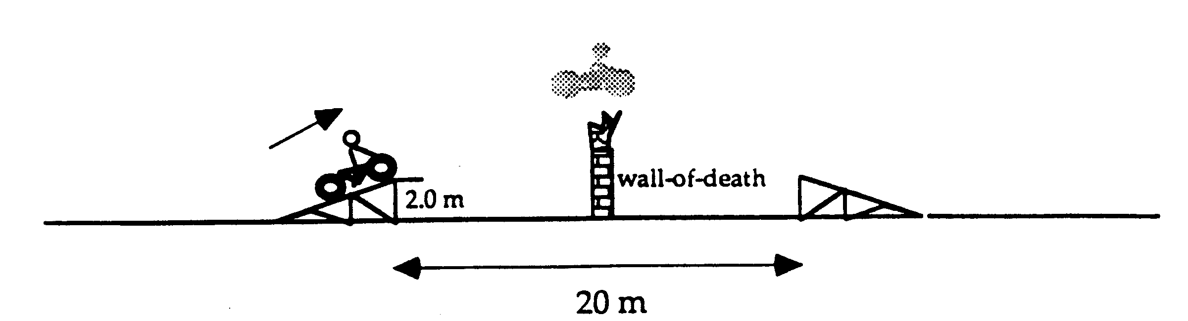

She crosses the gap and lands on the descending ramp after a flight lasting 0.80 seconds.

(i) What are the horizontal and vertical components of her take off velocity? [4]

Answer: ___________________

(ii) What is the maximum height that the top of the Wall-of-Death can be above ground level for the rider and bike to just clear the barrier? [3]

Answer: ___________________

8. A uniform horizontal veranda roof of length 4.00 m is supported by a strut ***F*** as shown in Figure below. At the end of the roof is an advertising sign. The weight of the roof is 400 N, while that of the sign is 80 N. The strut is attached to the veranda roof 1.00 m from the end.

***60o***

***W***

***F***

***1.00 m***

***Advertising sign***

(i) Is the strut under ***tension*** or ***compression***? Circle the correct answer. [1]

(ii) What is the force F in the strut? [2]

Answer: ___________________

(iii) Find the magnitude of the reaction at W. [3]

Answer: ___________________

(iv) If the veranda roof is bolted to the wall at W, would the bolts be under ***tension*** or ***compression***? Circle the correct answer. [1]

Answer: ___________________

9. A truck tows a 20 kg log of wood with a 3mm diameter aluminium cable attached to its winch through two pulleys as shown. The truck winch exacts a tension of T1 = 200 N. The pulleys each have friction and increase the tension by 5% on the driver side. (The 200N tension is 5% higher than the tension between D and E. The tension between D and E is 5% higher than that between B and C.)

***T1 = 200 N***

***to truck winch.***

***A***

***B***

***C***

***D***

***E***

***F***

***8.00m***

***1.00m***

***50o***

***45o***

***3.00m***

***45o***

***50o***

a) What is the tension in the cable section BC? [3]

Answer: ___________________

b) The friction on the log of wood is 20% of the normal reaction. Draw a free body diagram of the log of wood. Show all the forces on the log. [3]

c) Calculate the acceleration of the log of wood for the instant shown. [5]

Answer: ___________________

10. The diagram shows a solenoid wound on a length of paper tubing.

a) Draw magnetic lines of force around the solenoid and mark the end of the solenoid which behaves as the N-pole of a magnet. Draw the direction of current flow also. [3]

b) State the effect on the magnetic field of this electromagnet if

(i) the number of turns is increased; [1]

(ii) the current is decreased: [1]

(iii) a soft iron core is placed inside the solenoid. [1]

c) The figure shows the end view of a coil which is free to rotate in a magnetic field.

**S**

**N**

•

(i) If the current flows in the coil as shown, what are the directions of the forces on the two sides of the coil? Show your answer on the diagram. [2]

(ii) Redraw the diagram to show the position of the coil in which the turning effect is:

Minimum [1] and Maximum [1]