1. The diagram shows a bar magnet that has a field strength half that of the Earth’s at the positions X and Y. Sketch the resultant magnetic field at positions X and Y. [3]

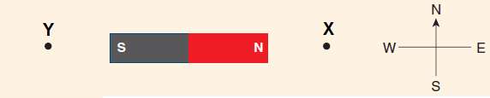

Briefly explain your sketches.

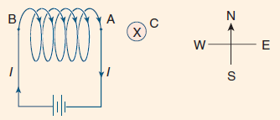2. The diagram shows a current-carrying solenoid located next to a long, straight, current-carrying conductor C (perpendicular to page) that carries a current into the page.

(a) In what direction is the magnetic force on this conductor? [1]

(b) The direction of the current in the solenoid is reversed and the magnitude is halved. The current in conductor C is also reversed and the magnitude doubled. In what direction will the force on conductor C be now? [1]

(c) How will the magnitude of the force on conductor C in part (b) compare to what it was in part (a)? [1]

3. Draw the magnetic field due to the arrangement of magnets shown. [6]

**N**

**N**

**N**

**S**

**S**

**S**

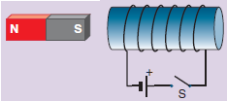4. An electromagnet with a soft iron core is set up as shown in the diagram below. A small bar magnet with its south end towards the electromagnet is placed to the left of it. The switch S is initially open.

The following questions refer to the force between the electromagnet and the bar magnet under different conditions.

a) Describe the force on the bar magnet while the switch remains open. [1]

b) Describe the force on the bar magnet when the switch is closed. [2]

c) The battery is removed and then replaced so that the current flows in the opposite direction. Describe the force on the bar magnet now. [2]

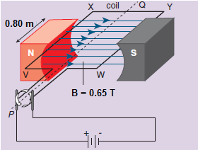5. The following is a simplified diagram of a DC motor

(a) Briefly write down the functions of the following parts.

(i) Field magnets [1]

(ii) Soft iron core [1]

(iii) Split ring commutator [1]

(iv) Carbon brushes [1]

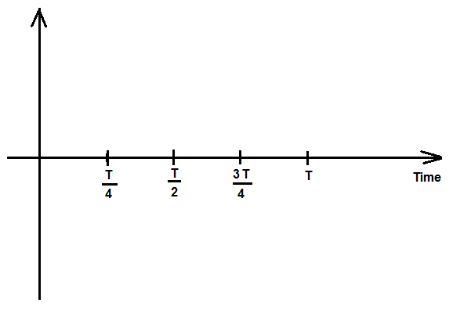(b) Sketch a torque versus time graph for one complete rotation, using the shown position as zero time. [3]

(c) List four ways in which the DC motor could be modified so the maximum torque could increase. [2]

(d) Motors can be used as generators if they are modified in a certain way. How could this motor be converted into a generator? [2]

(e) If the motor was modified and converted into a generator, would the generator produce AC or DC current? Explain briefly. [1]

**6. [3 marks]**

The diagram below shows 2 insulated wire coils.

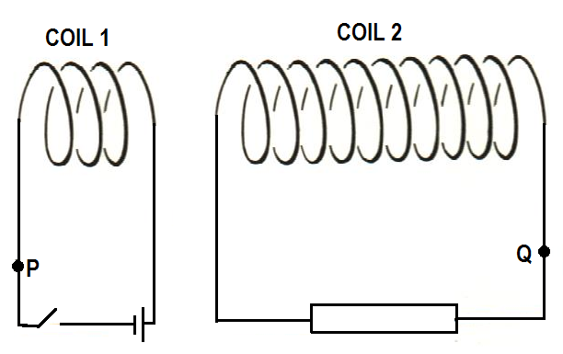

1. At the instant the switch is closed, a (conventional) current begins to flow in Coil 1. At the points P and Q, draw arrows to show the direction of the (conventional) current I1 in the circuit for Coil 1 and the direction of the induced (convectional) current I2 in the circuit for Coil 2. [2]
2. If the switch remains closed, what happens to the current in Coil 2? Circle your choice of the options given below. [1]

It Reverses It decreases to Zero It remains Unchanged

**7. [3 marks]**

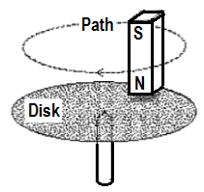A classroom physics demonstration apparatus consists of a non-magnetic disk balanced on a point support as shown in the diagram beside. The metal disk is initially stationary. A magnet is moved in a circular path just above the surface of the disk without touching it.

Will the disk:

1. Remain stationary
2. Rotate in the same direction as the magnet
3. Rotate in the opposite direction of the magnet?

Answer: _________________

State your reason(s) below:

**8.**

**77.2°**

**7.30 kg hammer**

**1.21 m**

A student is investigating the physics of the hammer throw event at the London Olympics. A hammer of mass 7.30 kg is describing uniform circular motion at a constant height. The length of the hammer is 1.21 m and the wire makes an angle of 77.2° with the vertical. Calculate the time taken for the hammer to make one revolution. (5)

**9.** A jet is flying directly over the magnetic pole in the Northern geographical hemisphere. The jet is flying at 858 km h−1, it has a wingspan of 15.0 m and the Earth’s magnetic flux density at this location is 57.8 μT.

**Magnetic Pole Northern Hemisphere**

**Jet (flying out of page)**

1. Draw the Earth’s magnetic field at this location by using 5 lines. (1)
2. Indicate on the diagram where electrons will build up on the wingspan. (1)
3. Calculate the emf induced across the wingspan. (2)

10. Oxygen ions (O2−) are injected into a vacuum chamber that contains a uniform magnetic field. For the cross section shown the magnetic flux is 2.88 × 10−4 Wb in an area 30.0 cm by 20.0 cm. The direction of the magnetic field is indicated and the ions enter at a speed of 2.76 × 104 m s−1.

⦁ ⦁ ⦁ ⦁ ⦁

⦁ ⦁ ⦁ ⦁ ⦁

⦁ ⦁ ⦁ ⦁ ⦁

O2- ions enter moving left

Vacuum chamber

a) In which direction will the ions be deflected? (Circle the correct response)

up the page down the page into the page out of the page

(1)

b) Calculate the magnitude of force experienced by each ion. (3)

**11.** A rigid wooden plank of mass 2.5 kg is attached to a wall by a pivot and is supported by a rope in tension. A 3.5 kg bowling ball is suspended from the plank. The diagram is to scale. **Estimate** the tension in the rope. Express your answer to an appropriate number of significant figures. (4)

**Bowling ball**

**Pivot**

**Plank**

**Rope**

**12.** A rigid boom of mass m is free to rotate about a frictionless pivot P. The boom is held in static equilibrium by a rope that is in tension. The boom is held in two different positions where the tension in position A is TA and the tension in position B is TB. The positions are shown in the diagram below.

**Position A**

**Position B**

**TA**

**TB**

**P**

**P**

**Boom**

**Boom**

**60°**

**90°**

1. When comparing the magnitude of tension in each position, circle the best response:

TA  = TB TA  > TB TA  < TB Insufficient information for a response (1)

1. Clearly explain your choice. (3)

**13.** In the Physics course we assume that the flux linkage between the primary and secondary windings of a transformer is always 100% efficient. However, we recognise that the transformer itself may not be 100% efficient.

1. Describe two sources of inefficiency in a transformer. (2)

1. Describe how these inefficiencies affect the electrical characteristics of a transformer. (1)

1. Explain how the design of a transformer can be modified to minimise the effects of these inefficiencies. (2)

**14.** The diagram at right shows a permanent magnet and a wire carrying current. (4)

1. Sketch 6 lines to indicate the field of the magnet.

**N S**

⦿

1. Indicate on the diagram the direction of magnetic force acting on the wire

1. The second diagram at right shows the cross section of a powered solenoid. The magnetic polarity at each end of the solenoid is shown.

**N**

**S**

1. Shown on the diagram, the direction of current that will establish this field.
2. Sketch 3 magnetic field lines within the solenoid core.

**15.** A person is sitting on a swing that is moving through the arc of a circle. It has reached the lowest point and is moving at maximum speed. Explain with reference to a vector diagram how the person’s apparent weight is different compared to being at rest on the swing. (4)

Arc of swing

**16.** The diagram shows the side view of a DC electric motor. A square coil is placed flat in the uniform magnetic field between the North and South magnetic poles. Current direction in the coil is shown on the sides adjacent to the magnetic poles. The commutator and carbon brushes are also shown.

**S**

**N**

****

****

**Commutator**

**Carbon brushes**

1. In which direction will the coil turn from this start position? (1)

1. On the diagram sketch and label the location/s of insulator materials on the commutator at this start position. (1)
2. Explain the function of the brush and commutator arrangement. (2)

1. Using the symbols  and  sketch on the above diagram the location of the coil after 60º of rotation from this start position. Put arrows on your symbols to indicate the direction of magnetic force acting on them. (2)
2. At this new position after 60º of rotation from the start position; state the torque value of the motor as a percentage of maximum torque. (2)
3. A single 90.0 mm length of wire adjacent to a magnetic pole experiences a 0.0240 N force when a current of 6.20 A is present. Calculate the magnetic flux density between the poles. (2)
4. The motor is later modified to have two sets of evenly spaced coils and a commutator with four segments. On the axes below, sketch the shape of the torque output curve for one revolution from the start position shown. (3)



17. A physics student observes a stone of mass 350 g being catapulted from the top of a cliff. The launch position at the top of the cliff is 15.0 m above ground level and it takes the stone a time of 5.00 seconds to reach the ground. The stone lands 88.0 m in front of the launch position. You may ignore air resistance for the calculations.

**15.0 m**

**88.0 m**

**Cliff**

1. Calculate the vertical component of the velocity when the stone is launched. (3)

1. Considering the kinetic energy of the stone along its flight path. Circle the best response for the following statement. The kinetic energy of the stone at maximum height is:

Maximum 50% of maximum Zero Minimum   
  
Equal to all other positions (1)

1. Calculate the initial velocity of the stone, referring to the angle of elevation above the horizontal for direction. (4)
2. Calculate the kinetic energy of the 350 g stone just before it hits the ground. (3)

**18.** The diagram shows the coil PQRS of an AC generator placed between magnetic poles.

* The uniform magnetic field of flux density 0.0386 T is indicated.
* The dimensions of the coil are: PQ = SR = 7.00 cm and PS = QR = 5.00 cm
* The coil rotates about the axle as indicated when a torque is applied to the pulley.
* The coil has 400 turns of wire and is rotated at 750 revolutions per minute (rpm).

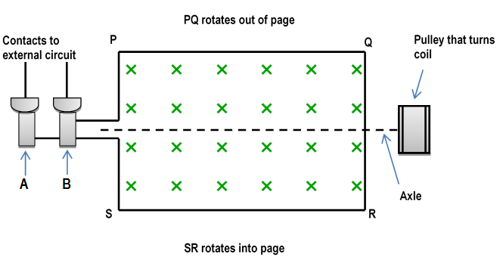

1. Identify components A and B shown on the diagram, explain their function and explain why they are used rather than a commutator. (3)

1. Mark on the diagram the direction of current along PQ and SR as the coil rotates from the position shown and explain briefly how you arrived at your answer. (2)

1. Calculate the magnitude of the average induced emf from the AC generator by considering one quarter of a rotation from the position shown. (4)
2. On the axes shown below, sketch the shape of the emf output for this generator as it rotates one full turn from the initial position shown. Put in a suitable numerical time scale on the time axis and label your curve ‘750 rpm’. (2)



1. Sketch a second shape of the emf output for a rate of rotation of 1500 rpm and label this curve ‘1500 rpm’. (2)

19. The orbit of Venus lies between the Earth’s orbit and the Sun. The radius of Venus is 6.05 ×106 m. The Magellan spacecraft was launched by NASA in 1995 for the purpose of radar mapping Venus. At one stage Magellan was put into a circular orbit of Venus at an altitude of 346 km. It took Magellan 94 minutes to complete this orbit. Magellan had a mass of 1035 kg.

1. Calculate the centripetal acceleration of the Magellan satellite in this orbit. (3)
2. Calculate the mass of the planet Venus using the satellite data provided. (3)
3. If the Magellan spacecraft was double the mass in this orbit explain how its orbital period would be affected. (2)
4. There is a location between the Earth and the Sun where the net gravitational field strength due to the Earth and the Sun is zero. Calculate the distance from Earth to this location. (3)

**20.** An uncharged flake of metal is stripped of 9.57 million electrons and fed into the space between two horizontal plates set 35.0 mm apart. The plates are charged by a source of emf that establishes an electric field strength of 6.40 × 104 N C−1 in the space. The metal flake is seen to rise up in the space between the plates.

**Metal flake**

**Source of emf**

**Charged plate**

**Charged plate**

**35 mm**

a) Indicate on the diagram the polarity of the source of emf, the charge polarity on each plate and sketch at least five field lines for the uniform electric field. (2)

b) Calculate the magnitude of the potential difference across the parallel plates (2)

c) Calculate the magnitude of the electric force acting on the metal flake. (2)

21. A 1.34-kg ball is attached to a rigid vertical rod by means of two massless strings each 1.70 m long. The strings are attached to the rod at points 1.70 m apart. The system is rotating about the axis of the rod, both strings being taut and forming an equilateral triangle with the rod, as shown in the figure. The tension in the upper string is 35.0 N. Calculate the tension in the lower string, the net force on the ball and the speed of the ball at the instant shown. [5]

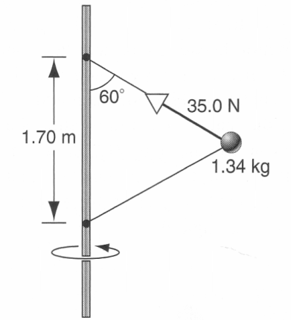

22. **Using a mass spectrometer for a crime scene investigation.**

Australian Federal Police have isolated an element found at a crime scene. They think the element may be sodium or potassium so have asked the forensic laboratory to run tests on the element to identify it. The laboratory is able to ionise the element to give it a single positive charge. They then accelerate the ions through a potential difference (Vd) and by use of a velocity filter are able to send ions that have reached their maximum kinetic energy into a mass spectrometer. When the ions enter the mass spectrometer they are acted on by a uniform magnetic field and follow a semi -circular path.

Technicians conduct a series of tests and measure the radius of circular motion for different values of potential difference used to accelerate the charged ions.

***Schematic diagram of mass spectrometer***

**Positive ion beam follows semicircular paths**

**Magnetic flux density B within chamber fixed at 3.50 🞩 10−2 T**

**Ionisation**

**Accelerating Voltage**

***Adjustable Vd***

**Faraday plates detect ion strikes**

**Velocity filter**

The table below shows the results obtained when the magnetic flux density B in the mass spectrometer was fixed at 3.50 × 10−2 T. Measurements of radius have been expressed with an uncertainty of ±5% and radius squared with an uncertainty ±10%.

|  |  |  |
| --- | --- | --- |
| Potential difference Vd  (volts) | Radius of circular path (metres) | Radius squared  (metres squared) |
| 200 | 0.270 ± 0.014 | 0.073 ± 0.007 |
| 400 | 0.370 ± 0.019 |  |
| 600 | 0.490 ± 0.025 |  |
| 800 | 0.530 ± 0.053 |  |
| 1000 | 0.620 ± 0.027 |  |
| 1200 | 0.670 ± 0.034 | 0.449 ± 0.045 |

Mass of a potassium K+ ion = 6.49 × 10−26 kg   
Mass of sodium Na+ ion = 3.82 × 10−26 kg

It can be shown that the radius ***r*** of circular motion for an ion of mass ***m*** and charge ***q***, entering the mass spectrometer at speed ***v*** and being deflected by a magnetic field of flux density ***B*** is as follows:

$r=$

$r=\frac{m.v}{q.B}$

Answer the following questions

1. Use the equation $r=\frac{m.v}{q.B}$ and other equations on the formulae and constant sheet that link the kinetic energy in (joules) attained by a mass of charge **q** (coulombs) in a potential difference **Vd** (volts) and derive the following expression:

(3) $r^{2}=\frac{2.m}{q.B^{2}}.V_{d}$

The equation follows the format y **= mx + c** for values of r2 plotted against Vd

1. Complete the table by filling in the values of radius squared **r2** with the appropriate uncertainty range. Two values have been done for you. (3)
2. Plot the graph of **r2** (vertical axis) versus **Potential difference Vd** (horizontal axis) on the graph paper next to the table. Include error bars and a line of best fit. (5)

C:\Documents and Settings\Peter\My Documents\Physics\PG Documents\Year 12 Physics\7. 12 Phys Exams\2011\Venus 0.14  black 20 blue 4 12x 10y.emf

1. Calculate the gradient of your line of best fit from your graph showing all working.

(3)

1. Use the value of the gradient that you obtained to calculate the mass of the charged ions.   
   (If you could not obtain a gradient use the numerical value 4.00 × 10-4) (3)
2. Based on the results you have calculated, what is the identity of the charged ion?

(1)