**Test 5**

Continuous Random Variables

The Normal Disribution

Sample Proportions

## Semester Two 2018 Year 12 Mathematics Methods

**Calculator Assumed**

**Name:**

**Teacher:**

**Mr McClelland**

**Miss Berry**

**Mr Gannon**

**Ms Cheng**

**Mr Staffe**

**Mr Strain**

**Date: Fri 17th Aug. 7:45am**

**You may have a formula sheet for this section of the test.**

**Classpad Calculators**

**1 page of Notes**

**Total___________/47 50 minutes**

**Question 1 (5 marks)**

The life of an electronic component is given by the probability density function:

*f*(*x*) = 

Find:

(a) the probability that a component lasts for more than 250 hours. (2 marks)

(b) the median life of a component. (2 marks)

(c) the lifetime for 95% of components. (1 mark)

**Question 2 (4 marks)**

(a) Pr(*Z* < –0.376), where *Z* is a standard normal random variable is: (1 mark)

(b) If *Z* is a standard normal random variable, and Pr(*Z* > *c*) = 0.75, then the value of *c* is? (1 mark)

(c) If *X* is a normally distributed random variable with mean μ = 4 and standard deviation,

σ = √2, then the transformation that maps the curve of the density function of *X*, *f*(*x*), to the curve of the standard normal distribution is: (2 marks)

**Question 3 (2 marks)**

The weight of a population of teenage females is normally distributed with a mean of 55 kg and a standard deviation of 8 kg. If the lowest 5% of teenage females is classified as underweight, what is the cut-off weight for this group?

**Question 4 (6 marks)**

A probability density function is given by

*f*(*x*) = *Ax*(6 – *x*)2  0 < *x* < 6

Find the value of A and hence the mean and the standard deviation of this distribution.

**Question 5 (10 marks)**

A taxi company determined that on an annual basis the distance travelled per taxi is normally distributed with a mean of 92 000 kilometres and a standard deviation of 23 500 kilometres.

(a)What is the probability, correct to four decimal places, that a taxi travels less than 75 000 kilometres per year?

(b) What is the probability, correct to four decimal places, that a taxi travels more than

80 000 kilometres per year?

(c) What is the probability, correct to four decimal places, that a taxi travels between 60 000 and 100 000 kilometres in the year?

(d) Find the minimum mileage that could be expected by 95% of taxis, to the nearest km.

(e) Fred runs a fleet of 10 taxis. What is the probability that at least four of the taxis travel more than 80 000 kilometres in a year?

**Question 6 (1 marks)**

A bag contains 4 black balls and three blue balls. If a random sample of four balls is taken from the bag, without replacement, the possible values of the sample proportion of blue balls in the sample are:

**Question 7 (9 marks)**

A random sample of 100 people indicated that 19% had taken a plane flight in the last year.

(a) Determine a 90% confidence interval for the proportion of the population that had taken a plane flight in the last year. (3 marks)

Assume the 19% sample proportion applies to the whole population.

(b) A new sample of 200 people was taken and X= the number of people who had taken a plane flight in the last year was recorded. Give a range, using the 90% confidence internal, within which you would expect X to lie. (1 mark)

(c) Determine the probability that in a random sample of 120 people, the number who had taken a plane flight in the last year was greater than 26. (3 marks)

(d) If seven surveys were taken and for each a 95% confidence interval for p was calculated, determine the probability that at least four of the intervals included the true value of p. (2 marks)

**Question 8 (10 marks)**

A random survey was conducted to estimate then proportion of mobile phone users who favoured standard smart phones over the new *phablet* style smart phones. It was found that 283 out of 412 people surveyed preferred the new *phablet* style smart phones.

(a) Determine the sample proportion  of those in the survey who preferred a phablet style smart phone. (1 mark)

(b) Use the survey results to estimate the standard deviation of , for the sample proportions. (2 marks)

(c) A follow – up survey is to be conducted to confirm the results of the initial survey. Working with a confidence interval of 95%, estimate the sample size necessary to ensure margin of error of at most 4%. (3 marks)

The 90% confidence interval of the sample proportion , from the initial survey is 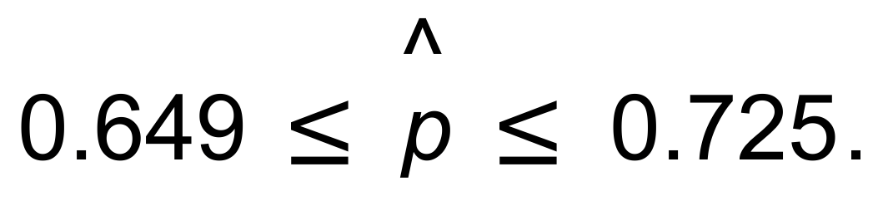

(d) Use the 90% confidence interval of the initial sample to compare the following samples:

(i) A random sample of 365 people at a shopping centre found that 258 had a preference for the phablet style smart phone. (2 marks)

(ii) A random sample of 78 people at a retirement village for Maths teachers 52 had a preference for the phablet style smart phone. (2 marks)