
IY4101 Practical Programming Assignment
Object Oriented Programming Shape Management Program

Student Id: P456360
Student Name: Hadi Haidar
Tutor: Marzieh Farahani
Report date: 2 June 2026

Introduction
This assignment was programmed in java language it manages different geometric shapes. The user can add or remove shapes and he can show one or all shapes additionally calculate the area and perimeter, also translate or scale all the shapes. Each class has a purpose. The Coordinates class stores the x and y values, while Shape is the main parent class for the shape types. The Triangle, Rectangle, Square, and Circle classes represent the different shapes. ShapeList keeps all the shapes in one place as a storage place, and ShapeManagement contains the menu that the user interacts with.

Design and UML Diagram
The design uses inheritance because rectangle, square, circle and triangle are all types of Shape. The subclasses override getArea(), getPerimeter(), scale() and display() where needed. The ShapeList class stores Shape objects, so the program can use polymorphism and call the same methods on different types of shapes.
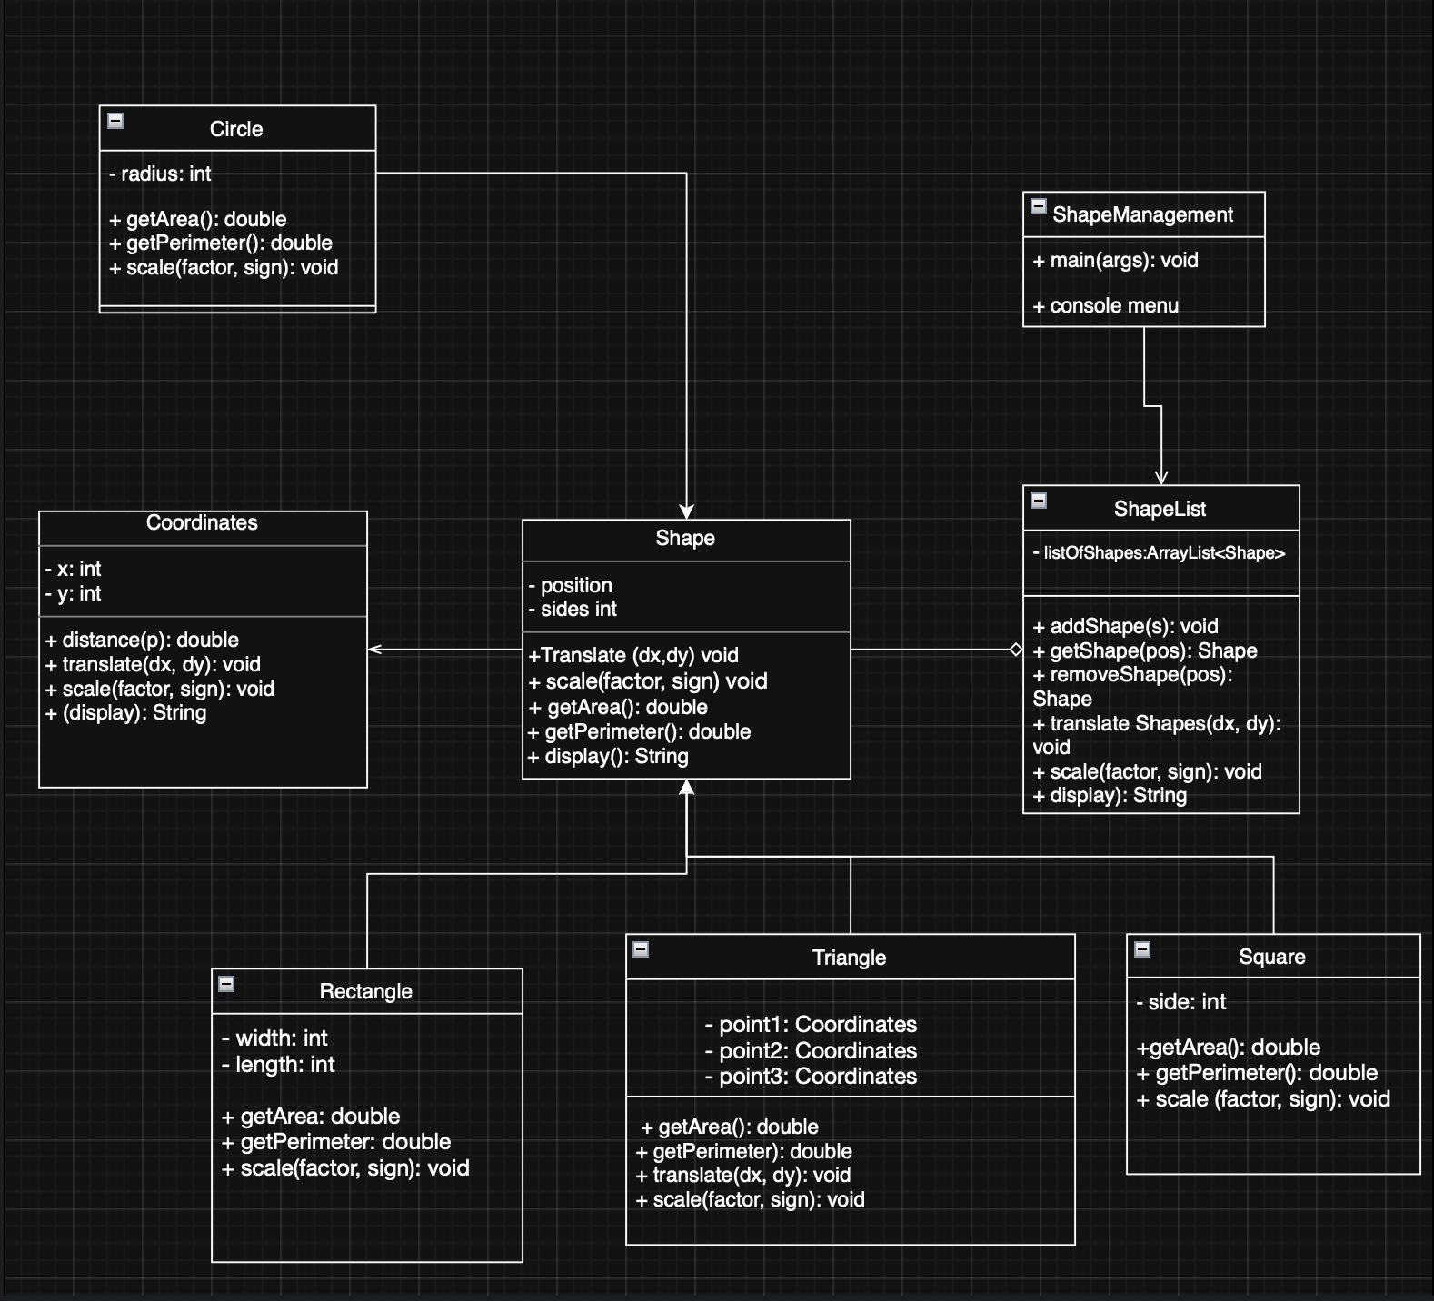

Implementation
The Coordinates class includes methods to find distance, move a point, scale it, and display it. The distance method uses the standard formula to calculate the distance between two points, however the Shape class keeps track of the shape’s main coordinate and how many sides it has.
The Triangle class is a little different because it has three points instead of just one main coordinate. Because of this Triangle overrides the translate() and scale() methods so that all three vertices are changed correctly. The area of the triangle is calculated using Heron’s formula. The Rectangle, Square, and Circle classes use their normal formulas for area and perimeter.
The menu uses positions starting from 1 because this is easier for a normal user to understand than Java’s zero-based ArrayList index. The ShapeList class checks whether a position is valid before removing or returning a shape. This helps prevent errors and stops the program from crashing.

Testing and Results
I tested the program by following the actions in the assignment brief. I also tested invalid list positions to check that the program handled errors safely.
Action | Expected result | Actual result
- Create a triangle with vertices (50,50), (20,70), (70,70) and add it. | Triangle is added to the list. | Passed. The program showed 'Triangle added' and displayed the triangle with area 500.00 and perimeter 114.34.
- Create a rectangle at (100,20), width 10, length 15. | Rectangle is added and calculations are correct. | Passed. The rectangle was added. Area was 150.00 and perimeter was 50.00.
- Create a circle at (80,100), radius 25. | Circle is added and calculations use pi. | Passed. The circle was added. Area was 1963.50 and perimeter was 157.08.
- Create a square at (90,40), side 20. | Square is added and calculations are correct. | Passed. The square was added. Area was 400.00 and perimeter was 80.00.
- Add three other shapes. | The list accepts more shapes. | Passed. Added another rectangle, circle and triangle.
- Show area and perimeter of the second shape. | The second shape is the rectangle, so area is 150 and perimeter is 50. | Passed. The program displayed Area = 150.00 and Perimeter = 50.00.
- Display all shapes. | All shapes are shown with their attributes, area and perimeter. | Passed. The program displayed seven shapes in the list.
- Remove the third shape. | The third shape is removed without an error. | Passed. The program removed the circle in position 3.
- Translate all shapes by x = 10 and y = 15. | Every shape coordinate changes by adding 10 to x and 15 to y. | Passed. For example the rectangle moved from (100,20) to (110,35).
- Increase all shapes by factor 2. | Coordinates and dimensions are multiplied by 2. | Passed. For example the rectangle became position (220,70), width 20 and length 30.
- Remove a shape in position 20. | The program should not crash and should show an error message. | Passed. The program displayed 'There is no shape in that position.'
- Show area of the shape in position 100. | The program should not crash and should show an error message. | Passed. The same invalid position message was displayed.

Problems and Reflection
One problem was deciding how to translate a triangle. If Triangle only used the inherited translate() method, only one coordinate would move. I solved this by overriding translate() in Triangle and moving all three vertices. Another issue was invalid positions in the list. I solved this by checking the position before using ArrayList get() or remove().
Additionally, Encapsulation is used because the attributes are private and accessed through methods. Inheritance is used because all specific shapes extend Shape. Polymorphism is used in ShapeList because the list stores Shape references but can hold triangles, rectangles, squares and circles. Overriding is used so each subclass can calculate its own area and perimeter in the correct way.
If I improved the program later, I would add saving and loading from a file, more validation for negative coordinates, and maybe a graphical interface. For this version, the focus is on meeting the assignment requirements clearly using basic Java classes.

Reference List
Oracle. (2026) Java Platform, Standard Edition Documentation. Available at: https://docs.oracle.com/
W3Schools. (2026) Java Reference. Available at: https://www.w3schools.com/java/

Java Source Code

Coordinates.java
// This class stores one point on the screen.
// A point has an x value and a y value.
public class Coordinates {
private int x;
private int y;

// Constructor: this runs when a new Coordinates object is created.
public Coordinates(int x, int y) {
this.x = x;
this.y = y;
}

// Returns the x value.
public int getX() {
return x;
}

// Returns the y value.
public int getY() {
return y;
}

// Calculates the distance from this point to another point.
public double distance(Coordinates p) {
int xDifference = p.getX() - x;
int yDifference = p.getY() - y;

return Math.sqrt((xDifference * xDifference) + (yDifference * yDifference));
}

// Moves the point by adding dx to x and dy to y.
public void translate(int dx, int dy) {
x = x + dx;
y = y + dy;
}

// Scales the point.
// If sign is true, the values are multiplied.
// If sign is false, the values are divided.
public void scale(int factor, boolean sign) {
if (factor == 0) {
return;
}

if (sign) {
x = x * factor;
y = y * factor;
} else {
x = x / factor;
y = y / factor;
}
}

// Returns the point as simple text.
public String display() {
return "X = " + x + ", Y = " + y;
}
}

Shape.java
// Shape is the parent class.
// Rectangle, Square, Circle and Triangle all extend this class.
public class Shape {
private Coordinates position;
private int sides;

// Constructor for a general shape.
public Shape(int noOfSides, Coordinates coord) {
sides = noOfSides;
position = coord;
}

// Returns the main position of the shape.
public Coordinates getCoordinates() {
return position;
}

// Returns the number of sides.
public int getSides() {
return sides;
}

// Changes the main position of the shape.
public void setCoordinates(Coordinates newcoord) {
position = newcoord;
}

// Moves the shape by moving its main coordinate.
public void translate(int dx, int dy) {
position.translate(dx, dy);
}

// Scales the shape by scaling its main coordinate.
public void scale(int factor, boolean sign) {
position.scale(factor, sign);
}

// This is replaced by the child classes.
public double getArea() {
return 0;
}

// This is replaced by the child classes.
public double getPerimeter() {
return 0;
}

// Displays basic shape information.
public String display() {
return "Shape at " + position.display();
}
}

Rectangle.java
// Rectangle is a child class of Shape.
public class Rectangle extends Shape {
private int width;
private int length;

// Creates a rectangle using position, width and length.
public Rectangle(Coordinates coord, int width, int length) {
super(4, coord);
this.width = width;
this.length = length;
}

// Returns the width.
public int getWidth() {
return width;
}

// Returns the length.
public int getLength() {
return length;
}

// Rectangle area = width * length.
public double getArea() {
return width * length;
}

// Rectangle perimeter = 2 widths + 2 lengths.
public double getPerimeter() {
return (2 * width) + (2 * length);
}

// Scales the position, width and length.
public void scale(int factor, boolean sign) {
super.scale(factor, sign);

if (factor == 0) {
return;
}

if (sign) {
width = width * factor;
length = length * factor;
} else {
width = width / factor;
length = length / factor;
}
}

// Shows all the rectangle information.
public String display() {
return String.format(
"Rectangle: position (%s), width = %d, length = %d, area = %.2f, perimeter = %.2f",
getCoordinates().display(), width, length, getArea(), getPerimeter());
}
}

Square.java
// Square is a child class of Shape.
public class Square extends Shape {
private int side;

// Creates a square using position and side length.
public Square(Coordinates coord, int side) {
super(4, coord);
this.side = side;
}

// Returns the side length.
public int getSide() {
return side;
}

// Square area = side * side.
public double getArea() {
return side * side;
}

// Square perimeter = 4 * side.
public double getPerimeter() {
return 4 * side;
}

// Scales the position and side length.
public void scale(int factor, boolean sign) {
super.scale(factor, sign);

if (factor == 0) {
return;
}

if (sign) {
side = side * factor;
} else {
side = side / factor;
}
}

// Shows all the square information.
public String display() {
return String.format(
"Square: position (%s), side = %d, area = %.2f, perimeter = %.2f",
getCoordinates().display(), side, getArea(), getPerimeter());
}
}

Circle.java
// Circle is a child class of Shape.
public class Circle extends Shape {
private int radius;

// Creates a circle using centre position and radius.
public Circle(Coordinates coord, int radius) {
super(0, coord);
this.radius = radius;
}

// Returns the radius.
public int getRadius() {
return radius;
}

// Circle area = pi * radius * radius.
public double getArea() {
return Math.PI * radius * radius;
}

// Circle perimeter = 2 * pi * radius.
public double getPerimeter() {
return 2 * Math.PI * radius;
}

// Scales the position and radius.
public void scale(int factor, boolean sign) {
super.scale(factor, sign);

if (factor == 0) {
return;
}

if (sign) {
radius = radius * factor;
} else {
radius = radius / factor;
}
}

// Shows all the circle information.
public String display() {
return String.format(
"Circle: centre (%s), radius = %d, area = %.2f, perimeter = %.2f",
getCoordinates().display(), radius, getArea(), getPerimeter());
}
}

Triangle.java
// Triangle is a child class of Shape.
// A triangle is different because it has three points.
public class Triangle extends Shape {
private Coordinates point1;
private Coordinates point2;
private Coordinates point3;

// Creates a triangle using its three points.
public Triangle(Coordinates point1, Coordinates point2, Coordinates point3) {
super(3, point1);
this.point1 = point1;
this.point2 = point2;
this.point3 = point3;
}

// Distance between point 1 and point 2.
public double getSideA() {
return point1.distance(point2);
}

// Distance between point 2 and point 3.
public double getSideB() {
return point2.distance(point3);
}

// Distance between point 3 and point 1.
public double getSideC() {
return point3.distance(point1);
}

// Triangle area is calculated using Heron's formula.
public double getArea() {
double a = getSideA();
double b = getSideB();
double c = getSideC();
double s = (a + b + c) / 2;
double areaValue = s * (s - a) * (s - b) * (s - c);

if (areaValue < 0) {
return 0;
}

return Math.sqrt(areaValue);
}

// Triangle perimeter is side A + side B + side C.
public double getPerimeter() {
return getSideA() + getSideB() + getSideC();
}

// A triangle has three points, so all of them must be moved.
public void translate(int dx, int dy) {
point1.translate(dx, dy);
point2.translate(dx, dy);
point3.translate(dx, dy);
setCoordinates(point1);
}

// Scales all three points of the triangle.
public void scale(int factor, boolean sign) {
point1.scale(factor, sign);
point2.scale(factor, sign);
point3.scale(factor, sign);
setCoordinates(point1);
}

// Shows all the triangle information.
public String display() {
return String.format(
"Triangle: point 1 (%s), point 2 (%s), point 3 (%s), area = %.2f, perimeter = %.2f",
point1.display(), point2.display(), point3.display(), getArea(), getPerimeter());
}
}

ShapeList.java
import java.util.ArrayList;

// This class stores all the shapes in one list.
public class ShapeList {
private ArrayList<Shape> listOfShapes;

// Creates an empty list of shapes.
public ShapeList() {
listOfShapes = new ArrayList<Shape>();
}

// Adds one shape to the list.
public void addShape(Shape s) {
listOfShapes.add(s);
}

// Positions are written as 1, 2, 3 for the user.
private boolean isValidPosition(int pos) {
return pos >= 1 && pos <= listOfShapes.size();
}

// Moves every shape in the list.
public void translateShapes(int dx, int dy) {
for (Shape shape : listOfShapes) {
shape.translate(dx, dy);
}
}

// Gets one shape using its position.
public Shape getShape(int pos) {
if (isValidPosition(pos)) {
return listOfShapes.get(pos - 1);
}
return null;
}

// Removes one shape using its position.
public Shape removeShape(int pos) {
if (isValidPosition(pos)) {
return listOfShapes.remove(pos - 1);
}
return null;
}

// Returns the area of one shape.
public double area(int pos) {
Shape shape = getShape(pos);
if (shape != null) {
return shape.getArea();
}
return -1;
}

// Scales every shape in the list.
public void scale(int factor, boolean sign) {
for (Shape shape : listOfShapes) {
shape.scale(factor, sign);
}
}

// Returns the perimeter of one shape.
public double perimeter(int pos) {
Shape shape = getShape(pos);
if (shape != null) {
return shape.getPerimeter();
}
return -1;
}

// Returns how many shapes are in the list.
public int getNumberOfShapes() {
return listOfShapes.size();
}

// Displays every shape in the list.
public String display() {
if (listOfShapes.size() == 0) {
return "There are no shapes in the list.";
}

String output = "";

for (int i = 0; i < listOfShapes.size(); i++) {
output = output + (i + 1) + ": ";
output = output + listOfShapes.get(i).display() + "\n";
}

return output.toString();
}
}

ShapeManagement.java
import java.util.Scanner;

// This is the main class.
// It shows the menu and uses the other classes.
public class ShapeManagement {
private static Scanner input = new Scanner(System.in);
private static ShapeList shapes = new ShapeList();

// The program starts here.
public static void main(String[] args) {
int choice;

do {
showMenu();
choice = readInt("Enter your choice: ");

if (choice == 1) {
addShape();
} else if (choice == 2) {
removeShape();
} else if (choice == 3) {
showOneShape();
} else if (choice == 4) {
showAreaAndPerimeter();
} else if (choice == 5) {
System.out.println(shapes.display());
} else if (choice == 6) {
translateAllShapes();
} else if (choice == 7) {
scaleAllShapes();
} else if (choice == 0) {
System.out.println("Program finished.");
} else {
System.out.println("Please choose a valid option.");
}
} while (choice != 0);
}

// Prints the menu choices.
public static void showMenu() {
System.out.println("\nShape Management Menu");
System.out.println("1: add a shape");
System.out.println("2: remove a shape by position");
System.out.println("3: get information about a shape by position");
System.out.println("4: area and perimeter of a shape by position");
System.out.println("5: display information of all the shapes");
System.out.println("6: translate all the shapes");
System.out.println("7: scale all the shapes");
System.out.println("0: quit program");
}

// Lets the user choose and add a new shape.
public static void addShape() {
System.out.println("\nChoose the shape to add");
System.out.println("1: Triangle");
System.out.println("2: Rectangle");
System.out.println("3: Circle");
System.out.println("4: Square");

int shapeChoice = readInt("Enter shape choice: ");

if (shapeChoice == 1) {
Coordinates p1 = readCoordinates("point 1");
Coordinates p2 = readCoordinates("point 2");
Coordinates p3 = readCoordinates("point 3");
shapes.addShape(new Triangle(p1, p2, p3));
System.out.println("Triangle added.");
} else if (shapeChoice == 2) {
Coordinates position = readCoordinates("rectangle position");
int width = readPositiveInt("Enter width: ");
int length = readPositiveInt("Enter length: ");
shapes.addShape(new Rectangle(position, width, length));
System.out.println("Rectangle added.");
} else if (shapeChoice == 3) {
Coordinates position = readCoordinates("circle centre");
int radius = readPositiveInt("Enter radius: ");
shapes.addShape(new Circle(position, radius));
System.out.println("Circle added.");
} else if (shapeChoice == 4) {
Coordinates position = readCoordinates("square position");
int side = readPositiveInt("Enter side: ");
shapes.addShape(new Square(position, side));
System.out.println("Square added.");
} else {
System.out.println("Invalid shape choice.");
}
}

// Removes a shape from the list.
public static void removeShape() {
int position = readInt("Enter the position to remove: ");
Shape removedShape = shapes.removeShape(position);

if (removedShape == null) {
System.out.println("There is no shape in that position.");
} else {
System.out.println("Removed: " + removedShape.display());
}
}

// Displays one shape from the list.
public static void showOneShape() {
int position = readInt("Enter the position to display: ");
Shape shape = shapes.getShape(position);

if (shape == null) {
System.out.println("There is no shape in that position.");
} else {
System.out.println(shape.display());
}
}

// Displays the area and perimeter of one shape.
public static void showAreaAndPerimeter() {
int position = readInt("Enter the position: ");
Shape shape = shapes.getShape(position);

if (shape == null) {
System.out.println("There is no shape in that position.");
} else {
System.out.printf("Area = %.2f\n", shape.getArea());
System.out.printf("Perimeter = %.2f\n", shape.getPerimeter());
}
}

// Moves all shapes by x distance and y distance.
public static void translateAllShapes() {
int dx = readInt("Enter x distance: ");
int dy = readInt("Enter y distance: ");
shapes.translateShapes(dx, dy);
System.out.println("All shapes translated.");
}

// Makes all shapes bigger or smaller.
public static void scaleAllShapes() {
int factor = readPositiveInt("Enter the scale factor: ");
System.out.println("1: increase");
System.out.println("2: decrease");
int signChoice = readInt("Choose scale type: ");

if (signChoice == 1) {
shapes.scale(factor, true);
System.out.println("All shapes increased.");
} else if (signChoice == 2) {
shapes.scale(factor, false);
System.out.println("All shapes decreased.");
} else {
System.out.println("Invalid scale type.");
}
}

// Reads x and y from the user and creates a Coordinates object.
public static Coordinates readCoordinates(String name) {
System.out.println("Enter coordinates for " + name);
int x = readInt("X: ");
int y = readInt("Y: ");
return new Coordinates(x, y);
}

// Reads a number that must be bigger than zero.
public static int readPositiveInt(String message) {
int number = readInt(message);
while (number <= 0) {
System.out.println("Please enter a number greater than 0.");
number = readInt(message);
}
return number;
}

// Reads a whole number from the user.
// This helps stop the program crashing if the user types text.
public static int readInt(String message) {
while (true) {
System.out.print(message);
if (input.hasNextInt()) {
return input.nextInt();
}
System.out.println("Please enter a whole number.");
input.next();
}
}
}

