# Exercise 1

1. K = 2

P1 = 5, P2 = 3

The resulting plots are as follows:

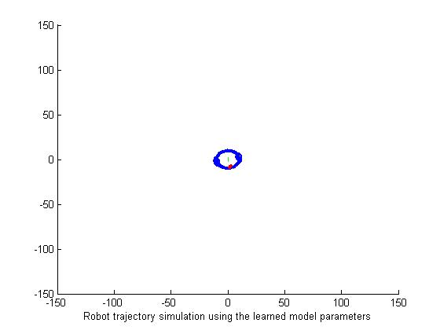

$$\left(v,ω\right)=\left(0,0.05\right)$$

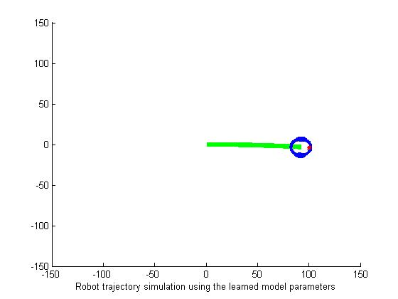

$$\left(v,ω\right)=\left(1,0\right)$$

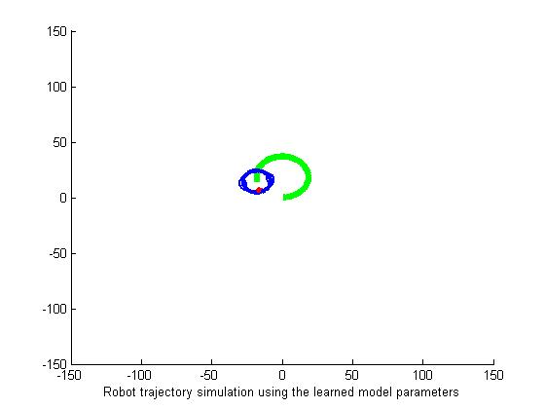

$$\left(v,ω\right)=\left(1,0.05\right)$$

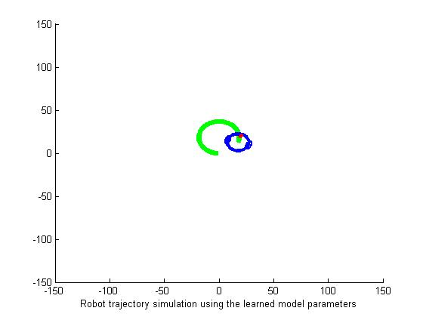

$$\left(v,ω\right)=\left(-1,-0.05\right)$$

1. K = 5

P1 = 4, P2 = 1

The resulting plots are as follows:

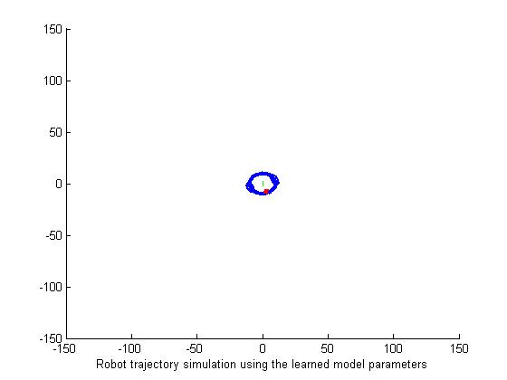

$$\left(v,ω\right)=\left(0,0.05\right)$$

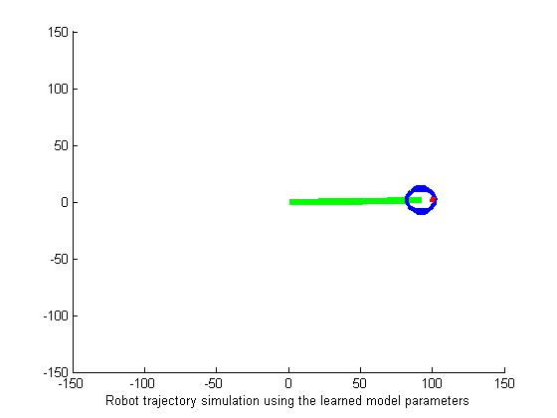

$$\left(v,ω\right)=\left(1,0\right)$$

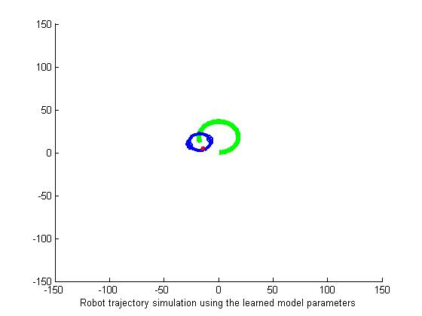

$$\left(v,ω\right)=\left(1,0.05\right)$$

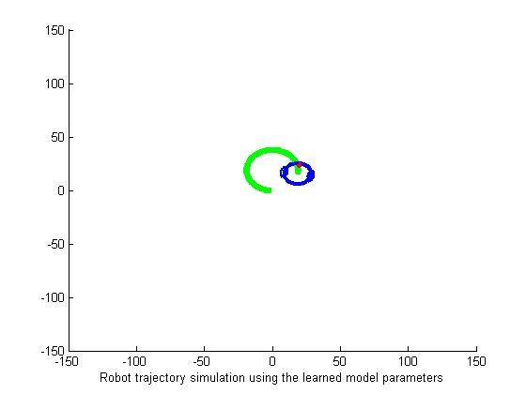

$$\left(v,ω\right)=\left(-1,-0.05\right)$$

# Exercise 2

The optimal value of **d is 48**. The minimal **classification error is 0.0362**. The **confusion matrix** is as follows:

|  |  |  |  |  |  |  |  |  |  |
| --- | --- | --- | --- | --- | --- | --- | --- | --- | --- |
| 970 | 0 | 1 | 0 | 0 | 2 | 1 | 1 | 5 | 0 |
| 0 | 1098 | 11 | 1 | 2 | 1 | 1 | 0 | 21 | 0 |
| 3 | 0 | 1001 | 3 | 3 | 0 | 2 | 1 | 18 | 1 |
| 2 | 0 | 8 | 972 | 0 | 5 | 0 | 2 | 17 | 4 |
| 1 | 0 | 3 | 0 | 964 | 0 | 3 | 2 | 3 | 6 |
| 2 | 0 | 1 | 18 | 0 | 859 | 2 | 0 | 10 | 0 |
| 8 | 1 | 1 | 0 | 3 | 13 | 924 | 0 | 8 | 0 |
| 1 | 2 | 31 | 1 | 2 | 3 | 0 | 956 | 13 | 19 |
| 3 | 0 | 7 | 10 | 1 | 5 | 1 | 1 | 941 | 5 |
| 5 | 1 | 10 | 7 | 10 | 2 | 0 | 6 | 15 | 953 |

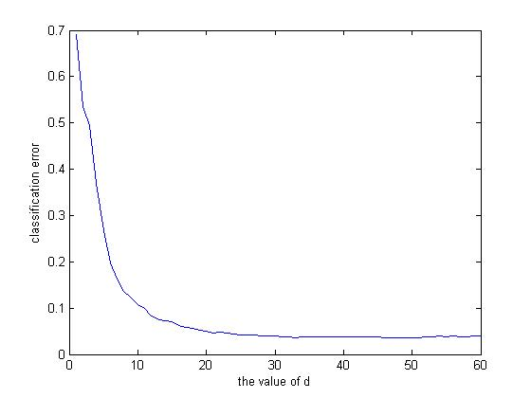

Classification errors

# Exercise 3

1. K-Means

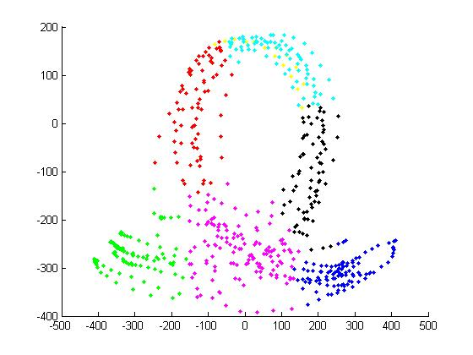

Gesture_l

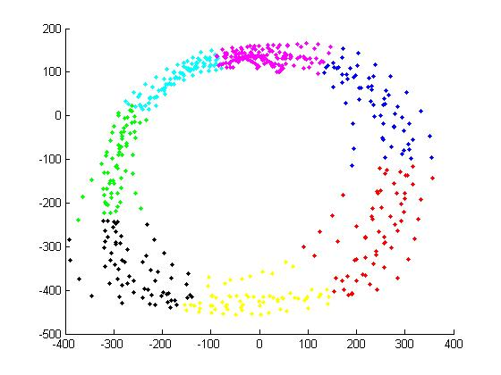

Gesture_o

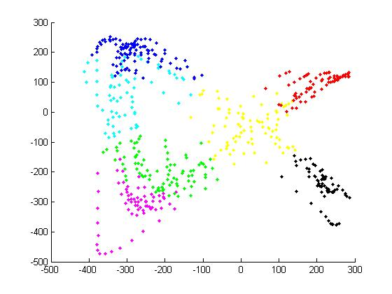

Gesture_x

1. Nub

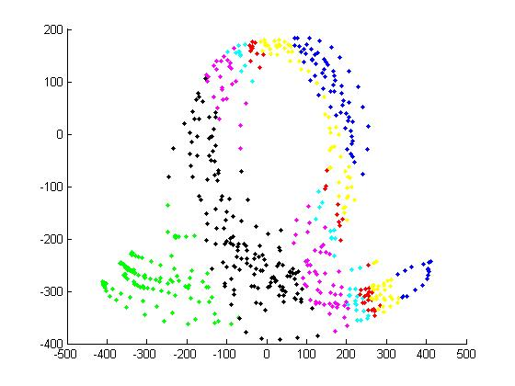

Gesture_l

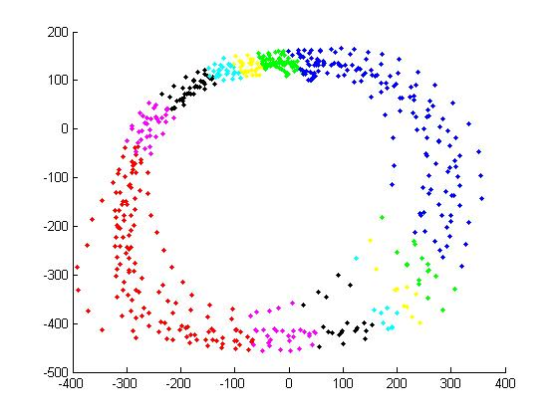

Gesture_o

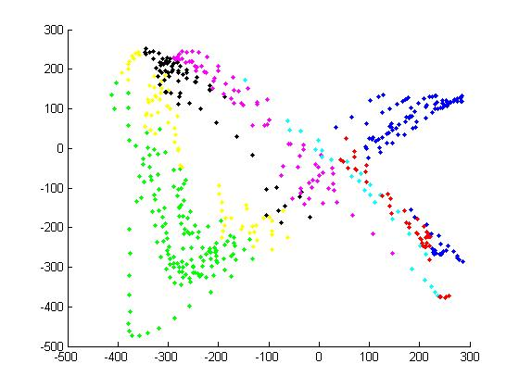

Gesture_x