**Adopting Positive Psychology in Schools: A Path to Enhanced Wellbeing and Educational Success**

Author

Affiliation

Course

Instructor

Due Date

**Adopting Positive Psychology in Schools: A Path to Enhanced Wellbeing and Educational Success**

As the society develops at a very fast pace, it is now more important than ever to promote the health and wellbeing of children in schools. The conventional schooling systems have mainly concentrated on the academic accomplishments, while little or no attention has been given to the student’s emotional, psychological and social growth. This presentation supports the use of positive psychology in schools that include social and emotional learning (SEL) and strength-based interventions for enhancing students’ wellbeing and learning. Positive psychology therefore focuses on building up positive aspects of the human personality that enhances personal and academic success. Through promoting students’ wellbeing, school can make a positive learning climate that is more positive, healthy, and productive (Seligman et al., 2009). The concept of wellbeing has emerged as a subject of interest in educational research because students with good wellbeing perform better in school, have better interpersonal relationships and are more involved in school activities as found by Waters (2011). In this paper, the author will explain how and why positive psychology, social and emotional learning, as well as strengths-based approaches are important in education based on current theories and research.

**Positive Psychology and its Link to Education**

**Defining Positive Psychology**

Positive psychology which was initiated by Martin Seligman aims at identifying and understanding the factors that promote positive functioning. While traditional psychology focuses on the treatment of mental disorder, positive psychology aims at increasing the optimum experience and the satisfaction of the individuals (Seligman & Csikszentmihalyi, 2000). At the core of this field is the concept that people can reach optimal functioning through positive emotion, engagement, relationships, meaning, and accomplishment (PERMA) (Seligman, 2011).

**Principles in Education**

Applying positive psychology in educational context is possible and can be highly effective. For instance, the PERMA model is a wellbeing framework which can be easily implemented in the school setting. Positive emotion puts the learners in a good mood and makes them receptive to learning while engagement directs their attention towards the tasks and encourages them to persevere. Happiness is fostered by relationships that enable students to work together and interact with fellow human beings, meaning which provides students with a purpose, and accomplishment which makes them proud of their efforts (Seligman, 2011). When these principles are incorporated in the practice of education, schools are able to produce students who not only perform well academically but also have proper social and emotional development.

**Current Research**

Studies have confirmed the use of positive psychology interventions in schools. Suldo et al. (2009) also observed that students who were involved in positive psychology programs had improved wellbeing, life satisfaction and successes in academics. In the same way, Waters (2011) in a meta-analysis found out that positive psychology interventions in school had a positive impact on the students’ wellbeing, academic achievement, and social interaction with peers and teachers. It is therefore clear that positive psychology can help in the creation of a prosperous educational climate.

**Social and Emotional Learning (SEL)**

**Defining SEL**

Social and Emotional Learning (SEL) is a comprehensive educational framework aimed at fostering the development of five key competencies: SEL includes five competencies, which are self-awareness, self-management, social awareness, relationship skills, and responsible decision-making (Collaborative for Academic, Social, and Emotional Learning [CASEL], 2020). SEL provides students with the knowledge and skills to recognize and regulate emotions, foster constructive goals and accomplish them, appreciate other people’s feelings, and build and sustain healthy relationships, and solve problems effectively. These competencies are very useful in enabling the students to overcome hurdles in their academic as well as their personal lives. SEL complements academic knowledge and development by promoting emotional and social skills that improve the students’ well-being and coping mechanisms.

**Link to Education**

SEL is directly linked to better learning outcomes especially in academic achievement and emotional and social development. Zins et al. (2004) noted that students who have better social and emotional skills will be able to do better academically as they are able to deal with stress, persist with tasks and cooperate. SEL has been implemented in curricula in different countries and has helped students learn important life skills like self-control, communication and problem solving. These programs do not only enhance the classroom manners but also foster a friendly and encouraging school climate, which prepares students for future endeavours out of school (Durlak et al., 2011).

**Research Evidence Enhancing Social and Emotional Learning (SEL)**

There is sufficient evidence that support the use of structured activities in the development of SEL competencies. The “Share a Book, wake a Thought” (SABWAT) project implemented at the University of Batangas is an example of how SEL is implemented in schools. The research was conducted on 111 College of Education students and showed that the SABWAT activity enhanced the students’ social awareness, self-awareness, relationship skills, self-management, and responsible decision-making (Napa et al., 2022). Apart from promoting the worth of book donations to community needs, the students also practiced several SEL competencies that are useful in other aspects of life through the reflective activities. The research highlighted some of the challenges faced by the institution including low student engagement and inadequate funds and the study recommended a development plan to overcome these challenges.

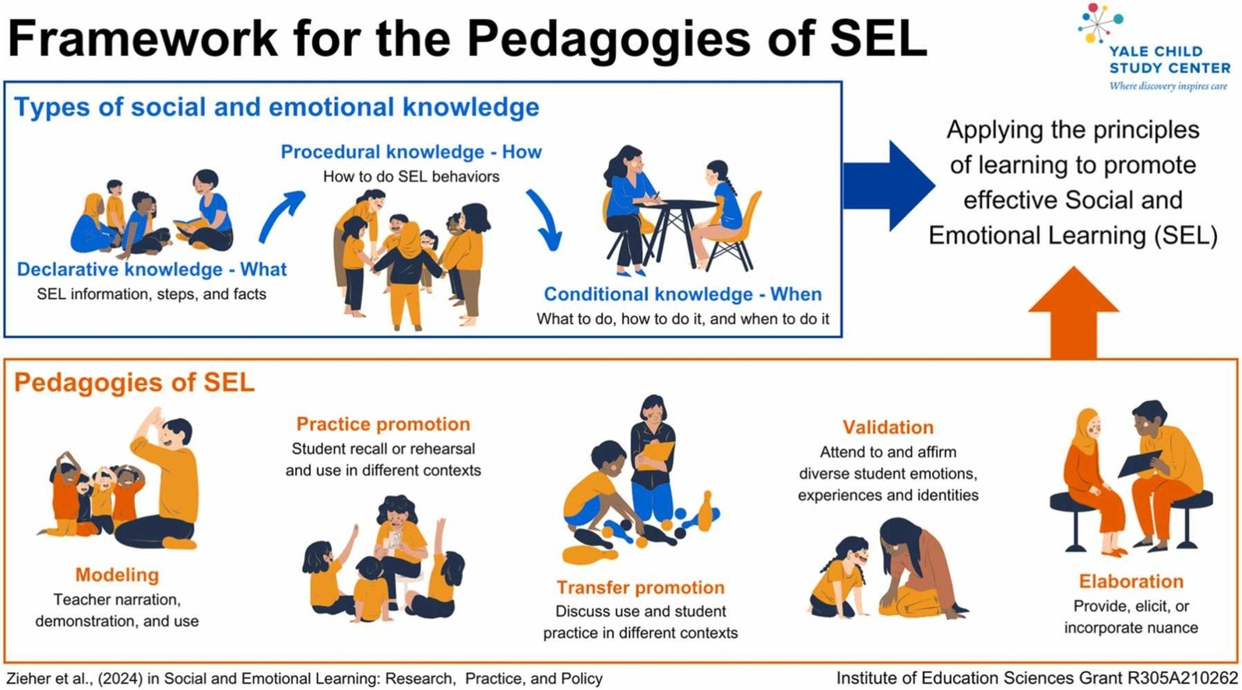

In another study, Zieher et al. (2022) described a theoretical model for the pedagogies of SEL, focusing on the teacher as the agent of how SEL skills are applied systematically across domains. SEL knowledge comprises three kinds of knowledge that are applied together with five teaching practices for enhancing students’ learning (Napa et al., 2022). The authors pay much attention to the cultural and identity aspects of SEL, noting that teachers should help students develop ways to use SEL competencies in culturally sensitive contexts. This research highlights the importance of educators in the development of SEL and the need to adopt individual teaching methods for the best results.

SEL has been found to enhance educational and life success, according to research. Durlak et al. (2011) conducted a meta-analysis that showed that the students who underwent SEL programs had a better academic performance by 11 percentiles as compared to the students who did not undergo any SEL programs. SEL also provided a positive impact on the mental health of the students, and it reduced the emotional disorders, depressions, and anxiety. Taylor et al. (2017) in a longitudinal study established that people with high SEL competencies in childhood had better life outcomes such as better employment status and mental health status in their adulthood. These studies show that the effects of SEL are long-term and have a positive influence on academic performance as well as on the character.

**Strengths-Based Approach**

**Defining Strengths-Based Approach**

The strengths-based approach in education is centred on identification and development of the student’s strengths, talents, and potential instead of the emphasis on the deficiencies. This approach can also be said to be in line with the positive psychology approach, and focuses on the strengths of each student. Some of the tools that facilitate the identification of the strengths include VIA Character Strengths and Clifton-Strengths model that helps the students to use them in their academic and personal lives (Clifton & Anderson, 2002). Due to the strengths-based approach, students are encouraged because the focus is made on the possibilities rather than on the difficulties they have.

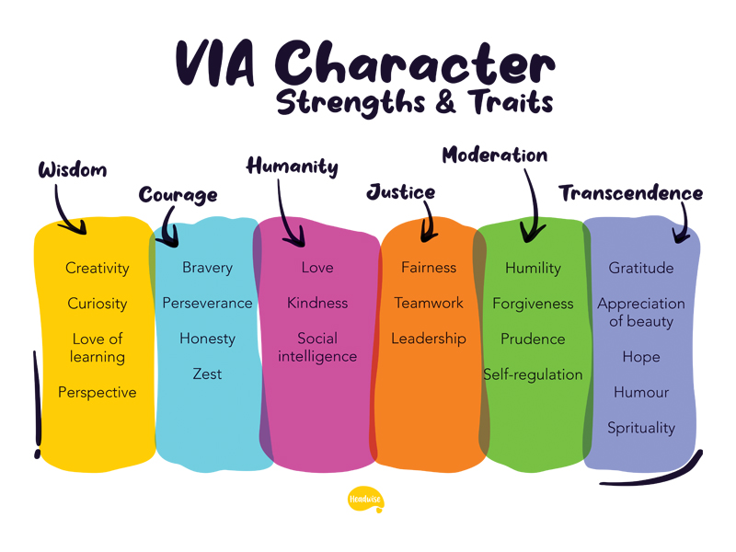

*VIA Character Strengths*

**Application in Education**

The use of strengths based approach in the classroom enables the learning processes to be individualized based on the strengths of the students. For instance, the leadership skills may be promoted by allowing the students with leadership qualities to lead in group discussions or projects while the creative skills may be encouraged by allowing creativity in problem solving among the students (Napa et al., 2022). This specific approach to learning helps develop a growth-orientation where the students perceive the difficulties as positive factors that can be turned into strengths. The emphasis on the strengths helps students develop self- efficacy and therefore increase their motivation and participation in class and co-curricular activities.

In the case of education, there is evidence that proves that a strength-based perspective is indeed effective. In their study, Zieher et al. (2024) revealed that students who were urged to concentrate on their strengths, experienced better life satisfaction and academic performance compared to the students who concentrated on their areas of weakness. Napa et al. (2022) also revealed that strengths-based intervention in schools enhanced the student’s resilience to deal with academic stress. Furthermore, there is evidence from Seligman and Csikszentmihalyi (2021) on how strengths-based education improves students’ intrinsic motivation and thus their wellbeing and achievement.

**Considerations and Critiques**

**Challenges**

The integration of positive psychology, SEL, and strengths-based interventions is not without its problems. A major criticism that has been made is the fact that these frameworks are culturally biassed. Some of these approaches especially the positive psychology originate from the western psychological systems and may not fit the non-western cultures (Christopher & Hickinbottom, 2008). This cultural bias may lead to programs that do not meet the emotional, social, and psychological needs of culturally diverse students. For instance, students from collectivist cultures may not value the individualism and self-actualization as much as the western theories propose, thus decreasing the effectiveness of such approaches. The over-emphasis on the positive attitude or the ‘toxic positivity’ is another issue where people are discouraged from expressing negative feelings (Held, 2004). This can lead to the formation of a culture where students have to deny their emotions, which may not be healthy for the growth of the students’ emotional intelligence and critical thinking.

**Ethical Considerations**

It is important to consider the ethical issues when using positive psychology, SEL, and strengths-based interventions in schools especially in relation to diversity and equality. It may also increase the students’ detachment from the learning process due to cultural, socioeconomic, and linguistic differences. For interventions to be fair, schools have to modify programs to suit their students’ needs and circumstances. This may entail changing the curriculum to reflect cultural diversity or providing extra assistance to students who are from low income families (Norrish, 2015). Schools should also pay attention to issues of language, in that the material used in teaching should be understood by the students in case they have little or no understanding of the language used in the classroom. Furthermore, schools should ensure that they do not marginalise learners with mental health problems or emotional problems by making positive psychology and SEL seem like a solution to all emotional problems.

**Counterarguments**

Positive Psychology and SEL programs, have been hailed as the most effective and student-oriented programs; however, the critics’ arguments are also worth considering since they question the effectiveness of these programs in the long term and their ability to produce tangible results. A major criticism is that it is hard to measure impact of such interventions. It is difficult to quantify changes in such aspects as happiness or emotional stability because wellbeing is a self-perceived state (Ciarrochi et al., 2016). This makes it hard to define clear and measurable goals of success. Some critics have also raised concern on whether schools should focus so much on wellbeing of students at the expense of their performance. Ecclestone and Hayes (2009) have noted that the increasing emphasis on the emotional aspects may divert attention from the academic subjects which are important for students’ achievement. They frown at a situation where the child is allowed to develop his or her emotions at the expense of the intellect, which may lead to poor performance in academically related activities (Napa et al., 2022). Furthermore, some teachers still have apprehensions on the fact that sometimes, the programs for wellbeing may not be in harmony with the academic curriculum and goals, thus the conflict arises. These counterarguments support the argument that there is no reason why one has to achieve academic success at the expense of the emotional health of the students.

**Conclusion**

Finally, integrating positive psychology into the school setting, together with SEL and strengths-based models, should improve students’ wellbeing and achievement. In this way, the positive emotions, social skills, and personal strengths of students can be developed to enhance the learning atmosphere in schools. But it is important to look at the possible drawbacks and the ethical issues that may be associated with these approaches to guarantee that the approaches are implemented right and fairly. It is imperative that schools focus on academic performance while at the same time considering the welfare of the students in their institutions. The existing literature clearly points to the effectiveness of such interventions, thus, schools should act to ensure that they incorporate these approaches in their programs for the benefit of students and the rest of the school populace.

References

Christopher, J. C., & Hickinbottom, S. (2008). Positive psychology, ethnocentrism, and the disguised ideology of individualism. Theory & Psychology, 18(5), 563-589. <https://doi.org/10.1177/0959354308093396>

Ciarrochi, J., Atkins, P. W. B., Hayes, L. L., Sahdra, B. K., & Parker, P. (2016). Contextual positive psychology: Policy recommendations for implementing positive psychology into schools. Frontiers in Psychology, 7(1561), 1-14. <https://doi.org/10.3389/fpsyg.2016.01561>

Clifton, D. O., & Anderson, E. (2002). StrengthsQuest: Discover and develop your strengths in academics, career, and beyond. Gallup Press.

Collaborative for Academic, Social, and Emotional Learning. (2020). What is SEL? CASEL. <https://casel.org/what-is-sel/>

Durlak, J. A., Weissberg, R. P., Dymnicki, A. B., Taylor, R. D., & Schellinger, K. B. (2011). The impact of enhancing students' social and emotional learning: A meta-analysis of school-based universal interventions. Child Development, 82(1), 405-432. <https://doi.org/10.1111/j.1467-8624.2010.01564.x>

Ecclestone, K., & Hayes, D. (2009). The dangerous rise of therapeutic education. Routledge. <https://www.routledge.com/The-Dangerous-Rise-of-Therapeutic-Education/Ecclestone-Hayes/p/book/9780367001667?srsltid=AfmBOoqYPH3ChoWg9cPkmoElRwJ5_E7dQbYyIZmYxaxdIkysqV37NNWv>

Held, B. S. (2004). The negative side of positive psychology. Journal of Humanistic Psychology, 44(1), 9-46. <https://doi.org/10.1177/0022167803259645>

Mifsud, D. (2024). Social Justice and Equity in Education and Schooling. *Emerald Publishing Limited EBooks*, *239*, 1–25. <https://doi.org/10.1108/978-1-83549-758-620241001>

Napa, A., Babasa, E., Maranan, E., Gilera, A., & Asistin, J. (2022). Enhancing Social and Emotional Learning (SEL) Competencies among Education Students through the “Share a Book, Wake a Thought (SABWAT)” Activity. *JPAIR Multidisciplinary Research*, *47*(1), 93–111. <https://doi.org/10.7719/jpair.v47i1.471>

Norrish, J. (2015). Positive education: The Geelong Grammar School journey. Oxford University Press.

Seligman, M. E. P. (2011). Flourish: A visionary new understanding of happiness and well-being. Free Press.

Shoshani, A., & Steinmetz, S. (2014). Positive psychology at school: A school-based intervention to promote adolescents' mental health and well-being. Journal of Happiness Studies, 15(6), 1289-1311. <https://doi.org/10.1007/s10902-013-9476-1>

Taylor, R. D., Oberle, E., Durlak, J. A., & Weissberg, R. P. (2017). Promoting positive youth development through school-based social and emotional learning interventions: A meta-analysis of follow-up effects. Child Development, 88(4), 1156-1171. <https://doi.org/10.1111/cdev.12864>

Waters, L. (2011). A review of school-based positive psychology interventions. The Educational and Developmental Psychologist, 28(2), 75-90. <https://doi.org/10.1375/aedp.28.2.75>

Wigelsworth, M., Humphrey, N., Kalambouka, A., & Lendrum, A. (2010). A review of key issues in the measurement of children's social and emotional skills. Educational Psychology in Practice, 26(2), 173-186. <https://doi.org/10.1080/02667361003738372>

Zieher, A. K., Bailey, C. S., Cipriano, C., McNaboe, T., Smith, K., & Strambler, M. J. (2024). Considering the “How” of SEL: A Framework for the Pedagogies of Social and Emotional Learning. *Social and Emotional Learning: Research, Practice, and Policy*, 100030. <https://doi.org/10.1016/j.sel.2024.100030>

Zieher, A. K., Bailey, C. S., Cipriano, C., McNaboe, T., Smith, K., & Strambler, M. J. (2022). Considering the “How” of SEL: A framework for the pedagogies of social and emotional learning. Contemporary Educational Psychology, 70, 102086. <https://doi.org/10.1016/j.cedpsych.2022.102086>

Zins, J. E., Weissberg, R. P., Wang, M. C., & Walberg, H. J. (2004). Building academic success on social and emotional learning: What does the research say? Teachers College Press. <https://psycnet.apa.org/record/2004-21939-000>