

**Assignment_3 “”**



# Supervised by: Dr. Ahmed Badawy

**Submitted to:**  Eng. Laila Abbas &

Eng. Omar Dawah

|  |  |  |  |  |
| --- | --- | --- | --- | --- |
| **Name** | |  | **Section** | **B.N** |
|  | Marwan Osama |  | 2 | 26 |
|  |
| **Shehab Mohamed** | |  | 1 | 33 |
| Heidi Hussin | |  | 2 | 44 |
| **Salema AbdalTawab** | |  | 1 | 29 |
| **Mohamed Aziz** | |  | 2 |  |

**Harris operator:**

* + - The Harris operator is a corner detection algorithm used in computer vision to identify key points or corners in an image. It works by analyzing the intensity variations in different directions at each pixel to determine if it is a corner or an edge.
    - the Harris corner detection algorithm remains a fundamental tool in computer vision for feature extraction and image analysis tasks. Its versatility and robustness make it suitable for a wide range of applications in fields such as robotics, augmented reality, and medical imaging.

**Benefits of Harris Operator:**

* + - It is robust to noise and lighting changes.
    - It provides accurate corner detection and suitable for feature matching and object recognition tasks.
    - The extracted features can be used for image stitching, object tracking and 3D reconstruction.

**Thresholding:**

* + - **Lower Threshold: -** If you set a lower threshold, more pixels will be considered as corners, including weaker corners and noise. This may lead to a higher number of detected corners, but it could also result in false positives, where non-corner pixels are incorrectly identified as corners.
    - **Higher Threshold: -** On the other hand, if you set a higher threshold, only pixels with a very strong corner response will be detected as corners. This may lead to missing some corners, especially if they are not very pronounced or if the image has low contrast.
    - The function probably applies thresholding to the Harris response matrix and extracts the indices of corners, edges, and flat areas.

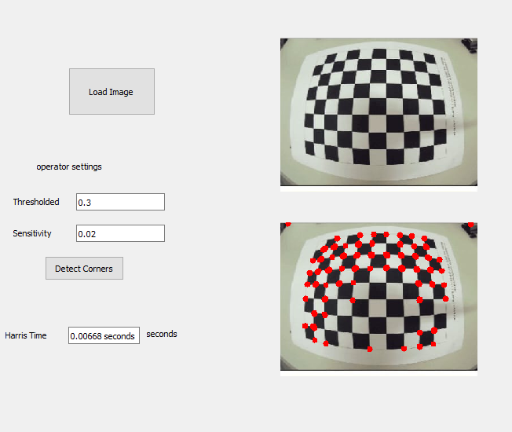

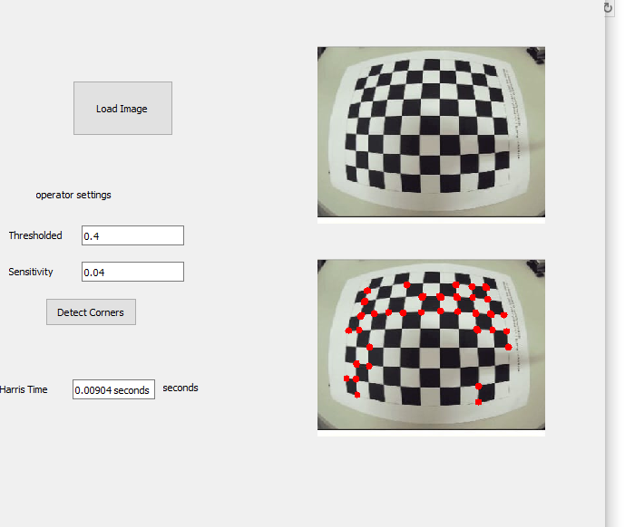

**Scale-Invariant Feature Transform (SIFT): -**

Is computer vision algorithm for finding and describing key points in images. These key points are distinctive features that can be matched between different images, even if the images have been resized, rotated, or slightly distorted.

* **Key point Detection:** SIFT first identifies key points in an image. These are points of interest that are likely to be unique and repeatable. SIFT uses a combination of image gradients and stability measures to find these key points.
* **Scale Invariance:** A key feature of SIFT is its ability to find key points that are independent of the image scale. It achieves this by searching for key points at multiple scales of the image.
* **Key point Description:** Once the key points are identified, SIFT creates a descriptor for each key point. This descriptor is a representation of the local neighborhood around the key point, capturing its orientation and gradient information.
* **Matching Key points:** In the final stage, SIFT can be used to match key points between two images. The descriptors for each key point are compared, and matches are found between key points with similar descriptors.

By matching key points, SIFT allows us to find corresponding features in different images. This has numerous applications in computer vision, including:

* + 1. **Image matching:** Finding similar images in a database.
    2. **Object recognition:** Recognizing objects in images, even if they are viewed from different angles or distances.
    3. **3D reconstruction:** Reconstructing the 3D structure of a scene from multiple images.

**The sum of squared differences (SSD): -**

is a concept used in various fields, most commonly in statistics and image processing. It's a measure of how much a group of data points differ from a specific value, typically the mean (average) or a corresponding point in another dataset.

1. **Calculate Differences:** For each data point, you subtract the reference value (mean, corresponding point). This gives you the difference between the data point and the reference.
2. **Square the Differences:** Squaring each difference emphasizes larger deviations from the reference value. This makes sure that even small positive and negative differences contribute to the overall measure.
3. **Sum the Squares:** Finally, you add up all the squared differences. This gives you the total squared deviation from the reference value.

**Image Processing:** In image processing, SSD is a common way to compare how similar two images are. To do this, you calculate the SSD between corresponding pixels in each image. A lower SSD indicates a higher similarity between the images. This is useful for tasks like image matching or finding the best fit for a patch in an image.

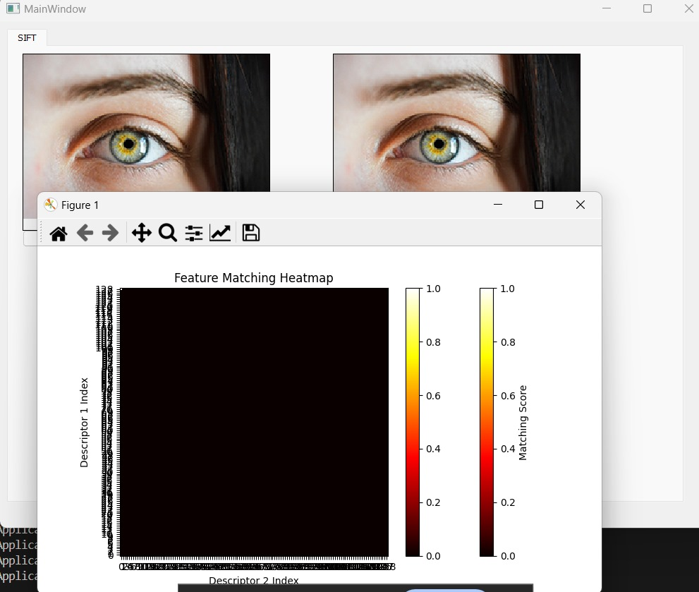

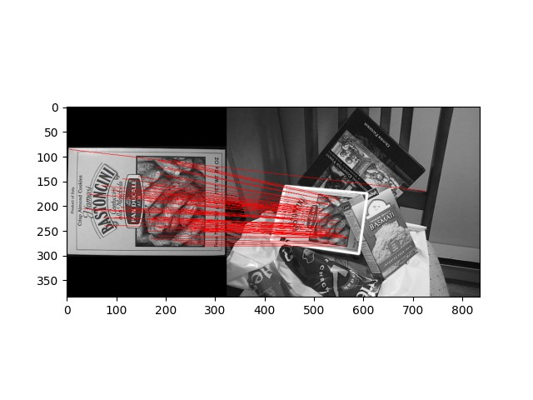

**Normalized Cross Correlation: -**

Normalized cross-correlation (NCC) is a mathematical tool used in signal and image processing to measure the similarity between two signals (like time series data) or image patches. Unlike regular cross-correlation, NCC incorporates normalization, making it more robust to variations in signal intensity or contrast.

**Calculation:**

1. **Template vs. Search Image:** Imagine a reference signal (template) you want to find in a larger signal (search image). NCC slides the template across the search image, calculating a correlation value at each position.
2. **Cross-Correlation:** At each position, NCC calculates the standard cross-correlation, which measures how similar the overlapping parts of the template and search image are. This involves multiplying corresponding elements and summing them up.
3. **Normalization:** The key difference from regular correlation is the normalization step. NCC divides the raw correlation value by the product of the standard deviations of the template and the search image window. This makes the result independent of the overall intensity or contrast of the signals.

**Benefits of Normalization:**

* **Scale Invariance:** NCC becomes less sensitive to changes in signal intensity or contrast. This allows you to find the template even if it's brighter or dimmer in the search image.
* **Clearer Interpretation:** The normalized output between -1 and 1 makes it easier to understand the degree of similarity. A value closer to 1 indicates a strong match, while a value closer to -1 indicates a strong negative correlation (opposite patterns).

**Applications of NCC:**

* **Template Matching:** NCC is a popular tool for finding a specific pattern (template) within an image (search image). This is useful for object recognition, image registration (aligning images), and visual tracking.
* 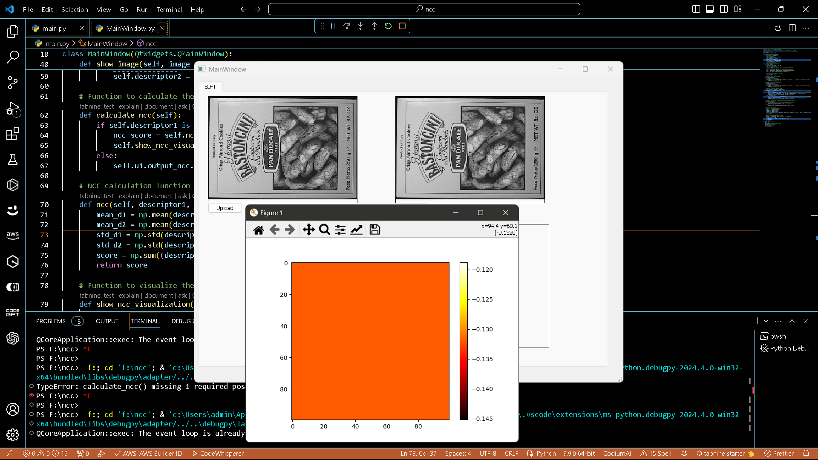**Signal Analysis:** In signal processing, NCC can be used to identify similar patterns or recurring events within a time series data set.