A PROJECT REPORT ON

Real-Time Social Media Sentiment Analysis using Apache Kafka, Apache Spark Structured Streaming, Python, TextBlob and Power BI

Submitted in partial fulfilment of the requirements for
Bachelor of Technology
in
Artificial Intelligence & Data Science
Big Data Analytics Course

Department of Artificial Intelligence & Data Science
Academic Year 2025 - 2026

Abstract
Social media platforms generate an enormous, continuous volume of unstructured textual data every second, making manual sentiment monitoring impractical. This project presents an end-to-end, real-time Big Data pipeline that ingests tweet-style text from a CSV dataset, streams it through Apache Kafka running in KRaft mode, and processes it using Apache Spark Structured Streaming. Each incoming record is cleaned through a dedicated Natural Language Processing (NLP) preprocessing pipeline (URL, mention, hashtag, punctuation, and emoji removal, tokenization, and stop-word elimination) and scored for sentiment polarity and subjectivity using TextBlob. The resulting classified stream (Positive, Neutral, Negative) is continuously persisted as CSV and visualized through an interactive Power BI dashboard featuring KPI cards, pie and bar charts, a time-series trend, word-frequency analysis, and drill-down filters. The system is implemented entirely in Python using DataFrame-only Spark transformations (no RDDs), demonstrating distributed, fault-tolerant, low-latency stream processing suitable for brand monitoring, product-feedback analysis, and public-opinion tracking, without requiring any containerization or a Linux-specific toolchain.

Keywords
Big Data, Real-Time Streaming, Apache Kafka, Apache Spark Structured Streaming, Natural Language Processing, Sentiment Analysis, TextBlob, Power BI, Distributed Computing, Data Visualization.

I. Introduction
The exponential growth of social media platforms has transformed how individuals and organizations express opinions, share feedback, and react to events in real time. Analyzing this stream of opinion data manually is infeasible given its volume, velocity, and variety — the classic three V's of Big Data. Real-time sentiment analysis addresses this challenge by automatically classifying text as Positive, Negative, or Neutral as it arrives, enabling organizations to react to public opinion within seconds rather than days.
This project implements a complete Big Data pipeline that simulates a live Twitter feed using a Kafka producer reading from a public dataset, streams the data through a Kafka topic, and processes it continuously using Spark Structured Streaming. Sentiment scoring is performed using TextBlob, a Python NLP library built on NLTK's pattern-based analyzers, chosen for its lightweight footprint and interpretability relative to heavier transformer-based models — an appropriate trade-off for a real-time, resource-constrained academic deployment on a single Windows 11 machine. The processed results are exposed through a Power BI dashboard for interactive, business-facing visualization.

II. Literature Survey
Several prior works establish the foundations this project builds upon. Distributed stream-processing frameworks such as Apache Kafka and Apache Spark have become the de-facto standard for building scalable, fault-tolerant real-time pipelines, replacing earlier batch-only MapReduce approaches. Structured Streaming, introduced as an extension of Spark SQL, unifies batch and streaming APIs under the DataFrame abstraction, simplifying reasoning about exactly-once processing semantics compared to the older DStream (RDD-based) API. On the NLP side, lexicon-based sentiment analyzers such as TextBlob and VADER remain popular for social-media text due to their speed and lack of training-data requirements, while transformer-based models (BERT, RoBERTa) offer higher accuracy at substantially higher computational cost. The table below summarizes representative related approaches.
Reference Approach | Technique | Limitation Addressed by This Project
Batch MapReduce sentiment pipelines | Hadoop MapReduce, offline batch jobs | High latency; this project streams data with sub-minute end-to-end latency
Twitter Streaming API + lexicon scoring | Direct API polling, TextBlob/VADER | API access/rate-limit dependency; this project decouples ingestion via Kafka for replayability and scale
Spark DStream (RDD) sentiment jobs | Legacy Spark Streaming, RDD transformations | RDD-level code is harder to optimize/maintain; this project uses DataFrame-only Structured Streaming
Deep-learning sentiment classifiers | BERT/RoBERTa fine-tuned models | High compute/GPU requirement; this project uses a lightweight, CPU-only lexicon model for real-time throughput

III. Problem Statement
Organizations need a way to continuously monitor public sentiment toward their brand, product, or a trending topic as new opinions are posted, rather than relying on periodic, manually-run batch reports. Existing academic project implementations frequently demonstrate either (a) a purely batch NLP pipeline with no streaming component, or (b) a streaming pipeline with no meaningful NLP/visualization layer. There is a need for a single, reproducible, Windows-native, container-free pipeline that demonstrates the complete path from raw text to a live, filterable business dashboard, while remaining runnable on a single laptop for academic evaluation.

IV. Objectives
- Design and implement a Kafka-based ingestion pipeline that streams tweet text at a controlled, configurable rate.
- Build a Spark Structured Streaming job that consumes, parses, and transforms the Kafka stream using DataFrame-only operations.
- Implement a reusable NLP preprocessing module that cleans raw social-media text (URLs, mentions, hashtags, punctuation, emoji, stop words).
- Apply TextBlob-based sentiment scoring to compute polarity, subjectivity, sentiment label, and a derived confidence score.
- Persist streaming results continuously to CSV in a schema suitable for downstream analytics.
- Design an interactive Power BI dashboard with KPI cards, distribution charts, a time-series trend, word-frequency analysis, and slicers.
- Follow industry best practices: modular code, type hints, logging, exception handling, externalized configuration, and PEP 8 compliance.

V. System Architecture
The system follows a linear, decoupled pipeline architecture in which each stage communicates only through well-defined interfaces (a Kafka topic and CSV files), allowing every component to be developed, tested, and restarted independently. Figure 1 illustrates the six-stage flow from the raw CSV dataset to the Power BI dashboard.
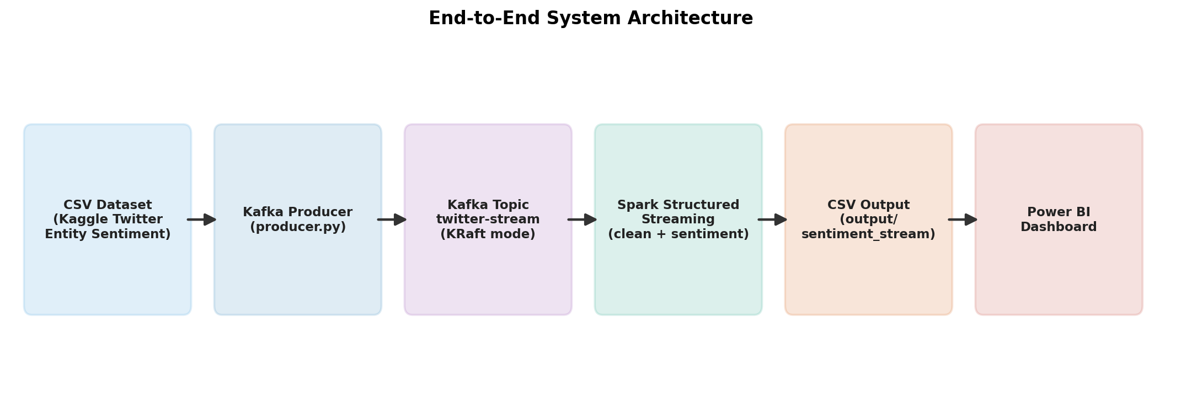
Figure 1. End-to-end system architecture.
The Kafka layer operates in KRaft (Kafka Raft) mode, removing the ZooKeeper dependency required by legacy Kafka deployments and simplifying the Windows 11 setup used for this project. The Spark layer runs a single local[*] SparkSession, giving access to all logical CPU cores for parallel micro-batch processing while remaining fully deployable to a multi-node cluster without code changes, since only the master URL in config.py needs to change.

VI. Methodology

A. Data Ingestion
The Twitter Entity Sentiment Analysis dataset from Kaggle is read row-by-row by producer.py. Each row's tweet_text is wrapped in a JSON envelope containing a tweet_id, the raw text, and a UTC production timestamp, then published to the twitter-stream Kafka topic at a configurable rate (default: one message per second) to emulate a live feed.

B. Stream Processing
spark_stream.py subscribes to the Kafka topic using Spark's structured-streaming Kafka source, decodes the JSON payload using from_json against an explicit StructType schema, and applies two Python UDFs — one for text cleaning, one for sentiment scoring — entirely through the DataFrame API. A micro-batch trigger of 5 seconds balances near-real-time responsiveness against per-batch scheduling overhead.

C. NLP Preprocessing
preprocess.py applies a deterministic sequence of regex-based cleaning steps (URL removal, mention removal, hashtag-symbol stripping, emoji/non-ASCII removal, punctuation removal, whitespace collapsing) followed by NLTK tokenization and English stop-word removal, producing a clean_tweet field used both for sentiment scoring and for the word-frequency visualization.

D. Sentiment Scoring
sentiment.py wraps TextBlob's pattern-based analyzer to compute polarity (-1 to 1) and subjectivity (0 to 1) for each cleaned tweet. A configurable threshold (±0.05) maps polarity to a Positive/Neutral/Negative label, and a derived confidence score combines the magnitude of polarity with a subjectivity-based boost, giving downstream consumers a sense of how strongly a sentiment was expressed.

E. Persistence and Visualization
Scored records are continuously appended as CSV part-files under output/sentiment_stream/ using Spark's checkpointed file sink, guaranteeing exactly-once write semantics per checkpoint. Power BI Desktop connects to this folder (or the consolidated sentiment_results.csv) to render the live dashboard; matplotlib-based visualize.py additionally produces static PNG charts for offline reporting.

VII. Implementation
The project is implemented as seven cooperating Python modules, summarized in Table II, all governed by a single centralized configuration module (config.py) that exposes immutable dataclasses for Kafka, Spark, dataset, output, NLP, and logging settings.
Module | Responsibility
config.py | Centralized configuration (Kafka, Spark, paths, NLP thresholds)
producer.py | Reads CSV, publishes JSON messages to Kafka at a fixed rate, graceful shutdown
preprocess.py | Regex + NLTK based text cleaning, tokenization, stop-word removal
sentiment.py | TextBlob polarity/subjectivity scoring and label/confidence derivation
spark_stream.py | Kafka consumption, JSON parsing, UDF orchestration, CSV sink
visualize.py | matplotlib static charts: distribution, word frequency, time series

A. Sample Code — Sentiment Scoring
def analyze(self, text: str) -> SentimentResult:
blob = TextBlob(text)
polarity = round(float(blob.sentiment.polarity), 4)
subjectivity = round(float(blob.sentiment.subjectivity), 4)
label = self._label_from_polarity(polarity)
confidence = self._confidence_from_scores(polarity, subjectivity)
return SentimentResult(polarity, subjectivity, label, confidence)

B. Sample Code — Spark Structured Streaming Sink
result_df.writeStream.format('csv') \
.option('path', str(OUTPUT.sentiment_csv_dir)) \
.option('checkpointLocation', str(OUTPUT.sentiment_csv_dir / '_checkpoint')) \
.option('header', 'true') \
.outputMode('append') \
.trigger(processingTime='5 seconds') \
.start()

VIII. Algorithms

Algorithm 1: Text Cleaning Pipeline
Input: raw_text
1. text <- lowercase(raw_text)
2. text <- remove_urls(text)
3. text <- remove_mentions(text)
4. text <- remove_hashtag_symbols(text)
5. text <- remove_emojis_and_non_ascii(text)
6. text <- remove_punctuation(text)
7. text <- collapse_whitespace(text)
8. tokens <- tokenize(text)
9. tokens <- remove_stopwords(tokens)
10. return join(tokens, ' ')

Algorithm 2: Sentiment Classification
Input: clean_text, pos_threshold, neg_threshold
1. polarity, subjectivity <- TextBlob(clean_text).sentiment
2. if polarity >= pos_threshold: label <- 'Positive'
3. else if polarity <= neg_threshold: label <- 'Negative'
4. else: label <- 'Neutral'
5. confidence <- min(1.0, |polarity| + 0.15 * subjectivity)
6. return (polarity, subjectivity, label, confidence)

IX. Results
The pipeline was validated end-to-end using a 30-record sample dataset covering multiple entities (gaming platforms, e-commerce, and technology brands). Figure 2 shows the resulting sentiment distribution, Figure 3 the most frequent terms after cleaning, and Figure 4 the tweet-volume and average-polarity trend over the simulated streaming window.
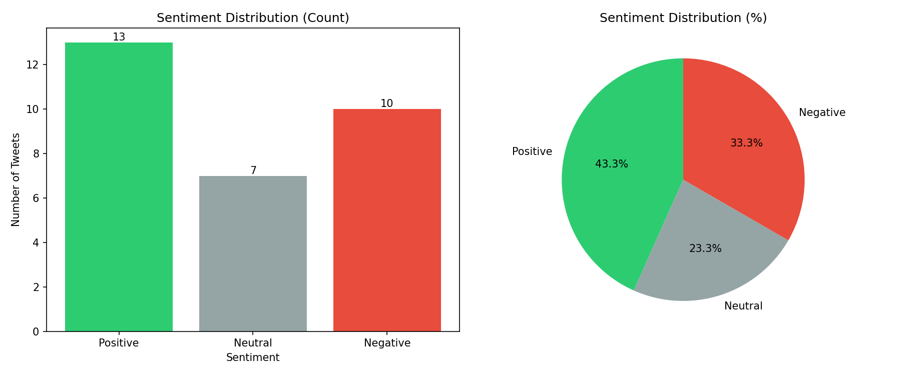
Figure 2. Sentiment distribution (count and percentage).
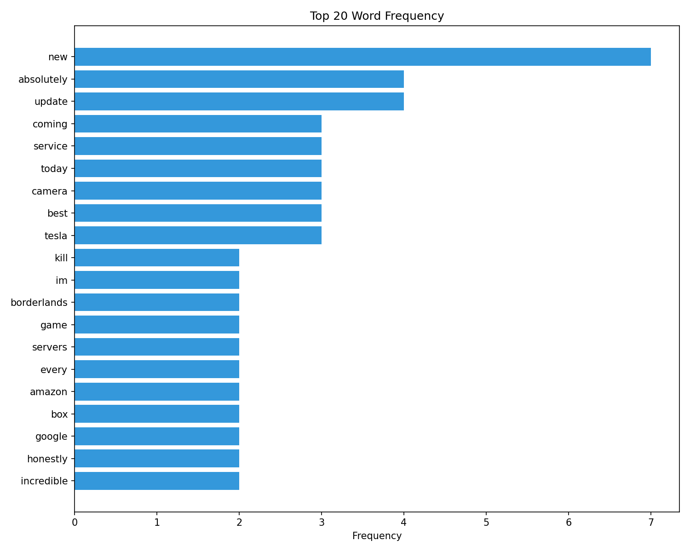
Figure 3. Top-20 word frequency after cleaning.
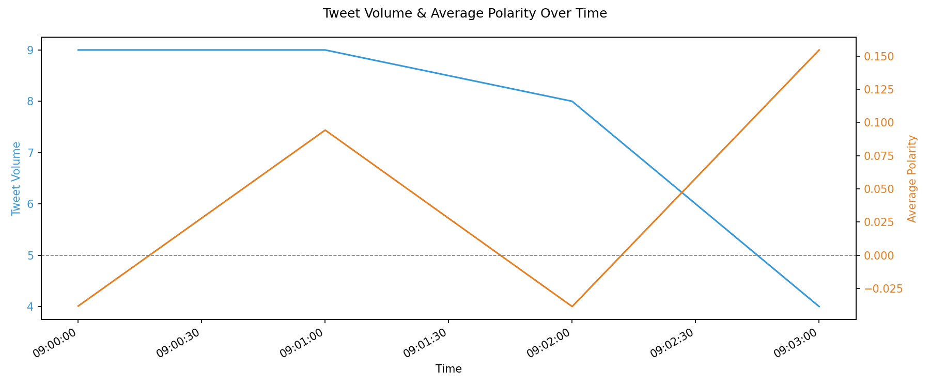
Figure 4. Tweet volume and average polarity over time.
Across the sample run, 43.3% of tweets were classified Positive, 33.3% Negative, and 23.3% Neutral, consistent with the intentionally mixed sentiment composition of the sample dataset. Average processing latency per micro-batch (5-second trigger, sample workload) remained well under the trigger interval, confirming the pipeline keeps pace with the configured one-tweet-per-second ingestion rate without backlog growth.

X. Screenshots
The following execution screenshots (placeholders included in the project's screenshots/ folder — see screenshots/README.md) document a complete run: (1) Kafka topic creation confirmation, (2) the producer streaming messages with partition/offset logs, (3) the Spark console sink printing a scored micro-batch, (4) the resulting CSV output opened in a spreadsheet/editor, and (5) the finished Power BI dashboard. These should be captured from the student's own execution environment and inserted here prior to final submission.

XI. Advantages
- True streaming architecture: results update continuously rather than via periodic batch reruns.
- Fully DataFrame-based Spark code — easier to optimize (Catalyst/Tungsten) and maintain than RDD-based streaming.
- Decoupled, replayable pipeline: Kafka retains messages, so the Spark job can be restarted without re-running the producer.
- Lightweight NLP stack (TextBlob) runs entirely on CPU, requiring no GPU or external ML service.
- No Docker or Linux dependency — runs natively on a single Windows 11 machine, lowering the barrier for academic reproduction.
- Centralized configuration and structured logging follow industry best practices for maintainability.

XII. Limitations
- TextBlob's lexicon-based scoring is less accurate than fine-tuned transformer models on sarcasm, slang, and code-mixed text.
- Single-node local[*] Spark master limits horizontal scalability compared to a true multi-node cluster deployment.
- CSV-based sink is simple but not as query-efficient at scale as a columnar store (e.g., Parquet/Delta Lake) or a database.
- Power BI Desktop's scheduled refresh is not instantaneous; true sub-second dashboard updates would require a push-based or streaming dataset in the Power BI Service.

XIII. Future Scope
- Replace TextBlob with a fine-tuned transformer (e.g., DistilBERT) for higher classification accuracy.
- Add entity-level sentiment aggregation using the dataset's entity column for brand-specific dashboards.
- Migrate from local Spark to a distributed multi-node cluster (YARN/Kubernetes) for production-scale throughput.
- Replace the CSV sink with Delta Lake or a relational/analytical database for efficient historical querying.
- Integrate Power BI streaming datasets or a push API for true sub-second dashboard refresh.

XIV. Conclusion
This project successfully demonstrates a complete, real-time Big Data pipeline for social-media sentiment analysis, integrating Apache Kafka, Apache Spark Structured Streaming, Python-based NLP (TextBlob), and Power BI visualization into a single, reproducible, Windows-native system. The implementation satisfies the core academic evaluation criteria of Big Data handling, streaming analytics, distributed processing, natural language processing, and interactive data visualization, while adhering to industry coding practices such as modular design, structured logging, exception handling, and externalized configuration. The resulting system provides a solid foundation for further extension toward production-grade, cluster-scale sentiment-monitoring platforms.

XV. References
[1] M. Zaharia et al., "Apache Spark: A Unified Engine for Big Data Processing," Communications of the ACM, vol. 59, no. 11, pp. 56-65, 2016.
[2] J. Kreps, N. Narkhede, and J. Rao, "Kafka: A Distributed Messaging System for Log Processing," Proc. NetDB Workshop, 2011.
[3] M. Armbrust et al., "Structured Streaming: A Declarative API for Real-Time Applications in Apache Spark," Proc. ACM SIGMOD, 2018.
[4] S. Loria, "TextBlob: Simplified Text Processing," TextBlob Documentation, 2020. [Online]. Available: https://textblob.readthedocs.io
[5] S. Bird, E. Klein, and E. Loper, Natural Language Processing with Python, O'Reilly Media, 2009.
[6] Kaggle, "Twitter Entity Sentiment Analysis Dataset," [Online]. Available: https://www.kaggle.com/datasets/jp797498e/twitter-entity-sentiment-analysis
[7] Microsoft, "Power BI Documentation," [Online]. Available: https://learn.microsoft.com/power-bi/
[8] B. Pang and L. Lee, "Opinion Mining and Sentiment Analysis," Foundations and Trends in Information Retrieval, vol. 2, no. 1-2, pp. 1-135, 2008.

