CLASSROOM COMMUNITY • CULTURAL CONNECTION
Five Minutes of Australia
Stories, slang, traditions, and fun facts shared before class

A small pre-class tradition that helps students know their instructor, encounter another culture, and begin class in a relaxed, welcoming way.
Eden Danielsen-Jensen | August 2026
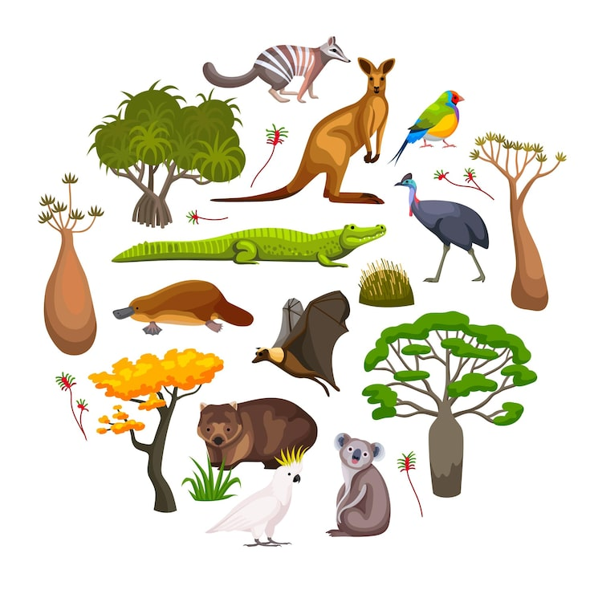
“She made class more fun by doing little things like Australian facts of the day and icebreaker questions for us to discuss before class starts. I really enjoyed that, because it made it feel easier to interact with both her and my peers!”- Anonymous Student Feedback

Building Community Through “Five Minutes of Australia”
TEACHING PRACTICE
At the beginning of many class meetings, I spend approximately five minutes sharing an aspect of Australian culture, language, geography, wildlife, or daily life. These brief conversations give students a relaxed way to get to know me as a person while learning something unexpected about another culture.
Over the semester, “Five Minutes of Australia” becomes a familiar class tradition. It creates an accessible opening for conversation, invites student questions, and contributes to a classroom atmosphere in which students feel comfortable participating and connecting with their instructor.
1  RELATIONSHIP  Students learn something personal and memorable about their instructor. | 2  CURIOSITY  A surprising fact or phrase gives students an easy entry point into conversation. | 3  BELONGING  A low-stakes routine helps the room feel welcoming before mathematical work begins.

How I use it
- Choose one topic that can be introduced in about three minutes.
- Invite one or two guesses, reactions, or questions from students.
- Connect the topic to a personal story when appropriate.
- End with a memorable phrase, image, comparison, or mini challenge.



Australian Slang Dictionary
Aussie word | Meaning | In context
Avo | Avocado | “I put avo on my toast.”
Arvo | Afternoon | “I’ll see you this arvo.”
Agro | Aggressive | “He was agro after the fight”
Devo | Devastated | “That’s devo”
Smoko | A short work break | “We stopped for smoko.”
Bottle-o | Liquor store | “The bottle-o is around the corner.”
Servo | Service station / gas station | “We need to stop at the servo.”
Mozzie | Mosquito | “The mozzies are terrible tonight.”
Barbie | Barbecue | “We’ll have a barbie on the beach.”
Sunnies | Sunglasses | “Don’t forget your sunnies.”
Chrissie | Christmas | “What are you doing for Chrissie?”
Pressie | Present | “I bought you a pressie.”
Brekky | Breakfast | “Let’s get brekky.”
Biccy | Biscuit/Cookie | “I brought biccies to share”
Choccy | Chocolate Bar | “Can I have a choccy please?”
Brolly | Umbrella | “Bring a brolly, it’s going to rain”
Footy | Football/NFL/AFL | “Want to play some footy?”
Esky | Cooler | “Put the drinks in the esky.”
Kindy | Kindergarten | “She starts kindy this year.”
Uni | University | “I studied mathematics at uni.”
Trackies | Tracksuit pants | “I wore trackies all weekend.”
Bludger | A freeloader | “Stop being a bludger”
Dag/Daggy | Someone quirky or uncool | “You are dressed like a dag”
Cark it | To die | “My car carked it yesterday”
Flat Out | Busy | “I’ve been flat out lately”
Chockers | Full | “The party was chockers”
Whinger | Someone who complains | “Stop being a whinger”
Sookie-la-la | A sook | “You’re being a Sookie-la-la”
Sheila | A woman | “Take a look at that Sheila”
Bloke | A man | “He was a strong bloke”

Expressions That Need a Translation
She’ll be right | It will be all right. Things will work themselves out.  When the plan is imperfect but probably fine.
Yeah, nah / Nah, yeah | Usually “no” / usually “yes.”  Tone and context matter more than grammar.
Good on ya | Well done—or sarcastically, “great job.”  Listen carefully to the tone.
My shout | I will pay for everyone.  Often used when buying food or drinks.
Have a sticky beak | Take a curious look.  A playful way to say “go have a look.”
Take a squiz | Have a quick look.  “Take a squiz at this.”
Sus it out | Investigate or figure it out.  A useful everyday phrase.
Chuck a sickie | Call in sick to do something fun instead.  A cheeky Australian classic.
Spit the dummy | Have a tantrum.  Like a baby spitting out a pacifier.
Chuck a wobbly | Have a tantrum or dramatic outburst.  Often humorous rather than literal.
Go troppo | Become irrational or lose your temper.  Historically linked to tropical heat.
Pull your head in | Stop behaving foolishly or arrogantly.  A blunt warning.
Bugger off / Rack off | Go away.  Informal and impolite.
Chuck a U-ey | Make a U-turn.  A very practical driving phrase.
Woop woop | The middle of nowhere.  “They live out in woop woop.”
Are you right? | Have you lost all your brain cells? Get lost  An invitation to back off now.

Australia ↔ United States
Same idea. Different word. Excellent classroom debate.
Australia | United States
Capsicum | Bell pepper
Coriander | Cilantro
Mince | Ground meat
Lollies | Candy
Fairy floss | Cotton candy
Esky | Cooler
Bogan | Redneck
Trolley | Shopping cart
Jumper | Sweater / hoodie / jacket
Footpath | Sidewalk
Whipper snipper | Weed whacker
Witches hat | Traffic cone
Dunny / loo | Toilet / restroom
Snag | Sausage, often served in bread
Chips | Can mean fries or packaged chips
Scissors, paper, rock | Rock, paper, scissors

Pronunciation Challenge
Ask students to say the word first—then give the Australian version.
Mazda | Nissan | Hyundai

Aluminium | Buoy | Adidas

Basil | Oregano | Tomato

Teaching note
This works best as a live comparison rather than a formal phonetic guide. Students can listen for differences in vowel sounds, stress, and syllable emphasis, and they often contribute words from their own families, regions, or languages.
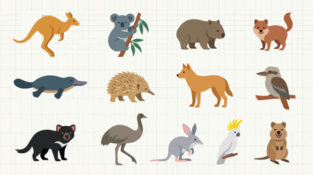

Places, Systems, and Everyday Life
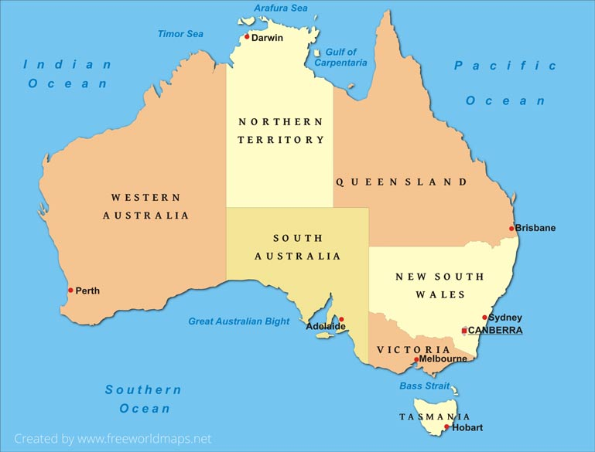  A useful opening topic: Guess where I live. | DISCUSSION TOPICS  - Driving on the left  - Australian currency  - Australian politics and voting  - Weather  - Schooling system  - School buses and school uniforms  - Australia Day  - Australia’s “Big Things” roadside attractions  - The dance taught in schools “The Nutbush”  - Australian Christmas  - Happy Birthday Song

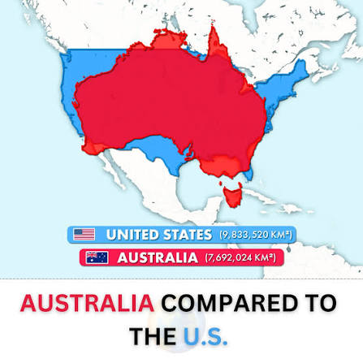 | USEFUL FACTS  - The Population of Australia is about 27 million people, that’s less than the population of California.  - 90% of Australia’s population lives within 50 km (~31 miles) of the coastline.  - More than 2/3rds of Australian’s live in just 8 cities  - Tasmania, the smallest state in Australia, is larger than Florida.

Wildlife and “Only in Australia” Facts
QUOKKAS | The famously photogenic marsupial native to Rottnest Island.
WOMBATS | Their cube-shaped droppings are an unforgettable conversation starter.
UNIQUE WILDLIFE | 80 % of Australia’s species are found nowhere else.
WORLD’S DEADLIST SPIDER | The Australian funnel-web spider is the most venomous spider in the world. It is also one of the most aggressive and deadliest creatures on Earth.
LARGE SPIDERS | The Huntsman spider can reach up to 15 to 30 centimeters (6 to 12 inches) across, easily covering an adult human's hand.
NATIONAL ANIMALS | Kangaroos and emus cannot walk backward due to how their bodies and large tails are built, which is why they appear on the national coat of arms
SNAKES | 21 of the 25 most toxic snakes in the world are all from Australia
CAMELS | There are more camels in Australia than Egypt and Saudi Arabia.
SHEEP | There are 3 times more sheep than people in Australia.
BEACHES | The number of beaches is so large that visiting a new one every day would take 27 years.
THE EMU WAR | A strange episode in Australian history that sounds fictional but makes students want the full story.
HAROLD HOLT | The prime minister disappeared while swimming; so we named a public swimming pool after him.
EARLY POLICE | Australia’s colonial history includes early constables drawn from transported convicts. Basically our first police were just the best behaved criminals…
BIG THINGS | Giant roadside sculptures—bananas, prawns, pineapples, and more—make a fun visual topic.
DAINTREE RAINFOREST | Australia has the oldest continuously surviving tropical rainforest on the planet
GREAT BARRIER REEF | The Great Barrier Reef is the largest living structure on Earth.
NO VOLCANOES | Australia is the only inhabited continent that does not have any active volcanoes

Food, Celebrations, and Taste Tests
Tim Tam Slam
Bite opposite corners from a Tim Tam, use it like a straw with milo or hot chocolate, and eat it before it collapses.
Sausage sizzle
A sausage, diagonally in bread, often sold as a fundraiser outside community events or hardware stores.
Aussie food
Vegemite, meat pies, lamingtons, pavlova, fairy bread, Milo, and chicken parmi.
Candy-bar translations
An Australian Milky Way resembles an American 3 Musketeers; an American-style Milky Way is closer to a Mars Bar.
Birthday tradition
“Hip hip hooray” after the birthday song.
Australia Day
A chance to discuss food, public celebrations, national identity, and the complexity of the date.
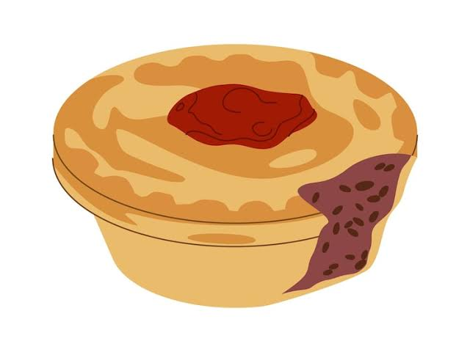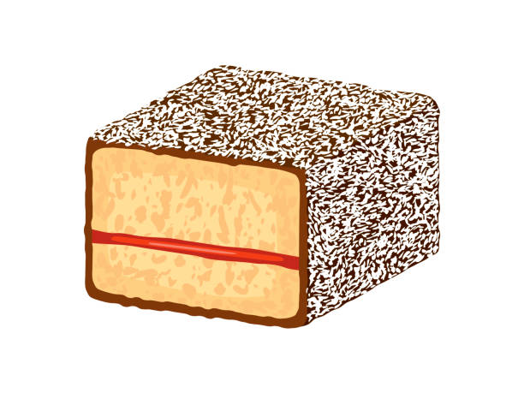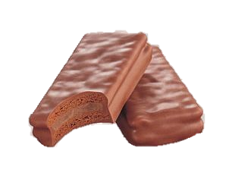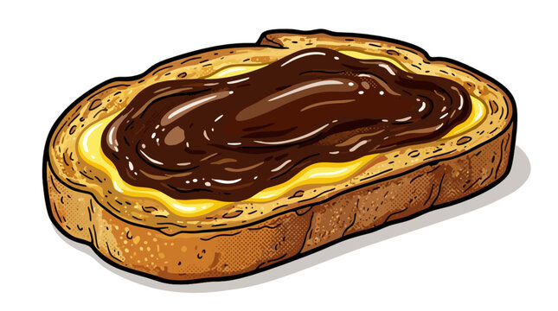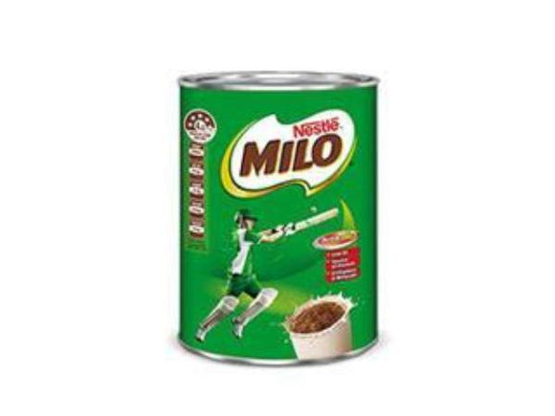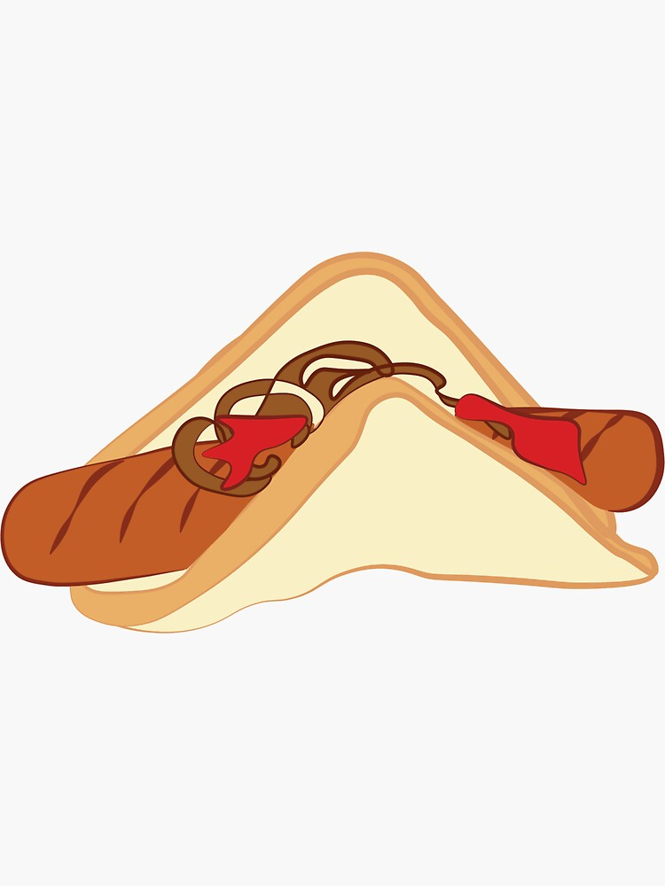

Aussie Quiz
Use at the end of the semester—or whenever the class needs a two-minute reset.
1. What is an esky?
A. A hat B. A cooler C. A kangaroo D. A backpack
Answer: A cooler
2. What is brekky?
A. Breakfast B. A short break C. A biscuit D. A barbecue
Answer: Breakfast
3. What animal has cube-shaped poo?
A. Koala B. Quokka C. Wombat D. Platypus
Answer: Wombat
4. What does “my shout” mean?
A. Speak louder B. I will pay C. Leave me alone D. It is your turn
Answer: I will pay
5. What is a snag?
A. A problem B. A sausage C. A mosquito D. A sweater
Answer: A sausage
6. “Yeah, nah” usually means…
A. Yes B. No C. Maybe D. Thank you
Answer: No
The goal is not simply to teach facts about Australia. It is to create a small, consistent moment of curiosity and connection before students begin the day’s mathematical work.

