Hadoop Basics

To four main components of hadoop are:

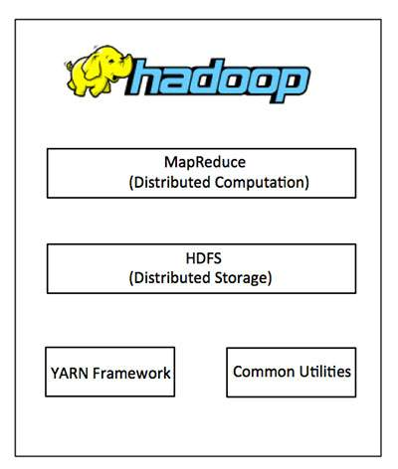

Description of above mentioned components:

MapReduce
Framework to easily writting applications which process big amount of data in parallel on large clusters. It has been designed with fault tolerance and reliability in mind. It's utilized by YARN job scheduling.

YARN
A framework for job scheduling and cluster resource management.
http://hadoop.apache.org/docs/current/hadoop-yarn/hadoop-yarn-site/YARN.html

HDFS
A distributed file system designed to run on commodity hardware. It hase been designed with high fault tolerance and recovery in mind. The file systems core functionlity is targeting batch processing instead of user interactivity and data throughput is more important than latency. It is highly tuned to support large files (GBs to Tbs), you don't want to put little files on it. Designed to write files ones and targeting only read access for data analysis afterwards. Last but not least it is designed to migrate the computation closer to where the data is located instead of copying the data within the cluster (moving computation is cheaper than moving the data). Files are organized/split up in blocks and replicated for fault tolerance. The replicationis configurable per file on creation and runtime.

There is one master node „NameNode“ and view „DataNodes“. Normally they are all running on different machines within the cluster. The „NameNode“ makes all decisions regarding replication of blocks and monitors the „DataNodes“ by receiving heartbeats in regular intervals from the „DataNodes“. However the read/write communication after „NameNode“ made a decision is directly done with the „DataNode“ the decision was made for.

HDFS files can be accessed with a Java API, C language wrapper API, HTTP browser and FS shell.
http://hadoop.apache.org/docs/current/hadoop-project-dist/hadoop-hdfs/HdfsDesign.html

In addition hadoop functionality can be extended by other software packages like:

- Apache Pig
- Apache Hive
- Apache Hbase
- etc.

Stichwortverzeichnis
DAG job | Direct Acycic Grap Job. This means You have more jobs running in parallel. Each job is gaining job specific data that afterwards (after all jobs have been executed) are aggregated.

