*Civilization is only good behavior.*

*The only thing to fear is ourselves.*

*As a citizen consider oneself spellbound—free has been placed in our lives.*

# How the Judeo-Christian System Influences Civilization (Part 1) http://tinyurl.com/HJCR1

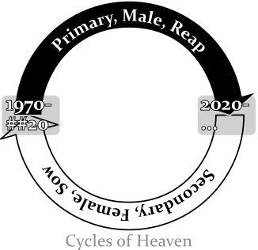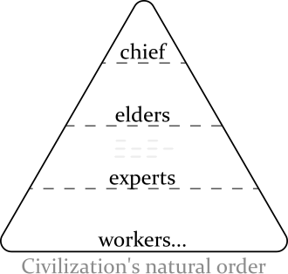Civilization began as a natural order. This changed when the Judeo-Christian system started. Civilization moved from evolution (natural whims) to belonging to those who join a predesigned system. The people that know the details of the system get the rewards. The system was started by the Jews and it comes from their “Secret of Heaven”. The system leads them to push on civilization a dualistic system (primary/secondary, male/female, reaping/sowing… ). It is implemented by rewarding a single group solely for an era of fifty years then rewarding a polar group for the other fifty years. For the first fifty years the Jews reward the first group for *reaping* acts (i.e. taking, usually men)—from this the Jews get protection and wealth. For the next fifty years the Jews reward the second group for *sowing* acts (i.e. giving/making-things-grow, usually women) from this the Jews develop trust. All through time the entire system is kept silent by the Jews. Both the silence and the alternating support has caused much confusion. Some desperate people react outside of nature’s law to fix things for themselves in the now (*drols and dogs*); the Jews reward this. So focused does the second group become on the first-group/Jews that the people lacking heavenly knowledge, the third group, get neglected and often treated as inferior. The Christian church (a succession of the second group) though largely practicing their beliefs with spiritual principles, is built upon a female leadership (formed with the New Testament) that becomes so extreme it *gives* people as sacrifices. The Jew maintain the system like a vital job. From it they get authority and advantageous lives; their definition of it is literally *heaven*. Any person that uses the system is likelier to have a successful life and is and likelier to keep heaven silent. I have yet to find anyone who has any sufficient overview on what is happening. This system has effected civilization around the world. •• *winning/losing?*

## Who I Am

I am one of the people that got used as a sacrifice. From a very early age I have been treated as non-existant by a number of people to get themselves better heavenly protection. So prevalent this has become to that it removed me from civilization. I learned what I know now by accepting truths that were hard (when life became too impossible to live reasonably anymore I had to look at improbable answers to try and survive). Other people are included besides me and we need the help. •• *Needs work.*

## Research Source

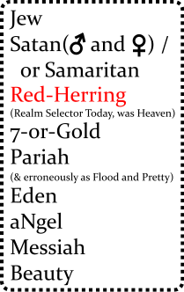The Judeo-Christian system does document its intent (institutions that have been around awhile usually provide a plan). Both the Jews and the Christians have described their plans in their Testaments. Those that know the system feel they have been divulgent enough with civilization. The Bible, the most read book in the world, *can* help decipher how this system influences modern civilization. However, to say it is an open declaration is false. Because the Bible is intentionally cryptic, gruesome, and only tells only part of the “Secret of Heaven” it falls short of that standard.[1]

## Hebrew Code

The Hebrew people use a code to share secrets with. It is hidden within ordinary language. The base meanings have very *absolute* definitions.

## The Secret of Heaven

The “Secret of Heaven” comes from before the Bible was written. The chance of understanding what the Bible is trying to convey absent of knowing the “Secret of Heaven” is very small. Though the “Secret of Heaven” is a real tool how it formed is part speculation. It is derived from my experience and my limited reading of *History of Egypt, Chaldea, Syria, Babylonia, and Assyria, Volume 3*[2].

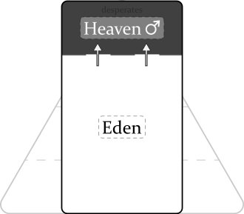The Secret of Heaven likely started because of an environmental threat. The area the system started in was the Tigris-Euphrates rivers of present-day Iraq around 4100 years ago. This is where Abraham came from (Gen 11:28-31). The area is surrounded by a lot of desert. Because surviving in the area was sometimes risky (droughts, distance from safe land…) it could create desperate men. Some people, doing better, became afraid of the desperate men mood that became visceral[3]. The ancient Hebrew saw an investment in it: financially save the desperate man… likely (even from the start) silently… and be in control on how he effects civilization. The ancient Hebrew gathered protection from this and eventually wealth. He felt very *intelligent/cerebral*. The desperate man being rewarded for his behavior became more *base/brutal/emotional/wild/visceral*. It begins by a feeling of open-boundedness, then built to narcissism, then being able to force what is good (divining[4]), and last an insularity can build where abnormal experiences are required for him to find things interesting. Both men prospered from this and prospered so much a feel of getting *free* began. The symbiotic bond formed that became to me known as the “Secret of Heaven”. The feeling of free kept building and encouraged others to reward likewise and the “Secret of Heaven” spread. Later, an era for desperate women was added. The great Jewish two system was born.

## Bible Translation

The Jews are so dedicated to their system, and are so protected are they by their desperates, they have become very secretive and spent much time highly refining the Bible. It is audacious and has many devices. The Bible is designed to be understood only by those that have supernatural safety. Its audaciousness and graphicness can contain meanings that can only be understood to those that are well-removed from the feelings that get portrayed (i.e. more removed from mortal psychological tragedies). A couple of things to know: The Bible is written revisionistically[5] (backwritten) to make newer rules apply throughout, and the beginning of the Bible is packed with details.

**Genesis 1** The Bible starts with a desperate man being so rewarded that the Jews refer to him as a “God” (Gen 1:1 NIV), “In the beginning *God* created the **heavens** and the **earth**” (i.e. two types of people). “Heaven on earth” was such an attraction more *divining*[6] was done : day/night, water/sky, land/sea, sun/moon, man/nature. The Hebrews allude to this type of behavior as to “Fear God”. ••*The Bible being revisionistic begins at the very start (backwriting)… Although the Hebrew put a lot of emphasis on “Creating Good and Evil” it hardly started this way. Originally the desperate/selfish/well-rewarded men just created “good” for themselves and the people associated with them. Evil came later with sacrifices… particularly with Job and later Jesus.*••

**Genesis 2** The first era of sowing, female rule. “By the **seventh** day God had finished the work… so on the **seventh** day…” (Gen 2:2). *The names of Adam and Eve are the first examples of the Bible being revisionistic (backwriting). Adam should be Hdm and Eve just Ee as these definitions have yet to be defined.•*

**Genesis 3** The serpent tempts Eve with divining, “Did God really say, ‘You must not eat from any tree [referring to the tree of good and evil] in the garden’?” (Gen 3:1). Eve submits because it was “pleasing to the eye, and also desirable for **gaining wisdom**”. “Gaining wisdom”” is more properly defined as “getting protection”, i.e answers/safety from a prescribed system rather than from natural experience. This has an effect on nakedness where naturalness begins to feel foreign (Gen 3:11). She gives the fruit to Adam but *only Adam* becomes a god, “The man has now become like one of us, knowing good and evil”. The cursing that is done by God onto the serpent, Eve, and Adam is FUD/a-smokescreen to disguise their ascension. A rule is created: gods being gods will be prevented from returning to Eden, “He must not be allowed to reach out his hand and take also from the tree of life and eat, and live forever” (Gen 3:22). The political left is born (this is different than it actually is today, though described the same [I’ll explain later]), “So the LORD God banished *him* from the Garden of Eden… [and] he placed on the east side of the Garden of Eden cherubim and a flaming sword flashing back and forth to guard the way to the tree of life” (Gen 3:24).

* *(He Said, Business, Partisanship, ~~Securing Heaven~~)*
* • The serpent, Satan, Moses are historically organizers of the flood. Is this an antagonization directed at females? Glory at their included male station? I have seen females that want to flood too. My feeling here is that Eve is curious she too wants to “be like God” but is prevented from being one because they think “only men can be diviners”. Later in history the feeling become anger from the want of inclusion.•*

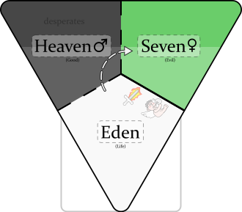**Genesis 4** *(She Said, Rest/Covering-Up/Getting-Heaven-Wrong, Creating Family—by getting some “saved”)*: Eve is the god here and Cain, Abel, and Seth are probably associates of Eve rather than her kin (kin usually get heavenly inclusion). Cain and Abel try to bribe Eve with “fruits” and “fat-portions” so that they can get to heaven. Eve from Eden (Gen 3:23) tries to do heaven like she saw the gods do before her. She too curses her male subjects to “save” them (Gen 3:14-19). She also gives Cain protection, “… anyone who kills Cain will suffer vengeance *seven* times over.” Cain followed the directive where the god before put “cherubim and a flaming sword” and went to the “Land of Nod, east of Eden” (to the new heaven on the right) (So nonchalantly a new heaven is created, the history appears to say "Everything is OK, a new heaven is fine, little deal---looks like the Jews are trying to make their history look polished.).

**Genesis 5** *(Yokel Said, Mortal Rule)*: A time span of ten male rulers from Adam to Noah is defined. God rule decreases as **yokel** rule becomes prevalent, Eden wins. Lamech proclaims that Noah is to restore god rule that Adam’s (weak!?) rule lost, “[Noah] will comfort us in the labor and painful toil of our hands caused by the ground the LORD has cursed (references Gen 3:17).”

**Genesis 6** *(She Said but a dual-power to restore heaven)*: Attack on Eden begins. God pronounces a dual-power, “a hundred and twenty years.” The “sons of God” (female leaders) sucked up the pride in their own god-ness and mated with the “daughters of humans” (desperate men, angels). This created Nephilim—people that are physical giants, knowing little borders, people to be feared—to create heaven again. The Lord (a female god here) is upset because civilization is co-operative and thoughtful (“wickedness… [and] evil” Gen 6:5) and wants to restore the gods to power. She uses Eden’s name (3,5,6) to set-up the exercising of god power, “The ark is to be *three* hundred cubits long, *fifty* cubits wide and *thirty* cubits high. (Gen 6:15).

**Genesis 7** *(He Said, Business, Partisanship)*: (The flood is rewarding, in synchronicity, a large number of *desperate* men to create "heaven on earth", partisanship, creating good and evil. [^flood].) The Lord found Noah “righteous” (godly) and he flooded the *earth*, put a*n*imals on the Ark, to restore the gods to power. More using Eden’s name for god power, “Noah was six hundred years old…”, etc.. ("The waters flooded the earth for a hundred and fifty days (Gen 6:24)" is used in modern times to denote yearly floods from to January 1 to May 31 (absent a leap year)).

* The serpent encouraged selfishness.
* The Jews try to make their history look planned here, but the truth is since the Jews keep heaven [the great Jewish two system] always silent, a progressive confusion begins early on the second group. The confusion has created a path for people that start near-sighted and ignorant of complicity but become desperate—a staging heaven to Judaism.
* Became eventually: The women are going to flood too and do it better.
* This directive (Gen 3:22) will develop to: that to become a god a person must do a sin that is unforgivable within civilization to get “saved”… it keeps them silent.
* [7]
* “friends (Job 2:11)”
* (narcisstic, desperate)
* it hides the flood

1. I refrain from calling the Judeo-Christian system a religion because the common definition of religion usually involves spirituality with an ethereal god or gods.
2. [History of Egypt, Chaldea, Syria, Babylonia, and Assyria, Vol. 3](https://www.gutenberg.org/files/17323/17323-h/17323-h.htm). On Librivox [Part 5](https://librivox.org/history-of-egypt-chaldea-syria-babylonia-and-assyria-vol-3-by-gaston-maspero/) in Volume 3 tells the original flood story.
3. I am using the definition from *Merriam Webster*: dealing with crude or elemental emotions, EARTHY; and from *The American Heritage® Dictionary of the English Language, 5th Edition*. Being or arising from impulse or sudden emotion rather than from thought or deliberation: synonym: instinctive.
4. I am using the definition of divining as: creating good (and consequence evil)… passionate about favoring things (particularly people). The Bible talks about this early in Genesis 2:9. Merriam-Webster of it says: of, relating to, or proceeding directly from God or a god.
5. * [Wiktionary](https://en.wiktionary.org/wiki/revisionistic)

  
6. I am using the definition of divining as: creating good (and consequence evil)… passionate about favoring things (particularly people). The Bible talks about this early in Genesis 2:9. Merriam-Webster of it says: of, relating to, or proceeding directly from God or a god.
7. For a more straight-forward description on what the flood is read the [History of Egypt, Chaldæa, Syria, Babylonia, and Assyria, Volume 3](https://www.gutenberg.org/ebooks/17323) (skip to “Men in the mean time became wicked”); it is also available on [LibriVox](https://librivox.org/history-of-egypt-chaldea-syria-babylonia-and-assyria-vol-3-by-gaston-maspero/) on Section 5. I also put backups [here](https://1drv.ms/f/s!AvLA1bEaFFRxgtMFQBrd6Xcw9tteqA?e=qo9kGy)