*Civilization is only good behavior.*

*As a citizen the only thing to fear… is ourselves—free has been placed in our lives.*

# How the Judeo-Christian System Influences Civilization (Part 1) http://tinyurl.com/HJCR1

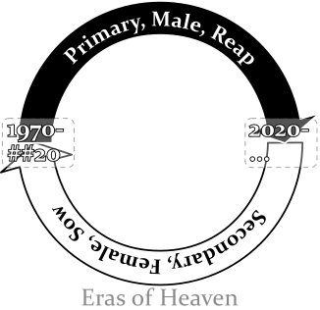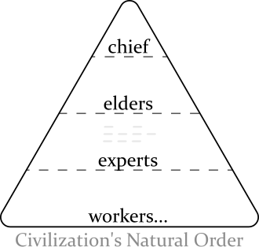Civilization began as a natural order. This changed when the Judeo-Christian system started. Civilization moved from evolution (natural whims) to belonging to those who join a predesigned system. The people that know the details of the system get the rewards. The system was started by the Jews and it comes from their “Secret of Heaven”. The “Secret of Heaven” leads them to push on civilization a dualistic system (primary/secondary, male/female, reaping/sowing, follow/trick… ). It is implemented by rewarding a single group solely for an era of fifty years then rewarding a polar group for an era of fifty years. For the first fifty years the Jews reward the first group for *reaping* acts (i.e. taking, usually men). For the next fifty years the Jews reward the second group for *sowing* acts (i.e. making-things-grow [giving], usually women). All through time, the Jews keep the entire system silent. Both the silence and the alternating support has caused much confusion, where *some* desperate people react outside of nature’s law to fix things in the now (for themselves) which the Jews seek to reward *(drol and dog)*. So focused does the second group become on the first-group that the people lacking heavenly knowledge, the third group, get neglected and often treated as inferior. The Christian church (a succession of the second group) largely practices their beliefs with spiritual principles but is built upon a female leadership (formed with the New Testament) which gets safety with the Jews by *giving* people as sacrifices. The Jew maintain the system like a vital job. From it they get: physical protection in the first fifty years, trust in the second fifty years, and through it all authority and wealth—their definition of it is literally *heaven*. Any person that uses the system is likelier to have a successful life and is and likelier to keep heaven silent. I have yet to find anyone who has any sufficient overview on what is happening. This system has effected civilization around the world.

## Who I Am

I am one of the people that got used as a sacrifice. From a very early age I have been treated as lower-standig by a number of people to get themselves better heavenly protection. So prevalent this has become that I have been removed from civilization. I learned what I know now by accepting truths that were hard (when life became too impossible to live reasonably anymore I had to look at improbable answers to try and survive). Other people are included besides me and we need the help.

## Research Sources

The research for this paper is generally from the Bible. The Judeo-Christian system does document its intent—institutions that have been around awhile usually provide a plan—both the Jews and the Christians have described their plans in their Testaments. When on understands the intent of the Bible (the most read book in the world) it helps decifer how this system influences civilization. Those that are a part of the system would like to say that the Testaments are fair declarations with civilization. However, to say it is enough of a declaration is false. Because the Bible is intentionally cryptic, gruesome, and only tells only part of the “Secret of Heaven” it falls short of the standard.[1]

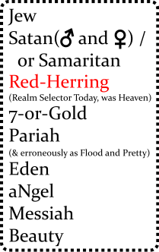The Jews are so profitable with their system and are so protected are they by their desperates/reapers, they have become very secretive and spent much time highly refining the Bible. It has many devices and its behavior is audacious. The Bible is designed to be understood only by those that have supernatural safety. The audaciousness and graphicness can contain meanings that that are meant to be understood only to those that are well-removed from mortal feelings. A couple of things to know: The Bible is written revisionistically[2] to make newer rules apply throughout (backwritten), and the beginning of the Bible is packed with details.

## Hebrew Code

The Hebrew people use a code to share secrets with. It is hidden within ordinary language. The base meanings have very *absolute* definitions.

## The Secret of Heaven

The “Secret of Heaven” comes from before the Bible was written. The chance of understanding what the Bible is trying to convey absent of knowing the “Secret of Heaven” is very small. How the “Secret of Heaven” was formed is in part speculation. It is derived from my experience and my limited reading of *History of Egypt, Chaldea, Syria, Babylonia, and Assyria, Volume 3*[3].

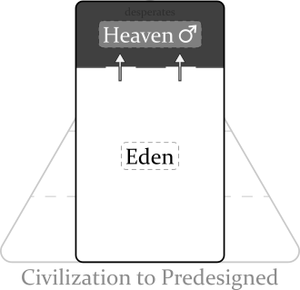The Secret of Heaven likely started because of an environmental threat. The area the system started in was the Tigris-Euphrates rivers of present-day Iraq around 4100 years ago. This is where Abraham came from (Gen 11:28-31). The area is surrounded by a lot of desert. Because surviving in the area was sometimes risky (droughts, distance from safe land…) it could create desperate men. People became afraid of the desperate men’s mood which became visceral[4]. Some people, doing better (the ancient Hebrew) saw an opportunity in this: reward/underwrite the desperate man and get his protection. Because living in the area was risky,the ancient Hebrew kept it to himself. The desperate man was very appreciative, a good friend to have, he ensured the ancient Hebrew was safe… did what he could for him. The ancient Hebrew kept using him to get better physical protection and kept rewarding him, he felt very *intelligent*. The desperate man being rewarded for his mood became more *visceral*. When the desperate man began to expect this support it he became very open-bounded, later he became narcisstic, it then built to the ability to create “good”[5] (for him—his supporter followed) ~~(good defined most by the ancient Hebrew)~~, and last an insularity can build where abnormal experiences are required for him to find things interesting. Both me prospered from this, a feeling of *free* began. A symbiotic bond formed that came to be known as the “Secret of Heaven”. It spread silently in the area. The great Jewish two system was born. It is about to **double** again…

## Bible Translation

G2: But something is wrong because Genesis 2 starts off with a female LORD. She (yes the Bible uses “he”) contends the creation of plants, formed man A DOUBLING… from Genesis 1 (an act, it is described later). To the quick: there is a problem with the all-male heaven, it became too obvious. Men reaping all the time also cause a lot of butting heads. So the females of some male-god, likely their wives, talked the serpent into getting the next rule. The sass of doing it better inspires the mortals. The idea they sold him on was: that they could take a desperate man’s wife and get her to enforce policy through him. The males were hardly getting it done, it was less risky. He readily agreed, such great selfishness. wo-man the concept is born, “against man”. (Reaping/Sowing explained: By nature a small part of man gathers food while his wife is with child; and a small part of woman tends to the child—these feelings make use feel good.) With such a long male rule the mortal women have become derperate and the **woman** LORD (who is just fine) hears them. Adam, a sprouting male god, is controlable. G3: The reign changes to the lower gods, who are told by the serpent (someone powerful) that eating from the tree of g&e the will “be like god”, that the partaking is “desireable for gaining wisdom”. They sin, got above nature (“afraid because I was naked”). The woman LORD chews them out; bizarro-world talk: congratulates them, the serpent is to be above everybody, the enmity between the serpent and the woman LORD really means that they are good friends, the lower woman god (Eve) will rule over her husband, and the man will represent us (kind of had to as the male gods generally think that this would fail to work), and Adam in his naiveness will be kept from returning to Eden.

**Genesis 1** *(Primary, Male, Reap)* Except for Genesis 1, the Bible is the beginning of the female side of the story (the story of male sacrifices… I’ll get to that). Originally heaven was a all-male institution that lasted a long time and Genesis 1 covers it all, brusquely. To the Hebrews, men by *taking*, for themselves, create good. A desperate-man/reaper took so much that the Hebrews refer to him as a “God”, “In the beginning *God* created the **heavens** and the **earth**” (Gen 1:1 NIV). Heaven was such an attraction more “good and evil”[6] was done: day/night, water/sky, land/sea, sun/moon, **man/nature**.

**Genesis 2** *(Secondary, Female, Sow)* First LORD. There is a common thread the Hebrews have developed through their history, when in trouble… time to double. They doubled (the predesigned system) because heaven became too obvious (with it being only male). So they started creating female lords with their ideas. The female lord here has decided to be the big-heads and create the policy while the just-starting people will enact the policy. “By the **seventh** day God had finished the work… so on the **seventh** day he rested from all his work.” (Gen 2:2). Adam and Eve created to enact the policy.[7]

**Genesis 3** *(Primary, Male, Reap)* *Eve, lulling Adam in, likes the idea of godhood. The serpent (just a man that has got to reap good) likes heaven so much he teases it to Eve “Did God really say, ‘You must not eat from any tree [referring to the tree of good and evil] in the garden’?” (Gen 3:1). Eve submits because reaping/taking gets people things, is attactive, “pleasing to the eye, and also desirable for **gaining wisdom**”. “Gaining wisdom” is (hu)man over nature, intellect or **visceralness**, safety solely by thinking (with the predesigned system)—a luxury for any animal. The reaping renews again when Eve then Adam partake of the fruit. Adam, now a god, shuns the natural, “I was afraid because I was naked”. Also, God adds a rule to protect heaven: gods are to be prevented from returning to Eden, “[A god] must not be allowed to reach out his hand and take also from the tree of life and eat, and live forever” (Gen 3:22)… protected by “cherubim and flaming swords” (serious male and female gods, defenders of heaven [sons and daughters later]).[8]

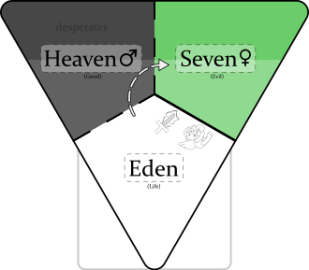**Genesis 4** *(Secondary, Female, Sow)* Some people have created a female god. Eve is the “LORD” here. Cain, Abel, and Seth are probably associates of Eve rather than her kin (kin usually get heavenly inclusion). Cain and Abel try to bribe Eve with “fruits” and “fat-portions” so that they can get to heaven (fat-portions probably wins because it is something other than the fruit like of the tree of good and evil). “Do what is right (3:7)” means to win, and “sin is crouching at your door” means to be wary of nature, “you must rule over it”. The line that “Cain attacked his brother Abel and killed him” is a fooling, a trick. It says that those with Eve/LORD will emphasize the later definition (e.g. “brothers keeper”)[9]. She too curses her male subjects (doubles the action… takes out the cursing) and still gets to “save” them *from Eden* (Gen 3:14-19). She also gives Cain protection, “… anyone who kills Cain will suffer vengeance **seven** times over”. Cain followed the directive where the god before put “cherubim and a flaming sword” and went around to the “east of Eden” (to the new heaven on the right). Lamech doubles the seven because he sees the trick, but something happened before:

**Genesis 5** *(Some Rule Eden, Generally Female Policy)*: A time span of ten male rulers from Adam to Noah is defined. ~~The “E” is kept so silent that the reapers accept ENOSH as leader?!~~ When the females get their era back they put a reaper god there to rule… within female policy. Two more eras happen (Mahalalel and Jared) then Enoch rules in another male era (even more Edenish) and the reapers figure it out, “God took him [Enoch] away (Gen 5:25).” An Eden ruler Methuselah rules the female era, then the reapers put in a female-appointed god (Lamech). Then Noah comes, the avenging angel. Lamech proclaims that Noah is to restore god rule that Adam’s weak, female appointed rule, lost, “[Noah] will comfort us in the labor and painful toil of our hands caused by the ground the LORD has cursed (references Gen 3:17).”

**Genesis 6** *(She Said but a dual-power to restore heaven)*: Attack on Eden begins. God pronounces a dual-power, “a hundred and twenty years.” The “sons of God” (female leaders) sucked up the pride in their own god-ness and mated with the “daughters of humans” (desperate men, angels). This created Nephilim—people that are physical giants, knowing little borders, people to be feared—to create heaven again. The Lord (a female god here) is upset because civilization is co-operative and thoughtful (“wickedness… [and] evil” Gen 6:5) and wants to restore the gods to power. She uses Eden’s name (3,5,6) to set-up the exercising of god power, “The ark is to be *three* hundred cubits long, *fifty* cubits wide and *thirty* cubits high. (Gen 6:15).

1. I refrain from calling the Judeo-Christian system a religion because the common definition of religion usually involves spirituality with an ethereal god or gods.
2. * [Wiktionary](https://en.wiktionary.org/wiki/revisionistic)

  
3. [History of Egypt, Chaldea, Syria, Babylonia, and Assyria, Vol. 3](https://www.gutenberg.org/files/17323/17323-h/17323-h.htm). On Librivox [Part 5](https://librivox.org/history-of-egypt-chaldea-syria-babylonia-and-assyria-vol-3-by-gaston-maspero/) in Volume 3 tells the original flood story.
4. I am using the definition from *Merriam Webster*: dealing with crude or elemental emotions, EARTHY; and from *The American Heritage® Dictionary of the English Language, 5th Edition*. Being or arising from impulse or sudden emotion rather than from thought or deliberation.
5. The Bible defines this as the “knowledge of good and evil” (Genesis 2:9). Originally it was only creating good, getting to choose what to support/favor (particularly people). Some may refer to it as divining: Merriam-Webster of it says, “of, relating to, or proceeding directly from God or a god”.
6. Already there is some revisionistic writing here (backwritting). Heaven/earth, day/night… are defined by the Hebrews as creating “good and evil” (Gen 2:9). This is a befuddlement, orginally only “good” was created. Evil came later when people started creating evil to get inclusion.
7. Key words: **Eden** (2:8), LORD (yes they do keep the pronoun he), and naked (“they felt no shame”).
8. Serpent is another term that is backwritten—the nine has yet to exist… an organizer of the flood. “Good and evil” is part of the great two system. The enmity is created by the Hebrews (3:15) is more backwriting; because both male and female are rewarded seperately for such a long time, they created friction between man and women (who lack knowing of heaven). The Hebrews to keep prosperous the using of naive people, refer to the people of Eden almost silently. Key words: dust, dust, dust (14, 19).
9. Using a Hebrew flood number/letter in the second term do get their angels somewhat excited… again defferential.