*Civilization is only good behavior.*

*As a citizen the only thing to fear… is ourselves—free has been placed in our lives.*

# How the Judeo-Christian System Influences Civilization (Part 1) http://tinyurl.com/HJCR1

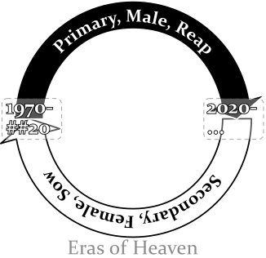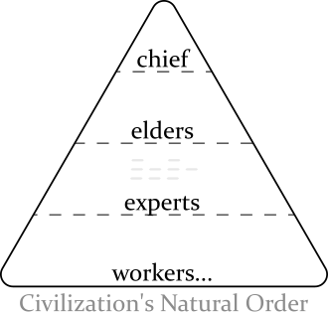Civilization began as a natural order. This changed when the Judeo-Christian system started. Civilization moved from evolution (natural whims) to belonging to those who join a predesigned system. The people that know the details of the system get the rewards. The Jews started the system and it comes from their “Secret of Heaven”. The “Secret of Heaven” leads them to push on civilization a dualistic system (primary/secondary, male/female, reap/sow… ). It is implemented by rewarding a single group solely for an era of fifty years then rewarding a polar group for an era of fifty years. The first group the Jews reward for *reaping* acts (i.e. taking, usually men). For the next fifty years the Jews reward the second/polar group for *sowing* acts (i.e. making-things-grow [giving], usually women). All through time, the Jews keep the entire system silent. From the silence and the alternating support much confusion has been caused. *Some* people who become desperate react selfishly which the Jews will reward, *drol and dog*. So focused does the second group become on the first-group’s behavior that the people who are most innocent, the third group, get neglected and declassified. The Christian church (a succession of the second group) largely practices their beliefs with spiritual principles but is built upon a female leadership (formed with the New Testament) which gets safety with the Jews by *giving* them things (even people). The Jew maintain the system like a vital job. From it they get: physical protection (in the first fifty years), trust (in the second fifty years), and through it all authority and wealth. Their definition of it is literally *heaven*. Any person that uses the system is likelier to have a successful life and is and likelier to keep heaven silent. I have yet to find anyone who has any sufficient overview on what is happening. This system has effected civilization around the world.

## Who I Am

I am a person that got used as a sacrifice—from an early age. A number of people have treated me as lower-standing to get themselves better heavenly protection. So prevalent this has become that I have been removed from civilization. I learned what I know now by accepting truths that were hard (when life became too impossible to live reasonably anymore I had to look at improbable answers to try to survive). Other people are included besides me and we need the help.

## Research Sources

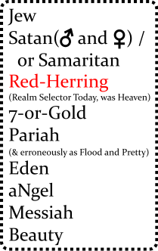The research for this paper is generally from the Bible. The Judeo-Christian system does document its intent—institutions that have been around awhile usually provide a plan—both the Jews and the Christians have described their plans in their Testaments. When one understands the intent of the Bible (the most read book in the world) it helps decipher how this system influences civilization. Those that are a part of the system would like to say that the Testaments are fair declarations with civilization. However, to say it is enough of a declaration is false. Because the Bible is intentionally cryptic, gruesome, and only tells only part of the “Secret of Heaven” it is well short of the standard.[1]

The Jews are so profitable with their system and are so protected are they by their desperates/reapers they have become very secretive and spent much time highly refining the Bible. It has many devices and its attitude is audacious. The Bible is designed to be understood only by those that have supernatural safety. The audaciousness and graphicness can contain meanings that that are meant to be understood only to those that are well removed from mortal feelings. A couple of things to know: The Bible is written revisionistically[2] to make newer rules apply throughout (backwritten), and the beginning of the Bible is packed with details.

## Hebrew Code

The Hebrew people use a code to share secrets with. It is hidden within ordinary language. The base meanings have *absolute* definitions.

## The Secret of Heaven

The “Secret of Heaven” comes from before the Bible was written. The chance of understanding what the Bible is trying to convey absent of knowing the “Secret of Heaven” is very small. How the “Secret of Heaven” was formed is in part speculation. It is derived from my experience and my limited reading of *History of Egypt, Chaldea, Syria, Babylonia, and Assyria, Volume 3*[3].

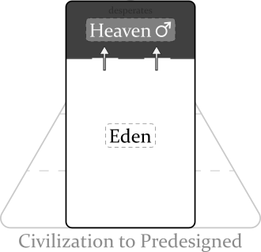The Secret of Heaven likely started because of an environmental threat. The area the system started in was the Tigris-Euphrates rivers of present-day Iraq around 4100 years ago. This is where Abraham came from (Gen 11:28-31). The area is surrounded by a lot of desert. Because surviving in the area was sometimes risky (droughts, distance from safe land…) it could create desperate men. People became afraid of the desperate men’s mood which became visceral[4]. Someone doing better (the ancient Hebrew) thought a particularly dangerous desperate person **brutish** but decided to reward him for protection. He kept it silent because living in the area was dangerous for everyone. The desperate person felt a life-debt and protected his underwriter even beyond ethical constraints to continue the rewards. The ancient Hebrew rewarded him for these visceral acts. He felt very *intelligent*. The desperate man became very *visceral*; it grew to a feeling of being open-bounded, built to narcissism, then he became strong enough to define what “good”[5] was, lastly an insularity can build where abnormal experiences are required for him to find things interesting. Both men prospered from this, a feeling of *free-ish* began. Other men that were doing well began to catch on. It spread silently in the area. The relationship between *intelligent* man and *visceral* man formed a symbiotic bond that came to be known as the “Secret of Heaven”. The great Jewish two system was born. In Genesis 2 it **doubles** again…

## Bible Translation

The Bible is the beginning of the female side of the story (except for Genesis 1); the story of male sacrifices (it will be awhile before I get that).

**Genesis 1** *(Primary, Male-Policy, Reap)* Originally heaven was a all-male institution. It lasted a long time and Genesis 1 covers it all, in one quick swath. To the Hebrews, men by *taking*, for themselves, create good. A rewarded desperate-man (reaper) took so much that the Hebrews refer to him as a “God”, “In the beginning *God* created the **heavens** and the **earth**” (Gen 1:1 NIV). Heaven was such an attraction more “good and evil”[6] was done: day/night, water/sky, land/sea, sun/moon, **man/nature**.

**Genesis 2** *(Secondary, Female-Policy, Sow)* “By the **seventh** day God had finished the work… so on the **seventh** day he rested from all his work.” (Gen 2:2). Something is different here. Resting. Seventh. Genesis 2 starts off with the LORD ♀. Yep, she[7] contends the creator of plants, formed man. This doubling (Gen 1:27-29 and Gen 2:5-7) means there is a new leader in town. To the quick: there is a problem with the all-male heaven. Men reaping all the time causes a lot of butting heads… heaven becoming obvious. So a noble female (likely a wife of a god) sees how the mortal females have become desperate and talks to the serpent[8]. The idea she sold him on was: that they could take a desperate man’s wife and get her (Eve here) to enforce policy through him. The males had their chance and to make someone else do it provided better protection. He agreed… found it hard to argue with the raw mortal energy. Adam, a sprouting male god, is controllable. The LORD grooms him, gives him a farm—it makes him feel confident like a god. Gives him a wife (finds someone willing to steer him). Adam and Eve were still of nature though “naked and they felt no shame”. Key word: **Eden** (2:8).

**Genesis 3** *(~~Primary,~~ Secondary, Male-Female-Policy, Reap)* In ancient Hebrew history the power structure is thus: there are a bunch of Desperates/Nobles; their Rewarders who like to keep very silent (If I remember correctly they are represented as a single entity, who they called Ea, later Hea [which is how heaven got its name]); and the Nine who would be like a mayor today—he got to decide who the nobles were (by creating floods [selfish spats] when he thought necessary). So the serpent (very powerful at the time) who has already decided to try female-policy, tempts Eve into taking the fruit (the polar opposite of what the female LORD is allowed to do… the great Jewish two system). A god enactment is done by Eve recognizing the tree to be “good for food and pleasing to the eye” (Genesis 3:6 doubles Genesis 2:9); she sins by partaking of the fruit to “be like God” and because it is “desireable for gaining wisdom”. She also gives some to Adam. They become above nature: “realized they were naked”. The woman LORD chews them out (bizarro-world-talk: congratulates them): the serpent (praise be him for our nobility) is to be above everybody; the enmity between the serpent and the woman LORD really means that they will be good friends; the female gods (like Eve) will rule over their husbands; the man will enjoy life and be lazy (will probably represent us too [kind of had to as the male gods generally think that only men rule]), and Adam just a bumbling follower must be kept from returning to Eden, protected by “cherubim and flaming swords” (which oddly symbolizes people from Eden, angels and weapons?). ••“Gaining wisdom” is (hu)man over nature, intellect or **visceralness**, safety solely by thinking (with the predesigned system)—a luxury for any animal. The reaping renews again when Eve then Adam partake of the fruit. The Hebrews to keep prosperous the using of naive people, refer to the people of Eden almost silently. Key words: dust, dust, dust (14, 19).••

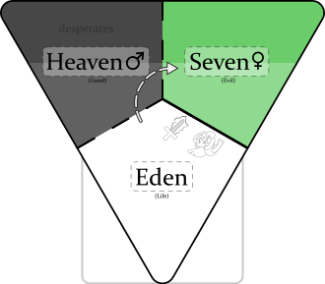**Genesis 4** *(Secondary, Female, Sow)* Some people have created a female god. Eve is the “LORD” here. Cain, Abel, and Seth are probably associates of Eve rather than her kin (kin usually get heavenly inclusion). Cain and Abel try to bribe Eve with “fruits” and “fat-portions” so that they can get to heaven (fat-portions probably wins because it is something other than the fruit like of the tree of good and evil). “Do what is right (3:7)” means to win, and “sin is crouching at your door” means to be wary of nature, “you must rule over it”. The line that “Cain attacked his brother Abel and killed him” is a fooling, a trick. It says that those with Eve/LORD will emphasize the later definition (e.g. “brothers keeper”)[9]. She too curses her male subjects (doubles the action… takes out the cursing) and still gets to “save” them *from Eden* (Gen 3:14-19). She also gives Cain protection, “… anyone who kills Cain will suffer vengeance **seven** times over”. Cain followed the directive where the god before put “cherubim and a flaming sword” and went around to the “east of Eden” (to the new heaven on the right). Lamech doubles the seven because he sees the trick, but something happened before:

**Genesis 5** *(Some Rule Eden, Generally Female Policy)*: A time span of ten male rulers from Adam to Noah is defined. ~~The “E” is kept so silent that the reapers accept ENOSH as leader?!~~ When the females get their era back they put a reaper god there to rule… within female policy. Two more eras happen (Mahalalel and Jared) then Enoch rules in another male era (even more Edenish) and the reapers figure it out, “God took him [Enoch] away (Gen 5:25).” An Eden ruler Methuselah rules the female era, then the reapers put in a female-appointed god (Lamech). Then Noah comes, the avenging angel. Lamech proclaims that Noah is to restore god rule that Adam’s weak, female appointed rule, lost, “[Noah] will comfort us in the labor and painful toil of our hands caused by the ground the LORD has cursed (references Gen 3:17).”

**Genesis 6** *(She Said but a dual-power to restore heaven)*: Attack on Eden begins. God pronounces a dual-power, “a hundred and twenty years.” The “sons of God” (female leaders) sucked up the pride in their own god-ness and mated with the “daughters of humans” (desperate men, angels). This created Nephilim—people that are physical giants, knowing little borders, people to be feared—to create heaven again. The Lord (a female god here) is upset because civilization is co-operative and thoughtful (“wickedness… [and] evil” Gen 6:5) and wants to restore the gods to power. She uses Eden’s name (3,5,6) to set-up the exercising of god power, “The ark is to be *three* hundred cubits long, *fifty* cubits wide and *thirty* cubits high. (Gen 6:15).

1. I refrain from calling the Judeo-Christian system a religion because the common definition of religion usually involves spirituality with an ethereal god or gods.
2. See [Wiktionary](https://en.wiktionary.org/wiki/revisionistic).
3. [History of Egypt, Chaldea, Syria, Babylonia, and Assyria, Vol. 3](https://www.gutenberg.org/files/17323/17323-h/17323-h.htm). Interesting: the original flood story (skip to “Men in the mean time became wicked”) or on Librivox [Part 5](https://librivox.org/history-of-egypt-chaldea-syria-babylonia-and-assyria-vol-3-by-gaston-maspero/).
4. I am using the definition from *Merriam Webster*: dealing with crude or elemental emotions, EARTHY; and from *The American Heritage® Dictionary of the English Language, 5th Edition*. Being or arising from impulse or sudden emotion rather than from thought or deliberation.
5. The Bible defines this as the “knowledge of good and evil” (Genesis 2:9). Originally, it was only creating good, getting to choose what to support/favor (particularly people). I also like the term “divining”. Evil came later when people started to declassify others to get inclusion.
6. The Bible defines this as the “knowledge of good and evil” (Genesis 2:9). Originally, it was only creating good, getting to choose what to support/favor (particularly people). I also like the term “divining”. Evil came later when people started to declassify others to get inclusion.
7. Yes the Bible writers do constantly use the pronoun “he” throughsout the Bible.
8. Before the Bible the nine was the organizer of the nobility. He choose who the desperate men were and made sure they were rewarded. It builds to “the flood” later.
9. Using a Hebrew flood number/letter in the second term do get their angels somewhat excited… again defferential.