*Civilization is only good behavior—it is all we judge by.*

*As a citizen consider oneself spellbound—free is available in life.*

# How the Judeo-Christian System Influences Civilization (Part 1) http://tinyurl.com/HJCR1

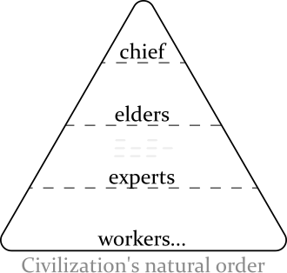Civilization began as a natural order. This all changed when the Judeo-Christian system started. Civilization moved from belonging to evolution (natural whims) to belonging to people who join a predesigned system—those that know the details of the system get the rewards. It was started by the Jews and comes from their “Secret of Heaven”. The “Secret of Heaven” leads them to push a dualistic system on civilization (male and female, good and evil, rich and poor…). The system is implemented by rewarding a single side solely for an era of fifty years then rewarding a polar side for an era of fifty years. The Jews keep all of this silent. The silence and the alternating support causes much confusion and encourages many selfish acts (particularly by the less-secure second side that gets intentionally incited). The Jews create the first side by rewarding selfish acts (usually men, a “flood”)—from this the Jews get protection. After fifty years the Jews create a second side by rewarding those who make things “look good” (resting acts [Gen 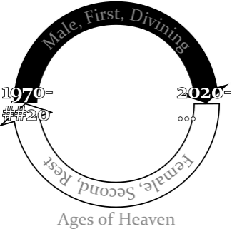2:2], usually women) to hide the flood. The Jew maintain the system like a vital job. From it they get authority and advantageous lives. Their definition of it is literally *heaven*. Any person that uses the system is likelier to have a successful life and is and likelier to keep heaven silent. The third side, the people with little knowledge of heaven, get treated by the first and second side often as inferior. The Christian church (a succession of the second side) though largely practicing their beliefs with spiritual principles, is built upon a female leadership (formed with the New Testament) that gets inclusion from the Jews by providing people as sacrifices. I have yet to find anyone who has any sufficient overview on what is happening. This system has existed for 4100 years.

## Why I May Be Listened Of

I am one of the people that got used as a sacrifice. From a very early age I have been treated disregardingly by some people so that they may protect themselves. So prevalent this became as to forcibly remove me from civilization. I learned what I know now by accepting truths that were hard (when life became too impossible to live reasonably anymore I had to look at improbable answers to try and survive). Please try to consider what I write here seriously.

## Research Source

I refrain from calling the Judeo-Christian system a religion because a common definition of religion usually involves spirituality with ethereal god or gods.

The Judeo-Christian system does discuss its plans (institutions that have been around awhile usually declare their intent). Both the Jews and the Christians have documented their plans in their Testaments. The Bible’s publication, the most read book in the world, makes the Judeo-Christian system feel it has been divulgent with civilization. The details found in the Bible (particular pieces of a large puzzle) once put together do help decipher how this system influences modern civilization. However, to say it is a an open declaration goes too far. Because the Bible is intentionally repellent (cryptic and gruesome), and only tells only part of the “Secret of Heaven” it falls short of that standard.

## Hebrew Code

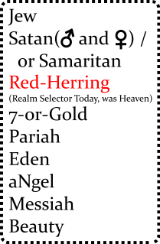The Hebrews use a code to share secrets with. It is hidden within ordinary language. The base meanings have very *absolute* definitions.

## The Secret of Heaven

*The “Secret of Heaven” comes from before the Bible was written. The possibility of understanding what the Bible is trying to say absent of knowing the secret is very small. Though the “Secret of Heaven” is a real tool, how it formed is speculation—it is derived from my limited reading of: History of Egypt, Chaldea, Syria, Babylonia, and Assyria.*

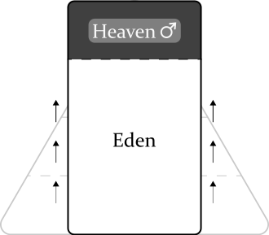Judaism started because of an environmental threat. The area the system started in was by the Tigris-Euphrates Rivers of present-day Iraq around 4100 years ago. This is where Abraham came from (Gen 11:28-31). The area is surrounded by a lot of desert. Because surviving in the area was sometimes risky (droughts, distance from safe land…) it could create desperate men. Some desperate men became dangerous. A desperate man was eventually rewarded for protection… silently. The rewarder (an ancestor of the Hebrew) highly valued the protection; he took care of the desperate man well and became very *intelligent*. The desperate man was able to rely on the support; he became selfish and *visceral*. The rewarding grew over time. A desperate man being contantly rewarded gives him a feeling of open-boundedness, builds to narcicism and then being able to force what is good (divining[^definition_divine]). Later an insularity might build where abnormal experiences are required for him to find things interesting. The protection gathered by the desperate man began a feeling of getting *free*. The relationship between the Hebrew and the desperate person is a symbiotic bond that started the “Secret of Heaven”. The feeling of free kept building and encouraged others to reward likewise and the “Secret of Heaven” spread. Later, an era for desperate women was added. The great Jewish two system was born.

* high and low, cerebral and visceral

## Bible Translation

*The Bible directs the Judeo-Christian system. The Jews love their system so much (so protected are they by their desperates/narcissists) they have become very secretive and spent much time highly refining their Bible. It is audacious and has many devices. The Bible is designed to be understood only by those that have supernatural safety—its graphicness can contain meanings that can only be understood to those that are well-removed from life (i.e. more removed from mortal psychological tradegies, [eternal life]). A couple of things to know: The Bible is written revisionistically*[1] *(backwritten) to make newer rules apply throughout; and the beginning of the Bible is packed with details.* fair

**Genesis 1** The Bible starts with a desperate man being so rewarded that the Jews refer to him as a “God”, “In the beginning *God* created the heavens and the earth” (Gen 1:1 NIV). *When the Hebrews said to “Fear God” this is what they meant.* “Heaven on earth” was such an attraction more *divining*[2] was done : day/night, water/sky, land/sea, sun/moon, man/nature. • *He Said, Business/Divining/Flooding*

**Genesis 2** An era of rest: “By the **seventh** day God had finished the work… so on the **seventh** day he rested” (Gen 2:2). Adam created and Eve created. *• She Said, Rest/Golden-Age—The names of Adam and Eve are the first examples of the Bible being revisionistic (backwriting). Adam should be Hdm and Eve just Ee as these definitions have yet to be defined.•*

**Genesis 3** The serpent tempts Eve with divining, “Did God really say, ‘You must not eat from any tree [referring to the tree of good and evil] in the garden’?” (Gen 3:1). Eve submits because it was “pleasing to the eye, and also desirable for **gaining wisdom**”. “Gaining wisdom”” is more properly defined as “getting protection”, i.e answers/safety from a prescribed system rather than from natural experience. This has an effect on nakedness where naturalness begins to feel foreign (Gen 3:11). She gives the fruit to Adam but *only Adam* becomes a god, “The man has now become like one of us, knowing good and evil”. The cursing that is done by God onto the serpent, Eve, and Adam is FUD/a-smokescreen to disguise their ascension. A rule is created: gods being gods will be prevented from returning to Eden, “He must not be allowed to reach out his hand and take also from the tree of life and eat, and live forever” (Gen 3:22). The political left is born (this is different than it actually is today, though described the same [I’ll explain later]), “So the LORD God banished *him* from the Garden of Eden… [and] he placed on the east side of the Garden of Eden cherubim and a flaming sword flashing back and forth to guard the way to the tree of life” (Gen 3:24).

* *(He Said, Business, Partisanship, ~~Securing Heaven~~)*
* • The serpent, Satan, Moses are historically organizers of the flood. Is this an antagonization directed at females? Glory at their included male station? I have seen females that want to flood too. My feeling here is that Eve is curious she too wants to “be like God” but is prevented from being one because they think “only men can be diviners”. Later in history the feeling become anger from the want of inclusion.•*

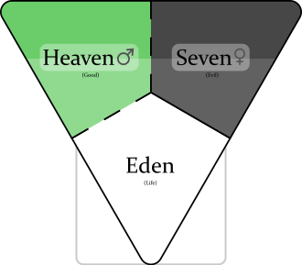**Genesis 4** *(She Said, Rest/Covering-Up/Getting-Heaven-Wrong, Creating Family—by getting some “saved”)*: Eve is the god here and Cain, Abel, and Seth are probably associates of Eve rather than her kin (kin usually get heavenly inclusion). Cain and Abel try to bribe Eve with “fruits” and “fat-portions” so that they can get to heaven. Eve from Eden (Gen 3:23) tries to do heaven like she saw the gods do before her. She too curses her male subjects to “save” them (Gen 3:14-19). She also gives Cain protection, “… anyone who kills Cain will suffer vengeance *seven* times over.” Cain followed the directive where the god before put “cherubim and a flaming sword” and went to the “Land of Nod, east of Eden” (to the new heaven on the right) (So nonchalantly a new heaven is created, the history appears to say "Everything is OK, a new heaven is fine, little deal---looks like the Jews are trying to make their history look polished.).

**Genesis 5** *(Yokel Said, Mortal Rule)*: A time span of ten male rulers from Adam to Noah is defined. God rule decreases as yokel rule becomes more prevalent. Lamech proclaims that Noah is to restore god rule that Adam’s (weak!?) rule lost, “[Noah] will comfort us in the labor and painful toil of our hands caused by the ground the LORD has cursed (references Gen 3:17).”

**Genesis 6** *(She Said but a dual-power to restore heaven)*: God pronounces a dual-power, “a hundred and twenty years.” The “sons of God” (female leaders) sucked up the pride in their own god-ness and mated with the “daughters of humans” (desperate men, angels). This created Nephilim—people that are physical giants, knowing little borders, people to be feared—to create heaven again. The Lord (a female god here) is upset because civilization is co-operative and thoughtful (“wickedness… [and] evil” Gen 6:5) and wants to restore the gods to power. She uses Eden’s name (3,5,6) to set-up the exercising of god power, “The ark is to be *three* hundred cubits long, *fifty* cubits wide and *thirty* cubits high. (Gen 6:15).

**Genesis 7** *(He Said, Business, Partisanship)*: (The flood is rewarding, in synchronicity, a large number of *desperate* men to create "heaven on earth", partisanship, creating good and evil. [^flood].) The Lord found Noah “righteous” (godly) and he flooded the *earth*, put a*n*imals on the Ark, to restore the gods to power. More using Eden’s name for god power, “Noah was six hundred years old…”, etc.. ("The waters flooded the earth for a hundred and fifty days (Gen 6:24)" is used in modern times to denote yearly floods from to January 1 to May 31 (absent a leap year)).

* The serpent encouraged selfishness.
* The Jews try to make their history look planned here, but the truth is since the Jews keep heaven [the great Jewish two system] always silent, a progressive confusion begins early on the second side. The confusion has created a path for people that start near-sighted and ignorant of complicity but become desperate—a staging heaven to Judaism.
* Became eventually: The women are going to flood too and do it better.
* This directive (Gen 3:22) will develop to: that to become a god a person must do a sin that is unforgivable within civilization to get “saved”… it keeps them silent.
* [3]
* “friends (Job 2:11)”
* (narcisstic, desperate)
* it hides the flood
* the right: the enablers, the finger-waggers
* quotes as ” or ’ rather than ’ and ” ?!
* Verbatim Character in templates fix.
* favoring or divining?? divisive, partisian? ** Alt text ![](images/##_identification_birthdate-and-name.svg

## The Story of the Moral

*Where are the people who feel feel responsible for what is now a genocide?* First, any creature has evolved to think in only *one* reality. The great Jewish two system confuses the mind of those less safe. Second, since most people are ignorantly rewarded by the two system in the environment those that know anything are directed by the Jews (Angels?) to hate the Jews (get incited might be a better way to put it) rather than to look at themselves for their own complicity. The third side is often too confused (by the two system) and busy (repairing their lives) to try and assemble an accusation.

* If we fail to go through it together, evolve together, the revolutions continue. These Jobisms truly only help those that do them. Right: forcing their way in. **Socially necessary information** never again *cycle of poverty*.
* 50 years right has always thought that giving to left will reach satiation ([American Made](https://www.imdb.com/title/tt3532216/))
* Creating gods – He and She God competition, battle of the fatfaces, good for the people that are part of the battle.
* Vegetarian importance—odd to the new—respect for all life can get us to Eden again.
* complicit
* A desperate man being constantly rewarded builds in time an insularity where more abnormal feelings are required for him to find things interesting. And from this insularity his behavior begins to wear on civilization’s standards. He becomes so immobile that when the Hebrews say to “fear God”… this is what they mean.
* Turns out to be a selfish splitting by both sides of heaven.
* confuses

1. definition-revisionistic
2. I am using the definition of divining as: creating good (and consequence evil)… passionate about favoring things (particularly people). The Bible talks about this early in Genesis 2:9. Merriam-Webster of it says: of, relating to, or proceeding directly from God or a god. : [Wiktionary](https://en.wiktionary.org/wiki/revisionistic)
3. For a more straight-forward description on what the flood is read the [History of Egypt, Chaldæa, Syria, Babylonia, and Assyria, Volume 3](https://www.gutenberg.org/ebooks/17323) (skip to “Men in the mean time became wicked”); it is also available on [LibriVox](https://librivox.org/history-of-egypt-chaldea-syria-babylonia-and-assyria-vol-3-by-gaston-maspero/) on Section 5. I also put backups [here](https://1drv.ms/f/s!AvLA1bEaFFRxgtMFQBrd6Xcw9tteqA?e=qo9kGy)