Introduction to Computer Graphics, Exercise 2
Spring 2026, Reichman University
Eden Tsarfaty – 208847467

Question 1 (30 pts) – Image Processing and Affine Spaces
  - We’ll compute the interpolation on the $x$ axis:
$C_{cd}=\left\|\frac{0.4}{1-0}\right\|\left(\begin{matrix}0 \\ 255 \\ 0\end{matrix}\right)+\left(1-\left\|\frac{0.4}{1-0}\right\|\right)\left(\begin{matrix}255 \\ 165 \\ 0\end{matrix}\right)=\left(\begin{matrix}153 \\ 201 \\ 0\end{matrix}\right)$ and$C_{ab}=\left\|\frac{0.4}{1-0}\right\|\left(\begin{matrix}0 \\ 0 \\ 255\end{matrix}\right)+\left(1-\left\|\frac{0.4}{1-0}\right\|\right)\left(\begin{matrix}255 \\ 0 \\ 255\end{matrix}\right)=\left(\begin{matrix}153 \\ 0 \\ 255\end{matrix}\right)$.
We’ll follow with the interpolation on the $y$ axis and get:
$C_{e}=\left\|\frac{0.85-0}{1-0}\right\|\left(\begin{matrix}153 \\ 201 \\ 0\end{matrix}\right)+\left\|\frac{1-0.85}{1-0}\right\|\left(\begin{matrix}153 \\ 0 \\ 255\end{matrix}\right)=\left(\begin{matrix}153 \\ 170.85 \\ 38.25\end{matrix}\right)$.
Rounding up to the nearest decimal number we get $\boxed{C_{e}=\left(\begin{matrix}153 \\ 171 \\ 38\end{matrix}\right)}$.
  - We’ll first assert that our shape represents a tilted square (or parallelogram). Since $a$ is sitting on the origin, we can do this by measuring that adding $ad$ and $ab$, which guarantees $dc$ and $cb$ are of the same length. Indeed $ab+ad=\left(\begin{matrix}-1 \\ 2\end{matrix}\right)+\left(\begin{matrix}2 \\ 1\end{matrix}\right)=\left(\begin{matrix}1 \\ 3\end{matrix}\right)$.
Next we look at how much the projection of $ae$ leans in the direction of $ad:\frac{ae⋅ad}{{\left\|ad\right\|}^{2}}=\frac{0⋅\left(-1\right)+2⋅2}{{(-1)}^{2}+2^{2}}=0.8$, and in the direction of $ab: \frac{ae⋅ab}{{\left\|ab\right\|}^{2}}=\frac{0⋅2+2⋅1}{2^{2}+1^{2}}=0.4$.
Let $g,h$ be points such that $g=d+0.4\left(\begin{matrix}2 \\ 1\end{matrix}\right)=\left(\begin{matrix}-0.2 \\ 2.4\end{matrix}\right),$ $h=a+0.4\left(\begin{matrix}2 \\ 1\end{matrix}\right)=\left(\begin{matrix}0.8 \\ 0.4\end{matrix}\right)$.
We now use linear interpolation and get:
$f\left(g\right)=0.6⋅f\left(d\right)+0.4⋅f\left(c\right)=0.6⋅8+0.4⋅21=13.2$
$f\left(h\right)=0.6⋅f\left(a\right)+0.4⋅f\left(b\right)=0.6⋅3+0.4⋅1=2.2$
Therefore:
$f\left(e\right)=0.8⋅f\left(g\right)+0.2⋅f\left(h\right)=0.8⋅13.2+0.2⋅2.2=11⟹\boxed{f\left(e\right)=11}$.

    - Assuming we use the standard basis (Piazza @45) we just go from the origin 2 squares down and 1 to the left:
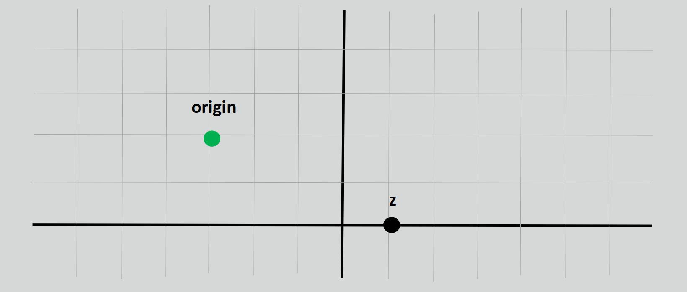
    - Likewise, we just count from the origin, how many points point $z$ is down and to the right
$\boxed{z=\left(4,-2\right)}$.

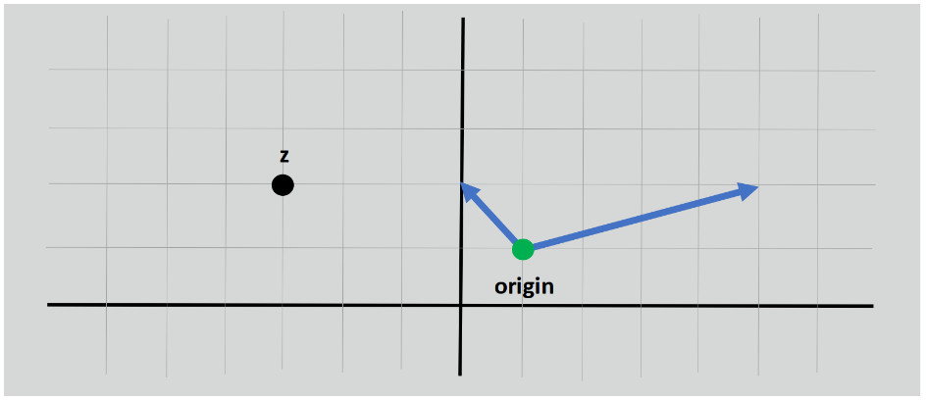
    - To draw the affine point $\left(-4,-0.5\right)$ on the global coordinate system we need to use our new base vectors and origin:
$p=\left(1,1\right)-4\left(-1,1\right)-0.5\left(4,1\right)=\boxed{\left(3,-3.5\right)}$.
As the grid does not cover the entire coordinate system we place the point where it would be in the original Euclidean system – 3 squares to the right and 3.5 squares down from the black axes convergence.
    - $z$ sits on the on coordinate $(-3,2)$. To find the affine coordinates we compute:
$z=\left(\begin{matrix}-3 \\ 2\end{matrix}\right)=\left(\begin{matrix}1 \\ 1\end{matrix}\right)+t\left(\begin{matrix}-1 \\ 1\end{matrix}\right)+u\left(\begin{matrix}4 \\ 1\end{matrix}\right)⟹\left\{\begin{aligned}-3=1-t+4u \\ 2=1+t+u\end{aligned}\right.$
By adding the second equation onto the first we get $-1=2+5u⟹u=-0.6$
Solving for $t$ we get $t=1.6$. Consequently, $\boxed{z=\left(1.6,-0.6\right)}$.
Question 2 (70 pts) – Geometry and Modeling

    - Let us define $p=\left(1,4,-3\right)$, $u=\left(2,2,2\right)$ and $\vec{v}=a-p=\left(3,-5,7\right)$. We’ll first compute the projection of $\vec{v}$ on $u$. $${\text{Proj}}_{u} \vec{v}=\frac{\vec{v}⋅u}{{\left\|u\right\|}^{2}}u=\frac{3⋅2-5⋅2+7⋅2}{2^{2}+2^{2}+2^{2}}\left(\begin{matrix}2 \\ 2 \\ 2\end{matrix}\right)=\left(\begin{matrix}1\frac{2}{3} \\ 1\frac{2}{3} \\ 1\frac{2}{3}\end{matrix}\right)$$Thus, the projection of point $a$ on $l$ is $p^{'}=p+{Proj}_{t} \vec{v}=\left(\begin{matrix}1+1\frac{2}{3} \\ 4+1\frac{2}{3} \\ -3+1\frac{2}{3}\end{matrix}\right)=\boxed{\left(\begin{matrix}2\frac{2}{3} \\ 5\frac{2}{3} \\ -1\frac{1}{3}\end{matrix}\right)}$.
Let $\vec{w}=a-p^{'}=\left(\begin{matrix}1\frac{1}{3} \\ -6\frac{2}{3} \\ 5\frac{1}{3}\end{matrix}\right)$. We compute the magnitude of $\vec{w}$ to find the distance: $\left\|\vec{w}\right\|=\sqrt{{\left(\frac{4}{3}\right)}^{2}+{\left(-\frac{20}{3}\right)}^{2}+{\left(\frac{16}{3}\right)}^{2}}=\boxed{\frac{4\sqrt{42}}{3}≈8.64}$.
    - Let us examine the case where $y=y_{1}=-3$. We equate $l=l_{2}:$$$\left(\begin{matrix}1+2t \\ 4+2t \\ -3+2t\end{matrix}\right)=\left(\begin{matrix}2 \\ 3-3s \\ 2-3s\end{matrix}\right)⟹\left\{\begin{aligned}1+2t=2 \\ 4+2t=3-3s \\ -3+2t=2-3s\end{aligned}\right.$$Solving the first equation we get $t=0.5$, and plugging it to the second equation we get $s=-\frac{2}{3}$. Substituting $s$ and $t$ in the third equation we get $-2=0$. Due to the false equivalence, there is no intersection between the lines.
To calculate the distance between the lines, we consider the vector that is the normal to both lines, as the shortest distance is a vector that must be perpendicular to both lines.
We denote $w=\left(0,-3,-3\right)$ the vector of $l_{2}$. Using cross product we get:
$$w×u=\left(\begin{matrix}0 \\ -3 \\ -3\end{matrix}\right)×\left(\begin{matrix}2 \\ 2 \\ 2\end{matrix}\right)=\left|\begin{matrix}1 & 1 & 1 \\ 0 & -3 & -3 \\ 2 & 2 & 2\end{matrix}\right|=\left(\begin{matrix}\left(-3\right)⋅2-\left(-3\right)⋅2 \\ -\left(0⋅2+3⋅2\right) \\ 0⋅2-\left(-3\right)⋅2\end{matrix}\right)=\left(\begin{matrix}0 \\ -6 \\ 6\end{matrix}\right)$$And divided by the magnitude we get:
$$\vec{n}=\frac{w×u}{\left|w×u\right|}=\frac{1}{\sqrt{{\left(-6\right)}^{2}+6^{2}}}\left(\begin{matrix}0 \\ -6 \\ 6\end{matrix}\right)=\left(\begin{matrix}0 \\ -\frac{\sqrt{2}}{2} \\ \frac{\sqrt{2}}{2}\end{matrix}\right)$$We pick $p_{1}$ and $p_{2}$ to be the points given in the line equation $l_{1}$ and $l_{2}$ respectively. Then:
$p_{2}-p_{1}=\left(2-1,3-4,2-\left(-3\right)\right)=\left(1,-1,5\right)$.
Using projection we get $\left|\left(p_{2}-p_{1}\right)⋅\vec{n}\right|=1⋅0+\left(-1\right)⋅-\frac{\sqrt{2}}{2}+5⋅\frac{\sqrt{2}}{2}=\boxed{3\sqrt{2}}$.
To check with $y=y_{2}=2$ we do the same:
$$\left(\begin{matrix}1+2t \\ 4+2t \\ -3+2t\end{matrix}\right)=\left(\begin{matrix}2 \\ 3+2s \\ 2-3s\end{matrix}\right)⟹\left\{\begin{aligned}1+2t=2 \\ 4+2t=3+2s \\ -3+2t=2-3s\end{aligned}\right.$$We solve it and get $t=0.5, s=1$ using the first two equations. For the third one we get $-2=-1$. Again, we arrive at skewed lines. Define $w=\left(0,2,-3\right)$, then:
$$w×u=\left(\begin{matrix}0 \\ 2 \\ -3\end{matrix}\right)×\left(\begin{matrix}2 \\ 2 \\ 2\end{matrix}\right)=\left|\begin{matrix}1 & 1 & 1 \\ 0 & 2 & -3 \\ 2 & 2 & 2\end{matrix}\right|=\left(\begin{matrix}2⋅2-\left(-3\right)⋅2 \\ -\left(0⋅2+3⋅2\right) \\ 0⋅2-2⋅2\end{matrix}\right)=\left(\begin{matrix}10 \\ -6 \\ -4\end{matrix}\right)$$as well as $\vec{n}=\frac{w×u}{\left|w×u\right|}=\frac{1}{\sqrt{{10}^{2}+{\left(-6\right)}^{2}+{\left(-4\right)}^{2}}}\left(\begin{matrix}10 \\ -6 \\ -4\end{matrix}\right)=\left(\begin{matrix}\frac{5}{\sqrt{38}} \\ -\frac{3}{\sqrt{38}} \\ -\frac{2}{\sqrt{38}}\end{matrix}\right)$.
Using the same vector $p_{2}-p_{1}$ we get:
$$\left|\left(p_{2}-p_{1}\right)⋅\vec{n}\right|=\left|1⋅\frac{5}{\sqrt{38}}+\left(-1\right)⋅\left(-\frac{3}{\sqrt{38}}\right)+5⋅\left(-\frac{2}{\sqrt{38}}\right)\right|=\boxed{\frac{2}{\sqrt{38}}}$$

    - We recall that the normal vector to the plane can be extracted from the parametric representation of the plane. As $π_{1}:-x+4y+2z=1$ then $\vec{n}=\left(-1,4,2\right)$. Combined with the point we get $\boxed{l=\left(5,-5,1\right)+t\left(-1,4,2\right)}$.
    - Let us denote $q$ the closest point to $p$ which lies on the plane. The vector $p-q=t\vec{n}$ for some $t∈R$ since the shortest distance is obtained through a vector perpendicular to the plane.
As a result, we can define $q=\left(5-t,-5+4t,1+2t\right)$. We insert the point into the plane equation and get $π_{1}\left(q\right)=-\left(5-t\right)+4\left(-5+4t\right)+2\left(1+2t\right)-1=0⟹$$$t-5+16t-20+2+4t-1=0⟹21t=24⟹t=\frac{8}{7}$$That means that that the distance between $p$ and $q$ is $\left|\frac{8}{7}\left(-1,4,2\right)\right|=\sqrt{{\left(-\frac{8}{7}\right)}^{2}+{\left(\frac{32}{7}\right)}^{2}+{\left(\frac{16}{7}\right)}^{2}}=\frac{8\sqrt{21}}{7}$.
That distance is also the radius for a point that starts at point $p$. The resulting sphere equation is $\boxed{{\left(x-5\right)}^{2}+{\left(y+5\right)}^{2}+{\left(z-1\right)}^{2}=\frac{192}{7}}={\left(\frac{8\sqrt{21}}{7}\right)}^{2}$.
    - We substitute $t$ for the point $q$ and get $\boxed{q=\left(\frac{27}{7},-\frac{3}{7},\frac{23}{7}\right)}$.
    - The intersection line will be parallel to both lines (since it is within them), thus it will be perpendicular to normals to the planes. The normal to the plane $π_{2}:x+3y-4z=3$ is $\left(1,3,-4\right)$. Using cross product we get:
$$\left(1,3,-4\right)×\left(-1,4,2\right)=\left(\begin{matrix}3⋅2+4⋅\left(-4\right) \\ -\left(1⋅2+1⋅\left(-4\right)\right) \\ 1⋅4-3⋅\left(-1\right)\end{matrix}\right)=\left(\begin{matrix}22 \\ 2 \\ 7\end{matrix}\right)$$To find a point on the line we can just set $y=0$ and solve both plane equations:
$$\left\{\begin{aligned}-x+2z-1=0 \\ x-4z-3=0\end{aligned}\right.$$Adding the second to the first we get $-2z-4=0⟹z=-2$ and plugging in to the second we get $x+8-3=0⟹x=-5$. Combining both we get $l^{\sim }=\left(-5,0,-2\right)+s\left(22,2,7\right)$.
For any point on the line $\left(-5+22s,2s,-2+7s\right)$, we want the radius of the sphere to be the magnitude of the vector that reach $p$. The resulting equation is ${\left(x+5-22s\right)}^{2}+{\left(y-2s\right)}^{2}+{\left(z+2-7s\right)}^{2}={\left(5+5-22s\right)}^{2}+{\left(-5-2s\right)}^{2}+{\left(1+2-7s\right)}^{2}⟹$$$\boxed{{\left(x+5-22s\right)}^{2}+{\left(y-2s\right)}^{2}+{\left(z+2-7s\right)}^{2}={\left(10-22s\right)}^{2}+{\left(-5-2s\right)}^{2}+{\left(3-7s\right)}^{2}}$$

    - We pick the 6 planes such that each plane is parallel to 2 axes – a canonical choice if we will. Therefore, we only need to consider 3 normals represented by the canonical normal basis: $\left(1,0,0\right),\left(0,1,0\right),\left(0,0,1\right)$, as the planes are perpendicular to only one axis, the vectors only have 1 component with a non-zero value.
As the plane equation is $Ax+By+Cz-D=0$, we only need to find $D$. We note that from the center point of the sphere $\left(x_{0},y_{0},z_{0}\right)$, we only need to go $r$ length in each direction.
Ceiling:
$\overset{A}{\overbrace{0}}x+\overset{B}{\overbrace{0}}y+\overset{C}{\overbrace{1}}z-D =0⟹z-D=0$
As the plane point of tangency is $\left(x_{0},y_{0},z_{0}+r\right)$, and because it lies on the plane, plugging it into the plane equation above gives us $\left(z_{0}+r\right)-D=0⟹D=z_{0}+r$.
Therefore the final plane equation is $\boxed{z-z_{0}-r=0}$.
Floor:
We can use the same normal vector (even though the direction is changed).
$\overset{A}{\overbrace{0}}x+\overset{B}{\overbrace{0}}y+\overset{C}{\overbrace{1}}z+D =0⟹z-D=0$
Our point of tangency is now $\left(x_{0},y_{0},z_{0}-r\right)$, therefore $\left(z_{0}-r\right)-D=0⟹D=z_{0}-r$, and the plane equation is $\boxed{z-z_{0}+r=0}$.
Repeating for planes perpendicular to axes $X$ and $Y$ we get:
$$\boxed{y-y_{0}-r=0} \\ \boxed{y-y_{0}+r=0} \\ \boxed{x-x_{0}-r=0} \\ \boxed{x-x_{0}+r=0}$$
    - Since the new sphere is still centered around the center point of the original sphere, we only need to find the radius for the new sphere.
Since the length of every edge of the cube is $2r$ as established on the previous item ($r$ in each direction), then the cube’s face diagonal is $\sqrt{{\left(2r\right)}^{2}+{\left(2r\right)}^{2}}=\sqrt{4r^{2}+4r^{2}}=2\sqrt{2}r$ and the cube diagonal is $\sqrt{{\left(2\sqrt{2}r\right)}^{2}+{\left(2r\right)}^{2}}=\sqrt{8r^{2}+4r^{2}}=2\sqrt{3}r$. The radius is half the diagonal of the cube – $\sqrt{3}r$.
Combining both, we get the sphere equation $\boxed{{\left(x-x_{0}\right)}^{2}+{\left(y-y_{0}\right)}^{2}+{\left(z-z_{0}\right)}^{2}-3r^{2}=0}$.

    - For each plane, we calculate two vectors using the given points (efficiently choosing vectors which are shared by multiple planes):
$p_{6}-p_{2}=\left(1,\sqrt{2},0\right)-\left(1,0,0\right)=\left(0,\sqrt{2},0\right)$ (parallel to $π_{4},π_{5}$)
$p_{6}-p_{5}=\left(1,\sqrt{2},0\right)-\left(0,\sqrt{2},1\right)=\left(1,0,-1\right)$ (parallel to $π_{2},π_{5}$)
$p_{6}-p_{7}=\left(1,\sqrt{2},0\right)-\left(0,\sqrt{2},-1\right)=\left(1,0,1\right)$ (parallel to $π_{2},π_{4}$)
Using cross product and the Right Hand Rule we have the normal for $π_{5}$:
$\left(p_{6}-p_{5}\right)×\left(p_{6}-p_{2}\right)=\left(1,0,-1\right)×\left(0,\sqrt{2},0\right)=\left(\sqrt{2},0,\sqrt{2}\right)$ or $\boxed{\left(1,0,1\right)}$For $π_{2}$:
$\left(p_{6}-p_{7}\right)×\left(p_{6}-p_{5}\right)=\left(1,0,1\right)×\left(1,0,-1\right)=\left(0,2,0\right)$ or$\boxed{\left(0,1,0\right)}$
For $π_{4}$:
$\left(p_{6}-p_{2}\right)×\left(p_{6}-p_{7}\right)=\left(0,\sqrt{2},0\right)×\left(1,0,1\right)=\left(\sqrt{2},0,-\sqrt{2}\right)$ or$\boxed{\left(1,0,-1\right)}$
For the matching parallel planes we just invert the vectors:
For $π_{1}:-1\left(0,1,0\right)=\boxed{\left(0,-1,0\right)}$
For $π_{3}:-1\left(-1,0,1\right)=\boxed{\left(-1,0,1\right)}$
For $π_{6}:-1\left(1,0,1\right)=\boxed{\left(-1,0,-1\right)}$
    - We already have the normals to the planes which gives us $A,B$ and $C$ in the implicit representation $Ax+By+Cz=D$, to find $D$ we only need a point.
Point $p_{6}=\left(1,\sqrt{2},0\right)$ will do for planes $π_{5},π_{2}$ and $π_{4}$, while point $p_{4}=\left(-1,0,0\right)$ will be used for planes $π_{3},π_{1}$ and $π_{6}$.
For plane $π_{5}$: using the normal $\left(1,0,1\right)$ implicit plane equation is $1x+0y+1z=D$. Plugging in point $p_{6}$ will give us $1⋅1+0⋅\sqrt{2}+0⋅0=D⟹1=D$. Hence the plane equation is $\boxed{π_{5}:x+z=1}$.
Repeating for the rest:
$π_{2}$: $1y=D\overset{p_{6}}{⟹}\sqrt{2}=D⟹\boxed{π_{2}:y=\sqrt{2}}$
$π_{4}$: $1x-1z=D\overset{p_{6}}{⟹}1⋅1-1⋅0=D⟹\boxed{π_{4}:x-z=1}$
$π_{1}$: $-1y=D\overset{p_{4}}{⟹}-1⋅0=D⟹\boxed{π_{1}:-y=0}$
$π_{3}$: $-1x+1z=D\overset{p_{4}}{⟹}\left(-1\right)⋅\left(-1\right)+1⋅0=D⟹\boxed{π_{3}:-x+z=1}$
$π_{6}$: $-1x-1z=D\overset{p_{4}}{⟹}\left(-1\right)⋅\left(-1\right)+\left(-1\right)⋅0=D⟹\boxed{π_{6}:-x-z=1}$

    - The sphere and the cube share the same center point. To find the center of the cube we take the average of two opposing points, $p_{4}$ and $p_{6}$.
$$C=\left(c_{x}=\frac{-1+1}{2}=0,c_{y}=\frac{0+\sqrt{2}}{2}=\frac{1}{\sqrt{2}},c_{z}=\frac{0+0}{2}=0\right)$$The radius is half the length of the cube’s edge. We can take any vector we found in item a.
$$r=\frac{\left|p_{6}-p_{5}\right|}{2}=\frac{\sqrt{1^{2}+{\left(-1\right)}^{2}}}{2}=\frac{1}{\sqrt{2}}$$Inserting into the sphere equation we get ${\left(x-0\right)}^{2}+{\left(y-\frac{1}{\sqrt{2}}\right)}^{2}+{\left(z-0\right)}^{2}=\boxed{x^{2}+{\left(y-\frac{1}{\sqrt{2}}\right)}^{2}+z^{2}=\frac{1}{2}}$.
    - For any point, we test it against the sphere, and each pair of parallel planes.
By substituting the point into the equations we created in previous items, this can be done by testing whether we get $>0$ or $<0$ in the sphere equation, or if it’s between 2 planes by creating a 2-sided inequation:
      - $\left(0.5,0.5,0.6\right)$
Sphere: ${0.5}^{2}+{\left(0.5-\frac{1}{\sqrt{2}}\right)}^{2}+{0.6}^{2}-0.5≈0.153>0$
Cube: $π_{1},π_{2}:0≤y≤\sqrt{2}⟹0≤0.5≤\sqrt{2}$
$$π_{3},π_{4}:-1≤x-z≤1⟹-1≤-0.1≤1 \\ π_{5},π_{6}:-1≤x+z≤1⟹-1≤1.1≰ 1$$Conclusion: $\left(iii\right)$ outside of both
      - $\left(0.1,0.3,0.8\right)$
Sphere: ${0.1}^{2}+{\left(0.3-\frac{1}{\sqrt{2}}\right)}^{2}+{0.8}^{2}-0.5≈0.316>0$
Cube: $π_{1},π_{2}:0≤0.3≤\sqrt{2}$
$$π_{3},π_{4}:-1≤-0.7≤1 \\ π_{5},π_{6}:-1≤0.9≤1$$Conclusion: $\left(ii\right)$ inside the cube only
      - $\left(0.1,1.2,0.2\right)$
Sphere: ${0.1}^{2}+{\left(1.2-\frac{1}{\sqrt{2}}\right)}^{2}+{0.2}^{2}-0.5≈-0.207≤0$
Conclusion: $\left(i\right)$ inside the cube and the sphere

