|  |
| --- |
| **ADDIS ABABA INSTITUTE OF TECHNOLOGY** |

|  |
| --- |
| **WEB DESIGN AND DEVELOPMENT** |

|  |
| --- |
| **ASSIGNMENT 1** |

|  |
| --- |
| **INTERNET AND WEB** |

|  |  |
| --- | --- |
| AUTHOR : EDEN TAKELE. | SUBMITTED TO: FITUM ALEMU. |
| Id : ART/3622/11. |  |

DATE 03-06-2020 EC.

|  |
| --- |
|  |

### Acknowledgement

In preparation of my assignment, I had to take the help and guidance of some respected persons, who deserve my deepest gratitude. As the completion of this assignment gave me much pleasure, I would like to show my gratitude Mr. Fitum Alemu, Course Instructor, on Addisababa University for giving me a good guidelines for assignment throughout numerous consultations. I would also like to expand my gratitude to all those who have directly and indirectly guided me in writing this assignment.

***Abstract***

Internet is a big blessing to students and professors. Students can log on to internet and browse various subjects to complete their projects, assignments and update their subject related knowledge. Professors & teachers from prestigious universities can teach online to impart knowledge to their students residing abroad. Internet also enhances our historical knowledge. Internet has replaced snow mails and fax.

The Internet, sometimes called simply "the Net," is a worldwide system of computer networks -- a network of networks in which users at any one computer can, if they have permission, get information from any other computer (and sometimes talk directly to users at other computers). It was conceived by the Advanced Research Projects Agency (ARPA) of the U.S. government in 1969 and was first known as the [**ARPA Net**](https://searchnetworking.techtarget.com/definition/ARPANET). The original aim was to create a network that would allow users of a research computer at one university to "talk to" research computers at other universities. A side benefit of ARPANet's design was that, because messages could be routed or rerouted in more than one direction, the network could continue to function even if parts of it were destroyed in the event of a military attack or other disaster.

Table of Contents

[1.0 THE EVOLUTION OF THE INTERNET 1](#_Toc34402361)

[1.1 How it starts …..? 1](#_Toc34402362)

[1.2 How the name gets changed and start to play large? 1](#_Toc34402363)

[1.3 How Internet hosts grow exponentially? 1](#_Toc34402364)

[1.4 How Internet users top 1 billion? 2](#_Toc34402365)

[1.5 How Internet becomes a global phenomenon? 2](#_Toc34402366)

[1.6 How domain name sales grow 10-fold this decade? 2](#_Toc34402367)

[1.7 How invention of the Web drives Internet usage? 2](#_Toc34402368)

[1.8 How internet traic keeps trucking? 2](#_Toc34402369)

[1.9 How making money on the 'Net? 3](#_Toc34402370)

[1.10 How Security threats rise along with usage? 3](#_Toc34402371)

[1.11 How spam grows to be costly, dangerous ? 3](#_Toc34402372)

[1.12 what's next for the Internet: More growth ? 3](#_Toc34402373)

[2.0 WEBSITES PROGRESS OBSERVATION 4](#_Toc34402374)

[2.1 LINKEDIN 4](#_Toc34402375)

[2.2 PINTEREST 6](#_Toc34402376)

[2.3 Instagram.com 8](#_Toc34402377)

[2.4 Microsoft.com 8](#_Toc34402378)

[2.5 github.com 8](#_Toc34402379)

[3.0 TYPES OF WEBSITES 8](#_Toc34402380)

[3.1 PORTAL WEBSITE 8](#_Toc34402381)

[What is a portal website 8](#_Toc34402382)

[3.1.1 Banking & Insurance Portals 9](#_Toc34402383)

[3.1.2 Patient portals 9](#_Toc34402384)

[3.1.3 Federal government portal 10](#_Toc34402385)

[3.1.5 Student & faculty portal 10](#_Toc34402386)

[3.1.6 COPPER POINT, INSURANCE PORTAL 11](#_Toc34402387)

[3.2 News website 12](#_Toc34402388)

[What is news website 12](#_Toc34402389)

[3.3 Informational website 13](#_Toc34402390)

[What are information sites 13](#_Toc34402391)

[3.4 Bussiness websites 14](#_Toc34402392)

[3.5 EDUCATIONAL WEBSITES 15](#_Toc34402393)

[3.6 INTERTAINMENT WEBSITES 17](#_Toc34402394)

[What is an entertainment website 17](#_Toc34402395)

[3.7 ADVOCACY WEBSITES 18](#_Toc34402396)

[What are ADVOCACY WEBSITES? 18](#_Toc34402397)

[3.8 BLOG WEBSITES 19](#_Toc34402398)

[What are BLOG WEBSITES? 19](#_Toc34402399)

[3.9 WIKI WEBSITES 20](#_Toc34402400)

[What are WIKI WEBSITES? 20](#_Toc34402401)

[3.10 SOCIAL NETWORK WEBSITE 21](#_Toc34402402)

[3.11 CONTENT AGGREGATOR 26](#_Toc34402403)

[What is CONTENT AGGREGATOR website 26](#_Toc34402404)

[What is Content Aggregation, Anyway? 27](#_Toc34402405)

[Examples of Content Aggregator Websites 27](#_Toc34402406)

[3.12 PORSONAL WEBSITES 28](#_Toc34402407)

[4.0 WEBSITE EVALUATION 29](#_Toc34402408)

[Guidelines for Evaluating WebSites. 29](#_Toc34402409)

[Technical considerations 29](#_Toc34402410)

[PURPOSE 30](#_Toc34402411)

[CONTENT 30](#_Toc34402412)

[AUTHORSHIP/SPONSORSHIP 31](#_Toc34402413)

[FUNCTIONALITY 31](#_Toc34402414)

[DESIGN/AESTHETICS 31](#_Toc34402415)

[References 33](#_Toc34402416)

[Websites 33](#_Toc34402417)

# 1.0 THE EVOLUTION OF THE INTERNET

## 1.1 How it starts …..?

The origins of the Internet date back nearly 40 years, with the U.S. military's funding of a research network dubbed Arpanet in 1969. Since then, the Internet has undergone more than just a name change. The number of computers connected to the Internet has grown exponentially, while the number of users has risen from a handful of computer scientists to 1.5 billion consumers. The network's reach has expanded beyond the United States to every corner of the globe. But its popularity has a dark side, as it has evolved from a friendly research network to a hotbed of criminal activity including fraud and identity theft.

## 1.2 How the name gets changed and start to play large?

The world's largest network of computer networks got its original name from the U.S. military arm that funded it: Arpanet was for the Advanced Research Projects Agency. Back in 1969 when Arpanet was created, it connected five sites: UCLA, Stanford, UC Santa Barbara, the University of Utah and BBN. In 1983, the U.S. Defense Department spuno MILNET\*, which was the part of Arpanet that carried unclassified military communications. Arpanet was renamed the Internet in 1984, when it linked 1,000 hosts at university and corporate labs.

MILNET was later re-named the Defense Data Network and finally NIPRNET, for Non-classified IP Router Network.

## 1.3 How Internet hosts grow exponentially?

The number of computers connected to the Internet has grown dramatically from the network's humble beginnings, when it connected four computers at university research labs. Today, the Internet links more than 440 million computers directly, and millions more have Internet access through private addressing schemes.

## 1.4 How Internet users top 1 billion?

Internet usage has exploded since 1995, when researchers first started tracking this statistic. Although estimates vary from the Internet having 1 billion to 1.5 billion users, everyone agrees that the 'Net has room for growth as the worldwide population tops 6 billion. That leaves more than 4 billion people around the world without Internet access today.

## 1.5 How Internet becomes a global phenomenon?

The Internet has changed from a U.S.-dominated communications medium to one that is seeing its fastest growth in Asia and Europe. Here's how the Internet's geographic reach stacked up then and now:

## 1.6 How domain name sales grow 10-fold this decade**?**

The Internet's Domain Name System was created in 1984 to match complex IP addresses with easy-to-remember names ending in extensions such as .com, .org, .edu, .gov, .mil and country codes including .de for Germany. In 1998, the U.S. Department of Commerce privatized domain name registrations and operations through the creation of the Internet Corporation for Assigned Names and Numbers. Since then, domain name sales have risen nearly 10-fold, but .com remains the most popular domain.

## 1.7 How invention of the Web drives Internet usage?

In 1990, Tim Berners-Lee invented the World Wide Web as a method of publishing information in a hypertext format on the Internet. The Web began to take o in 1993, aer computer science student Marc Andreessen created the first popular Web browser, known as Mosaic. Since then the number of Web sites and Web pages has exploded .

## 1.8 How internet traic keeps trucking?

Experts quibble about how much traic is on the Internet and how fast it's growing. Is it growing at 50% to 60% a year? Or 100% a year? But there's no question that the figure has exploded since 1974 , when daily traic on the Internet surpassed 3 million packets. First measured in terabytes and petabytes, scientists say the future points to monthly traic volumes in the exabytes - which is 10 to the 18th power bytes. Whatever you call it, that's a lot of packets!

## 1.9 How making money on the 'Net?

E-commerce burst on the scene in the mid-1990s, and it's been growing ever since - both in total sales and as a percentage of all retail sales. Worldwide e-commerce statistics are hard to find, but the U.S. Commerce Department has been tracking U.S. e-commerce sales since the fourth quarter of 1999. Here's a snapshot of their findings:

## 1.10 How Security threats rise along with usage?

Back in 1988, the Morris Worm was the first major attack on the Internet , disabling 10% of the Internet's 60,000 host computers. Today, hundreds of more sinister attacks are aimed at Internet users each day. Indeed, the U.S. Computer Emergency Readiness Team (US-CERT) stopped counting the number of security incident reports it received in 2004 because attacks against Internetconnected systems had become so commonplace that it felt this figure was getting too big to track.

## 1.11 How spam grows to be costly, dangerous ?

Back in 2003, an estimated 15 billion spam messages were sent over the Internet daily. That means 45% of all e-mail messages were unsolicited pitches for things such as drugs and penny stocks. Those figures seem quaint today, compared to the 164 billion spam messages being sent daily, representing 97% of all e-mail. During the last five years, spam has changed from being annoying to being malicious, with the growth of spam-driven phishing scams .

## 1.12 what's next for the Internet: More growth ?

Experts say the Internet will continue along its phenomenal growth path, despite the current global economic crisis. What's dierent is that the Internet will become increasingly mobile and social. By 2012, more people will access the Internet via cell phones than PCs. Their favorite activities will be downloading music, videos and ringtones rather than searching the Web or sending email.

# 2.0 WEBSITES PROGRESS OBSERVATION

Here the progress of the sites in some year gap

## 2.1 LINKEDIN

Linkedin started in 2002, Mountain View, California, US.

Linkedin is a social media platform geared to professionals. It enables you to network and to build your professional portfolio, but you can also go out into the world and look for a new job. Professionals who've been in business for decades use **LinkedIn** and so **do** newly minted college grads.

**LinkedIn** gives you the ability to showcase your profile, expertise, recommendations and connections, not only is your profile the first professional impression of you when recruiters and employers use **LinkedIn** to search for candidates but it also demonstrates credibility in your industry.

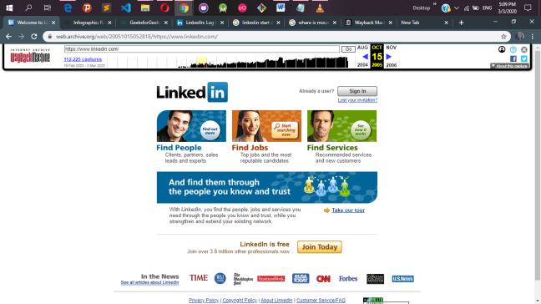

Oct 15,2005.

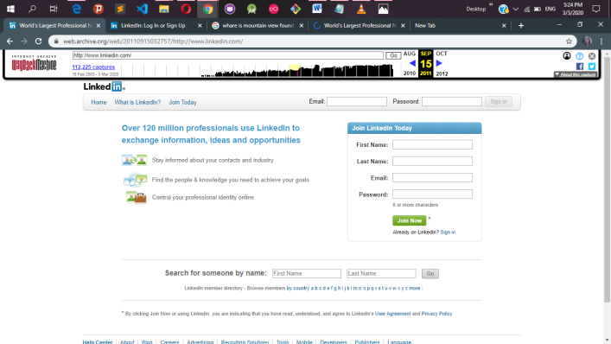

Sep 15 2011

. 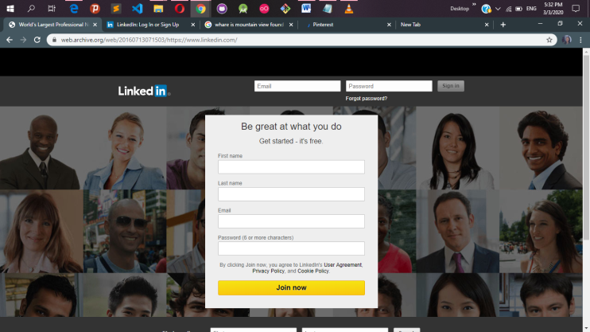

Jule,13,2016

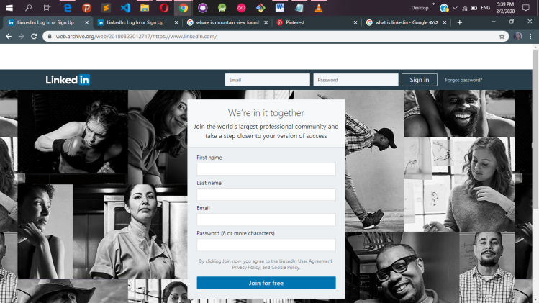

March 22 2018

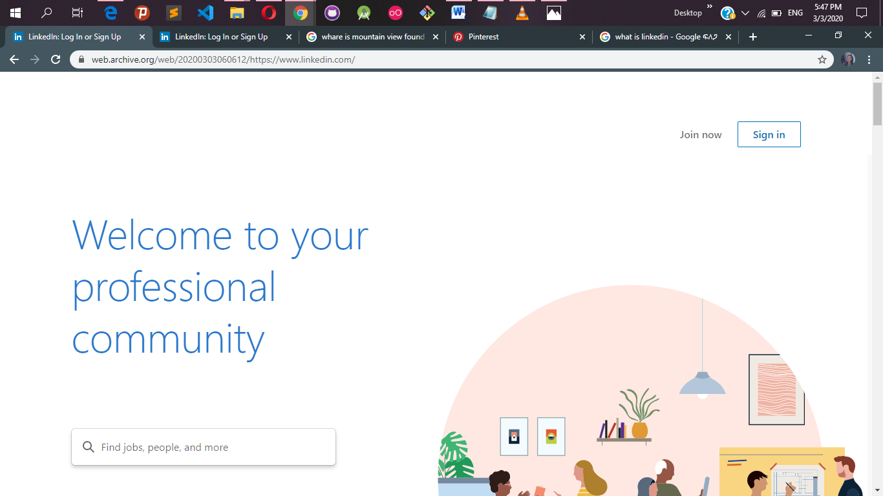

And finally now on March 3, 2020

* Generally as time goes by the website gets simpler and simpler.
* It starts to cover the whole width of the screen
* Drop downs gets smoother and smother
* It gets more attractive

## 2.2 PINTEREST

Pinterest was started in December 2009 in San Francisco, California, US.

Pinterest is social media network that allows users to share images associated with project, goods, and services, and to visually discover new interests by browsing images others have posted. You can think of Pinterest like a web-based pinboard or bulletin board — but with greater organizational functionality.

The purpose of pinterest  is a visual social bookmarking site that allows people to collect and organize photos, articles, and other forms of content according to specific areas of interest. Think of it like an online scrapbook.

* The images gets more clear and good looking
* The images get to be having a hover effect.
* Previously the images were seemed to be contained inside a table

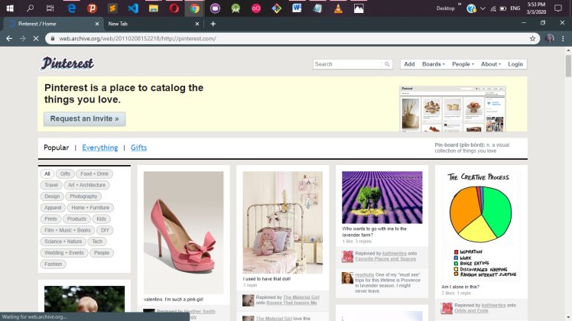

Feb 08 , 2011

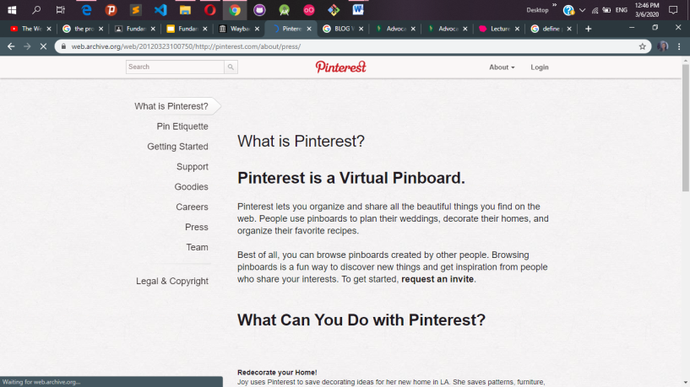

March 13,2012

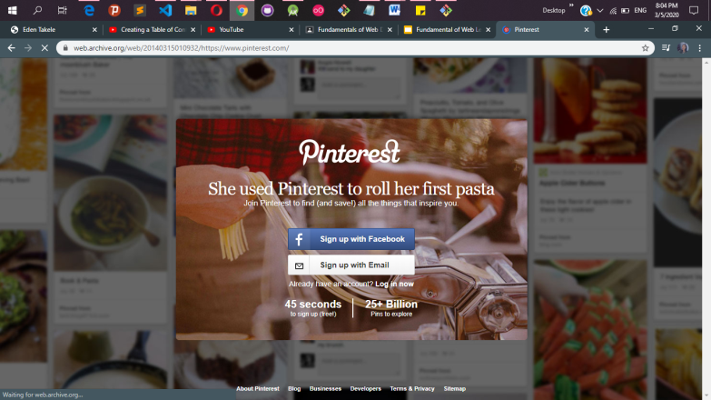

March 15,2014

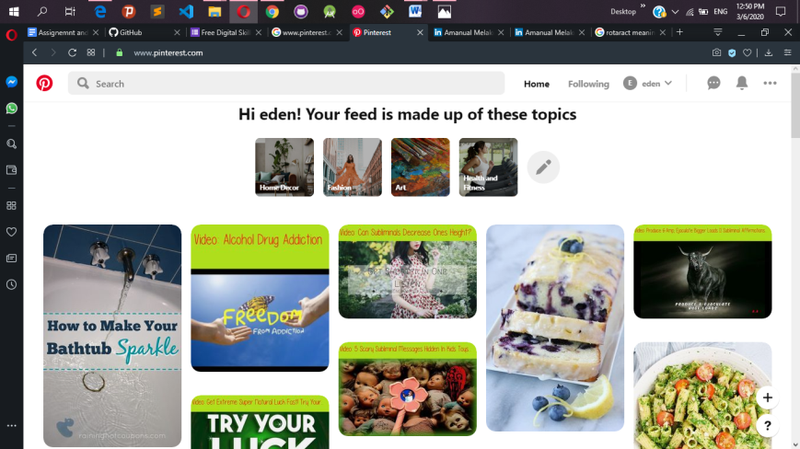

And now it looks like this

## 2.3 Instagram.com

**Instagram** is a social media app that allows users to share photos and videos from their lives, add captions, edit filters, tweak settings, engage with others, explore and creep, and so, so much more you just have to know what you're doing so you don't get overwhelmed! Generally as time goes by the website gets simpler and simpler.

* It starts to cover the whole width of the screen
* Drop downs gets smoother and smother
* It gets more attractive

## 2.4 Microsoft.com

* Generally as time goes by the website gets simpler and simpler.
* It starts to cover the whole width of the screen
* Drop downs gets smoother and smother
* It gets more attractive

## 2.5 github.com

* Generally as time goes by the website gets simpler and simpler.
* It starts to cover the whole width of the screen
* Drop downs gets smoother and smother
* It gets more attractive

# 3.0 TYPES OF WEBSITES

## 3.1 PORTAL WEBSITE

### What is a portal website

A web portal is a specially designed [**website**](https://en.wikipedia.org/wiki/Website) that brings information from diverse sources, like [**emails**](https://en.wikipedia.org/wiki/Email), [**online forums**](https://en.wikipedia.org/wiki/Internet_forum) and [**search engines**](https://en.wikipedia.org/wiki/Web_search_engine), together in a uniform way. Usually, each information source gets its dedicated area on the page for displaying information (a **[portlet](https://en.wikipedia.org/wiki/Portlet" \o "Portlet)**); often, the user can configure which ones to display. Variants of portals include [**mash ups**](https://en.wikipedia.org/wiki/Mashup_(web_application_hybrid)) and [**intranet**](https://en.wikipedia.org/wiki/Intranet) "dashboards" for executives and managers. The extent to which content is displayed in a "uniform way" may depend on the intended user and the intended purpose, as well as the diversity of the content. Very often design emphasis is on a certain "metaphor" for configuring and customizing the presentation of the content (e.g., a dashboard or map) and the chosen implementation framework or code libraries. In addition, the role of the user in an organization may determine which content can be added to the portal or deleted from the portal configuration.

A portal may use a search engine's [**application programming interface**](https://en.wikipedia.org/wiki/Application_programming_interface) (API) to permit users to search [**intranet**](https://en.wikipedia.org/wiki/Intranet) content as opposed to [**extranet**](https://en.wikipedia.org/wiki/Extranet) content by restricting which domains may be searched. Apart from this common [**search engines**](https://en.wikipedia.org/wiki/Search_engines) feature, web portals may offer other services such as [**e-mail**](https://en.wikipedia.org/wiki/E-mail), news, stock quotes, information from databases and even entertainment content. Portals provide a way for enterprises and organizations to provide a consistent "[**look and feel**](https://en.wikipedia.org/wiki/Look_and_feel)" with access control and procedures for multiple applications and databases, which otherwise would have been different web entities at various [**URLs**](https://en.wikipedia.org/wiki/URL). The features available may be restricted by whether access is by an authorized and authenticated user (employee, member) or an anonymous website visitor.

### 3.1.1 Banking & Insurance Portals

#### [****Santander Bank, Retail Banking Portal****](https://www.santanderbank.com/us/)

As one of the largest banks in the eurozone, Santander looked to build a new enterprise web platform that would integrate with existing software (CMS, Search Engine, Product Catalog) while allowing room for new content and features. Their site includes several retail banking features and ability to open new accounts and manage day-to-day banking operations.

#### [****CopperPoint, Insurance Portal****](https://www.copperpoint.com/)

CopperPoint is Arizona’s largest provider of workers compensation insurance and wanted to provide a better user experience for their policyholders and agents. Their site offers a flexible web design that enables payments and account management for clients, in addition to mobile notifications, push messages, email alerts, and more.

#### [****Allianz, Wealth Management / Insurance Portal****](http://www.allianz.com/)

Allianz Group, with a customer base of over 75 million, offers a site that is both dynamic and personal. With the "My Insurance Portfolio" customer site, users have the ability to retrieve historical records of purchased products and services along with integrated features to facilitate policy payments and renewals. The site also features easy-to-update contact information and communication preferences.

### 3.1.2 Patient portals

#### [****UAB Medicine, Patient Portal****](http://www.uabmedicine.org/)

UAB's top-ranked medical professionals found a platform through which they can reach many visitors and actual patients with health concerns. Their site hosts a free patient portal with a directory of various healthcare providers categorized by specialty, gender and location. It also features various subsections for knowledge about conditions and treatments, locations, contact info and FAQs.

#### [****Forest Hills Pediatrics, Patient Portal****](https://www.foresthillspediatrics.com/)

Right off the bat, you’ll notice the beautiful layout and color scheme of the Forest Hills site. On top of that, this patient portal features the ability to request appointments and refills, review growth charts, print immunization records, and fill out surveys for check-ups and other portions of the medical record.

#### [****Certification Commission for Healthcare Information Technology (CCHIT), Patient Portal****](http://www.cchit.org/)

The Certification Commission for Health Information Technology (CCHIT) introduced a new portal with content, self-paced learning, and readiness tools with the goal of streamlining the Electronic Health Record (EHR) certification training and assessment process for its clients. It's unique in that it has the ability to host multiple, branded portals for each of its certification programs, each with their own supporting community.

### 3.1.3 [****Federal government portal****](http://www.grants.gov/)

#### [****Grants.gov, Federal Government Portal****](http://www.grants.gov/)

The mission of Grants.gov is to allow applicants for federal grants to apply for and manage grant funds online through a common website. With a fully-functional government portal, the government could simplify grant management and eliminate redundancies. Grants.gov is unique in that it sends over 1 million email notifications at the public’s request and receives over 4 million page views weekly.

#### [****London Borough of Camden, Local Government Portal****](http://www.camden.gov.uk/)

With services ranging from housing control to social care, Camden wanted an online experience that was personalized for citizens and local businesses, as well as simplified with a single sign-on for streamlined services. Camden built a standards-compliance site that boasts a high level of configurability and integration capabilities (including Facebook, Google and Open ID login).

#### [****Marines, Federal Government Portal****](http://marines.com/)

Aside from being visually impressive, Marines host a slew of functions for both the interested applicant and average visitor. The site features personalized private home pages for applicants to access various forms along with the ability to submit questions to the Marine Corps and watch videos on demand.

### 3.1.5 [****Student & faculty portal****](https://passportyork.yorku.ca/ppylogin/ppylogin)

#### [****Stanford University AXESS, Student & Faculty Portal****](https://axess.sahr.stanford.edu/)

Stanford University developed a consolidated online platform called AXESS for the academic community to access information and record various transactions. The portal enables functions as related to student enrollment & financials, academic advising, teaching & grading, employment & training, and workflow-enabled administrative processes. The site is based on a user-centric design with modern UX standards.

#### [****York University Passport York, Student & Faculty Portal****](https://passportyork.yorku.ca/ppylogin/ppylogin)

My.Yorku.ca is the central information source for 55,000 students and a convenient one-stop shop for both internal resources and external data. The site includes personal course information (instructor, times, course Web site, etc.), grades, student account information, subscriptions to non-York newsfeeds and more. What's more, personal portal calendars are automatically loaded with class times and locations for registered courses while other campus events can be added if desired.

#### [****Capella University iGuide, Student & Faculty Portal****](https://sso3.capella.edu/openam/UI/Login)

Since all their courses are hosted online, Capella needed a portal platform that could support all their various functionalities. Capella's portal, iGuide, provides tools and relevant content for supporting learners in addition to direct access to class information, registration for classes, and bill payments upon portal login.

### 3.1.6 [****COPPER POINT, INSURANCE PORTAL****](https://www.copperpoint.com/)

#### [****Scion Owners, Extranet****](https://ssl.scion.com/owners/web/pages/home)

The Scion Owners site is an exclusive online resource for Scion owners. For any registered user, this site serves as a great resource for all the information you need to get the most out of owning a Scion. The well-designed extranet includes: access to the manuals and guides for your Scion, track mileage and lease details; ability to track the vehicle's major milestones on personal timeline; notifications for upcoming scheduled services, safety recalls, and more; participation in forums, local events and articles related to Scions.

#### [****AutoZone, Employee Portal****](http://www.autozone.com/)

AutoZone built an employee portal known as the Daily Online Communications (DOC) to help serve its 47,000 store employees. DOC is the place for employees to find what they need to know about their weekly tasks, benefits, and training. Also, the numerous portlets included with Liferay make any content and style changes easy and fast; this has proven beneficial in keeping information up-to-date in a fast-moving retail environment.

#### [****Saint-Gobain, Intranet****](http://www.saint-gobain.com/)

As an organization that processes several files for patents, Saint-Gobain needed a solution to help sustain innovation with speed and precision. They wanted an information systems portal that would allow users to create and manage their own pages/content. With their new site, users could contribute autonomously while having access to documents with internal doc management tools and collaborative platform communities through portlets. They also reduced their server load by half and cut maintenance costs.

## 3.2 News website

### What is news website

The news website is basically an online portal for News channel. They offer latest news headlines on Electronic format. You get all latest updates and notification on your device. There is various News portal present now a day.

#### the guardian.com

It’s another British newspaper company which has a very strong influence and hold over the British people.Talking about the best part then the website has a very unique theme towards its content and surely loved bymany people.And according to the Alexa ranking, the website is on 147 Rank globally.

#### New york times

It’s an American based newspaper from new york city. Due to its high popularity, as we already mentioned earlier the website receives the love of nearly 70 million unique visitors every month.The layout of the website is similar to a traditional newspaper which makes it even more unique to its competitors.

#### the Washington post.com

It’s similar to “Yahoo news”, as it also provides news related to almost every section such as politics, entertainment, technology and much more.The website also offers a very clean and unique layout which is loved by its visitors a lot.

Talking about the Alexa ranking then the website has25,114 Rank globally**.**

#### Nbcnews.com

It’s an American based broadcasting television network NBC, formerly known as the National Broadcasting Company.The website has a huge traffic base in both the US and Europe and also the social media handles are fairly loved by many people.

#### Foxnews.com

It is based on United States TV news channel owned by “Fox Entertainment Group”. The combination of blue and white colors on the website appeals to a lot of people.It also has similar news sections as we mentioned earlier in the above yahoo news.

#### CNN.COM

CNN (Cable News Network) is an American [**news**](https://en.wikipedia.org/wiki/News_broadcasting)-based [**pay television**](https://en.wikipedia.org/wiki/Pay_television) channel owned by [**AT&T**](https://en.wikipedia.org/wiki/AT%26T)'s **[WarnerMedia](https://en.wikipedia.org/wiki/WarnerMedia" \o "WarnerMedia)** . CNN was founded in 1980 by American [**media proprietor**](https://en.wikipedia.org/wiki/Media_proprietor) [**Ted Turner**](https://en.wikipedia.org/wiki/Ted_Turner) as a 24-hour [**cable news**](https://en.wikipedia.org/wiki/United_States_cable_news) channel. Upon its launch in 1980, CNN was the first television channel to provide [**24-hour news coverage**](https://en.wikipedia.org/wiki/24-hour_news_cycle)  and was the first all-news television channel in the United States.

#### Huffingtonpost.in

*HuffPost* (formerly *The Huffington Post* and sometimes abbreviated *HuffPo*) is an American [**news and opinion website**](https://en.wikipedia.org/wiki/News_aggregator) and [**blog**](https://en.wikipedia.org/wiki/Blog), with localized and international editions. It is edited from a [**left wing**](https://en.wikipedia.org/wiki/Left_wing) political perspective.  It was founded in 2005 by [**Andrew Breitbart**](https://en.wikipedia.org/wiki/Andrew_Breitbart), [**Arianna Huffington**](https://en.wikipedia.org/wiki/Arianna_Huffington), [**Kenneth Lerer**](https://en.wikipedia.org/wiki/Kenneth_Lerer), and [**Jonah Peretti**](https://en.wikipedia.org/wiki/Jonah_Peretti).  The site offers news, satire, blogs, and original content and covers politics, business, entertainment, environment, technology, popular media, lifestyle, culture, comedy, healthy living, women's interests, and local news.

#### News.google.com

Google News is a news aggregator app developed by Google. It presents a continuous, customizable flow of articles organized from thousands of publishers and magazines. Google News is available as an app on Android, iOS, and the Web.

#### News.yahoo.com

The website offers news related to almost every section, such as sports, finance, politics, and entertainment. And according to **Alexa** ranking, it’s on the 7th Rank globally.

## 3.3 Informational website

### What are information sites

Informationalwebsites are those **sites** which are created in order to provide a customized and branded resource for potential and active customers, members, investors and so forth. These websites are usually content and design driven. ... A great informational website can act as an excellent sales tool for your company.

#### ****[businessballs.com](http://businessballs.com/)****

This site has the largest collection of business articles of any site I know of. This site covers virtually every conceivable aspect of business. It’s a must bookmark for every small business owner.

#### Nobelprize.org

The Nobel Prize is a set of annual international awards bestowed in several categories by [**Swedish**](https://en.wikipedia.org/wiki/Sweden) and [**Norwegian**](https://en.wikipedia.org/wiki/Norway) institutions in recognition of academic, cultural, or scientific advances. The [**will**](https://en.wikipedia.org/wiki/Will_and_testament) of the [**Swedish**](https://en.wikipedia.org/wiki/Swedes) chemist, engineer and industrialist [**Alfred Nobel**](https://en.wikipedia.org/wiki/Alfred_Nobel) established the five Nobel prizes in 1895. The prizes in [**Chemistry**](https://en.wikipedia.org/wiki/Nobel_Prize_in_Chemistry), [**Literature**](https://en.wikipedia.org/wiki/Nobel_Prize_in_Literature), [**Peace**](https://en.wikipedia.org/wiki/Nobel_Peace_Prize), [**Physics**](https://en.wikipedia.org/wiki/Nobel_Prize_in_Physics), and [**Physiology or Medicine**](https://en.wikipedia.org/wiki/Nobel_Prize_in_Physiology_or_Medicine) were first awarded in 1901.The prizes are widely regarded as the most prestigious awards available in their respective fields .

#### w3.org

The World Wide Web Consortium (W3C) is an international community where [Member organizations](https://www.w3.org/Consortium/Member/List), a full-time [staff](https://www.w3.org/People/), and the public work together to develop [Web standards](https://www.w3.org/standards/).

#### Aol.com

AOL (stylized as Aol., formerly a company known as AOL Inc. and originally known as America Online) is an American [**web portal**](https://en.wikipedia.org/wiki/Web_portal) and [**online service provider**](https://en.wikipedia.org/wiki/Online_service_provider) based in [**New York City**](https://en.wikipedia.org/wiki/New_York_City). It is a [**brand**](https://en.wikipedia.org/wiki/Brand) marketed by [**Verizon Media**](https://en.wikipedia.org/wiki/Verizon_Media).

#### CNET.com

CNET (stylized as c|net), formerly Computer Network, is an American media website that publishes reviews, news, articles, blogs, podcasts, and videos on technology and [**consumer electronics**](https://en.wikipedia.org/wiki/Consumer_electronics) globally. Founded in 1994 by [**Halsey Minor**](https://en.wikipedia.org/wiki/Halsey_Minor) and Shelby Bonnie, it was the flagship brand of CNET Networks and became a brand of [**CBS Interactive**](https://en.wikipedia.org/wiki/CBS_Interactive) through CNET Networks' acquisition in 2008. CNET originally produced content for radio and television in addition to its website and now uses [**new media**](https://en.wikipedia.org/wiki/New_media) distribution methods through its [**Internet television network**](https://en.wikipedia.org/wiki/Internet_television), [**CNET Video**](https://en.wikipedia.org/wiki/CNET_Video), and its podcast and blog networks.

## 3.4 Bussiness websites

#### [****AllBusiness.com****](http://www.allbusiness.com/)

This is one of the most comprehensive sites on the Web for entrepreneurs and growing businesses. AllBusiness.com features articles, advice, forms, agreements, and videos covering small business topics, M&A, venture capital, angel financing, sales and marketing, careers, and more. The site offers over 33,000 articles written by experts from many different fields.

#### [****Bloomberg Business****](http://www.bloomberg.com/)

*Bloomberg* *Business* provides up-to-the-minute U.S. and international news on financial markets, commodities, currencies, company earnings, technology, and more. The site has numerous articles, feature stories, and videos.

#### [****Business Insider****](http://www.businessinsider.com/)

*Business Insider* is a business news site that certainly knows how to grab the reader’s attention with its catchy headlines. The articles and videos cover the markets, technology, companies, personal finance, venture capital, investing, start-ups as well as more commercial stories on culture and entertainment.

#### [****Financial Times****](http://www.ft.com/)

The Financial Times is a print and digital publisher based in London covering the world economy and markets. The site has particularly strong coverage of European companies and markets providing feature stories, analyses, and data insights.

#### [****Forbes****](http://www.forbes.com/forbes/welcome/)

Forbes has great and comprehensive content across every business category: the stock market, entrepreneurship, personal finance, M&A, technology, careers, and more. It contains many popular lists, including “The World’s Billionaires” and the “Most Valuable Brands.” It has numerous staff writers and over 1,800 contributing experts who generate a great quantity of articles, which results in over 75 million visitors a month to the site.

#### [****Fortune****](http://fortune.com/)

Fortune provides extensive coverage of the financial markets, especially larger companies that make up the “Fortune 500.” Topic categories include careers, entrepreneurs, finance, sports, technology, markets, most powerful women, and energy and the environment.

#### [****Inc.****](http://www.inc.com/)

*Inc.* is a popular site for entrepreneurs and startups, with thousands of articles on starting and growing a business, angel financing, sales and marketing, innovation, and more.

#### [****MarketWatch****](http://www.marketwatch.com/)

*MarketWatch* is a comprehensive news site covering stocks, bonds, commodities, U.S. and international markets, personal investing, real estate, and media. The site is known particularly for its continuous coverage of stock market updates.

#### [****MSN Money****](http://www.msn.com/en-us/money)

Microsoft’s *MSN Money* has comprehensive and current information and advice on the markets, investing, personal finance, real estate, small business, careers, taxes, and more. MSN does a great job curating quality content from multiple publishers.

#### [****New York Times****](http://www.nytimes.com/pages/business/index.html)

The venerable New York Times has outstanding coverage of the markets, international business, deals, the economy, entrepreneurship, technology, and personal finance. This includes daily updates of developments in the stock market and headline-making companies.

## 3.5 EDUCATIONAL WEBSITES

#### [Lynda.com](https://www.lynda.com/" \t "_blank) :

Lynda.com is probably the best place online for high-quality video tutorials and courses. Best of all, their videos are very diverse, which means you will be able to find courses on anything from coding and software to business. They also have tons of great tutorials when it comes to creative disciplines, such as design, and especially photography. And if you’re an international student, you will also be able to find Lynda courses in German, French, and Spanish.

#### [Skillshare](https://www.skillshare.com/?utm_source=Google&utm_medium=paidsearch&utm_campaign=Brand_DesktopTablet&matchtype=p&gclid=CICDvZ-MjtICFQMQaQodogYK7A" \t "_blank).com

Skillshare is a unique platform. Anyone can become a teacher if they feel like they possess enough knowledge on a particular subject. In case you are worried about the quality of their courses, don’t be, because most of them are taught by industry experts and leaders. In terms of variety, Skillshare offers even more than Lynda. They offer courses on business, advertising, fashion, design, photography, video, music, writing, publishing, and IT.

#### [Bestessays](https://www.bestessays.com.au/)

If you are short on time to write an essay yourself, or if you would like to improve your essay writing skills, Bestessays is the right platform for you. They gather some of the best writers and editors in the field, with years of experience behind them, which are capable of writing essays, term papers, coursework, and even dissertations. What makes them unique is their ability to stick to deadlines, no matter how tight, without ever letting the quality of their papers suffer.

#### [Codeschool](https://www.codeschool.com/)

There is no denying that being a developer is one of the most lucrative jobs of today. However, some students find it difficult, perhaps because they haven’t been taught the right way. Codeschool, with its blend of written materials, coding challenges, and videos will help you learn the basics of coding, and once you reach a certain level, even some of the advanced stuff. They offer courses on many programming languages, such as HTML/CSS, Javascript, PHP, Ruby, Python, .NET, and iOS, among others.

#### [Hyperpad](https://www.hyperpad.com/)

With Hyperpad, building your own app or a game has never been easier, without having to know coding of any kind. Simply create an app by importing custom graphics, and apply behaviors using drag and drop functionality. Not only is this a great way to get into coding once you are ready for a bigger challenge, but it’s a way for you to boost your student income, because you can submit your apps and games to the App Store!

#### [Docsity](https://www.docsity.com/en/)

Docsity is an online social network designed for learning. It gathers students and teachers from all over the world. They can share document, notes, study materials, as well as gain access to published articles, and video courses. Students are encouraged to share by collecting points, which enables to them to download additional materials and build their reputation. The platform also has a Q&A section, and publishes all the latest news in education, which are read by over 500,000 students worldwide.

#### [Duolingo](https://www.duolingo.com/)

If you are interested in learning a new language, it’s pretty hard to beat Duolingo. In addition to sbeing completely free, Duolingo allows you to choose among 66 different courses across 23 languages. The list just keeps on growing. One of the reasons why Duolingo is so effective is because it relies on gamification to keep to user engaged and hungry for more. The app is available on all major platforms, which means you will be able to use it whenever you need it.

#### [Quora.com](https://www.quora.com/)

Quora is not only a platform where you can spend hours or days doing research on a particular subject and have fun the process, interacting with other users, but also a place where you can receive a detailed answer written by an expert. It is probably the best place online if you are looking for high-quality answers and explanations on just about anything you can think. It’s an essential resource for every college student.

#### [TedEd](https://ed.ted.com/)

The world-famous TED talks need no introduction. But, TED has a lot more to offer to students and educators with its TED-Ed platform. TED-Ed is basically a huge library of educational videos and lessons. Each user can build a custom lesson around a particular video and share it with other users. Both types of videos, those which are created by experts, and those which are created by users, are equally effective at enhancing your learning process inside the classroom or at home.

#### [Udemy](https://www.udemy.com/courses/)

Udemy is one of the most reputable online learning platform. Students and adults who can find plenty of courses and studying materials on subjects which interest them the most. As of 2017, there are over 45,000 different courses available for you to explore. You can also become a course creator yourself, either for a fee, or free of charge.

## 3.6 INTERTAINMENT WEBSITES

### What is an entertainment website

A social entertainment service is an online service, platform or website which links back to social networking websites to help connect users and has begun to facilitate audience acquisition. ... Due to this shift in audience interaction, traditional media companies are acquiring social components to stay competitive.

#### Fandom.com

the entertainment site where fans come first. your daily source for all things tv, movies, and games, including star wars, fallout, marvel, dc and more.

#### Netflix.com

Netflix is a streaming service that allows our members to watch a wide variety of award-winning TV shows, movies, documentaries, and more on thousands of internet-connected devices. With Netflix, you can enjoy unlimited ad-free viewing of our content.

#### Youtube .com

YouTube is a free video sharing website that makes it easy to watch online videos. You can even create and upload your own videos to share with others. Originally created in 2005, YouTube is now one of the most popular sites on the Web, with visitors watching around 6 billion hours of video every month.

#### Imdb.com

IMDb (Internet Movie Database) is an online database of information related to films, television programs, home videos, video games, and streaming content online – including cast, production crew and personal biographies, plot summaries, trivia, fan and critical reviews, and ratings.

#### Spotify.com

Spotify is a completely legal way to stream music online and listen to podcasts. The company licenses tracks from major and minor record labels to include in its large music library, and pays the rights holders an undisclosed amount based on the number of times Spotify users listen to each track.

#### Douban.com

Douban.com is launched on March 6, 2005, is a Chinese [**social networking service**](https://en.wikipedia.org/wiki/Social_networking_service) website that allows registered users to record information and create content related to film, books, music, recent events, and activities in Chinese cities. It could be seen as one of the most influential web 2.0 websites in China. Douban also owns an internet radio station, which ranks No.1 in the **[iOS App Store](https://en.wikipedia.org/wiki/App_Store_(iOS)" \o "App Store (iOS))** in 2012. Douban was formerly open to both registered and unregistered users. For registered users, the site recommends potentially interesting books, movies, and music to them in addition to serving as a social network website such as **[WeChat](https://en.wikipedia.org/wiki/WeChat" \o "WeChat)**, **[Weibo](https://en.wikipedia.org/wiki/Weibo_(company)" \o "Weibo (company))** and record keeper; for unregistered users, the site is a place to find ratings and reviews of media.

#### Wattpad.com

The purpose of Wattpad is to allow amateur writers to have a platform where they can publish their work and get feedback for free. They provide a space for young writers to gain a following and potentially help launch their careers. The Wattpad community is centered around the users' love for literature.

## 3.7 ADVOCACY WEBSITES

### What are ADVOCACY WEBSITES?

An advocacy website's purpose is to influence public policy and resource allocation decisions within political, economic, and social systems and institutions.

* World Advocacy [**http://www.worldadvocacy.com**](http://www.worldadvocacy.com/)
* Greenpeace [**http://www.greenpeace.org**](http://www.greenpeace.org/)
* Sierra Club [**http://www.sierraclub.org**](http://www.sierraclub.org/)
* Environmental Defense Action Fund [**http:/www.undoit.org**](http://www.undoit.org/)
* Natural Resources Defense Council [**http://www.nrdcwildplaces.org**](http://www.nrdcwildplaces.org/)
* Jane Goodall Institute [**http://www.janegoodall.org**](http://www.janegoodall.org/)
* People for the Ethical Treatment of Animals [**http://www.peta.org/**](http://www.peta.org/)
* Environmental Defense Fund [**http://www.environmentaldefense.org/home.cfm**](http://www.environmentaldefense.org/home.cfm)
* Amnesty International [**http://www.amnesty.org**](http://www.amnesty.org/)
* Derechos Human Rights [**http://www.derechos.org**](http://www.derechos.org/)
* ACLU: American Civil Liberties Union [**http://aclu.org/**](http://aclu.org/)
* Freedom Forum [**http://www.freedomforum.org/**](http://www.freedomforum.org/)
* MoveOn.Org [**http://www.moveon.org**](http://www.moveon.org/)
* National Anti-Vivisection Society (opposed to animal testing) [**http://www.navs.org/**](http://www.navs.org/)
* National Association for Biomedical Research (favors animal testing) [**http://www.nabr.org**](http://www.nabr.org/)
* National Coalition to Abolish the Death Penalty [**http://www.ncadp.org/**](http://www.ncadp.org/)
* National Rifle Association [**http://www.nra.org/**](http://www.nra.org/)
* Center for a New American Dream [**http://www.newdream.org/**](http://www.newdream.org/)
* The National Network for Immigrant and Refugee Rights [**http://www.nnirr.org/**](http://www.nnirr.org/)
* Endangered Species Coalition [**http://www.stopextinction.org/**](http://www.stopextinction.org/)
* Vitamin Angel Alliance [**http://www.vitaminangel.org/**](http://www.vitaminangel.org/)
* National Association for Bilengual Education [**http://www.nabe.org/**](http://www.nabe.org/)
* Action on Smoking and Health [**http://ash.org/**](http://ash.org/)
* Fight Ordinances and Restrictions to Control and Eliminate Smoking [**http://www.forces.org/**](http://www.forces.org/)
* American Smoker's Alliance [**http://www.smokers.com**](http://www.smokers.com/)
* Common Cause [**http://www.commoncause.org/**](http://www.commoncause.org/)
* DRCNet: The Drug Reform Coordination Network [**http://drcnet.org/**](http://drcnet.org/)
* Security on Campus [**http://www.campussafety.org/**](http://www.campussafety.org/)
* Children's Defense Fund [**http://www.childrensdefense.org/**](http://www.childrensdefense.org/)
* Stand for Children [**http://www.stand.org/**](http://www.stand.org/)
* Bastard Nation: The Adoptee Rights Organization [**http://www.bastards.org/**](http://www.bastards.org/)
* Minority Rights Group International [**http://www.minorityrights.org/**](http://www.minorityrights.org/)
* National Organization of Women [**http://www.now.org/**](http://www.now.org/)
* NAACP [**http://www.naacp.org/**](http://www.naacp.org/)
* Japanese AmericanCitizens League [**http://www.jacl.org/**](http://www.jacl.org/)
* League of Latin American Citizens [**http://www.lulac.org**](http://www.lulac.org/)
* Bicycle Advocacy [**http://chainguard.org/**](http://chainguard.org/)
* Privacy International [**http://www.privacyinternational.org**](http://www.privacyinternational.org/)
* World Wildlife Fund [**http://www.panda.org**](http://www.panda.org/)
* The Wildlands Project [**http://www.twp.org**](http://www.panda.org/)
* Nature Conservancy [**http://nature.org**](http://nature.org/)
* Disability Rights Education and Defense Fund Inc. [**http://www.dredf.org/**](http://www.dredf.org/)

## 3.8 BLOG WEBSITES

### What are BLOG WEBSITES?

A blog (shortening of “weblog”) is an online journal or informational website displaying information in the reverse chronological order, with the latest posts appearing first. It is a platform where a writer or even a group of writers share their views on an individual subject.

* [**WordPress.org**](https://wordpress.org/)
* [**Wix.com**](https://wixstats.com/?a=10255&c=2577&s1=)
* Joomla.com
* Medium.com
* Ghost.org
* Squarespace.com
* Weebly.com
* Blogger.com
* Tumblr.com

## 3.9 WIKI WEBSITES

### What are WIKI WEBSITES?

A wiki (sometimes spelled "Wiki") is a server program that allows users to collaborate in forming the content of a Web site. ... The simplest wiki programs allow users to create and edit content. More advanced wikis have a management component that allow a designated person to accept or reject changes.

#### Catawiki.com

**Catawiki** is an online auction platform for buying and selling special items and collectibles. Catawiki was founded in 2008 as an online community for collectors. Since 2011, the company has been hosting weekly online auctions, in various categories such as vintage comic books, model trains, coins, watches, art, jewellery and classic cars.

#### AboutUs.com

**AboutUs.com** is a [**wiki**](https://en.wikipedia.org/wiki/Wiki) [**Internet domain**](https://en.wikipedia.org/wiki/Internet_domain) directory. It listed [**websites**](https://en.wikipedia.org/wiki/Websites) along with information about their content. As a wiki, AboutUs allows Internet users to add entries or modify information. AboutUs.com has since become a wiki for more than just websites. The site now allows pages to be created for people, places, and almost anything else.

#### Baidu Baike

Baidu Baike is a Chinese-language, collaborative, web-based encyclopedia owned and produced by the Chinese search engine **[Baidu](https://en.wikipedia.org/wiki/Baidu" \o "Baidu)**. Its test version was released on 20 April 2006, and within three weeks the encyclopedia had grown to more than 90,000 articles, surpassing the number in [**Chinese Wikipedia**](https://en.wikipedia.org/wiki/Chinese_Wikipedia). As of October 2019, Baidu Baike has more than 16.3 million articles.

#### Citizendium

It was first announced in September 2006 as a [**fork**](https://en.wikipedia.org/wiki/Fork_(software_development)) of the [**English Wikipedia**](https://en.wikipedia.org/wiki/English_Wikipedia)  but the idea had been abandoned before its March 2007 public launch in favor of emphasizing original content. The project aims to improve on the Wikipedia model by providing increased reliability. It hopes to achieve this by requiring virtually all contributors to use their real names, by strictly moderating the project for unprofessional behavior, by providing what it calls "gentle expert oversight" of everyday contributors, and also through its "approved articles". Approved articles have undergone a form of [**peer-review**](https://en.wikipedia.org/wiki/Peer-review) by topic experts with credentials, and are closed to real-time editing.

#### Encyclopedia Dramatica

**Encyclopedia Dramatica** (often abbreviated **ED** and **æ**) is a [**parody-themed**](https://en.wikipedia.org/wiki/Parody) [**wiki**](https://en.wikipedia.org/wiki/Wiki) website launched on December 10, 2004, that uses **[MediaWiki](https://en.wikipedia.org/wiki/MediaWiki" \o "MediaWiki)** software to [**lampoon**](https://en.wikipedia.org/wiki/Parody) encyclopedia topics and [**current events**](https://en.wikipedia.org/wiki/Current_events), especially those related or relevant to contemporary [**Internet culture**](https://en.wikipedia.org/wiki/Internet_culture). It often serves as a repository of information and a means of discussion for the internet [**subculture**](https://en.wikipedia.org/wiki/Subculture) known as [**Anonymous**](https://en.wikipedia.org/wiki/Anonymous_(group)). This [**NSFW**](https://en.wikipedia.org/wiki/Not_safe_for_work) Internet site celebrates a [**subversive**](https://en.wikipedia.org/wiki/Counterculture) "[**trolling**](https://en.wikipedia.org/wiki/Troll_(Internet)) [**culture**](https://en.wikipedia.org/wiki/Internet_culture)", and documents [**Internet memes**](https://en.wikipedia.org/wiki/Internet_memes), [**culture**](https://en.wikipedia.org/wiki/Cyberculture), and events, such as mass organized pranks, trolling events, "raids", large-scale failures of [**Internet security**](https://en.wikipedia.org/wiki/Internet_security), and criticism of [**Internet communities**](https://en.wikipedia.org/wiki/Internet_communities) which are accused of [**self-censorship**](https://en.wikipedia.org/wiki/Self-censorship) in order to garner prestige or positive coverage from traditional and [**established media outlets**](https://en.wikipedia.org/wiki/Old_media). The site has been described as hosting numerous [**pornographic**](https://en.wikipedia.org/wiki/Pornographic) images, and content that is "[**misogynistic**](https://en.wikipedia.org/wiki/Misogyny), [**racist**](https://en.wikipedia.org/wiki/Racist), and [**homophobic**](https://en.wikipedia.org/wiki/Homophobic)".

#### Familypedia

**Familypedia** is a free-to-use public [**wiki**](https://en.wikipedia.org/wiki/Wiki) on [**family history**](https://en.wikipedia.org/wiki/Family_history) and [**genealogy**](https://en.wikipedia.org/wiki/Genealogy). It is a collaborative effort by amateur genealogists and family historians, with over 61,000 unique people having their own pages among over 215,000 articles. For over 33,000 of those individuals, there is a corresponding subpage displaying an ancestry chart, automatically updated, and for most there is a similarly updated descendant table. Over 7,000 pages tabulate, for specific localities or larger areas such as counties, individuals who had life events such as birth or marriage at the locality. There are over 320,000 other pages, including over 13,000 [**surname categories**](http://www.wikia.com/wiki/w:c:familypedia:Category:Surnames). It is the largest English-language [**semantic wiki**](https://en.wikipedia.org/wiki/Semantic_wiki) concentrating on genealogy, but it is not restricted to English.

## 3.10 SOCIAL NETWORK WEBSITE

#### [Facebook](http://www.facebook.com/)

This is easily the largest social networking site in the world and one of the most widely used. And, Facebook was perhaps the first that surpassed the landmark of 1 billion user accounts.

Apart from the ability to network with friends and relatives, you can also access different Facebook apps to sell online and you can even market or promote your business, brand and products by using paid Facebook ads.

Recently Facebook has lost the trust of millions of its users by allowing 3rd parties to access over 87 million users’ personal data. This is a massive breech of trust and has created a feeling of unrest amongst the social media platform’s audience. So much so that there is now a #deletefacebook campaign where people are completely removing themselves from Facebook and using other networks instead. If you’re concerned about what Facebook is doing with your data, then why not check out my guide on [**alternatives to Facebook**](https://makeawebsitehub.com/facebook-alternatives/), and see if there’s a better place for you to interact with family and friends.

Number of active users per month: 1.59 billion approximately

#### [WhatsApp](https://www.whatsapp.com/)

Despite having been acquired by Facebook in 2014, this instant messaging platform exists as an independent entity.

It arrived on the scene much later than Facebook, but has been able to capture the imagination of millions of people across the world by giving them the ability to communicate and share instantly with individuals and groups. The WhatsApp call feature is just the icing on the cake!

Number of active users per month: 1 billion approximately

#### [QQ](http://www.qq.com/)

Tencent QQ (more popularly known as QQ) is an instant messaging (chat-based) social media platform. It became international (with more than 80 countries using it), after it was launched in China.

It can be used to stay in touch with friends through texts, video calls and voice chats. It even has a built-in translator to translate your chats. To find out more, head over to our [**Chinese Social Media stats page.**](https://makeawebsitehub.com/chinese-social-media-statistics/)

Number of active users per month: 853 million approximately.

#### [WeChat](http://www.wechat.com/)

This is an all-in-one communications app for messaging and calling (similar to WhatsApp) that enables you to connect with the people of your choice. It was also developed by Tencent in China and can easily work alongside QQ. As per the [**BI intelligence report**](http://mybroadband.co.za/news/smartphones/162718-wechat-is-catching-up-to-whatsapp.html), the number of WeChat users are fast catching up with the number of WhatsApp users.

Related article: **[WeChat keyboard shortcuts](https://makeawebsitehub.com/wechat-images-sizes/)**

Number of active users per month: 697 million approximately

#### [QZone](http://qzone.qq.com/)

Like QQ and WeChat, QZone is yet another social networking service developed by Tencent. It enables you to share photos, watch videos, listen to songs, write blogs, maintain diaries and so on. It also empowers you to choose the accessories and customize the look and feel of your QZone webpages.

Number of active users per month: 640 million approximately

#### [Tumblr](http://tumblr.com/)

Having been owned by Yahoo since 2013, Tumblr serves as a social media cum micro [**blogging platform**](https://makeawebsitehub.com/choose-right-blogging-platform/) that can be used to find and follow things that you like. You can also use it to post anything, including multimedia, to a short-form blog. Moreover, it gives you the flexibility to customize almost everything.

Number of active users per month: 555 million approximately

#### [Instagram](http://www.instagram.com/)

Instagram was launched as a unique social networking platform that was completely based on sharing photos and videos. This photo sharing social networking app thus enables you to capture the best moments of your life, with your phone’s camera or any other camera, and convert them into works of art.

This is possible because Instagram allows you to apply multiple filters to your photos and you can easily post them to other popular social networking sites, such as Facebook and Twitter. It is now part of the Facebook empire. Learn [**how to grow your Instagram audience**](https://makeawebsitehub.com/get-followers-likes-instagram/).

[**Read more on Instagram Tools**](https://makeawebsitehub.com/instagram-tools/) to help you increase social engagement and audience numbers.

Number of active users per month: 400 million approximately

#### [Twitter](http://twitter.com/)

This social networking site enables you to post short text messages (called tweets), containing a limited number of characters (up to 280), to convey your message to the world. With the growing craze for online shopping, Twitter also makes it possible to promote your businesses and even shop directly through tweets. Learn how to [**create the perfect Twitter profile**](https://makeawebsitehub.com/perfect-twitter-profile/).

Number of active users per month: 320 million approximately

#### Google+ ( No Longer Available )

Owned by the tech giant Alphabet (Google), this interest-based social networking platform enables you to stay in touch with people by sharing messages, photos, videos, useful links to sites and so on. It also extends support for video conferencing through Hangouts and allows businesses to promote their brands and products through Google+ business pages.

Number of active users: 300 million approximately

#### [Baidu Tieba](http://tieba.baidu.com/)

Offered by Baidu of China, a search engine company, Baidu Tieba (known as Postbar internationally) is a social forum network based on the keyword searches in the Baidu search engine. This discussion forum works on the unique concept of allowing you to create a social network group for a specific topic, using the search, or even to join an existing online social group.

Number of active users per month: 300 million approximately

#### [Skype](http://skype.com/)

Skype, owned by Microsoft, is one of the most popular communication-based social networking platforms. It allows you to connect with people through voice calls, video calls (using a webcam) and text messaging. You can even conduct group conference calls. And, the best part is that Skype-to-Skype calls are free and can be used to communicate with anyone, located in any part of the world, over the internet.

Number of active users per month: 300 million approximately

#### [Viber](http://www.viber.com/)

This multi-lingual social platform, which is available in more than 30 languages, is known for its instant text messaging and voice messaging capabilities. You can also share photos and videos and audio messages, using Viber. It offers you the ability to call non-Viber users through a feature named Viber Out.

Number of active users per month: 249 million approximately

#### [Sina Weibo](http://weibo.com/)

This is a highly popular microblogging social platform in China that is known for its hybrid mix of Twitter’s and Facebook’s features.

Number of active users per month: 222 million approximately

#### [LINE](http://line.me/)

LINE is a globally available messaging social network that enables you to share photos, videos, text messages and even audio messages or files. In addition, it allows you to make voice and video calls at any time of the day.

Number of active users per month: 215 million approximately

#### [Snapchat](https://www.snapchat.com/)

This is an image messaging social platform that enables you to chat with friends by using pictures. It allows you to explore news and even check out live stories that are happening around the world.

Number of active users per month: 200 million approximately

#### [YY](http://www.yy.com/)

YY is a major video-based social networking platform in China that enables group video chats. In such chats, more than 100,000 members can watch a single person doing an activity. Such an activity can be anything from giving a tutorial video to singing karaoke, which helps the users earn virtual currency that they can later convert into cash.

Number of active users per month: 122 million approximately

#### [VKontakte (VK)](https://vk.com/)

VK is one of the largest social networking platforms in Russia and has quite similar features to Facebook.Number of active users per month: 100 million approximately

#### [Pinterest](http://pinterest.com/)

This is a photo sharing and visual bookmarking social media site or app that enables you to find new ideas for your projects and save them. So, you can do DIY tasks or home improvement projects, plan your travel agenda and so on by using Pinterest.

Number of active users per month: 100 million approximately

#### [LinkedIn](http://www.linkedin.com/)

LinkedIn is easily one of the most popular professional social networking sites or apps and is available in over 20 languages. It is used across the globe by all types of professionals and serves as an ideal platform to connect with different businesses, locate and hire ideal candidates, and more. It boasts over 400 million members

Number of active users per month: 100 million approximately

#### [Telegram](https://telegram.org/)

This instant messaging network is similar to WhatsApp and is available across platforms in more than eight languages. However, Telegram has always focused more on the privacy and security of the messages you send over the internet by using its platform. So, it empowers you to send messages that are encrypted and self-destructive. This encryption feature has only just been made available for WhatsApp, whereas Telegram has always provided it.

Number of active users per month: 100 million approximately

#### [Reddit](https://www.reddit.com/)

This social media platform enables you to submit content and later vote for the content. The voting determines whether the content moves up or down, which is ultimately organized based on the areas of interest (known as subreddits).

Number of active users per month: 100 million approximately

## 3.11 CONTENT AGGREGATOR

### What is CONTENT AGGREGATOR website

Content aggregator websites are certainly something that you’ve run into at least a few times in your life on the web. But when it comes time to think about examples of content aggregator websites, your mind might be going blank.

Don’t worry! I’m here to help.

In this post, I’m going to showcase 6 different examples of successful content aggregator websites. Then, at the end of the post, I’ll tell you how you can use [**WP RSS Aggregator**](https://www.wprssaggregator.com/?ref=44&campaign=wpmayor-257814) to create your very own content aggregator site using WordPress.

### What is Content Aggregation, Anyway?

Content aggregator websites don’t produce their own content. Instead, they collect content from other websites around the Internet and “aggregate” it into one easy-to-find location.

While your first thought might go to copyright theft, it’s truly not a bad thing. Content aggregator websites benefit both visitors and content creators.

Visitors are happy because they get to view a huge variety of content in one spot. And content creators are happy because, as long as the aggregator website is being respectful and linking to the original source, content creators get to expose their content to a whole new audience.

### Examples of Content Aggregator Websites

The following sites are some of the best and most popular examples of successful content aggregator websites. Some span huge categories of topics, others are neat one-page designs, and still more are niche-specific content aggregators that only focus on one specific topic.

#### Alltop

Founded by startup legend Guy Kawasaki, **[Alltop](https://alltop.com/" \t "_blank)** is one of the biggest names in content aggregation and deservedly sits in first place on this list.

Alltop pulls in the latest posts from websites on a variety of topics. What’s neat about Alltop is that you can search for specific topics and then view aggregated content from some of the top blogs for that specific topic.

You can also submit your own site to be listed on Alltop, though Alltop is known for being fairly picky about the sites that it accepts.

#### Popurls

[**Popurls**](http://popurls.com/) is the site from which Alltop drew its inspiration. Alltop even credits Popurls in the Alltop footer!

With that endorsement, it’s no surprise that Popurls, branded as the “mother of all [**news aggregators**](https://wpmayor.com/how-to-build-latest-news-website/),” sits at #2 on our list.

Popurls pulls in content from a variety of social networks, blogs, and news organizations. It’s quite eclectic in its content – with my favorite example being BuzzFeed and The New York Times sitting side-by-side. How’s that for contrast?

Unlike Alltop, you can’t submit your own website to Popurls. But it’s still a neat example of the power of content aggregation.

#### The Web List

[**The Web List**](http://theweblist.net/) functions similarly to Popurls in that it’s a one-page content aggregator website that collects content from a huge variety of sources.

It’s not nearly as popular as Popurls or Alltop. But it’s highly customizable and uses some cool technology. And for that reason, I thought it was a great example of how far you can take content aggregation.

Like Popurls, though, you can’t submit your own site. It only aggregates content from a pre-made set of sources.

#### WP News Desk

[**WP News Desk**](http://wpnewsdesk.com/) is a content aggregator website that focuses specifically on WordPress. It automatically pulls in content from a variety of WordPress blogs and companies and displays posts on the front page.

Rather than needing to visit each blog individually, visitors can just click on individual articles to read the full article at the original source.

Like Alltop, bloggers can submit their own WordPress blog to be considered for inclusion in the news desk.

#### Blog Engage

Though [**Blog Engage**](http://www.blogengage.com/) is starting to fall victim to spammy content, it’s still one of the most popular blog content aggregators out there.

As the spam indicator suggests, Blog Engage’s standards are nowhere near as strict as Alltop, though.

But with that being said, it’s still a good example of how you can create a generalized aggregator website and make it successful.

#### Travel Blogger Community

[**Travel Blogger Community**](http://travelbloggercommunity.com/) is for travel bloggers what WP News Desk is for WordPress. That is, Travel Blogger Community aggregates content from travel bloggers all around the world in one accessible place.

Just like Alltop and WP News Desk, Bloggers can submit their own site to the community to get their content featured on the aggregator.

# 3.12 PORSONAL WEBSITES

A personal website is a group of web pages that someone creates about themselves. It basically contains things that are personal.

Some of the most internationally known best personal websites are

#### ****[Krista Gray](http://www.kristagray.com/" \t "_blank)****

**Why We Love It:** Gray’s homepage gives you all the basic information you need to know about her and her work in a clean, easy-to-read way. Plus, her “services” section explains exactly what she’s looking for, making it easy for people to understand how they can work with her.

#### [****Ximena Vengoechea****](http://www.ximenavengoechea.com/)

**Why We Love It:** The simple, clean design of this site makes the colors of Vengoechea’s illustrations and user design screenshots really pop—helping her work shine even more.

#### [****Rachael G. King****](http://www.rachaelgking.com/)

Why We Love It: King uses her simple website to tell a compelling story about herself—and then give a clear call to action for people to reach out to her to work together. Plus, her social profiles stand out loud and proud, which is critical since she’s a social media professional.

#### ****[Devon Stank](http://www.devonstank.com/" \t "_blank)****

Why We Love It: There’s no question about what this guy does. But, in addition to the simple, clear welcome screen, Stank does a stellar job of integrating information about his skills and abilities with just enough personality to stand out.

#### ****[Kristi Hines](http://kristihines.com/" \t "_blank)****

Why We Love It: Hines has managed to make the examples of her writing work visual with the help of publication logos—plus, her testimonials page is second to none.

#### ****[Red Russak](http://redrussak.com/" \t "_blank)****

**Why We Love It:** While this site doesn’t offer a ton in terms of information, it gives you just enough to know who he is, plus a visual you’ll never forget. And with ample ways to reach out to him or learn more, Russak really doesn’t need much else.

# 4.0 WEBSITE EVALUATION

## Guidelines for Evaluating WebSites.

With increased access to the Internet, Web sites are becoming popular educational resources. Not every site makes a good resource, however, so how does one decide whether a site is worth using? The following checklist, compiled from several sources, is a summary of criteria for evaluating Web sites; the more criteria a site meets, the more likely it is to be a valuable resource:

### Technical considerations

* Verify that the Web site's important capabilities, such as graphics or animations critical to the subject matter, can be utilized with the technology you have available. Some sites require more advanced browsers.
* The page should be stable, that is, consistently available.
* All the links and special features such as audios must be functioning; it is disconcerting if "Error" messages appear.
* If there is a fee for using the site, the site should provide a secure way to send payment.

### PURPOSE

* A site's purpose should be clear, and its content should reflect that purpose, be it to entertain, educate, or sell.
* Advertising should not overshadow the content.

### CONTENT

* A site's content should be comprehensible, appropriate, and of value to the intended audience. Awards won by a site may suggest quality but may also be little more than advertising banners for the issuing agencies.
* There should be enough information to make visiting the site worthwhile. Information on how often the site is visited may indicate its usefulness.
* Although there may be variations in how information is ordered, the organization should generally be logical.
* Sites that promote social biases (e.g., gender, racial, or religious biases) should be rejected or critically reviewed.
* If there are large amounts of information on the site, there should at least be a site map or outline of topics that allows users to find topics and move among them easily. A search function for locating information within the site would also be useful.
* The information should be current, accurate, and regularly updated. A "last updated" notification is a useful feature.
* Copyright information is useful if you anticipate copying a substantial amount of the content for dissemination.
* Links to more information on the topic should be provided.
* Graphics should be relevant and appropriate to the content.

### AUTHORSHIP/SPONSORSHIP

* The name of the individual or group creating the site should be clearly stated.
* The Web site author or manager should provide contact information for users to make comments or ask questions.
* Where applicable, reference sources for information cited should be provided.
* Sites that clearly violate copyright statutes or other laws should not be linked, listed, or recommended.

### FUNCTIONALITY

* Language used in messages and instructions should be clear, concise and easy to understand.
* The skills required to use the site's features should be appropriate for its intended audience.
* Navigation within the site should be easily carried out. Required "plug-ins" or other helper applications should be clearly identified, and navigational buttons should be of a consistent shape and location. Links should be descriptive of the content, and link text items should sound like invitations to content, not "click me/this/here."
* If a search function is available, instructions for conducting searches should be provided.
* There should be consistency in the use of features such as headers, backgrounds, fonts, and colors, particularly when they act as thematic pointers (e.g., sub-headings use a smaller font than major headings).
* A text-only option is useful for sites with a lot of graphics; otherwise, download time may be too lengthy. Generally, wait time should not exceed 15-20 seconds.
* If necessary, look for features catering to the needs of special populations such as visually impaired and hearing-impaired users. For example, images conveying important messages such as page titles or links should come with alternative text (text that is displayed when the cursor moves over the image), so that visually impaired users using screen readers will hear the relevant text when the cursor is over the image. Audio clips that convey important content (such as lyrics or announcements) must have optional links to readable text for hearing-impaired users.

### DESIGN/AESTHETICS

* The site design should be appropriately appealing to its intended audience.
* The text should be easy to read, and not cluttered with distracting graphics, fonts, and backgrounds. There should be appropriate "white space," that is, space that is not occupied by text or graphics.
* The design elements and features on the site, such as searchable databases, animations, graphics, sound files, and transitional pages, should be labeled and explained clearly.
* The site should make use of conventional rather than cute but confusing features. For example, hypertext should be in blue text rather than buttons without accompanying text.
* Links should not lead to so many levels that it is difficult for users to get back to the page they started from.
* Sometimes the same site looks different on different browsers. Colors, graphics, and text may change. If you are looking at a Web site on your own computer, check to see how it will appear on the computers that other users, such as students, will be using.
* The color scheme should not be too gaudy and hurtful to the eye. Most experts recommend that a site contain no more than four colors, with a limit of seven throughout the site. Some suggest that a site contain both warm colors (e.g., red, orange, yellow) and cool colors (purple, blue, green). The most important consideration, however, is whether the colors distract from the main message.
* The colors may also need to be appropriate for color-deficient users, who tend to see everything in shades of green and grey, so check to see whether important messages are conveyed by differences or changes in color.
* A site has better readability if dark text appears on a light background, or vice versa. If pages need to be printed, pages using light backgrounds and dark text will produce better hard copies than pages with dark backgrounds and light text.
* Large images should be presented in thumbnail versions, with links to the larger versions

# References

### Websites

<https://web.archive.org/web/20190701000027> (web archive)

<https://liferay.dev/blogs/-/blogs/15-awesome-web-portal-examples> (portal websites)

<https://acknowledgementsample.com/2018/09/12/example-of-acknowledgement-for-individual-assignment/> how to write an (acknowledgement)

<https://searchwindevelopment.techtarget.com/definition/Internet> (abstract on the internet)

<https://liferay.dev/blogs/-/blogs/15-awesome-web-portal-examples> (portal websites)

<https://www.networkworld.com/article/2870267/the-evolution-of-the-internet.html>

(evolution of the internet)

<https://www.techworm.net/2018/12/best-most-popular-news-websites-world.html> (news websites)

<https://en.wikipedia.org/wiki/CNN> (wikipedia)

<https://www.collegeraptor.com/find-colleges/articles/tips-tools-advice/10-best-educational-websites-that-will-make-you-smarter/> (educational websites)

<https://www.allbusiness.com/15-great-business-websites-you-should-be-reading-regularly-104003-1.html>

(BUSSINESS WEBSITES)

<https://www.similarweb.com/top-websites/category/arts-and-entertainment> (intertainment)

<https://www.csus.edu/indiv/k/kiddv/comssites/advocacy.html> (advocasy sits)

<https://websitesetup.org/best-blog-sites/> (blodg sites)

<https://en.wikipedia.org/wiki/List_of_wikis> (wiki sites)

<https://makeawebsitehub.com/social-media-sites/> (social network websites)

<https://wpmayor.com/6-best-examples-content-aggregator-websites/> (content aggregator)

<https://www.themuse.com/advice/the-35-best-personal-websites-weve-ever-seen>

(personal websites)

<https://www.ericdigests.org/1999-3/web.htm> (guidelines for evaluating sites)