CS 340 Project Two
Grazioso Salvare Rescue Dashboard
Eden Valentinov

What This Project Does
I used the CRUD module from Project One to finish a dashboard for Grazioso Salvare. Instead of asking someone to type MongoDB queries, the dashboard lets them choose a rescue category and review the animals that match. It is meant to help narrow down shelter records for possible search-and-rescue training, not to make a final decision about whether an animal should be trained.
The starting collection contains 10,006 records. I kept an All / Reset choice so users can return to those records after trying the rescue filters. I also made the currently selected animal visible beside the map, since choosing a row and seeing its location are supposed to work together.

How I Connected and Filtered the Data
The notebook imports AnimalShelter from CRUD_Python_Module.py. That class connects to the aac database and reads from the animals collection. I build the rescue query in the notebook, pass it to read(), and convert the returned documents into a pandas DataFrame for Dash. I remove MongoDB’s _id column because ObjectId values are not directly suitable for the table.
The filters use the breed list, sex upon outcome, and age in weeks from the CS 340 Dashboard Specifications Document. I used MongoDB’s $in for the accepted breed names and $gte/$lte for the required age range. I also account for the Mix version of the listed breeds when those appear in the dataset. Water Rescue looks for intact females from 26 to 156 weeks; Mountain or Wilderness looks for intact males from 26 to 156 weeks; Disaster or Individual Tracking looks for intact males from 20 to 300 weeks. Each rescue filter only returns dogs. Reset uses an empty query to return the full collection again (Southern New Hampshire University, n.d.).

What Users Can Do on the Dashboard
I kept radio buttons for the rescue choices because the user can see every option at once. The table shows ten rows per page with sorting and column filters. I changed the original field names into readable headings, highlighted the selected row, replaced missing names with “Not provided,” and formatted ages to two decimals and map coordinates to six. These are display changes, so the original coordinate values are still available for the map.
The breed chart shows the share of animals by breed, grouping the less common breeds under “Other breeds” when there are many categories. I also added an age-distribution bar chart, which groups the animals into five age ranges. Both charts use the data currently visible after filtering, so they change along with the table.
For the map, I use location_lat and location_long instead of relying on fixed column positions. Each table record has a stable row ID based on its record number. When a user selects a different row, the selected-animal label and the map marker update to that animal. If a table filter leaves no records, the pie chart and bar chart display a no-data message, and the map reports that no location matches. It does not fall back to the old, unfiltered records.
The Grazioso Salvare logo links to www.snhu.edu, and my name appears at the top. Those elements follow the branding directions in the Dashboard Specifications Document.

Why I Used These Tools
MongoDB works for this dataset because animal records can be queried using several fields together. PyMongo handles the connection and query work through my existing CRUD class. pandas makes it easier to prepare the returned records for the table and charts. I used Dash and JupyterDash for the web interface in Codio, Plotly Express for the pie and age charts, and Dash Leaflet for the map.
This follows the model-view-controller approach from class. MongoDB and AnimalShelter handle the data, the table and charts are the view, and Dash callbacks are the controller. I kept those responsibilities separate so changing a filter does not require rewriting how the data is retrieved.

Testing the Revised Dashboard
I ran the notebook in Codio and checked the results by changing the rescue filters, selecting table rows, and applying a table filter that produced no matches. These are the record totals I observed:
Filter selected | Records returned
All / Reset | 10,006
Water Rescue | 17
Mountain or Wilderness | 15
Disaster or Individual Tracking | 21
My main re-test was row selection. In the unfiltered view, I selected a different animal and checked that its name, animal ID, and map marker changed together. Figures 1 and 5 show two different selections while All / Reset is active. I also entered a value that did not match any table record. The table became empty, both charts stopped displaying the old data, and the map showed a no-results message (Figure 6). After clearing the filter, the data returned.

Changes I Made After the First Grading
The instructor pointed out that my first screenshots did not clearly demonstrate a selected row controlling the map. He also noted that the chart and map callbacks could reuse the original DataFrame when data was unavailable. I fixed both problems by using stable row IDs, showing the selected animal beside the map, and handling empty results without copying the original dataset into the charts.
I also followed the Week 7 suggestions for clearer data presentation. I reformatted the table headings and numerical values, added the age-distribution chart, and increased the chart’s vertical range so labels above the bars are not cut off. The table currently uses Dash’s built-in pagination and sorting. I did not implement server-side pagination.

Problems I Had to Work Through
The starter notebook still referenced animal_shelter and my-image.png, so I changed those to my actual CRUD module and the Grazioso Salvare logo. I also had to finish the filtering and chart callbacks. At one point I tried getpass() to avoid keeping the password in the notebook, but the Codio Jupyter session raised a TypeError involving memoryview. I used the course’s local credential approach and restarted the kernel to get the notebook running. The password should be removed before sharing this project publicly.

How to Reproduce the Project
- Open the CS 340 Codio workspace and make sure MongoDB is running. The aac database must contain the animals collection from the course’s modified Austin Animal Center dataset. This version includes location_lat, location_long, and age_upon_outcome_in_weeks; the original public dataset may not contain those added fields.
- Keep ProjectTwoDashboard.ipynb, CRUD_Python_Module.py, and Grazioso Salvare Logo.png in the same /code_files working folder. Use these filenames so the module import and logo path resolve correctly.
- Open the notebook in Python 3 / JupyterLab. The environment needs pymongo, pandas, dash, jupyter-dash, dash-leaflet, and plotly. Install missing packages if Codio does not already provide them.
- Confirm that the aacuser account has access to aac.animals. Enter the valid account password in the notebook’s connection settings. Do not put a real password in a public GitHub repository.
- Save the notebook and run the code cell. It starts a Dash app on port 8051. Open the URL printed in JupyterLab or the corresponding Codio preview; if the port is already occupied, choose another unused port.
- Test All / Reset, Water Rescue, Mountain or Wilderness, and Disaster or Individual Tracking. Next, choose two different rows and check that the map’s selected-animal label and marker change. Finally, filter the table to zero records and confirm both charts and the map clear, then remove that table filter.

Sources and Documentation
Southern New Hampshire University. (n.d.). CS 340 Dashboard Specifications Document [Course supporting material].
Southern New Hampshire University. (n.d.). Week 7: Full Stack Development Part II [Course announcement].
Austin Animal Center. (2020). Austin Animal Center Outcomes [Data set]. City of Austin Open Data Portal. https://doi.org/10.26000/025.000001
MongoDB documentation: https://www.mongodb.com/docs/
PyMongo documentation: https://pymongo.readthedocs.io/
Dash documentation: https://dash.plotly.com/
Plotly Express documentation: https://plotly.com/python/plotly-express/
Dash Leaflet: https://github.com/emilhe/dash-leaflet
Jupyter: https://jupyter.org/

Starting view with Reset selected
Figure 1. The dashboard starts with the full 10,006-record collection and automatically selects an animal for the map.

Water Rescue
Figure 2. Water Rescue returns 17 matching animals. The breed and age charts reflect these results. Additional rows are selected.

Mountain or Wilderness Rescue
Figure 3. Mountain or Wilderness Rescue returns 15 matching animals, with the chart values and mapped animal updated.

Disaster or Individual Tracking
Figure 4. Disaster or Individual Tracking returns 21 matching animals. The pie chart, age chart, and map reflect the filtered records.

Reset and individual row selection
Figure 5. With All / Reset showing 10,006 records, I selected Nyla (A700408). Compare with the first selected animal (A746874) in Figure 1. The map label and marker follow the selected row.
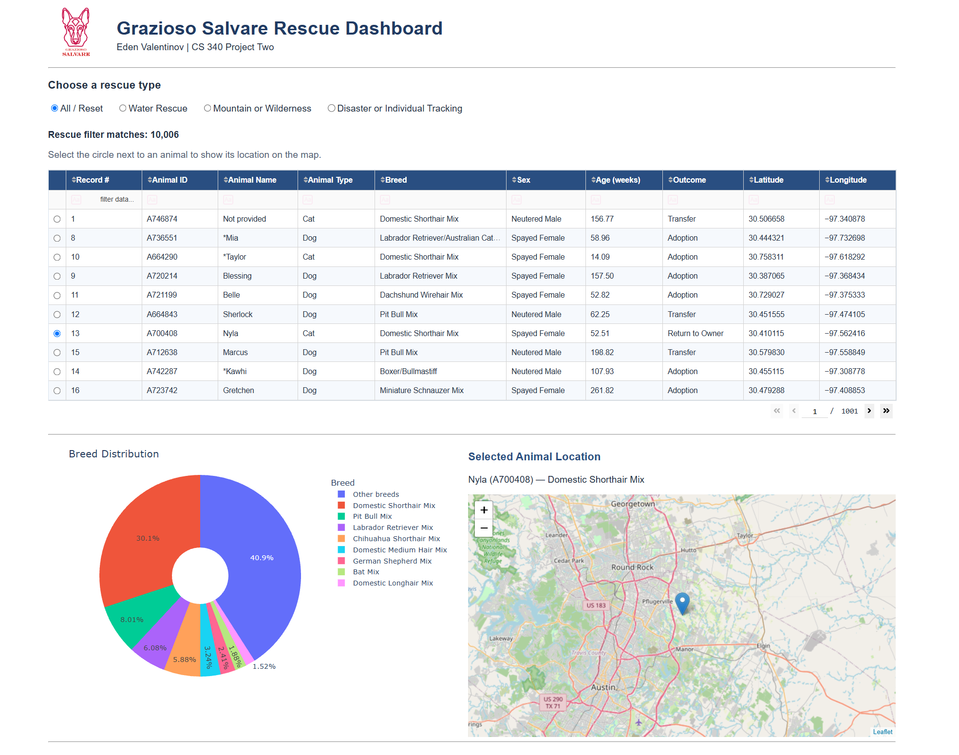

No matching records
Figure 6. An unmatched table filter leaves no visible rows. Both charts clear, and the map reports that no location matches instead of displaying old results.
