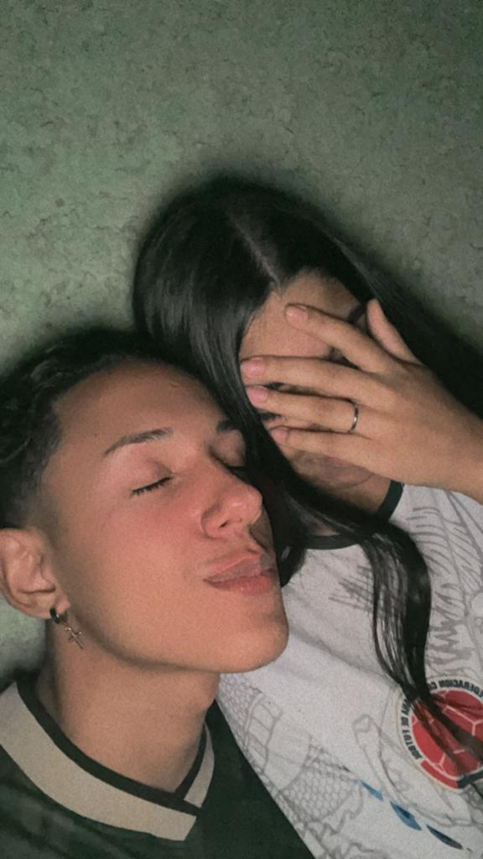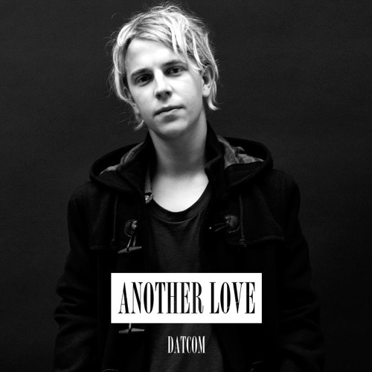 

“E essa foi a menos pior em kkkkkkkkkk”

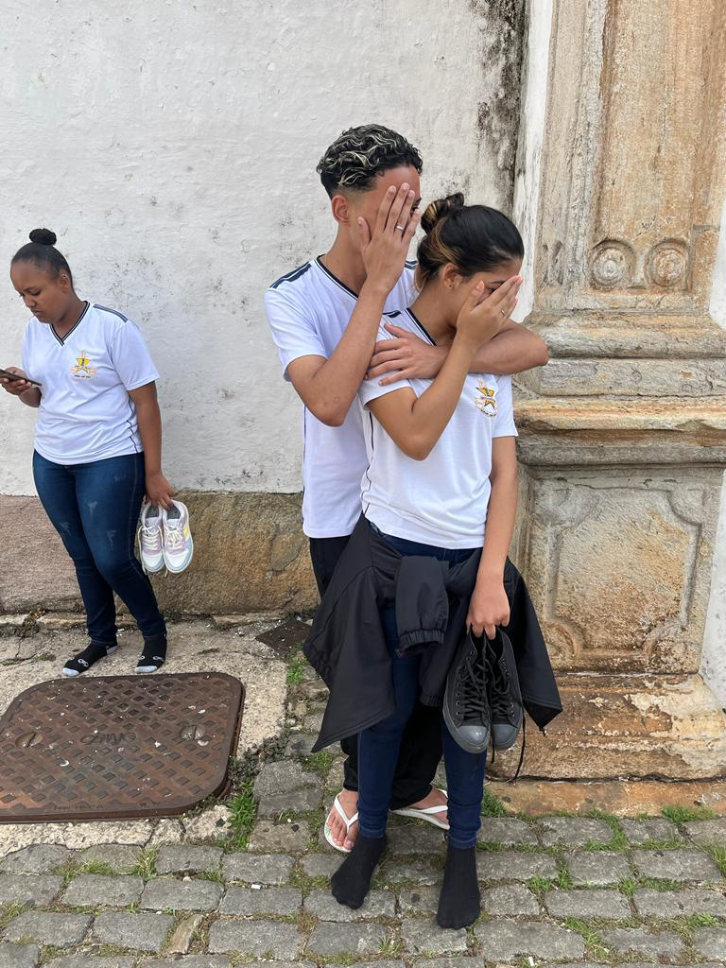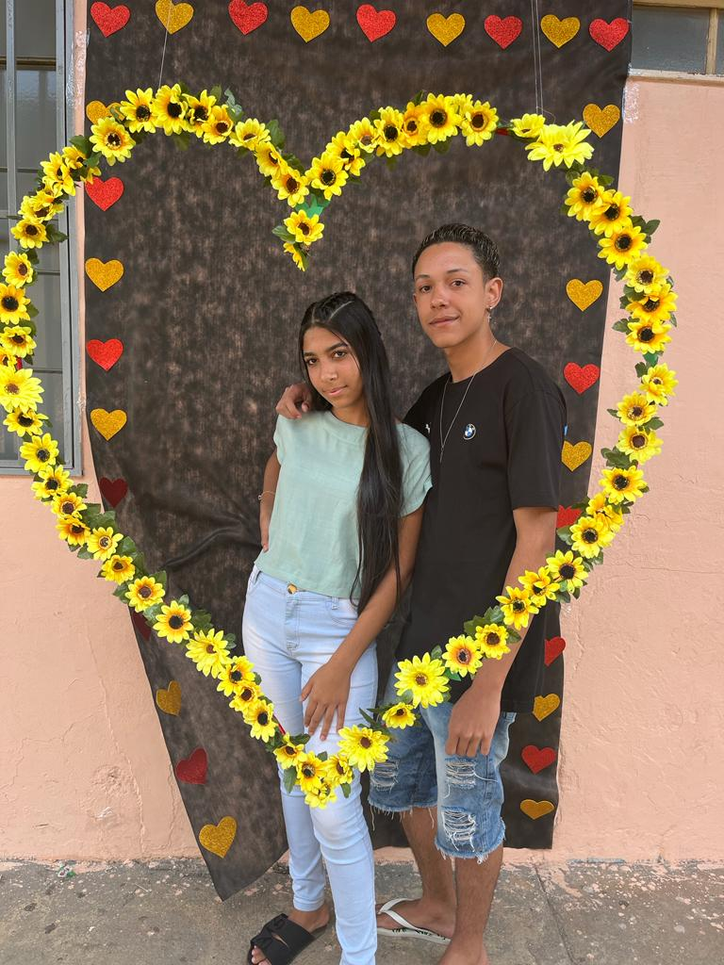 

“Nossa primeira foto”

“Pega meu chinelo”   
“Deixa que eu te carrego”

_______________

_______________

_______________

_______________

_______________

_______________

27.08.2022

_______________

_______________

_______________

_______________

_______________

_______________

09.12.2022

_______________

_______________

_______________

_______________

_______________

_______________

28.05.2022

_______________

_______________

_______________

_______________

_______________

_______________

29.10.2022