EXERCISE 8
- How many unique salary packages does our company, bignet, offer?
12 unique salary.
SELECT DISTINCT salary FROM employee_data ORDER BY salary DESC;
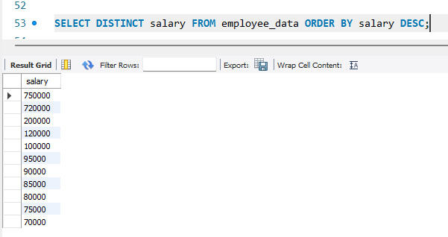
- How many distinct first name do we in our database?
21 unique f_names.
SELECT COUNT(DISTINCT f_name) AS distinct_first_names FROM employee_data;
