Edu-Track Installation Guide (Developer)
This guide explains how to set up the full development environment for the Edu-Track app: - Backend REST API (Spring Boot) - Frontend (React + Vite + TypeScript) - MySQL database via XAMPP
It is tailored to this repository structure: - Backend: edu-track/ (Spring Boot, Maven) - Frontend: results-amangement-system/ (Vite + React) - Docs: results-amangement-system/documentation/
Refer to the existing architecture diagrams for context: - results-amangement-system/documentation/system_architecture.svg - results-amangement-system/documentation/workflow.svg

Prerequisites
- Java 17 (required by Spring Boot)
- Maven 3.9+
- XAMPP (MySQL) or standalone MySQL 8.x
- Bun (recommended) or Node 18+ (Bun is used in scripts)
  - Install Bun: https://bun.sh
- Git
Verify versions:
java -version
mvn -v
bun -v # or node -v && npm -v

1) Database Setup (XAMPP MySQL)
- Start XAMPP Control Panel.
- Start the MySQL service.
- Open phpMyAdmin (http://localhost/phpmyadmin) or use MySQL CLI.
- Create the database:
- CREATE DATABASE edu_track CHARACTER SET utf8mb4 COLLATE utf8mb4_unicode_ci;
- Credentials used by the backend are configured in edu-track/src/main/resources/application.properties:
- spring.datasource.jdbc-url=jdbc:mysql://localhost:3306/edu_track
spring.datasource.username=root
spring.datasource.password=
  - If your MySQL root has a password, set spring.datasource.password=<your_password>.
  - If you prefer a non-root user, create one and grant rights:
  - CREATE USER 'edutrack'@'%' IDENTIFIED BY 'strong_password';
GRANT ALL PRIVILEGES ON edu_track.* TO 'edutrack'@'%';
FLUSH PRIVILEGES;
  - Then update username and password accordingly.
- Schema/migrations:
  - The project currently has spring.jpa.hibernate.ddl-auto=none (no auto schema creation).
  - For local development you have two options:
    - Option A (recommended for dev): temporarily set ddl-auto=update to let Hibernate create/update tables automatically.
    - # change this locally during development only
spring.jpa.hibernate.ddl-auto=update
    - Remember to revert to none before committing to production.
    - Option B: use provided SQL once available (not present in repo now). If you have an export, import it into edu_track.

2) Backend API Setup (Spring Boot)
Project: edu-track/
Key configuration: - Port: server.port=8080 (see application.properties) - DB: MySQL at localhost:3306, DB edu_track - JWT: configured via app.jwt.* properties
Run the API:
# from repo root or any directory, run Maven in the backend folder
mvn -f edu-track\pom.xml spring-boot:run
Alternative (package and run):
mvn -f edu-track\pom.xml clean package
java -jar edu-track\target\edu-track-0.0.1-SNAPSHOT.jar
Verify: - API should start at http://127.0.0.1:8080 - Watch logs for successful DB connection
Common issues: - Access denied to DB: verify username/password and that DB edu_track exists. - Port 8080 in use: either stop the other service or change server.port in application.properties.

3) Frontend Setup (Vite + React)
Project: results-amangement-system/
Install dependencies (Bun):
bun install --cwd "results-amangement-system"
Start dev server:
bun run --cwd "results-amangement-system" dev
Vite dev server runs at: http://127.0.0.1:5173 (default)
API proxy: - results-amangement-system/vite.config.ts proxies /api to the backend: ts server: { proxy: { "/api": { target: 'http://127.0.0.1:8080', changeOrigin: true, } } } - Keep the backend running on port 8080 for the proxy to work.
Build for production (optional):
bun run --cwd "results-amangement-system" build
bun run --cwd "results-amangement-system" preview

4) First Run: Creating a School and Users
Frontend routes use a /api prefix (proxied). Typical flow: 1. Open the app at http://127.0.0.1:5173 2. Register a school (see User Manual; route: src/routes/register-school.tsx). 3. Access system admin tools at /system-admin (see src/routes/system-admin/index.tsx) to review or manage schools. 4. For a given school subdomain, visit http://127.0.0.1:5173/<subdomain> to access the school’s landing page (see src/routes/$school/index.tsx). 5. School admins/teachers/guardians use the auth routes under /$school/auth/.

5) Suggested Local Development Settings
- Keep spring.jpa.hibernate.ddl-auto=update during iterative development to avoid manual schema changes.
- Create some seed data using the UI and then export the DB via phpMyAdmin for teammates.
- Consider adding Flyway or Liquibase later for versioned migrations.

6) Troubleshooting
- 404s to /api/... from the frontend:
  - Ensure backend is running and reachable at http://127.0.0.1:8080.
  - Ensure Vite dev server started without errors and proxy section exists in vite.config.ts.
- CORS errors when not using Vite dev server:
  - Use the Vite proxy during development or configure CORS in Spring Boot.
- Blank page or React errors:
  - Run bun install again, clear cache, check browser console.
- MySQL service not starting in XAMPP:
  - Ensure no conflicting MySQL service is running. Try changing the MySQL port in XAMPP and update JDBC URL accordingly.

7) Optional: Directory Quick Reference
- Backend
  - edu-track/pom.xml – Spring Boot 3.4.5, JPA, Web, Validation, MySQL
  - edu-track/src/main/resources/application.properties – DB, JWT, port
- Frontend
  - results-amangement-system/package.json – scripts (Bun + Vite)
  - results-amangement-system/vite.config.ts – /api proxy to 8080
  - results-amangement-system/src/routes/ – app routes (admin/teacher/guardian flows)

8) Visuals and Screenshots
Place UI screenshots under results-amangement-system/public/manual-images/ and reference them in docs. Examples (add these images after you capture them): - 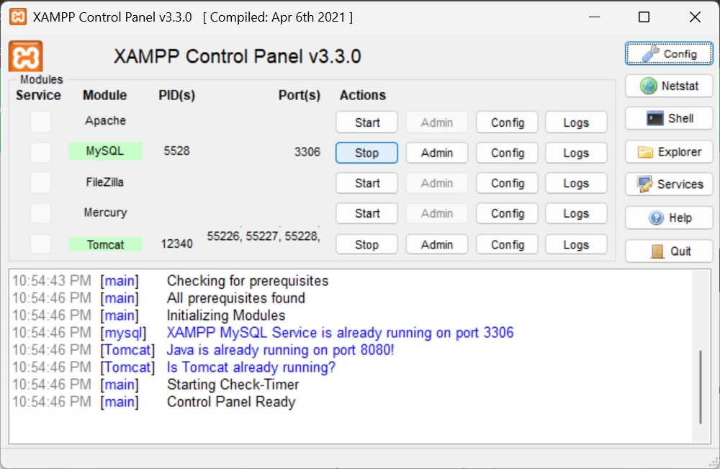 - Create Database in phpMyAdmin - 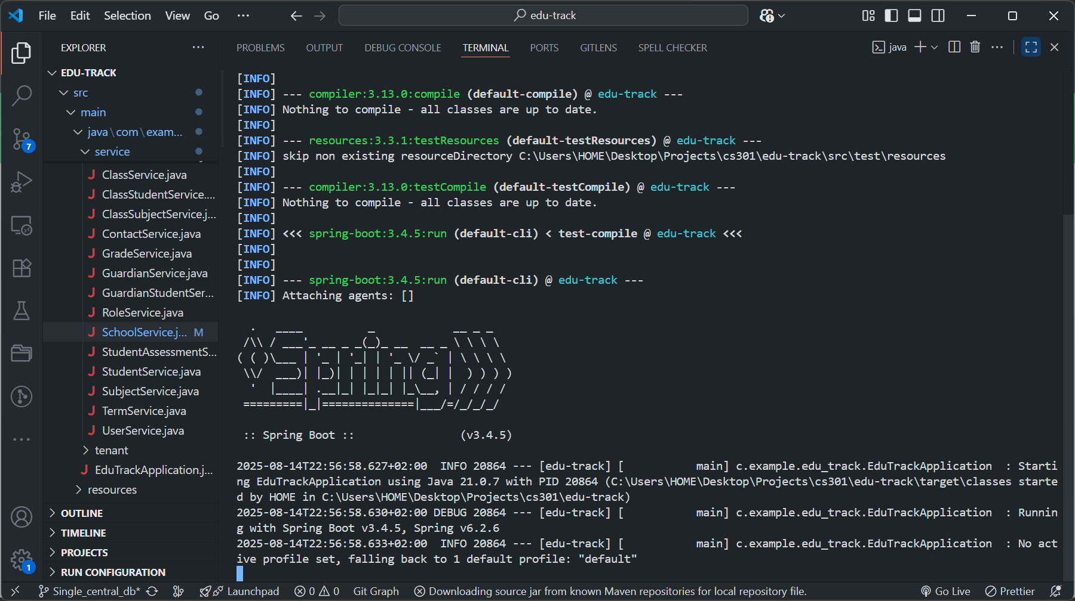 - 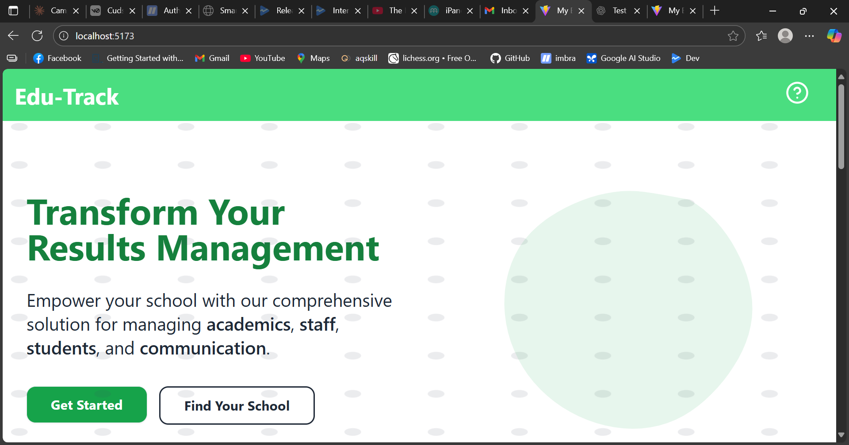
Tip: Use descriptive filenames and keep arrows/annotations in images for clarity.

