Edu-Track User Manual
This manual explains how end-users interact with the Edu-Track application: - System Admins (manage schools on the platform) - School Admins (configure a specific school) - Teachers (manage classes and assessments) - Guardians (view and interact with their ward’s records)
It references the app’s routes found under results-amangement-system/src/routes/ and aligns with the current UI.
Images are referenced as placeholders in results-amangement-system/public/manual-images/. Replace them with actual screenshots as you capture them.

1) Getting Started
- App URL during development: http://127.0.0.1:5173
- API is proxied from the frontend to the backend at http://127.0.0.1:8080 via Vite (see vite.config.ts).
Navigation overview: - Home/Landing: / - Register a School: /register-school (see src/routes/register-school.tsx) - System Admin console: /system-admin (see src/routes/system-admin/index.tsx) - School context: /<school-subdomain> (see src/routes/$school/index.tsx) - School dashboard (role-based areas): /<school-subdomain>/dashboard/... - Auth: /<school-subdomain>/auth/... (login/register flows)

2) Registering a School (First-time Setup)
Any user can request to register a new school on the platform.
Steps: 1. Visit http://127.0.0.1:5173/register-school. 2. Fill in the school details form (name, subdomain, contact info, etc.). 3. Submit the form. 4. The school record appears in the System Admin console for review.
Visuals to capture: - 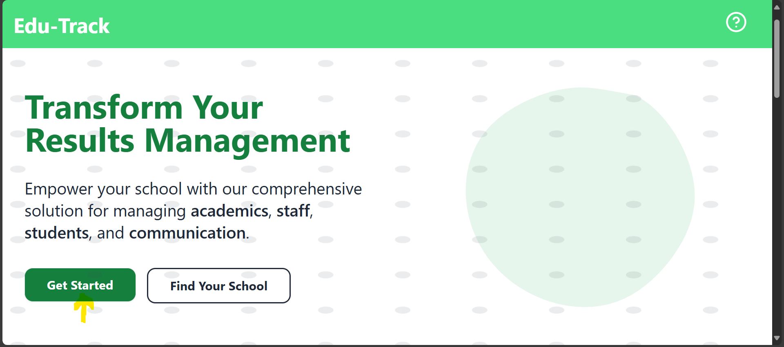 - 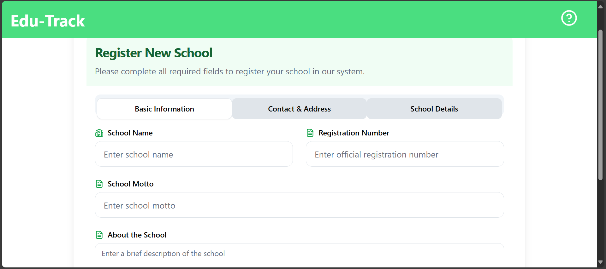 - Registration Success
Relevant code: src/routes/register-school.tsx (uses POST /api/schools/).

3) System Admin Use Cases
System Admins oversee all schools on the platform.
Access: - Go to /system-admin.
Key actions (see src/routes/system-admin/index.tsx): - View list of schools (GET /api/schools/). - Open a school details panel (GET /api/schools/{id}). - Search a system admin by email (GET /api/system-admins/email/{email}). - Perform actions such as approving or updating a school.
Typical workflow: 1. Open /system-admin and load schools. 2. Review new school registrations. 3. Approve/activate the school. 4. Communicate credentials or onboarding steps to the School Admin.
Visuals to capture: - 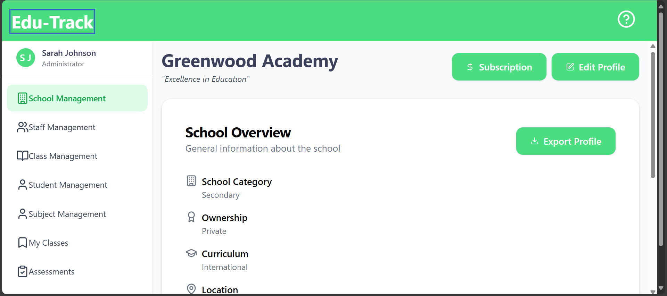 - School Details

4) School Admin Use Cases
A School Admin configures and manages a specific school’s data. Enter the school via its subdomain path: - http://127.0.0.1:5173/<subdomain> - Dashboard routes: /<subdomain>/dashboard/...
Common areas and actions:
- School Profile (see src/routes/$school/dashboard/school/index.tsx)
  - View or update school details (/api/schools/{id} and /api/schools/{subdomain}/subdomain).
  - Visuals:
    - School Profile
    - School Profile
- Staff Management (see src/routes/$school/dashboard/staff-management/)
  - View users/staff: GET /api/{school}/users/
  - Assign roles: GET /api/{school}/roles/ and PUT /api/users/{userId}/role
  - Update personal details/password: PUT /api/users/{userId}/personal-details, PUT /api/users/{userId}/password
  - Visuals:
    - 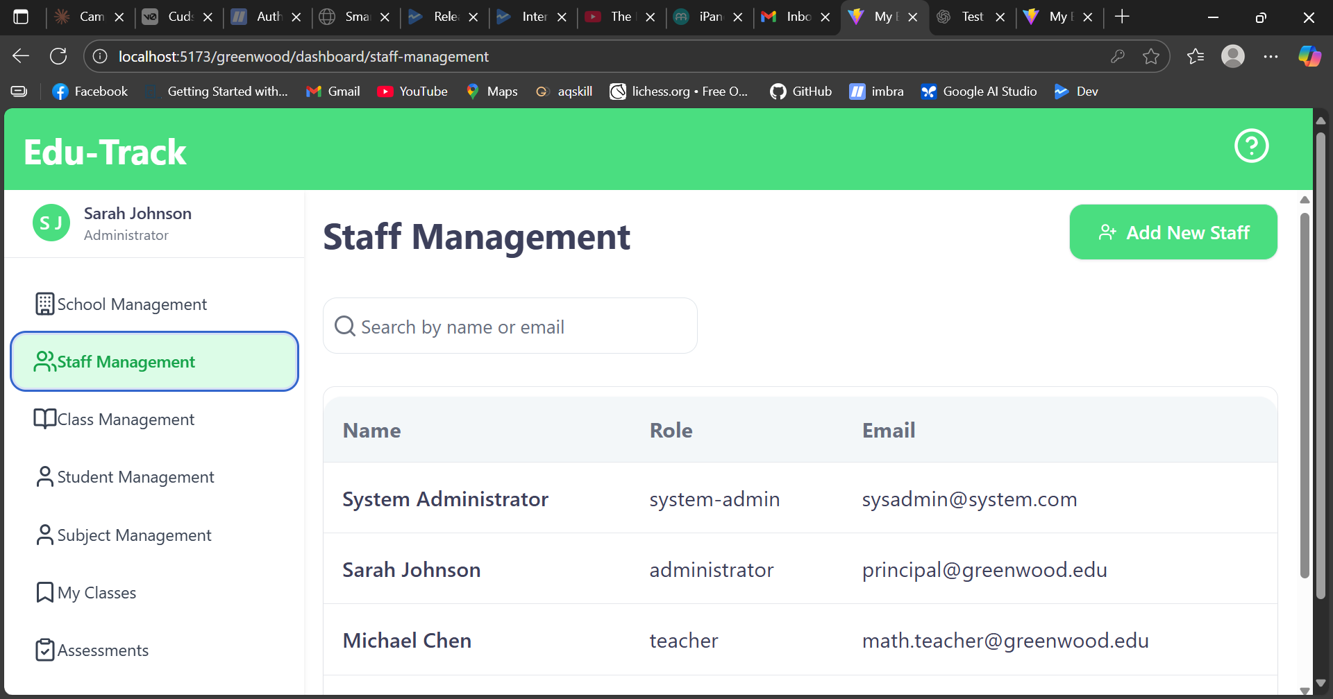
    - Staff List
    - 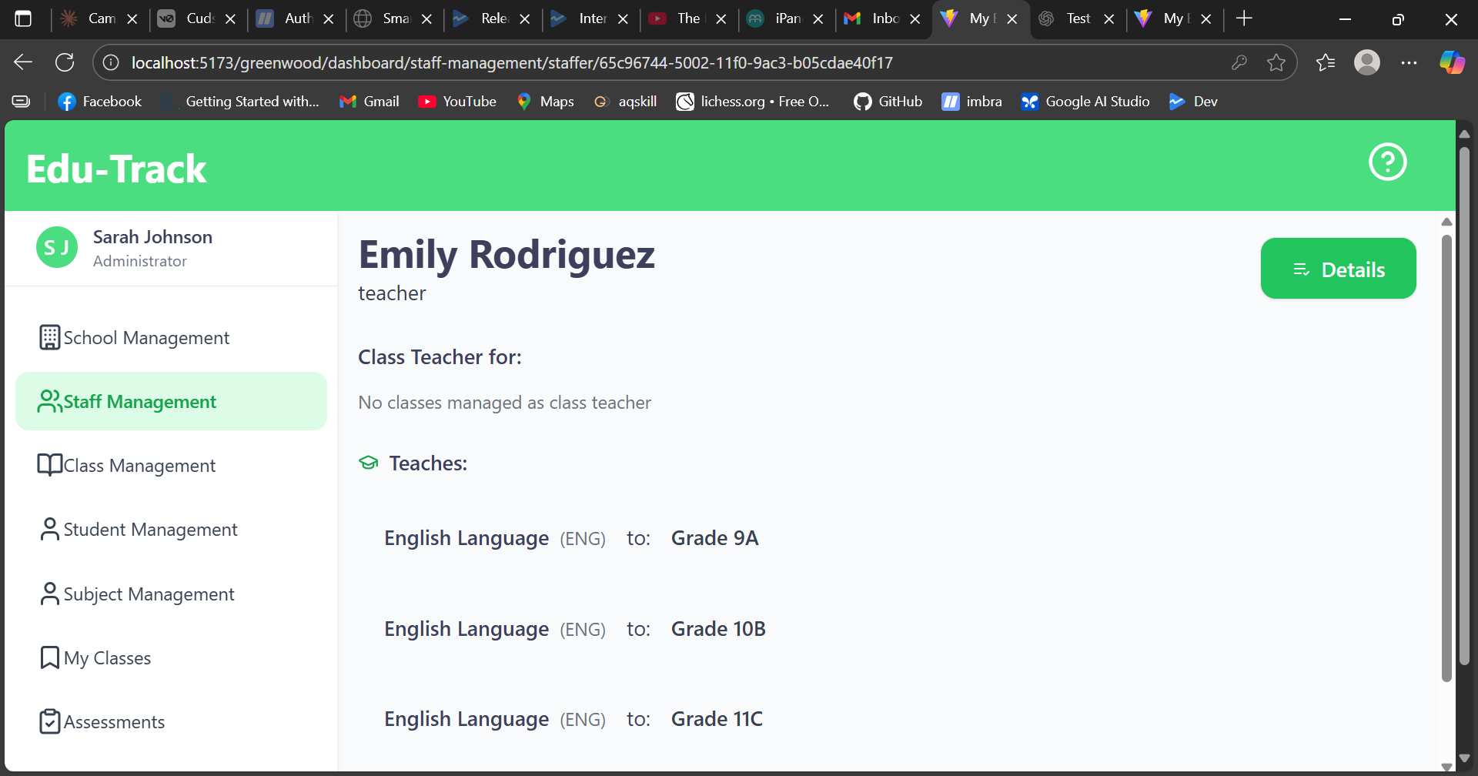
    - Edit Staff
- Subject Management (see src/routes/$school/dashboard/subject-management/index.tsx)
  - List subjects: GET /api/{school}/subjects/
  - Create/update subjects: POST/PUT /api/{school}/subjects/
  - Visuals:
    - 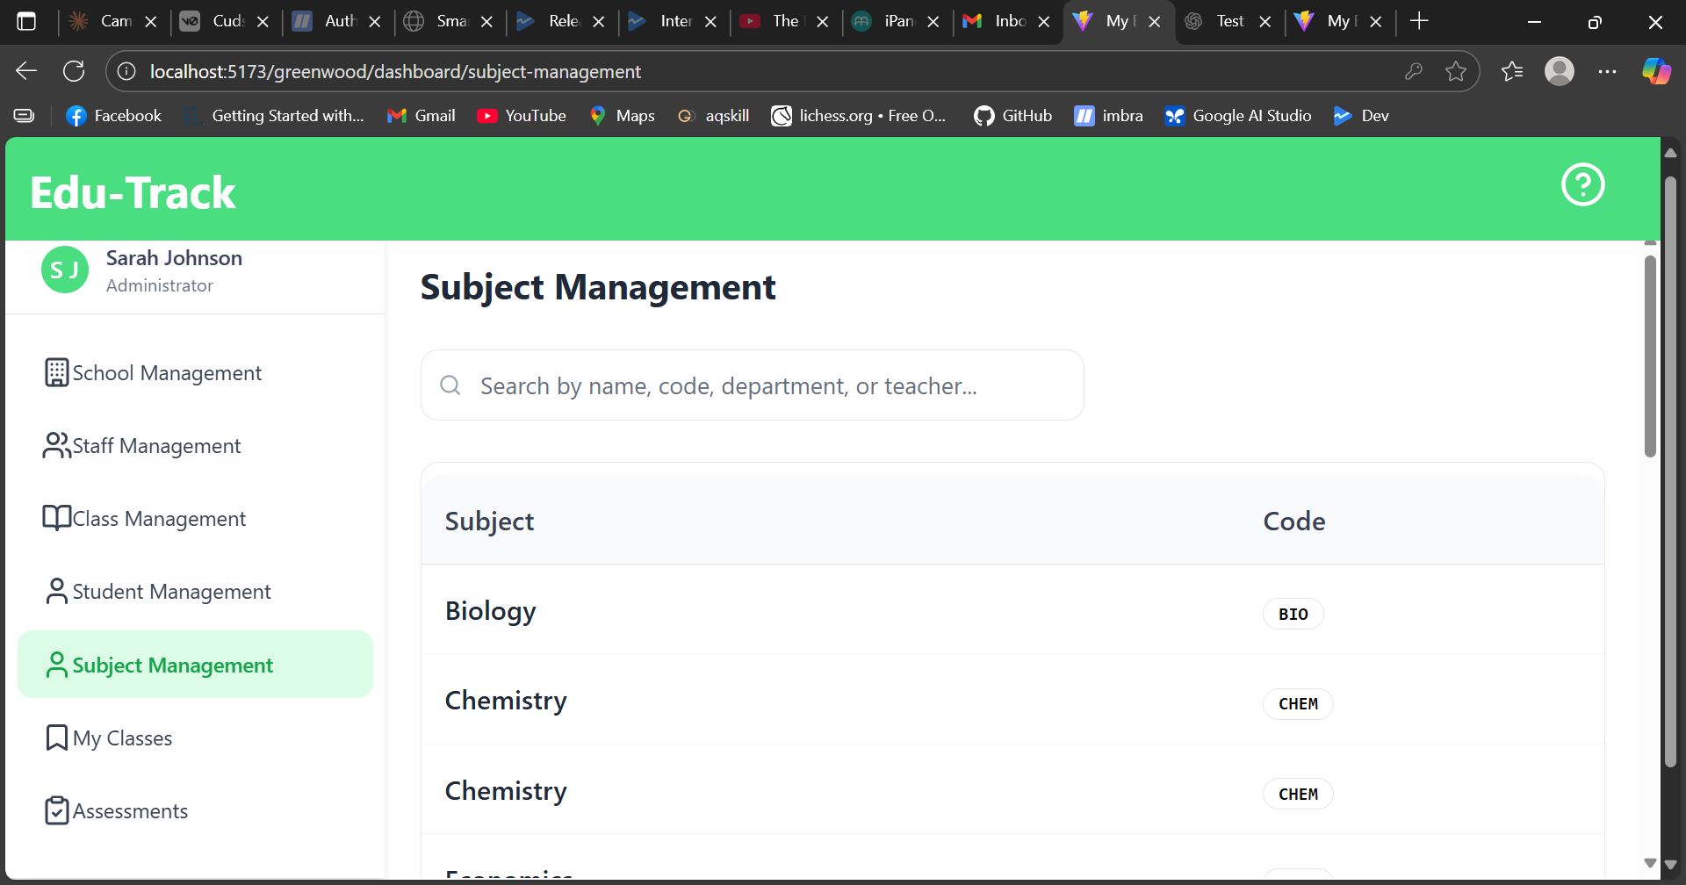
    - Subjects
- Class Management (see src/routes/$school/dashboard/class-management/)
  - List/Create classes: GET/POST /api/{school}/classes/
  - Assign teachers/subjects: combined calls to /api/{school}/users/ and /api/{school}/subjects/
  - Academic years and grades: GET /api/{school}/academic-years/, GET /api/{school}/grades/
  - Visuals:
    - 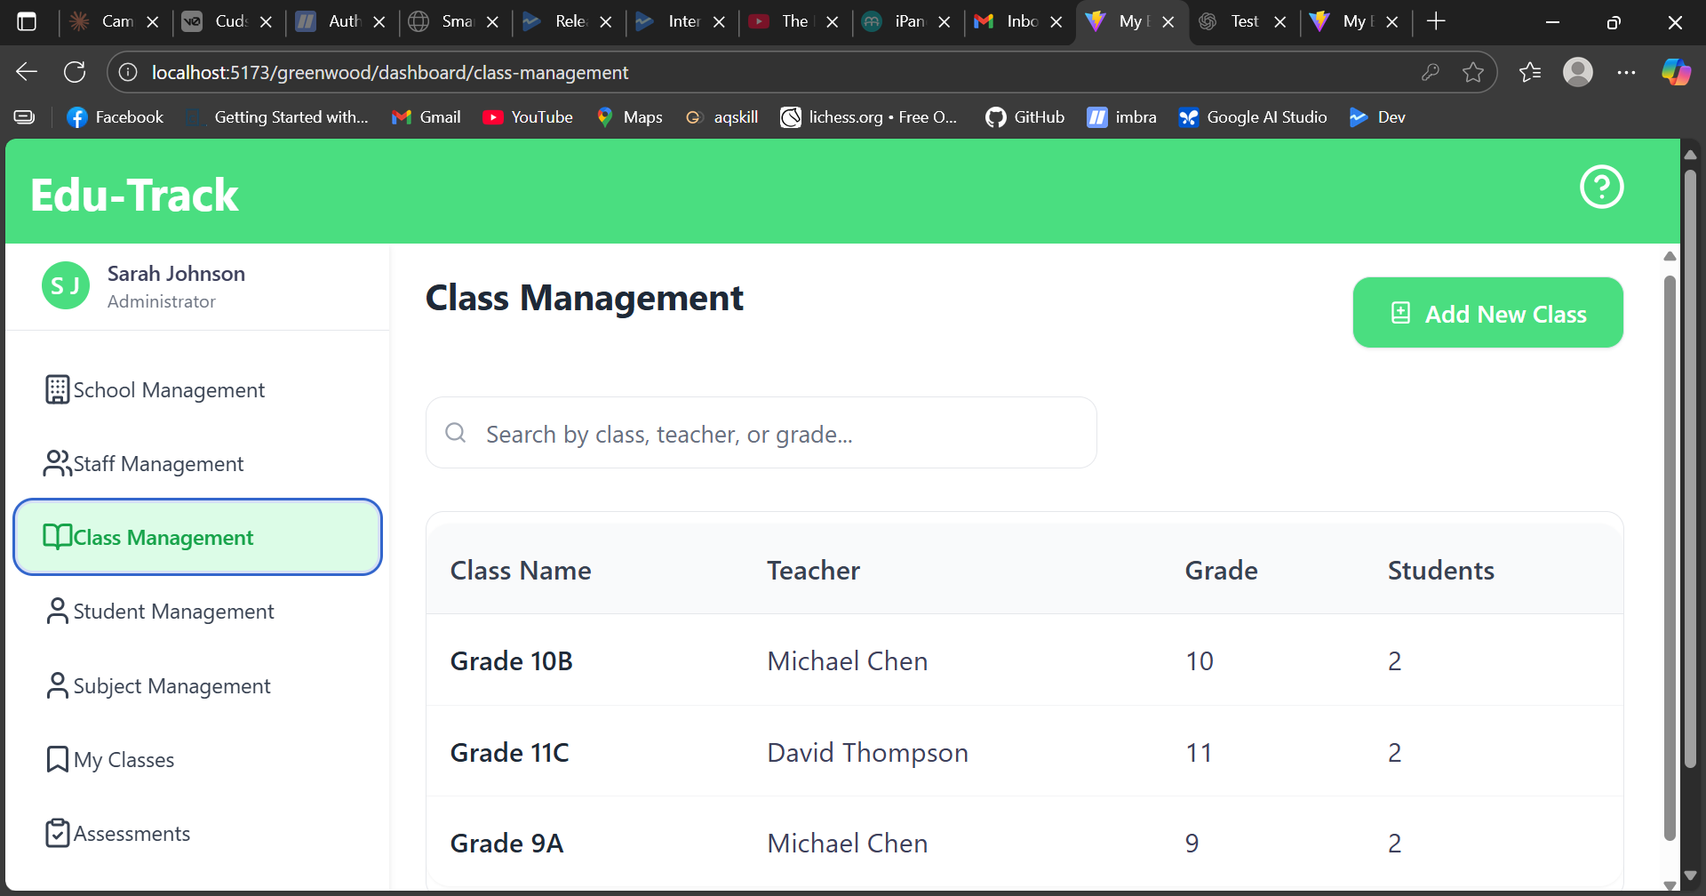
    - Classes
    - 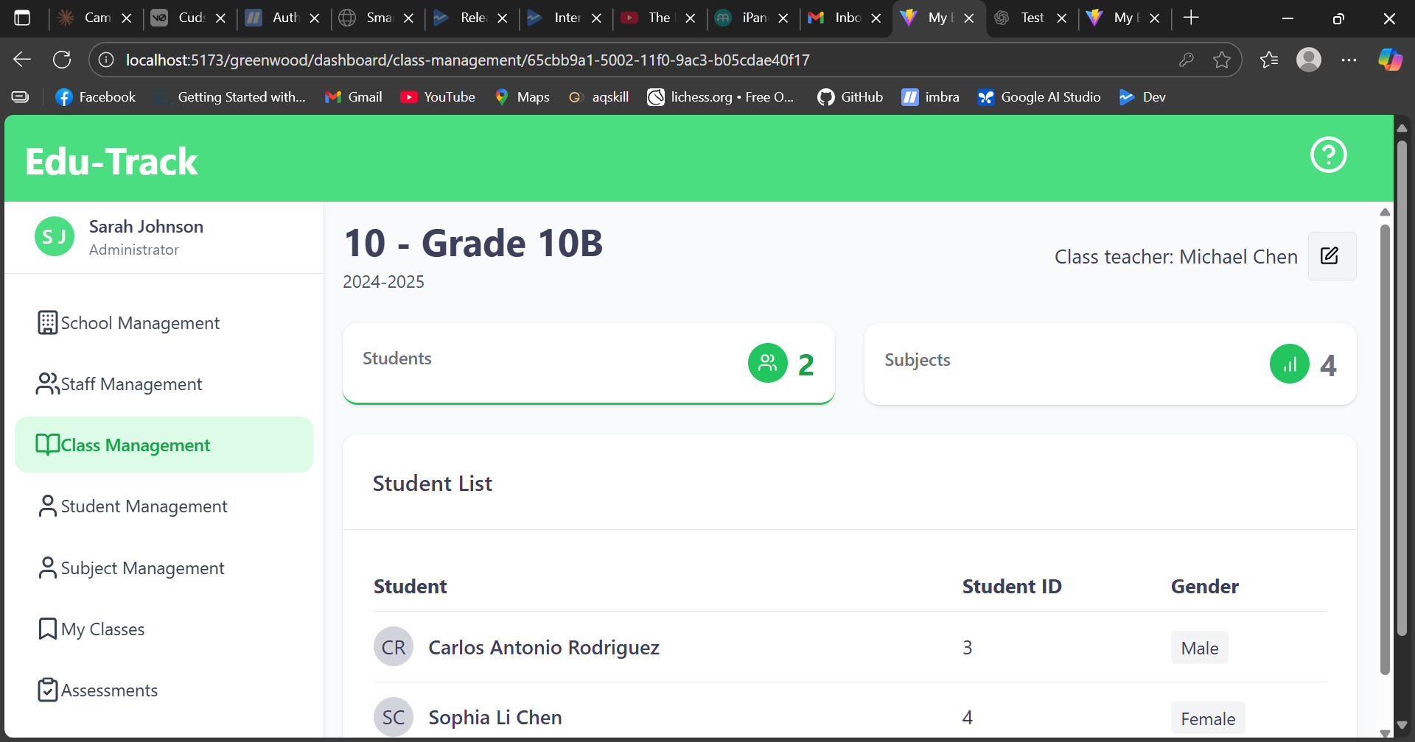
    - Assign Teacher/Subject
- Student Management (see src/routes/$school/dashboard/student-management/)
  - List students: GET /api/{school}/students/
  - View a student: GET /api/{school}/students/{id}
  - Create/update student profiles
  - Visuals:
    - 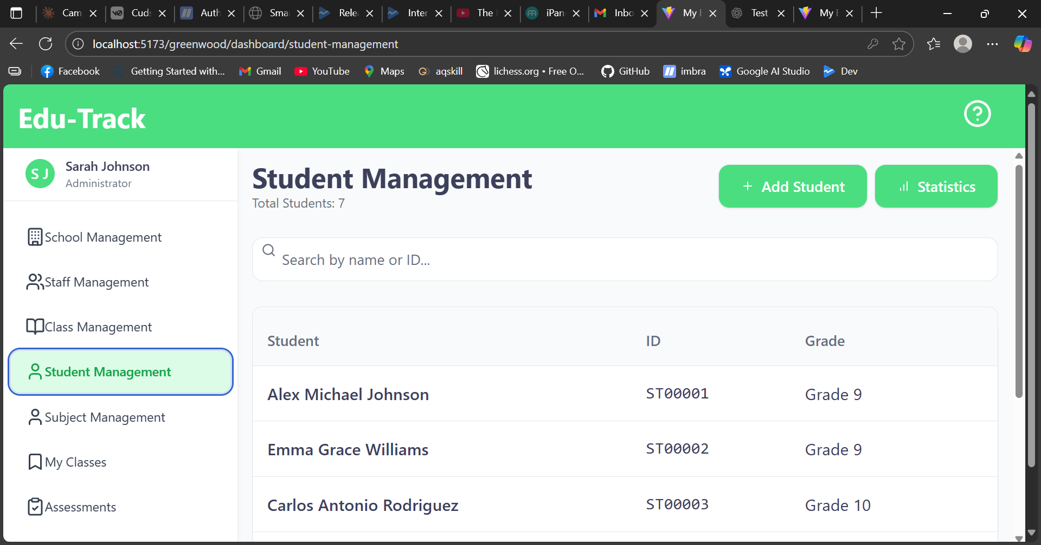
    - Students
    - 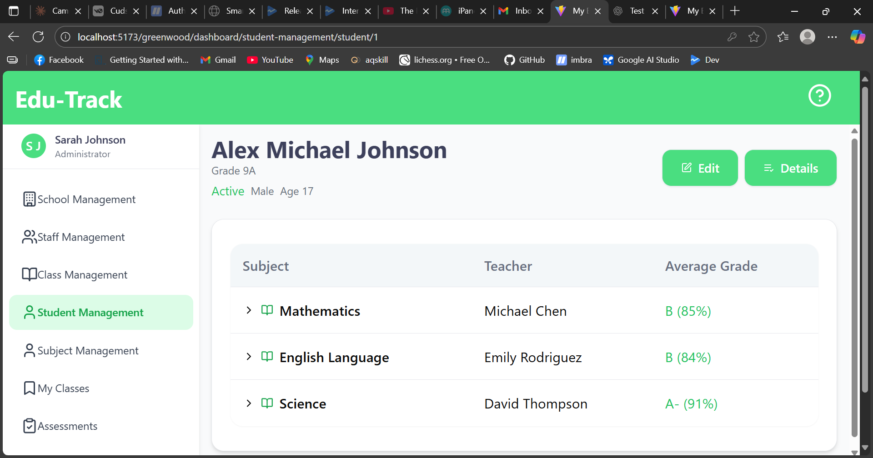
    - Student Details
- Assessments (see src/routes/$school/dashboard/assessments/index.tsx)
  - View/filter assessments for classes and subjects.
  - Create/record assessment entries for students.
  - Visuals:
    - 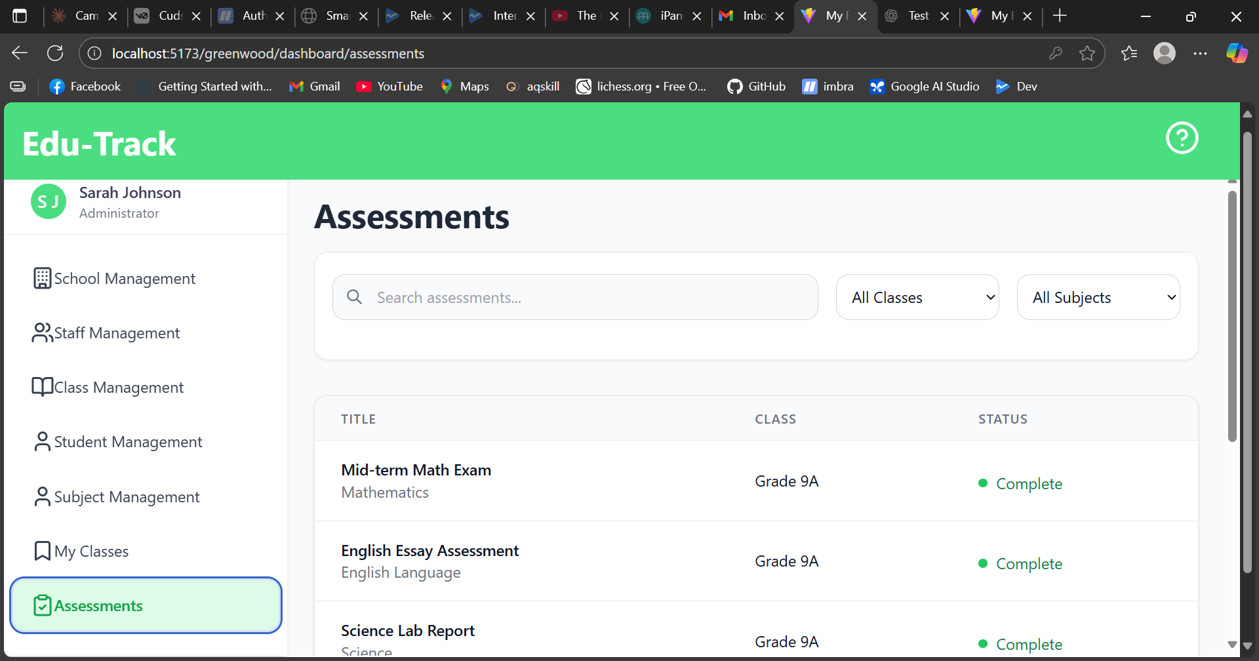
    - Assessments
Tips: - Use the Refresh/Retry controls in lists when changes don’t immediately appear. - Ensure the backend is running for all /api/... actions to work.

5) Teacher Use Cases
Teachers primarily manage their classes and assessments.
Access: - Visit /<subdomain>/dashboard/classes/ to see assigned classes (see src/routes/$school/dashboard/classes/index.tsx).
Common actions: - View class details: /<subdomain>/dashboard/classes/<classId> (src/routes/$school/dashboard/classes/$id/index.tsx) - View students in a class. - Enter/Update assessments for students (see the Assessments screens under the dashboard).
Steps example (recording an assessment): 1. Open your class page. 2. Select subject/assessment type. 3. Enter scores for students. 4. Save/submit. The data is stored via /api/{school}/... endpoints.
Visuals: - 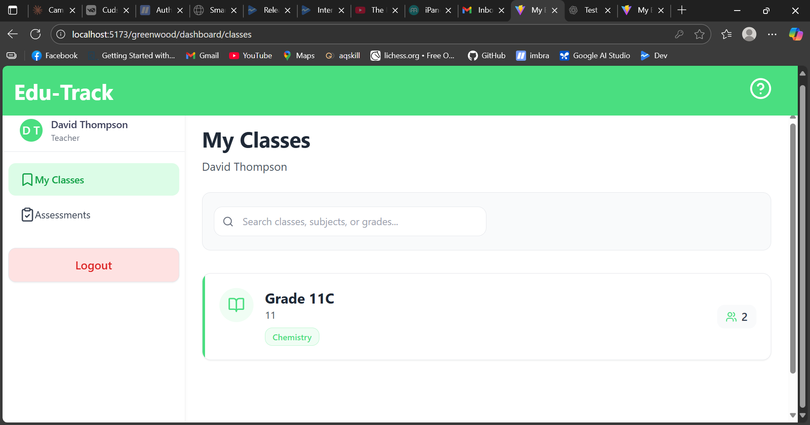 - 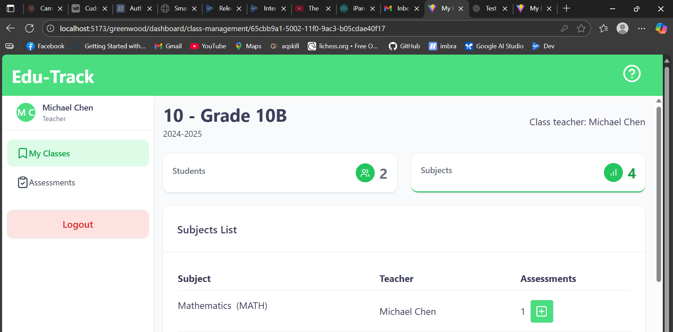 - 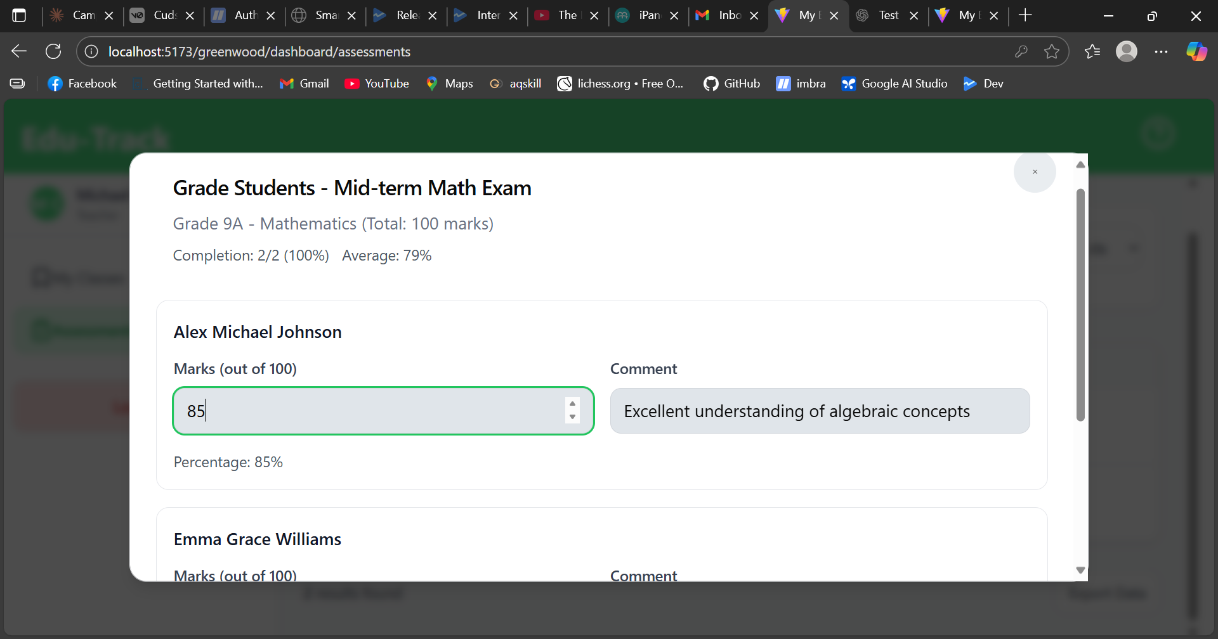

6) Guardian Use Cases
Guardians register and view their ward’s information and results.
Registration/Login: - Go to /<subdomain>/auth/register (see src/routes/$school/auth/register.tsx). - Registration may require a student identifier and guardian email. - Login at /<subdomain>/auth/login (see src/routes/$school/auth/login.tsx).
Common actions: - View student profile and class placement (see src/components/student-page.tsx and student-related routes). - View assessments or term results pages if provided by the school configuration.
Steps example (viewing a student): 1. Log in to your school portal: /<subdomain>/auth/login. 2. Navigate to your dashboard/home. 3. Open your child’s profile to view details and results.
Visuals: - Guardian Register - 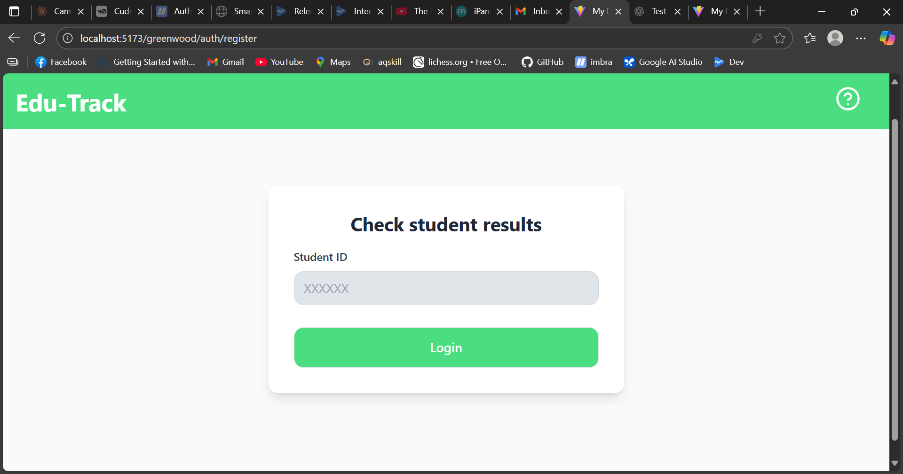 - 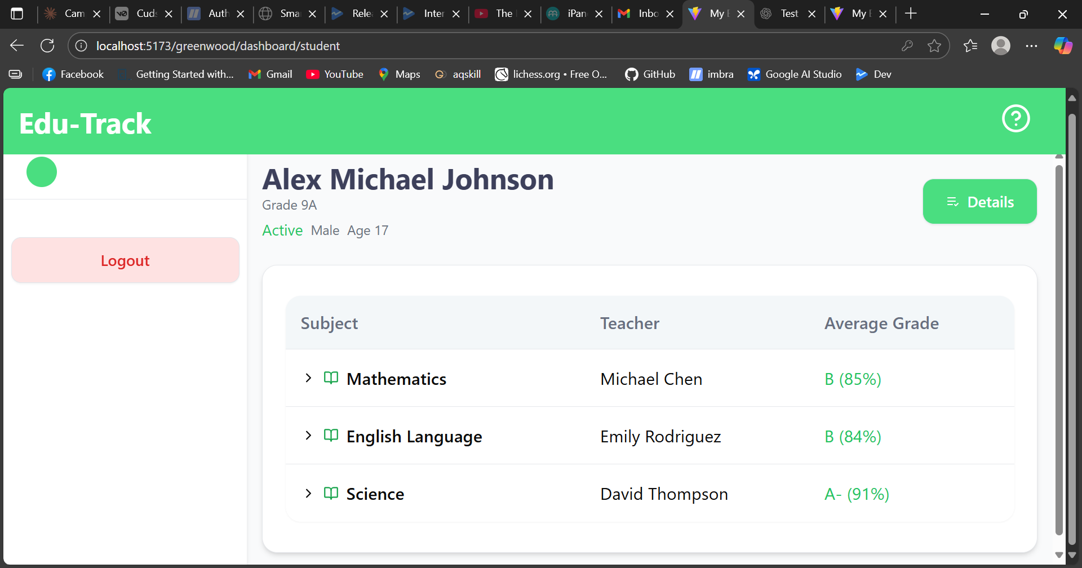

7) Authentication and Roles
- Authentication is handled via backend JWT (app.jwt.* in application.properties).
- Users are assigned roles (e.g., Admin, Teacher, Guardian) that control access to dashboard sections.
- If you cannot access a section, contact your School Admin to check your role assignments.

8) URLs Cheat Sheet
- Platform Home: /
- Register School: /register-school
- System Admin: /system-admin
- School Landing: /<subdomain>
- School Dashboard root: /<subdomain>/dashboard
- Classes: /<subdomain>/dashboard/classes
- Subjects: /<subdomain>/dashboard/subject-management
- Students: /<subdomain>/dashboard/student-management
- Staff: /<subdomain>/dashboard/staff-management
- Assessments: /<subdomain>/dashboard/assessments
- Auth Register: /<subdomain>/auth/register
- Auth Login: /<subdomain>/auth/login
Note: Exact labels may vary slightly in the UI.

9) Troubleshooting & Tips
- If lists are empty:
  - Click Retry/Refresh in the UI.
  - Ensure the backend API is running and database is connected.
- If you see an error banner:
  - Use any provided “Retry” button.
  - Capture a screenshot and contact your School Admin or System Admin.
- If your subdomain path (e.g., /my-school) doesn’t load:
  - Confirm the school was registered and approved.
  - Verify the correct subdomain spelling.

10) Visuals and How to Update This Manual
- Store screenshots in results-amangement-system/public/manual-images/.
- Use clear names and add annotations (arrows/boxes) for clarity.
- After placing images, ensure the relative links in this manual render correctly.
Example placeholders to replace: - 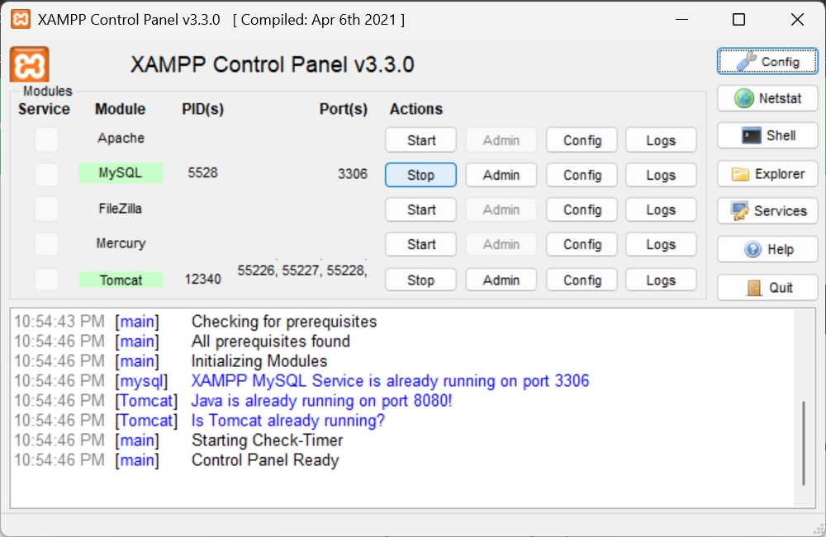 - 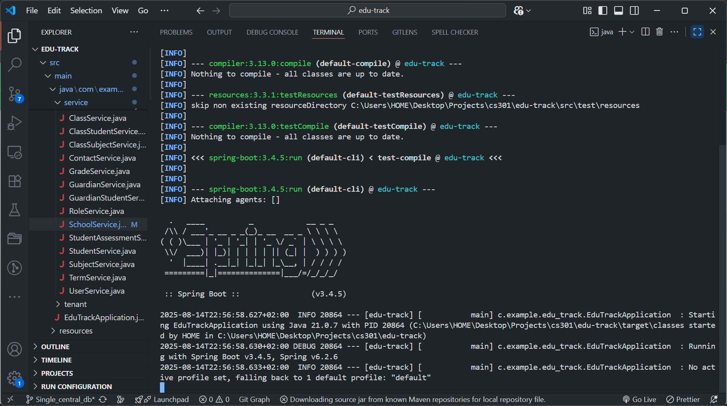 - 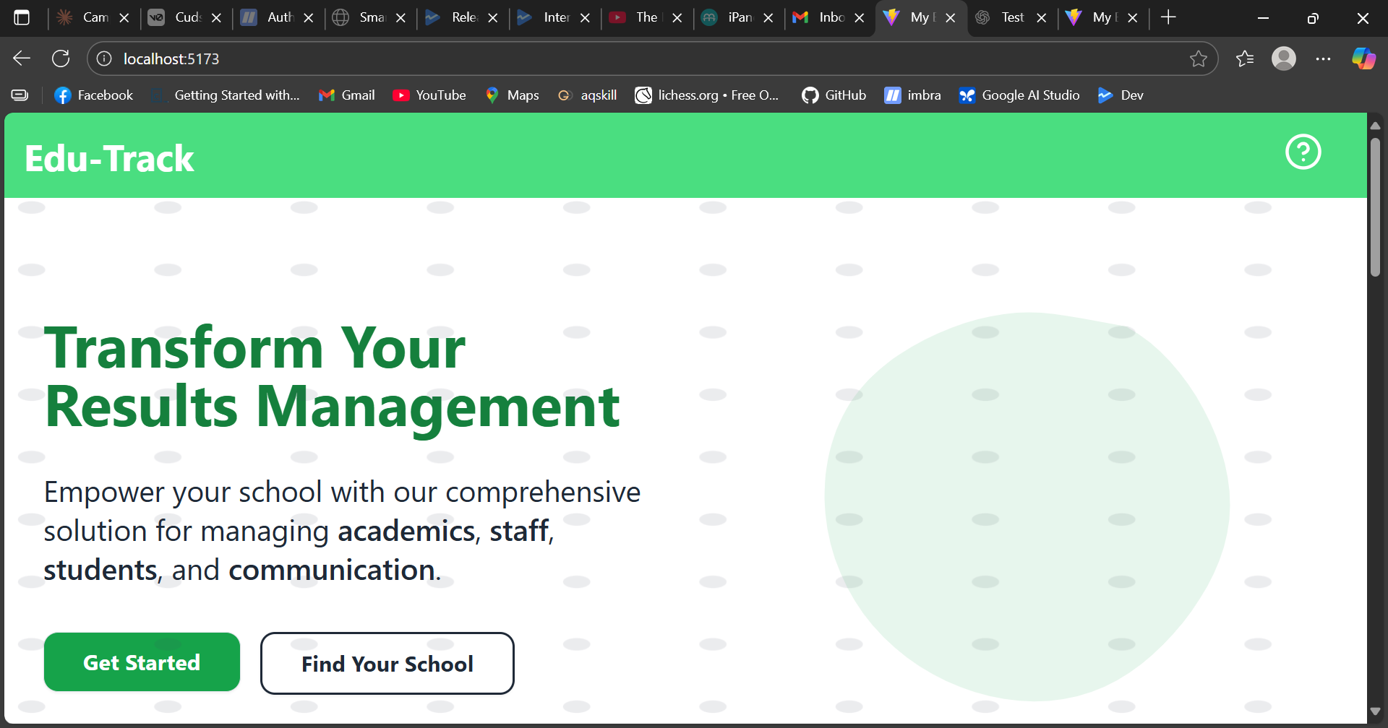

11) Feedback
If something in this manual doesn’t match the UI or you need additional steps, please report it to the development team so we can update the documentation.

