EVlert Official Change Log

(Debugging and Instructions Log)

Spresense Write Up: <https://docs.google.com/document/d/1cHBwsehvIXRTZQCubzxj_toqcKmab2Whq9DGKfKOazg/edit>

BOM:

|  |  |  |
| --- | --- | --- |
| ITEM | COST | TOTAL |
| Spresense Main Board | 65.00$ | /////////////////////////////// |
| Spresense LTE Extension | 99.95$ | /////////////////////////////// |
| Ultrasonic Sensor(s) | 13.50$ | /////////////////////////////// |
| 1.753D Printing PLA Filament | 24.99$ | /////////////////////////////// |
| Arduino Software | 0.00$ | /////////////////////////////// |
| /////////////////////////////// | Misc. | 203.44$ |

**I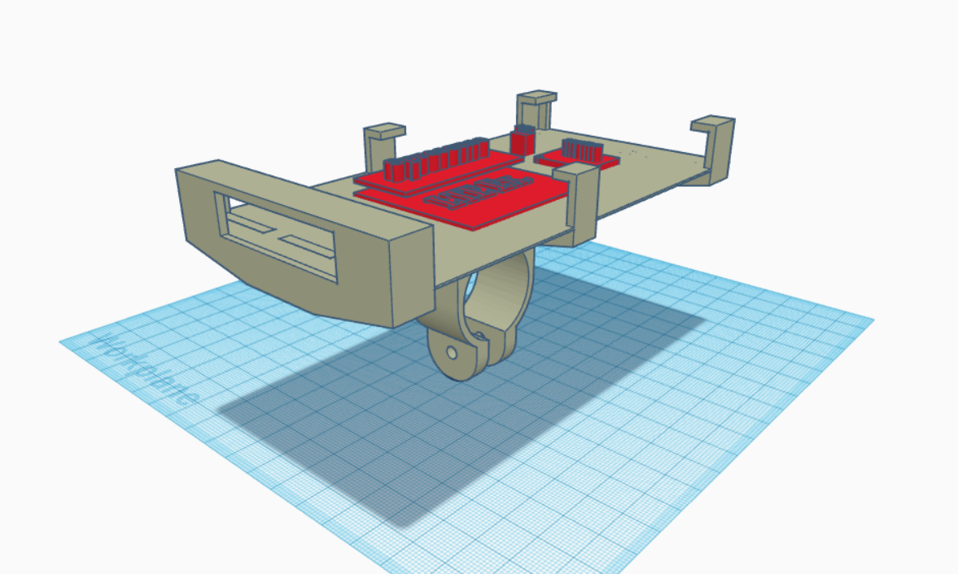nitial Design Choices:**

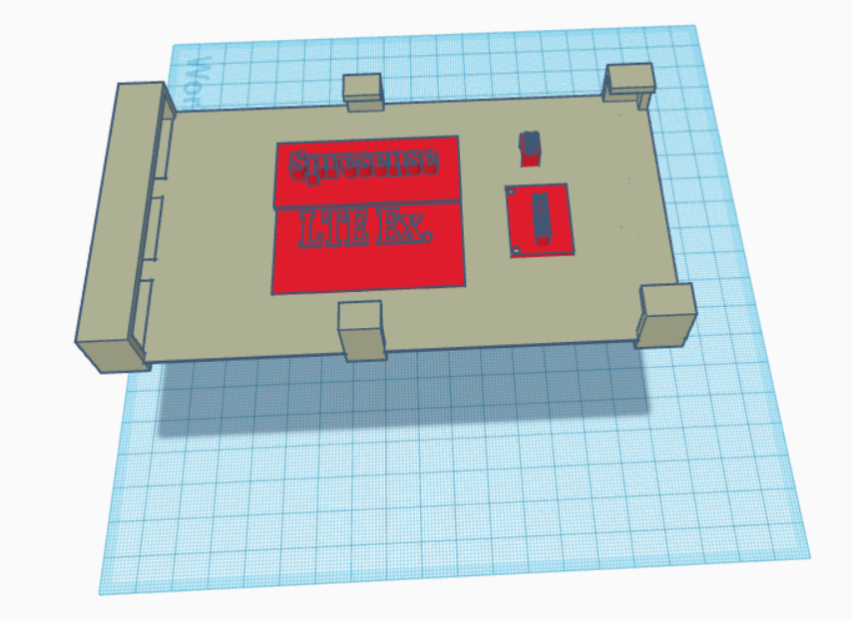

**Wiring Diagrams for Reference:**

**These images contain pins we used for the gyroscope and so on…**

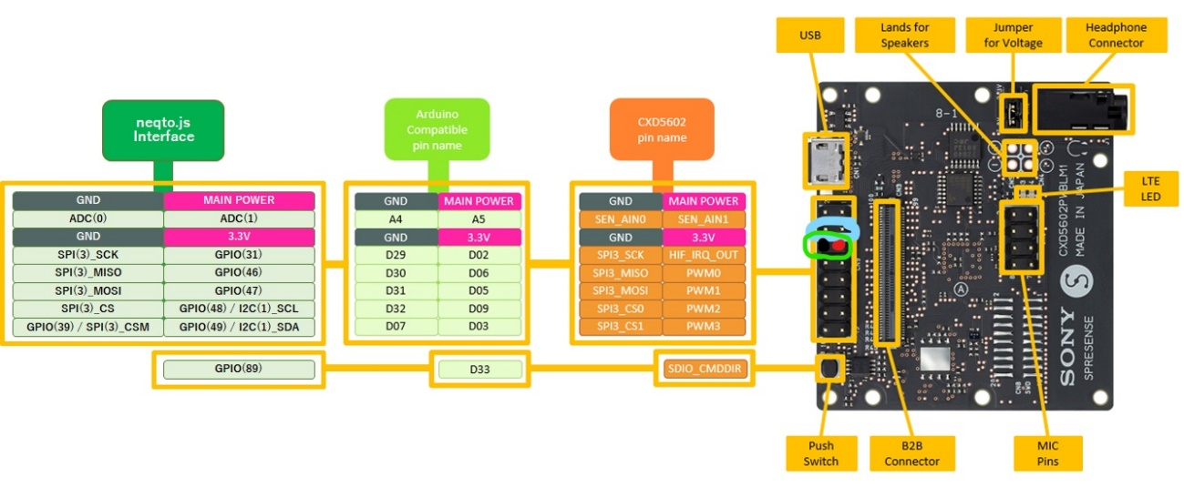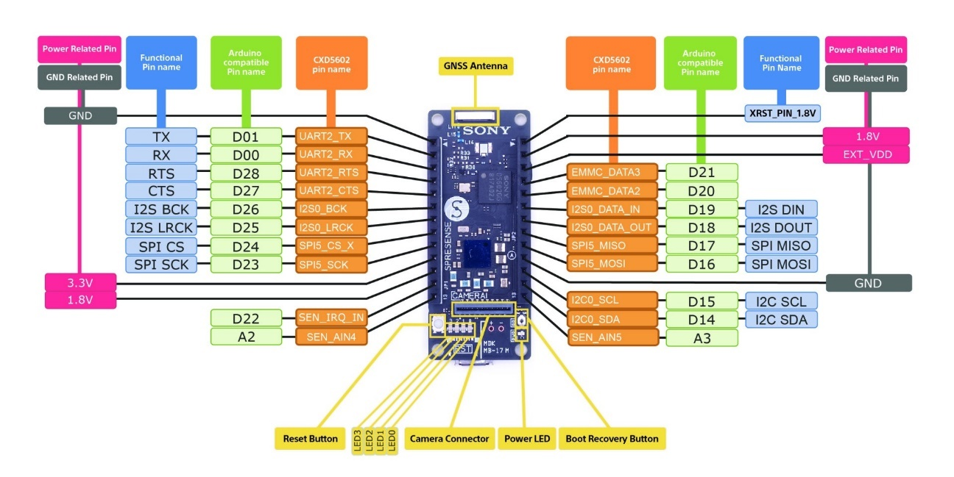

Debugging in the development of the project:

Error finding and collecting data 🡪 MPU 6050 with Spresense and Arduino:

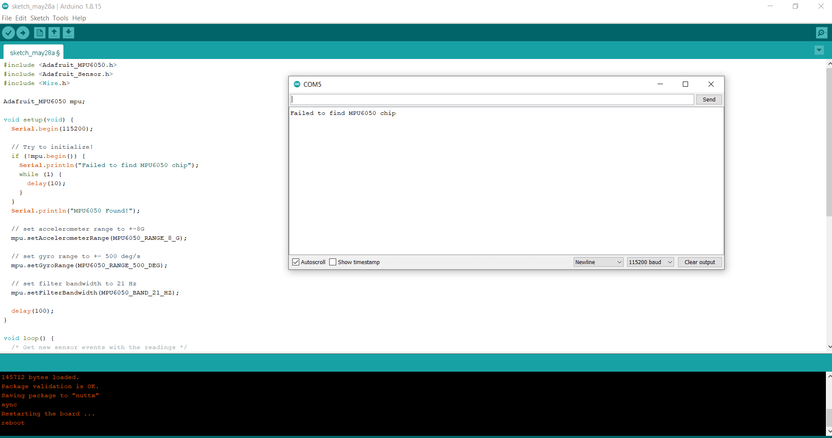

Attempt Solution 1: We tried to switch SCL and SDA pins on the MPU 6050. Did not work for detection. May have made it worse.

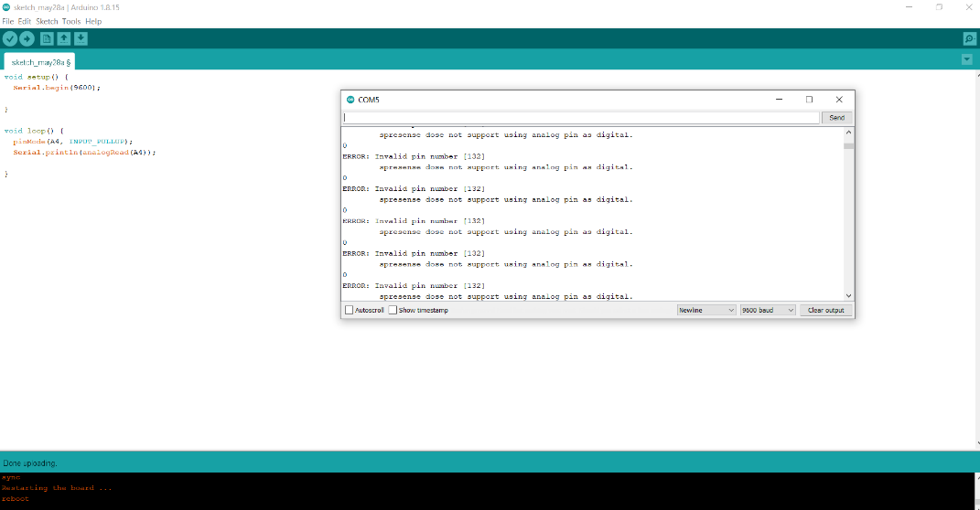

Attempt Solution 2: Turn on resistor within the Arduino that sends data to A4 pin and it said that it wanted us to use digital pins. Failed to accept pin input MPU6050.

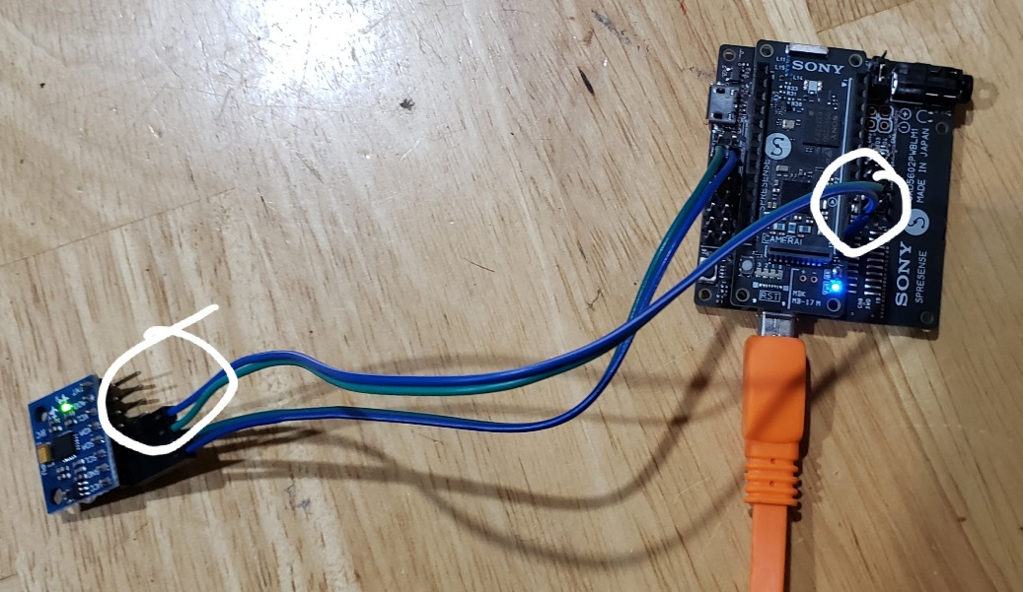Attempt Solution 3: The Main Board (Spresense) contains i2c SCL and SDA Pins for Arduino hardware such as the MPU 6050. We swapped our A4 and A5 Pins with the D15 (SCL) and D14 (SDA) pins and we were able to get raw rotation data.

Error looping timed audio prompt:

Attempt 1 Failed: moved the

int err = theAudio->writeFrames(AudioClass::Player0, myFile);

//other error functions

Into its own function, void play().

Attempt 2 Solution:

This failed so the first line above, the int err, needs to be looped because it is constantly sending audio frames to the spresense. So I placed it into a while(1) loop, inside the void play() and broke out of the loop when the file ends, the audio is played except that it didn’t restart when I called play() again the issue must be that once the file ends, I have to restart the file again from the beginning sort of rewinding.

