CSVTimer

Overview:

I have created 2 project, one for reading from CSV file and parsing json into the API. Another project is for taking JSONs, storing the in the database and getting all data or specific one by Customer reference.

Getting started:

Run “AspNetRestAPI” and it should open in the browser window (with Swagger). Run the “CSVReader” (it will use “Test.csv” located in Resources folder).

Breakdown:

CSVReader – it starts with reading the information from the csv file with StreamReader. Then for all lines (until line is null) it will create a class “CSVData” using the splitter in CSVData.FromCsv:

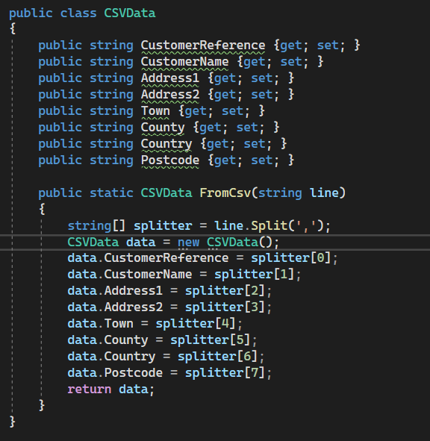

It will send it to “SendLineAsync” where data will be serialized, converted to Json and posted to the API using HttpClient.

AspNetRestAPI – I’ve started with creating Customer Model, also defining CustomerReference as Key (to find data using that property). I’ve set up and connected In-memory database (EntityFrameworkCore.InMemory), created ApiContext to process it. Lastly, I’ve created the controller where added “Post”, “Get” and “Getall” actions.