Titanic Survivor Analysis

Huma Abif

2023-07-09

## R Markdown

This is an analysis of the Titanic data taken from Kaggle. I use visualisation techniques to see how different demographics affected the passengers’ rate of survival.

## Extracting the data

library('tidyverse')

## ── Attaching core tidyverse packages ──────────────────────── tidyverse 2.0.0 ──  
## ✔ dplyr 1.1.2 ✔ readr 2.1.4  
## ✔ forcats 1.0.0 ✔ stringr 1.5.0  
## ✔ ggplot2 3.4.2 ✔ tibble 3.2.1  
## ✔ lubridate 1.9.2 ✔ tidyr 1.3.0  
## ✔ purrr 1.0.1   
## ── Conflicts ────────────────────────────────────────── tidyverse_conflicts() ──  
## ✖ dplyr::filter() masks stats::filter()  
## ✖ dplyr::lag() masks stats::lag()  
## ℹ Use the conflicted package (<http://conflicted.r-lib.org/>) to force all conflicts to become errors

library('readr')  
library('readxl')  
library('dplyr')  
library('ggplot2')  
library('ggthemes')  
library(hrbrthemes)

## NOTE: Either Arial Narrow or Roboto Condensed fonts are required to use these themes.  
## Please use hrbrthemes::import_roboto_condensed() to install Roboto Condensed and  
## if Arial Narrow is not on your system, please see https://bit.ly/arialnarrow

library('tinytex')  
train = read.csv("C:/Users/humaa/first folder/Desktop/Kaggle/titanic/train.csv")  
test = read.csv("C:/Users/humaa/first folder/Desktop/Kaggle/titanic/test.csv")  
gender = read.csv("C:/Users/humaa/first folder/Desktop/Kaggle/titanic/gender_submission.csv")

## Overview of the Data

We run some simple commands to understand the structure of our data

head(train)

## PassengerId Survived Pclass  
## 1 1 0 3  
## 2 2 1 1  
## 3 3 1 3  
## 4 4 1 1  
## 5 5 0 3  
## 6 6 0 3  
## Name Sex Age SibSp Parch  
## 1 Braund, Mr. Owen Harris male 22 1 0  
## 2 Cumings, Mrs. John Bradley (Florence Briggs Thayer) female 38 1 0  
## 3 Heikkinen, Miss. Laina female 26 0 0  
## 4 Futrelle, Mrs. Jacques Heath (Lily May Peel) female 35 1 0  
## 5 Allen, Mr. William Henry male 35 0 0  
## 6 Moran, Mr. James male NA 0 0  
## Ticket Fare Cabin Embarked  
## 1 A/5 21171 7.2500 S  
## 2 PC 17599 71.2833 C85 C  
## 3 STON/O2. 3101282 7.9250 S  
## 4 113803 53.1000 C123 S  
## 5 373450 8.0500 S  
## 6 330877 8.4583 Q

colnames(train)

## [1] "PassengerId" "Survived" "Pclass" "Name" "Sex"   
## [6] "Age" "SibSp" "Parch" "Ticket" "Fare"   
## [11] "Cabin" "Embarked"

## Analysing Data

First, we take a look at the number of survivors in each passenger class.

ggplot(data=train) + geom_bar(mapping = aes(x = as.factor(Survived), fill = as.factor(Survived)), show.legend = F) + facet_wrap(vars(Pclass) , labeller = as_labeller(c('1'='First Class','2'='Second Class','3'='Third Class')) ) + labs(x='Survived=1, Died=0', y = 'Number of people') + ggtitle('Titanic Survivor Analysis')

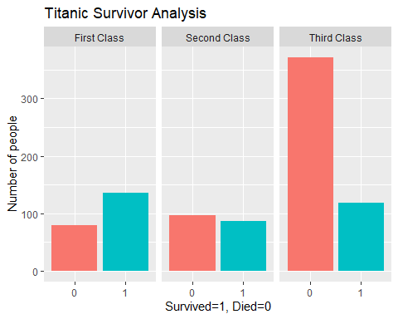 As evident from the graph, there are dispropotionate deaths in the Third Class which inidicates that passenger class may be a determining factor in the survival rate.

Next, we check if there is an interaction between Gender and Passenger Class.

ggplot(data=train) + geom_bar(mapping = aes(x = as.factor(Survived), fill = Sex )) + facet_wrap(vars(Pclass), labeller = as_labeller(c('1'='First Class','2'='Second Class','3'='Third Class')) ) + labs(x='Survived=1, Died=0', y = 'Number of people') + ggtitle('Titanic Survivor Analysis: Passenger Class and Gender')

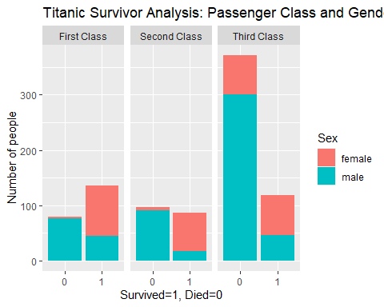 The plot shows that men were more likely to die across all classes.

Next, we check if the above discrepancy simply refelcted the fact that there were more men on board. In the next graph we check both variables together. The graph shows the number of male and female passengers for both categories: ‘Survived and Died’

ggplot(data=train) + geom_bar(mapping = aes(x=Sex, fill = as.factor(Survived)), show.legend = F)+ facet_wrap(vars(Pclass), labeller = as_labeller(c('1'='First Class','2'='Second Class','3'='Third Class')) ) + labs(x='Survived=1, Died=0', y = 'Number of people') + theme_economist() + scale_color_economist(name = NULL)

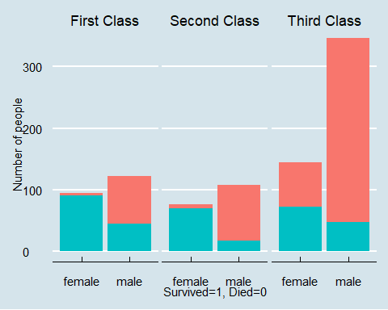

ggplot( data=train) + geom_bar(mapping = aes(x = as.factor(Survived), fill = Sex ), position = 'dodge') + facet_wrap(vars(Pclass), labeller = as_labeller(c('1'='First Class','2'='Second Class','3'='Third Class')) ) + labs(x='Survived=1, Died=0', y = 'Number of people') + ggtitle('Titanic Survivor Analysis: Class and Gender')

