|  |  |  |
| --- | --- | --- |
|  |  |  |
| Name: Iordache, Razvan R.E., Edgaras Spiridonovas  Class: SM31  Student No: 3699757, 3633055 |  |  |



**Smart Mobile**

**Design Document**

TABLE OF CONTENTS

[Version History 2](#_Toc55748213)

[Product Definition 2](#_Toc55748214)

[Personas 3](#_Toc55748215)

[Scenarios Lukas 3](#_Toc55748216)

[Scenarios John 4](#_Toc55748217)

[Scenarios Ava 6](#_Toc55748218)

[Use Cases 7](#_Toc55748219)

[Mockup 9](#_Toc55748220)

[Prototype 10](#_Toc55748221)

[Prototype (dark mode) 11](#_Toc55748222)

[Prototype (After testing) 14](#_Toc55748223)

# 

# 

# **Version History**

|  |  |  |  |
| --- | --- | --- | --- |
| Version | Date | Changes | Author |
| 0.1 | 24/09/2020 | Initial version, Product definition | Edgaras |
| 0.2 | 24/09/2020 | App mockup | Razvan |
| 0.3 | 06/11/2020 | Personas with scenarios, use cases, prototype | Razvan & Edgaras |
| 0.4 | 06/11/2020 | User testing | Edgaras |

# **Product Definition**

* **Current situation**

Nowadays a lot of people use their phones to look up recipes when they are cooking. However, if a recipe includes parts where your hand needs to get “dirty” and in order to see further cooking instructions you need to either wash your hands or make your phone “dirty” by touching it. Washing your hands every time or swiping though your messy phone can be annoying.

Our application helps users avoid touching their phone during cooking. This app will provide the user the opportunity to control their cooking with the help of voice commands. An application like this would be helpful for people who want to cook food without touching their phone.

# 

# **Personas**

# **C:\Users\Edward\Documents\GitHub\ios_duoapp_recipeapp\Personas\Persona Lukas.pngScenarios Lukas**

Backstory

Lukas is a bachelor graduate in Software Engineering that is now working for his master’s degree. He has a part-time job at an IT company in Utrecht, but still has plenty of free time for activities. He likes to cook in his free time, which is mostly around the weekend.

Ideal scenario

Lukas gets off his online work and goes on to cook something for him and his fiancé. He selects one of the recipes on the app and promptly begins to cook, having his ingredients all ready. He goes through all the steps with ease without having to touch his phone during the process, with the help of the voice commands. He finishes the meal without any hassle.

Worst case scenario

Lukas gets late off his overtime work and tiredly goes to take care of dinner. By mistake, he doesn’t have all his ingredients, so he goes to the supermarket to get the rest. He doesn’t find all the required ingredients, so he resorts to a simpler recipe. After he starts cooking, he notices that the voice commands are not working, since they were disabled from the previous time the app was used. He turns them on, but in the process dirties the phone’s screen from the oil he had on his hands. He now can’t see the screen properly and has to go to the trouble of cleaning himself and his phone before continuing. He mistakenly leaves some of his food on the enabled stove and burns some of it. After cleaning up everything, he finishes making the food, but in smaller portions.

Golden plate scenario

Lukas finishes his work early and so starts his weekend. He has guests coming over to dinner, so he decides to prepare a big meal for all of them. He already has all the necessary ingredients ready, so he goes on to the app to start the recipe. The kitchen was cleaned by his fiancé, so his workspace was not disturbed by unwashed dishes or anything else. He starts cooking and effortlessly follows the recipe without having to interact with his phone. He finishes the recipe and manages to put everything on the table moments before the guests arrive. Now he can enjoy a nice warm meal with all his friends.

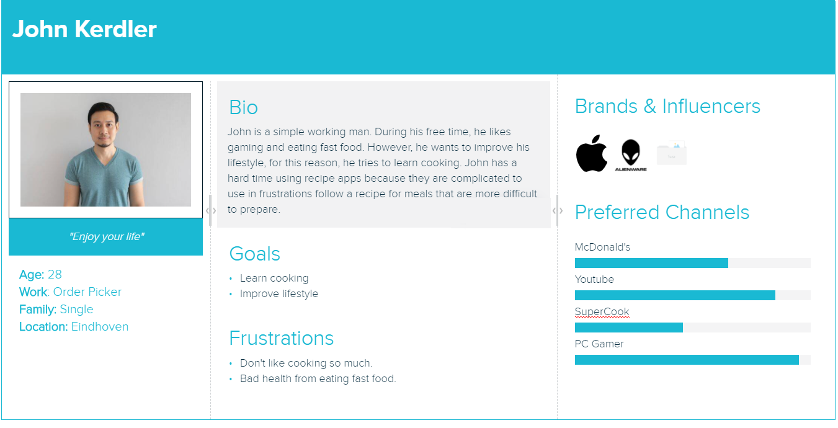

# **Scenarios John**

Backstory

John works in a warehouse five times a week. During his free time, he likes gaming and eating fast food. However, he wants to improve his lifestyle and, for this reason, wants to learn cooking. John has a hard time using recipe apps because they are complicated to use and frustrating to follow a recipe for meals that are more difficult to prepare.

Everyday Scenario

Since John decided to improve his lifestyle, he started using ICooKing recipe app to follow recipes. Every Friday he chooses one of the recipes in the app by checking the list of recipes and choses one. He likes to follow big recipes to improve his skills in cooking. He prepares all necessary ingredients and tools, places phone in a comfortable and visible place, starts the recipe app and turns on the voice command function. Once he has done certain step and wants to go to another step he says “Next” and then the app provides the following step and displays it on the screen. When time comes to set up a certain product to boil, the app shows the step with certain text. After saying “Next” the timer is set and displayed in the bottom with the name of the boiling food and it is visible during the whole process. When the boiling is done during the cooking, the app starts playing an alarm tone which informs that it’s finished boiling. Once all steps are completed and after saying “Next” during final step the app displays the finishing screen.

Ideal Scenario

After his Friday work shift, John returns in a very good mood. Even though he does not like cooking, today he is really into the mood to have a big healthy delicious meal. He opens the app and on the main page he sees a recipe containing food he likes and, what luck, he even has all the necessary ingredients in his fridge, so he does not need to go shopping! He takes out all the needed ingredients and tools. He puts on his favorite song on headphones and places his phone in a comfortable way to see the recipe’s steps and starts cooking. Once he completes a certain step he says “Next” and continues onto another step until he is done with all of them and his meal is ready. He used this recipe for the first time and in the end, he rated this recipe 5 stars because it contained well-structured steps and meal, had amazing smell! He also marked this recipe with a heart so it would remain in his favorites.

Horror Scenario

After work, John decided to invite some friends over for a dinner. He bought all the ingredients needed for the recipe. John prepared everything and started cooking using ICooKing app with voice control commands enabled. During cooking, his friends came over, so he went to let them in and returned to cooking. Because of the noise his friends were making by playing video games while he was cooking, the app could not hear his voice commands, so he could not continue with the voice command option enabled. This dish required him to get his hands dirty often, so he had trouble going through the steps. In the end, his phone got messy and he could not use it anymore to keep up with the recipe. He got annoyed and left the dish unfinished and ordered fast food for everyone.

# **C:\Users\Edward\Documents\GitHub\ios_duoapp_recipeapp\Personas\Persona Ava.bmp****Scenarios Ava**

Backstory

Ava is a student who always likes to try out new things during her free time. One of her hobbies is cooking. While cooking she wants the flexibility to cook whatever she wants without any disruptions and follow the recipe without making any mistakes.

Worst Scenario

Ava, after her lectures, starts cooking one of her recipes from the app. It involves getting her hands messy, so she decides to cook with the voice command function enabled. Unlucky for her, during her meal preparation, her neighbors started doing some construction work that is very noisy. The app cannot detect her commands and she tried to turn off the voice command function. But since she is used to cooking with voice commands, she didn’t think of washing her hands beforehand and got her phone messy. It was hard to use her phone since the screen was dirty, and so she got very annoyed by that and went to clean her phone. While she was cleaning it, what was boiling got burned and couldn’t be used.

Ideal Scenario

Ava after her lectures cooks herself a meal. She picks out one of the recipes and turns on the voice command function and places her phone nearby to be able to read the instructions of the recipe and proceeds to cook a nice warm meal.

Golden Plate Scenario

During the weekend, Ava decides to cook something interesting, so she picks out a big recipe from the list available on the cooking app. She then turns the voice command option on, since the recipe is quite big and involves getting her hands “dirty” and starts cooking. While she cooks, she can easily follow the recipe and time the boiling of certain ingredients. In the end she has a nice meal and her phone is spotless.

# **Use Cases**

**Use case**: Open recipe

**Primary Actor**: User

**Scope**: a cooking recipe app

**Brief**: The user selects any recipe through the app

**Main success scenario**:

1. The app displays a list of recipes.

2. User selects the recipe and chooses to open it.

3. App displays the selected recipe.

**Use case**: Start cooking

**Primary Actor**: User

**Scope**: a cooking recipe app

**Brief**: The user starts the previously selected recipe.

**Main success scenario**:

1. The app displays a “play” button that begins the process.
2. User presses the “play button”.
3. App starts showing the recipe’s steps.

**Use case**: Navigate through recipe’s steps

**Primary Actor**: User

**Scope**: a cooking recipe app

**Brief**: The user navigates through the recipe’s steps.

**Main success scenario**:

1. The app displays the current step of the recipe.
2. User says “next” or touches the right side of the screen to go on to the next step.
   1. The app continues to the next step.
3. User says “previous” or touches the left side of the screen to go back to the previous step.
   1. The app goes back to the previous step.

# **Mockup**

**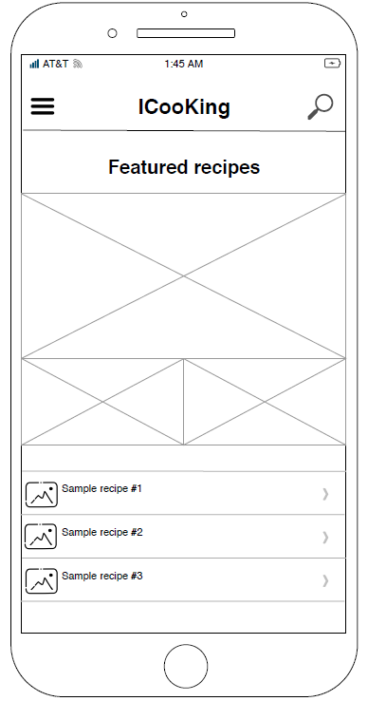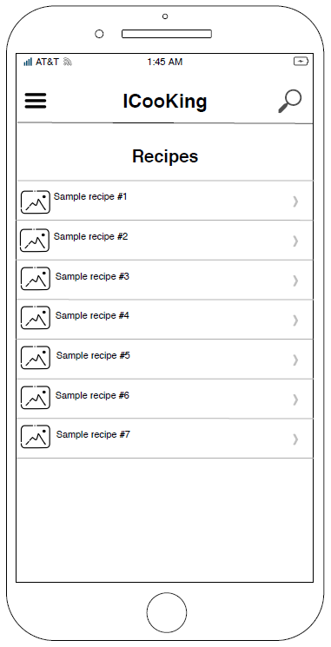**

Main screen

Recipe list

**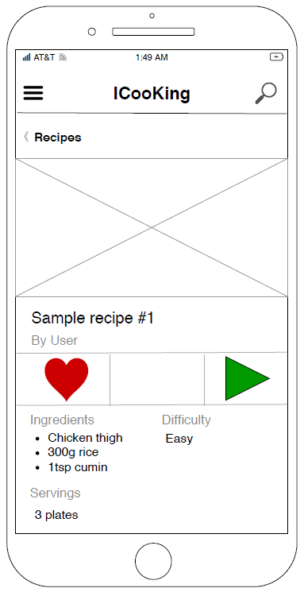**

Recipe details’ screen

**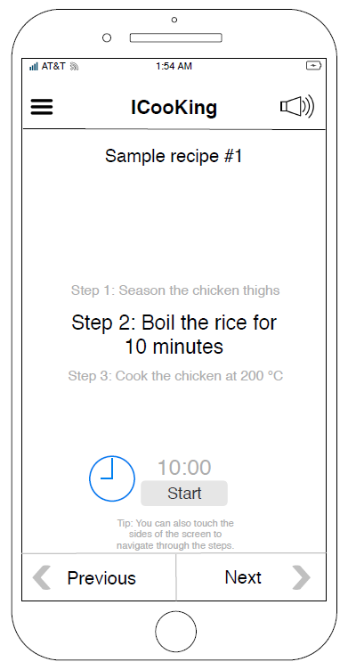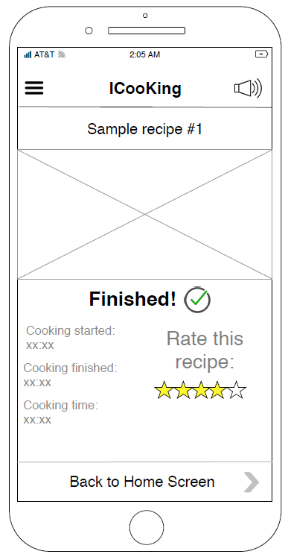**

Finish screen

Recipe step screen

# **C:\Users\Edward\Downloads\wetransfer-e599fe\Old_version_1.pngC:\Users\Edward\Downloads\wetransfer-e599fe\Old_version_3.pngC:\Users\Edward\Downloads\wetransfer-e599fe\Old_version_2.pngPrototype**

Main screen

Steps screen

Recipe screen

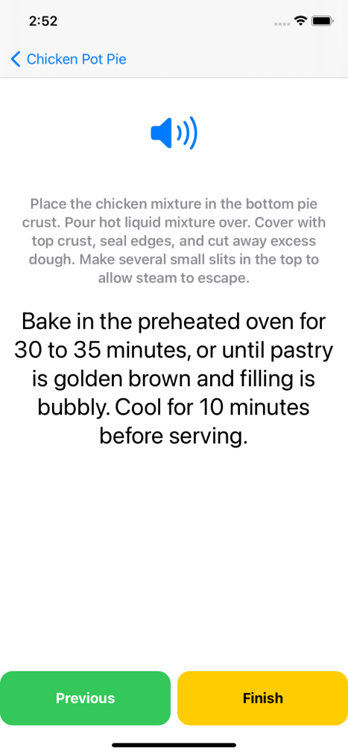

Finish screen

Steps screen (last step with voice commands enable)

# **Prototype (dark mode)**

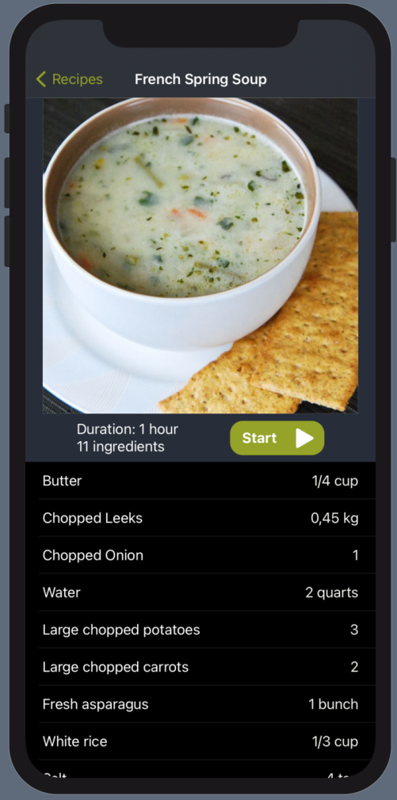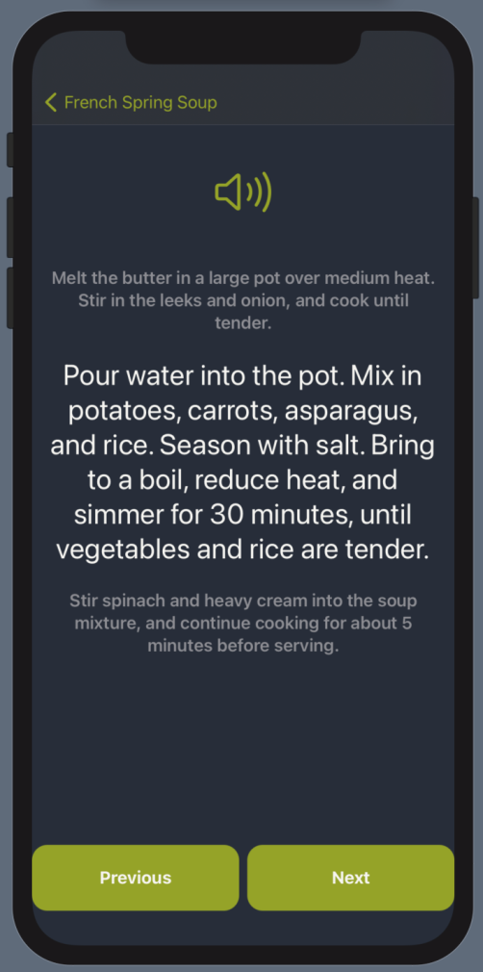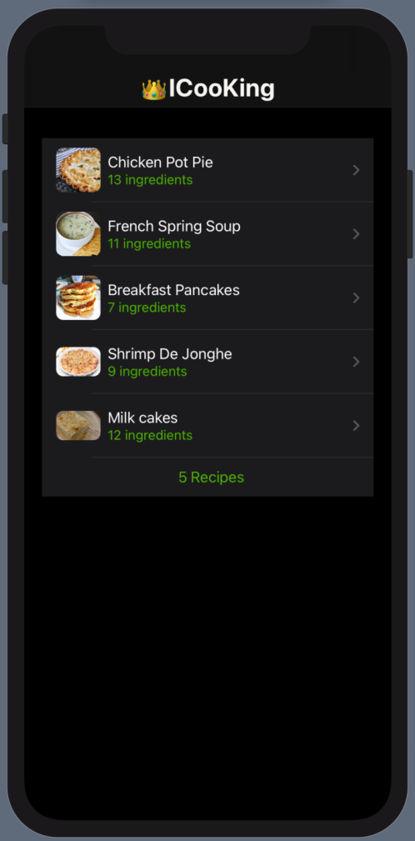

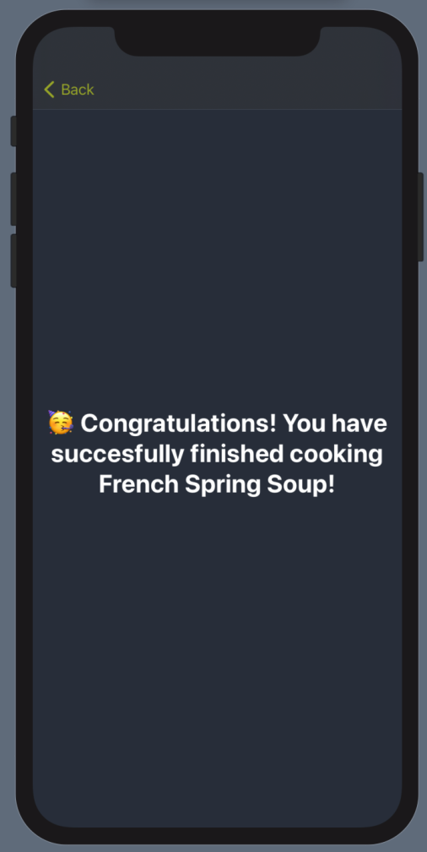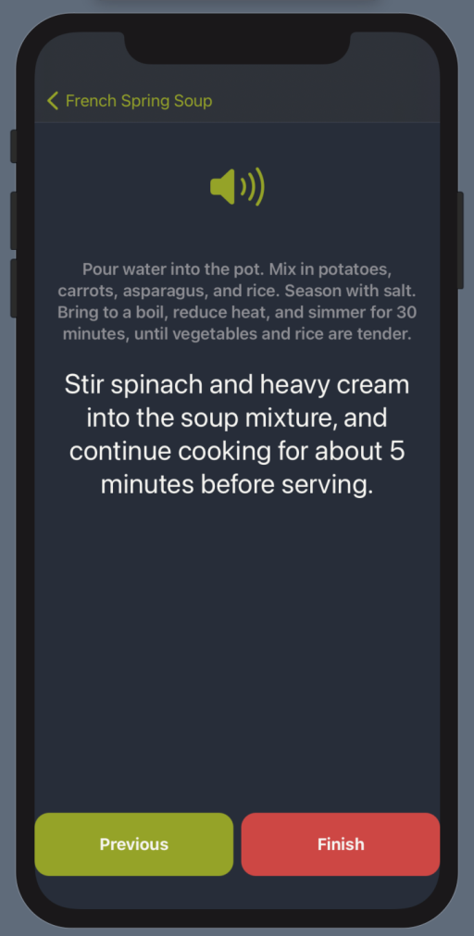

**Observation Results:**

Video 1 –

<https://www.dropbox.com/s/50sd73wlephu59z/first%20testing.mov?dl=0>

Video 2 –<https://www.dropbox.com/s/19ubpmauh5tn497/Testing%20with%20old%20code%20.mov?dl=0>

Video 3 - <https://www.dropbox.com/s/zovyuefvxwjvoch/After%20CHANGES.mov?dl=0>

Video 4 –

<https://www.dropbox.com/s/nt2vjge5s1ua9t2/Test%201%20-%20Razvan.mov?dl=0>

Video 5 –

<https://www.dropbox.com/s/vard89c5q1gxs45/Test%202%20-%20Razvan.mov?dl=0>

**Summary of Findings:**

|  |  |  |
| --- | --- | --- |
| Issue | Severity | Feedback |
| The “activate voice command” button is not clearly labeled. | Low | Make it clear where to press the button in order to activate the voice function. |
| Recipe step navigation buttons are not in a proper position | Low | The buttons are too low on the screen. They could be placed a bit higher. |
| Pressing back once the recipe is finished does not go back to the main screen | Low | A button could be made that goes right back to the main screen of the app. |

**What went well:**

Users that tested our app did not find it difficult to navigate through the app. It is very clear what each page leads to, and the voice command functionality worked well with all of our testers.

**Other things we learned:**

The design of our application was a bit confusing for some; one user did not know where to press in order to activate the voice control. One other nitpick was that our navigation buttons are a bit too low on the screen. Otherwise, everything was OK.

# **Prototype (After testing)**

