|  |  |
| --- | --- |
|  | Data Analytics |

Economic Activities – Portugal

RNCP

Edgar Tomé

June, 2022

Table of Contents

Introduction 3

Business study economic activities in Portugal 3

Data and data sources 4

Data collection 5

Metadata 6

Data cleaning and Exploratory data analysis 8

Data cleaning 8

Data visualization 13

Database 15

Types of databases 15

Entities. ER Model 16

SQL database 17

Conclusion 18

Figure 1 - Code process 1 part 1 9

Figure 2 - Code process 1 part 2 9

Figure 3 - Code process 2 part 1 11

Figure 4 - Code process 2 part 2 11

Figure 5 - Code process 2 part 3 11

Figure 6 - Bars plot production activities exports Portugal 13

Figure 7 - Boxplot production activities exports 14

Figure 8 - Correlation heatmap production activities exports 14

Figure 9 - ER Model 16

Table 1 - Table of the factors and sub factors 3

Table 2 - Files collected 5

Table 3 - Metadata production activities 6

Table 4 - Metadata efficiency and return 6

Table 5 - Metadata internationalization 7

Table 6 - Codification of industries 12

# Introduction

## Business study economic activities in Portugal

The goal of this project was to create a data set to future analyse of the evolution of the economy in factors of production activities, efficiency and return, internationalization of the economy, and they sub factors.

Table 1 - Table of the factors and sub factors

|  |  |  |
| --- | --- | --- |
| **Production Activities** | **Efficiency and Return** | **Internationalization** |
| Export | Apparent labour productivity | Degree of exposure to international trade |
| Import | Investment rate | Export intensity |
| Production | Degree of production | Import penetration rate |

The plan of the project was to chouse a data source that was able to provide the different factors of the economy in Portugal, by industry and the evolution along the years, and retrieve data from the choice source.

In this case the data source dint had API access, so for retrieving the data was by download of Excel files. Import the data to python script for clean, the none necessary columns and rows and nan values, and the years with complete data and the same industries in all tables.

After export of the clean data in to CSV files, imported the files in to a new script of Python, to produce visualizations, to perform a primary data analysis and verify that there were no outlier values, our still missing values and data it no relevance for the study. If necessary, return to the script in python and perform more data clean, to have the files exported in csv, to be imported in to database and future analysis

Create a database, create tables for import of the data information in all the clean files retrieved in csv for all the factors for analysis, and produce some queries that can give some evolution of the economy production.

# Data and data sources

Data source is PORDATA (<https://www.pordata.pt/>), the Database of Contemporary Portugal, organized and developed by the Francisco Manuel dos Santos Foundation, was created in 2009.

The collection, compilation, systematization and dissemination of data on multiple areas of society, for Portugal and its municipalities, and for the European countries. The reported statistics derive from official and certified sources, with data production skills in the respective areas.

Consists in collecting and organizing the data available, making it as clear and accessible as possible. Also, important work of contextualized information, the so-called "metadata", as an inextricable part of the data, enabling its adequate interpretation, to be providing a public service to the Portuguese society, free of charge and without any cost to the user.

PORDATA retrieves information from over sixty official agencies, with particular emphasis to Statistics Portugal, cooperate with PORDATA.

# Data collection

The data collection was retrieved in the format of excel files from PRODATA, for the three subfactors from each group of factors of the economy in Portugal, that are more important for the development and growth of the economy in the country.

The files were retrieved by download, as the site don’t have API access to retrieve the data.

Table 2 - Files collected

|  |  |  |
| --- | --- | --- |
| **Production Activities** | **Efficiency and Return** | **Internationalization** |
| Export of goods and services total and by product (2016).xlsx | Apparent labour productivity total and by industry.xlsx | Degree of exposure to international trade total and by product.xlsx |
| Import of goods and services total and by product (2016).xlsx | Investment rate total and by industry.xlsx | Export intensity total and by product.xlsx |
| Gross value of production total and by industry (2016).xlsx | Degree of production processing total and by industry.xlsx | Import penetration rate in the domestic market total and by product.xlsx |

# Metadata

Information about the data collected.

Table 3 - Metadata production activities

|  |  |  |  |  |
| --- | --- | --- | --- | --- |
| **Production Activities** | **Definition** | **Economic Activity** | **Geographic** | **Responsible entity** |
| Export of goods and services total and by product (2016).xlsx | Exports of goods and services consist of transactions in goods and services | Activity is characterized by an input of products, production process and an output of products | Portugal | INE – National institute of statists |
| Import of goods and services total and by product (2016).xlsx | Imports of goods and services consist of transactions in goods and services |
| Gross value of production total and by industry (2016).xlsx | Output is the total of products created during the accounting period |

Table 4 - Metadata efficiency and return

|  |  |  |  |  |
| --- | --- | --- | --- | --- |
| **Efficiency and Return** | **Definition** | **Economic Activity** | **Geographic** | **Responsible entity** |
| Apparent labour productivity total and by industry.xlsx | Measures the ratio between value added and the number of workers | Activity is characterized by an input of products, production process and an output of products | Portugal | INE – National institute of statists |
| Investment rate total and by industry.xlsx | Measures the relationship between gross fixed capital formation and gross value added |
| Degree of production processing total and by industry.xlsx | Measures the ratio between gross value added and output, i.e., the relative proportion of value added per unit produced |

Table 5 - Metadata internationalization

|  |  |  |  |  |
| --- | --- | --- | --- | --- |
| **Internationalization** | **Definition** | **Economic Activity** | **Geographic** | **Responsible entity** |
| Degree of exposure to international trade total and by product.xlsx | Indicator that assesses the extent to which the production of each product is exposed to international competition both via export of domestic production and by competition with imports in the domestic market | Activity is characterized by an input of products, production process and an output of products | Portugal | INE – National institute of statists |
| Export intensity total and by product.xlsx | Measures the ratio between the value of exports and output |
| Import penetration rate in the domestic market total and by product.xlsx | Import penetration assesses the growth of imports of goods and services in view of the growing global demand |

# Data cleaning and Exploratory data analysis

## Data cleaning

The data collection and exploratory data analysis process, had different process, because the excel files where not with the same formation, had different values, different types of values, missing values, different quantity of rows and columns. The process was in a loop, as after the first cleaning, in visualization verified that was necessary to remove more irrelevant information, and in the first creation of the database also realized that had to transpose the data frame to be stubble to the entity relationship model.

The process for the files export of goods, and import of goods, of the group production activities, the process of cleaning and preparation of CSV files to export to visualization and database, was the follow.

* Import of the libraries Pandas and Numpy;
* Import files with pandas to read Excel files;
* Listed the name of the columns to verifier;
* Place the name Years, in the same row as was the correct names of the columns;
* Delete rows with not relevant data, and non-values, and delete columns with not relevant data, and non-values;
* Rename the columns with the information on the row “6”, and print the data frame to verified the status of the data;
* As the names of the industries are long length, placed encoding to the columns;
* Placed new index to have order, as with the remove of rows the index add no order, and removed the old index, and the old columns name;
* Exported the files to csv, to perform visualizations, noticing that was some values with category of object, had to convert to integer and floats.
* Exported the files to csv, to perform visualizations, noticing that was some columns of industries that were no common to every file and category of study. Had to delete the row Col_39, as the industries was no common to the different groups, and for that reason, not comparable;
* Exported the files to csv, and uploaded on database with the entity relationship model as base, verified, that a new clean had to be performed to the files, to have them suitable for the creation of data base;
* Had to transform the data frame, so performed a transpose function, to convert e columns names in to index. Rename the columns names with the values of the row of Years, and remove the rows of Years and Total, then replace the columns names with range from 1995 to 2020, as the years were in float, and had to convert in integer from the year 1995 to 1999;
* Exported the file into csv with pandas, to be used on database;

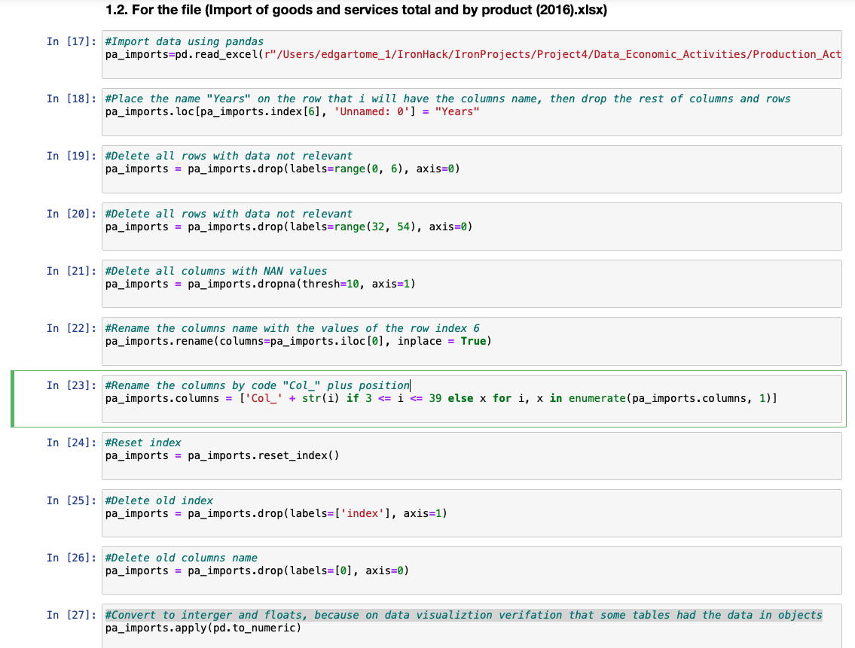

Figure 1 - Code process 1 part 1

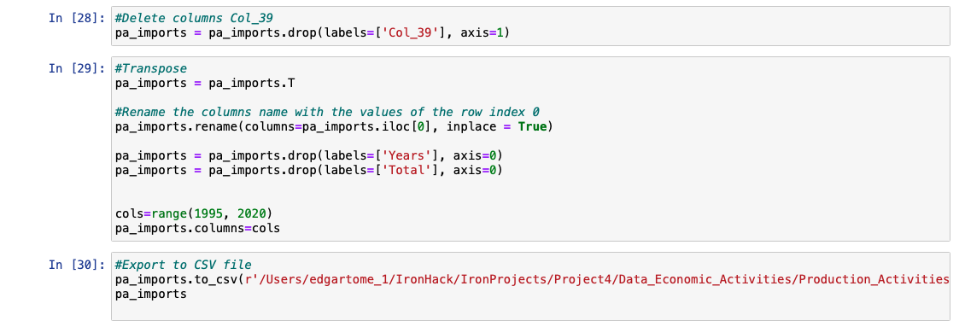

Figure 2 - Code process 1 part 2

For the rest of the files retrieved, the process of cleaning and preparation of CSV files to export to visualization and database, was the follow.

* On the excel files, delete rows and columns with nan values, or with legend information on the excel formation, not relevant for the analysis that was to be performed, and moved the columns name to the first row. This was performed different from the first two files, because, during the first process of data cleaning, the python was unable to convert all the object types in to numeric values, like float our integer.
* Import files with pandas to read Excel files;
* Listed the name of the columns to verifier;
* Delete rows with not relevant data, and non-values, and delete columns with not relevant data, and non-values;
* To perform visualizations, noticing that was some values with category of object, had to convert to integer and floats, and verified that had changed;
* As the names of the industries are long length, placed encoding to the columns;
* Exported the files to csv, to perform visualizations, noticing that was some columns of industries that were no common to every file and category of study. Had to delete the row Col_39, as the industries was no common to the different groups, and for that reason, not comparable;
* Exported the files to csv, and uploaded on database with the entity relationship model as base, verified, that a new clean had to be performed to the files, to have them suitable for the creation of data base;
* Had to transform the data frame, so performed a transpose function, to convert e columns names in to index. Rename the columns names with the values of the row of Years, and remove the rows of Years and Total, then replace the columns names with range from 1995 to 2020, as the years were in float, and had to convert in integer from the year 1995 to 1999;
* Exported the file into csv with pandas, to be used on database;

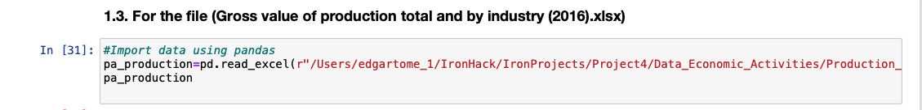

Figure 3 - Code process 2 part 1

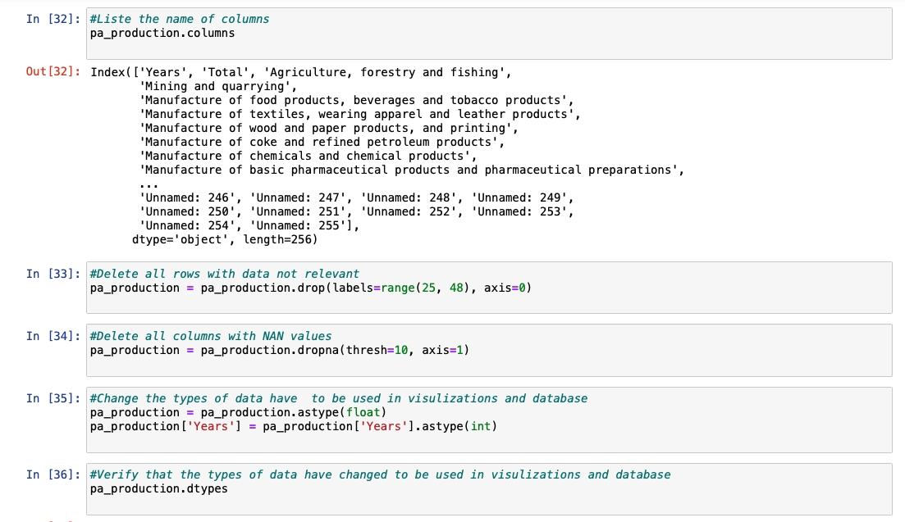

Figure 4 - Code process 2 part 2

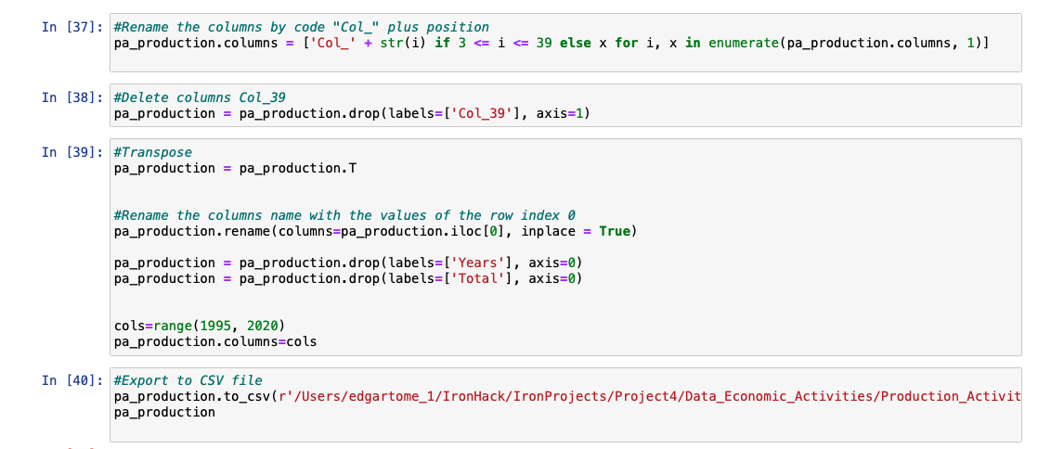

Figure 5 - Code process 2 part 3

Table 6 - Codification of industries

|  |  |
| --- | --- |
| Col_3 | Products of agriculture, forestry and fishing |
| Col_4 | Mining and quarrying |
| Col_5 | Food products, beverages and tobacco products |
| Col_6 | Textiles, wearing apparel and leather products |
| Col_7 | Wood and paper products, and printing services |
| Col_8 | Coke and refined petroleum products |
| Col_9 | Chemicals and chemical products |
| Col_10 | Basic pharmaceutical products and pharmaceutical preparations |
| Col_11 | Rubber and plastics products, and other non-metallic mineral products |
| Col_12 | Basic metals and fabricated metal products, except machinery and equipment |
| Col_13 | Computer, electronic and optical products |
| Col_14 | Electrical equipment |
| Col_15 | Machinery and equipment n.e.c. |
| Col_16 | Transport equipment |
| Col_17 | Furniture, other manufactured goods, repair and installation services of machinery and equipment |
| Col_18 | Electricity, gas, steam and air-conditioning |
| Col_19 | Water supply, sewerage, waste management and remediation services |
| Col_20 | Constructions and construction works |
| Col_21 | Wholesale and retail trade services, repair services of motor vehicles and motorcycles |
| Col_22 | Transportation and storage services |
| Col_23 | Accommodation and food services |
| Col_24 | Publishing, audiovisual and broadcasting services |
| Col_25 | Telecommunications services |
| Col_26 | Computer programming, consultancy and related services, information services |
| Col_27 | Financial and insurance services |
| Col_28 | Real estate services |
| Col_29 | Legal and accounting services, services of head offices, management consulting services, architectural and engineering services, technical testing and analysis services |
| Col_30 | Scientific research and development services |
| Col_31 | Advertising and market research services, other professional, scientific and technical services, veterinary services |
| Col_32 | Administrative and support services |
| Col_33 | Public administration and defence services, compulsory social security services |
| Col_34 | Education services |
| Col_35 | Human health services |
| Col_36 | Social work services |
| Col_37 | Arts, entertainment and recreation services |
| Col_38 | Other services |
| Col_39 | Services of households as employers, undifferentiated goods and services produced by households for own use (DROP because missed on Investment rate total and by industry.xlsx) |

## Data visualization

During the process of data cleaning, was performed at the same time data visualization, in python with the libraries matplotlib and seaborn, to analyse if the data was clean, and the relations between the values were corrected, and if was need to removed outliers our columns and rows with no relevance to the study. This process was performed to all files, extracted during the loop process in data cleaning, with same visualizations and plots for each file.

In this example was applied the function to obtain bars plot for the evolution true the years for production activities exports, because of the relevance of exporting as to the economy in Portugal.

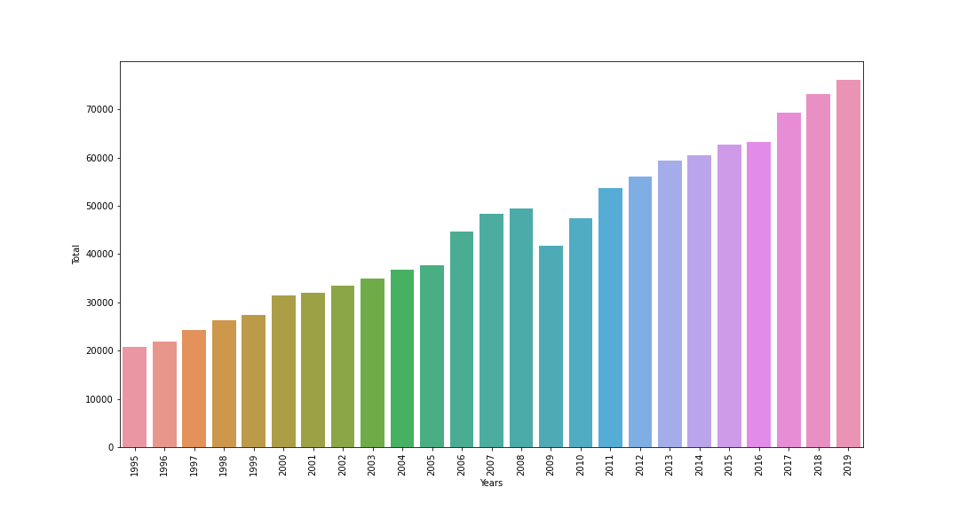

Figure 6 - Bars plot production activities exports Portugal

To be verified if existed outliers in the data, was used a function of box plot, for visualization of the distribution of the values for all the industries. Was identified outliers in the industries Col_16 (Transport equipment), that was verified has a growth on that industry in the past years, doubling the value in five years.

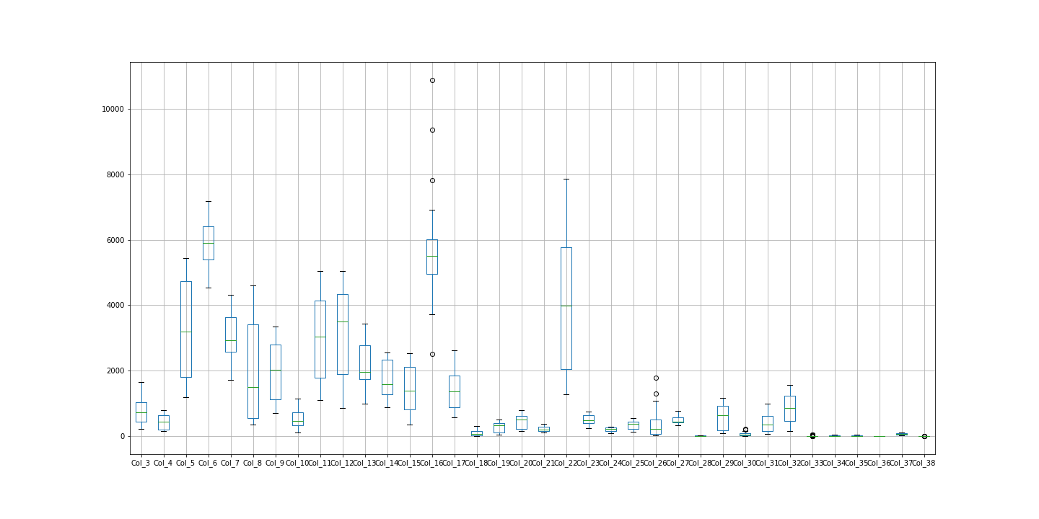

Figure 7 - Boxplot production activities exports

To be verified the relation between the industries in production activities exports, was applied the function correlation of numeric values and plotted using the function of heatmap.

Verifying that the industries Col_23 (Accommodation and food services), have higher correlation to the industries Col_3 (Products of agriculture, forestry and fishing) and Col_5(Food products, beverages and tobacco products), the increased industries of turism makes that the industries that provides food, beverage increases with the consumption of the tourists in the accommodations and in bars and restaurants.

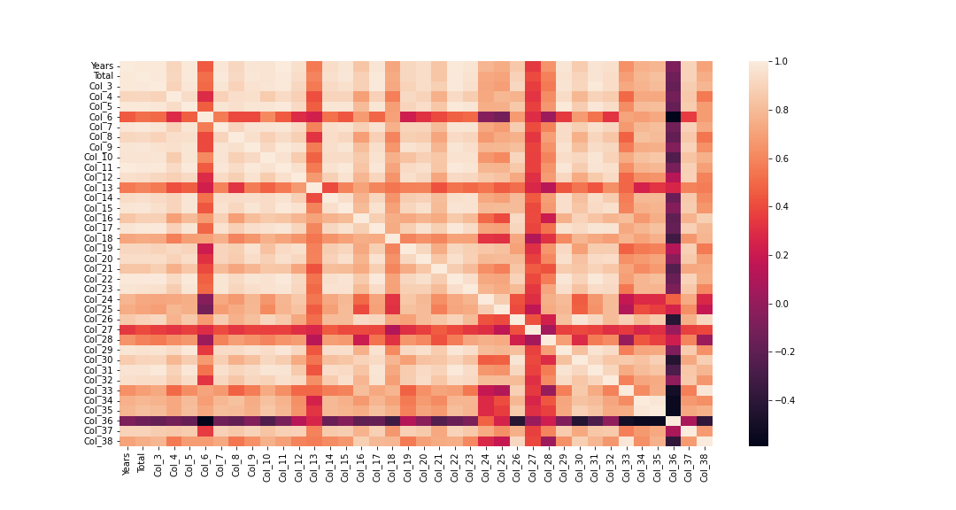

Figure 8 - Correlation heatmap production activities exports

# Database

## Types of databases

In order to store the data collected in a database, that can produce queries and retrieve information with relations our not, is necessary to choose the database that is more suitable for the project. Choosing the wrong database, can came in the long run as sometimes painful to fix, and is important to know the limitations in choosing one database for the project. There are two main types, relational databases (SQL based), and NoSQL databases.

The relational databases (SQL based), collects data in tables like csv files, each row in a table represents a record. It this structed database can be proceeded relations between rows, production of queries that relates information in different tables, but that have a relation key that are common in the tables for correlation. For that reason, before insertion of data, is need to produce the entity relationship model.

The NoSQL databases there is no common structured schema for all records, most of the NoSQL database contain JSON records, and different records can include different fields. The main types are document-oriented the schema can vary between different documents and contain different fields, as the records are not depended it supports parallel computations. Columnar database, the data is store column by column, that makes column-based queries very efficient. Key-value database, is based on key only, requesting for a key and getting its value, not supporting queries across different record values.

Comparing the relation database and document database, the relational as advantages in simple structure that matches most kind of data, supports join operations, allows fast data updating with relations between records, and performs atomic transitions. The disadvantage is the query execution time that depends of the size of the table. The advantages in document database allows to keep object with different structures, can represent almost all data structures, supports schema validation making collection schematized, the querying is very fast as the independent and therefore the query time is independent of database size, the disadvantages are that the process of updating the database is slow, and not atomic transactions are possible.

## Entities. ER Model

For the project considering the data collected and relations between industries that are of great value for analyses, it was chooses the relation data base in SQL. For the use of relations database is necessary, before upload the data into SQL, create entity relationship model, with the different entities, and their relations, primary keys and foreign keys.

In this project for each table was create a primary key with the code of industries, and created a dictionary table with primary key being the name of the industries and the foreign keys the code of industries, to be related with each table of information. The tables can be related between them with the primary key that is the code of the industries and is common to all tables, producing queries of relations between exports and imports and production values

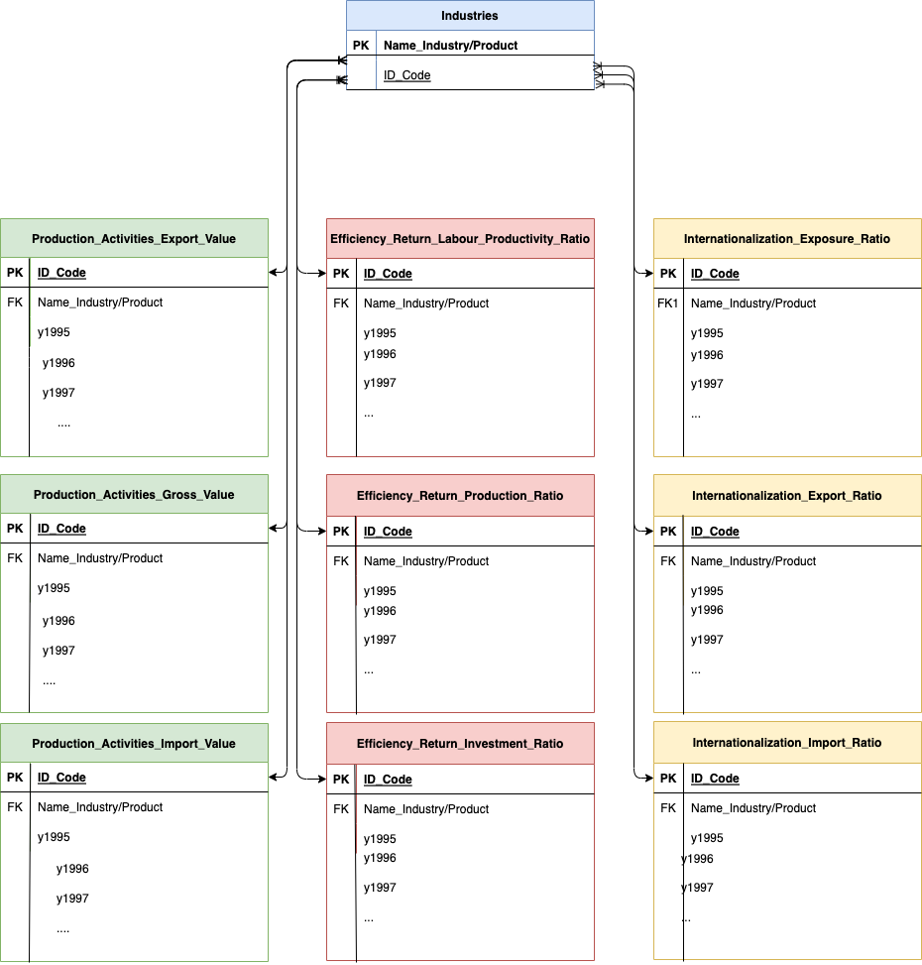

Figure 9 - ER Model

## SQL database

For the project considering the data collected and relations between industries that are of great value for analyses, it was chooses the relation data base in SQL. The import of the data was performed true the wizard process as the data was big with many files and columns and rows and many numeric values.

After the imported data was placed in the tables created in SQL script, was performed some queries, with join tables and left join of tables, using has primary key the code of the industries, to relate the information on the different tables, and analyze the relations between the information collected.

The five queries created are the follow:

1. Production value comparison for import and export for the year 2019, for the industry with more value of export and industries with more value of import;
2. Production value comparison for import and export for the year 2019;
3. Internationalization ratio comparison for import and export for the year 2019;
4. Efficiency ratio comparison for investment and production for the year 2019;
5. Total of production export and production import for last 5 years all years

## Conclusion

The process of collection data, cleaning data, visualization data, creation of database and retrieving queries from all the data inputted. It serves as the principal base for analyzed the data of the object of study required, giving information, that have to contextualized with object in study and whit is required of the project.

This process is a loop, that for each iteration, some conclusions can be made and a new perspective can be observed, being necessary to perform all the process again to refine the data, so can be obtain the conclusion with data support to the question placed of the object in study.