This picture 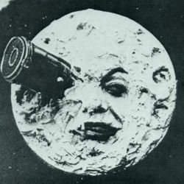 is an identicon.
Here is one  that links.

