upload image

Face-recognition、mep-agent、postgres、redis need upload harbor , for example；





### 

### Configure edge nodes

First create an edge node on the MECM platform (if you only deploy and test in Developer, you can ignore this part, but if you want to publish an application, you must operate this part)

The following steps require an administrator account

1. In the systems ->MEPM ,New Registeration

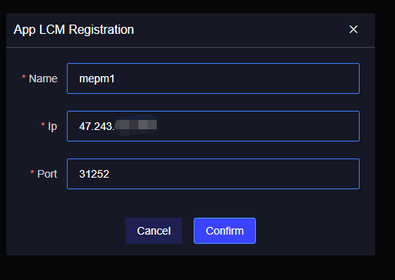

1. In the systems ->App Store，New Registeration

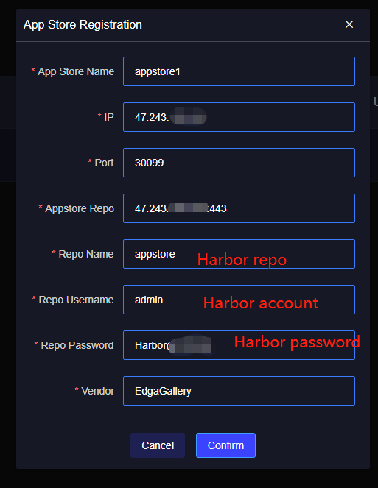

3.In the edge node, register the edge node

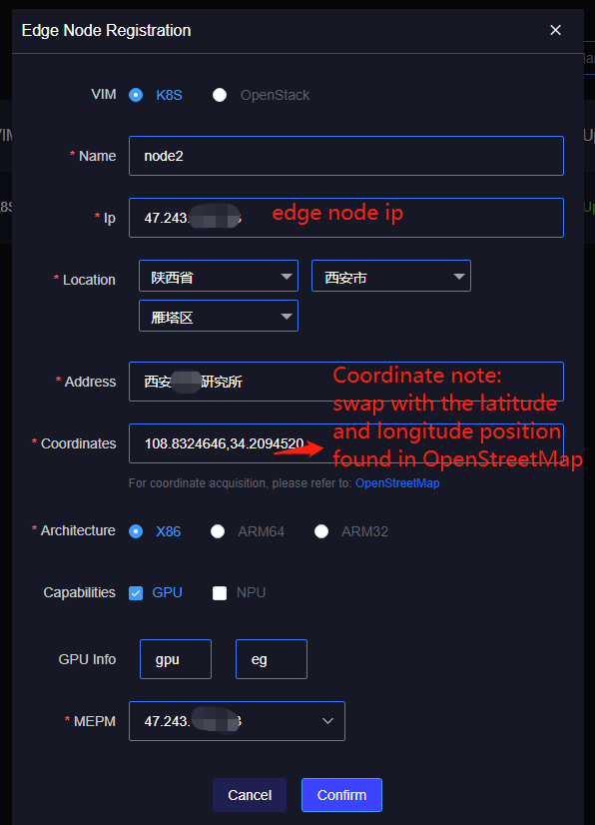

After successful registration, upload the config file downloaded from the server (The path on the server is generally /home/edge/.kube/, depending on your installation location)

After the above steps are completed, you can operate on the Developer platform.

### Developer platform operation

#### Add the sandbox environment

In System -> Host Management, Add Host

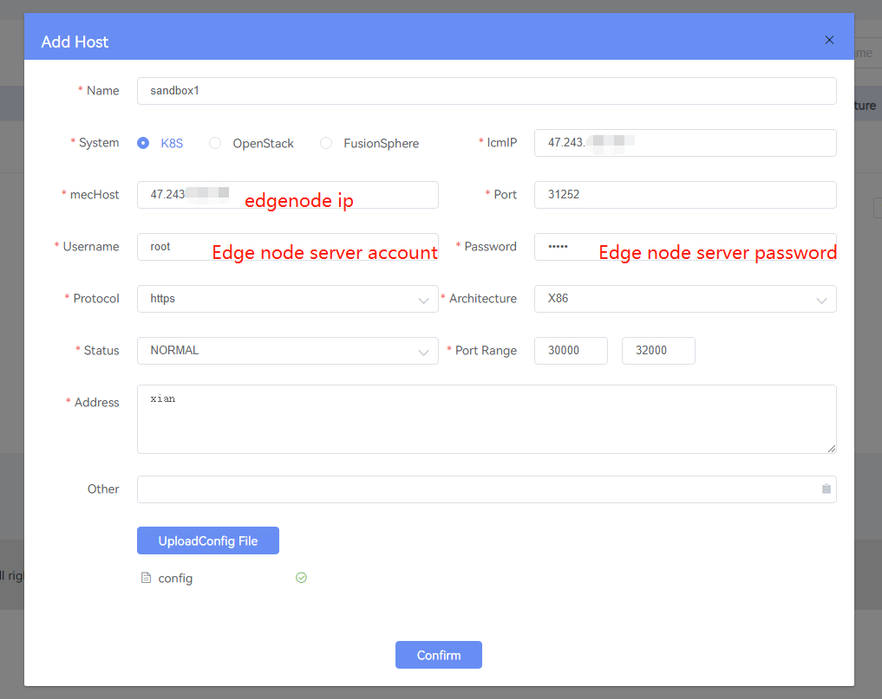

#### Create Project

Select Application Development on the homepage or in the workspace, click create project, select Application Developement

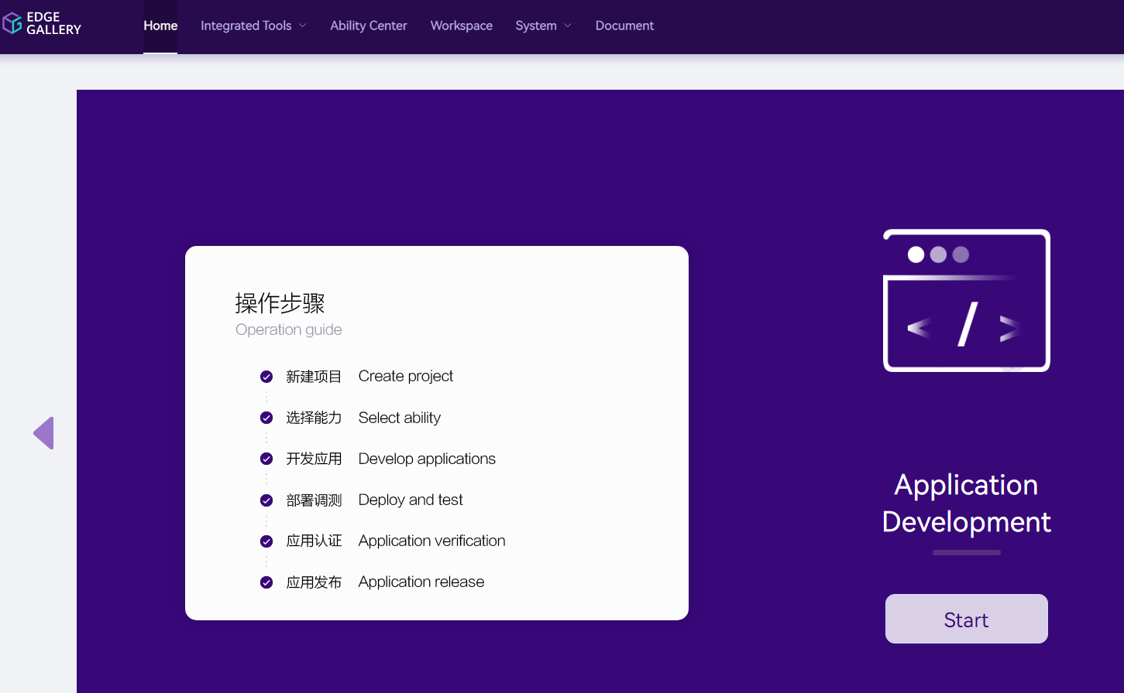

Click start to create a new application development project:face_recognition

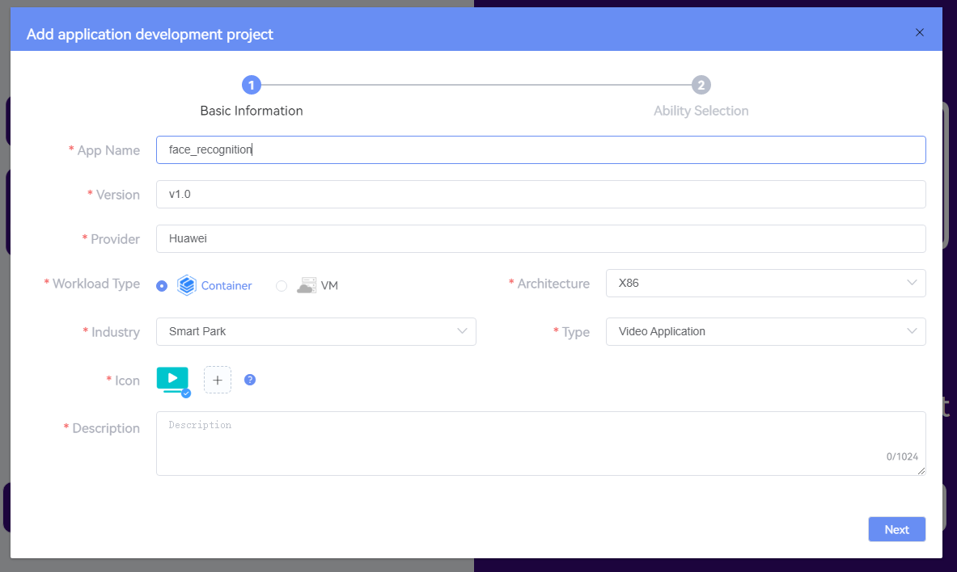

Click Next, check the service discovery capability

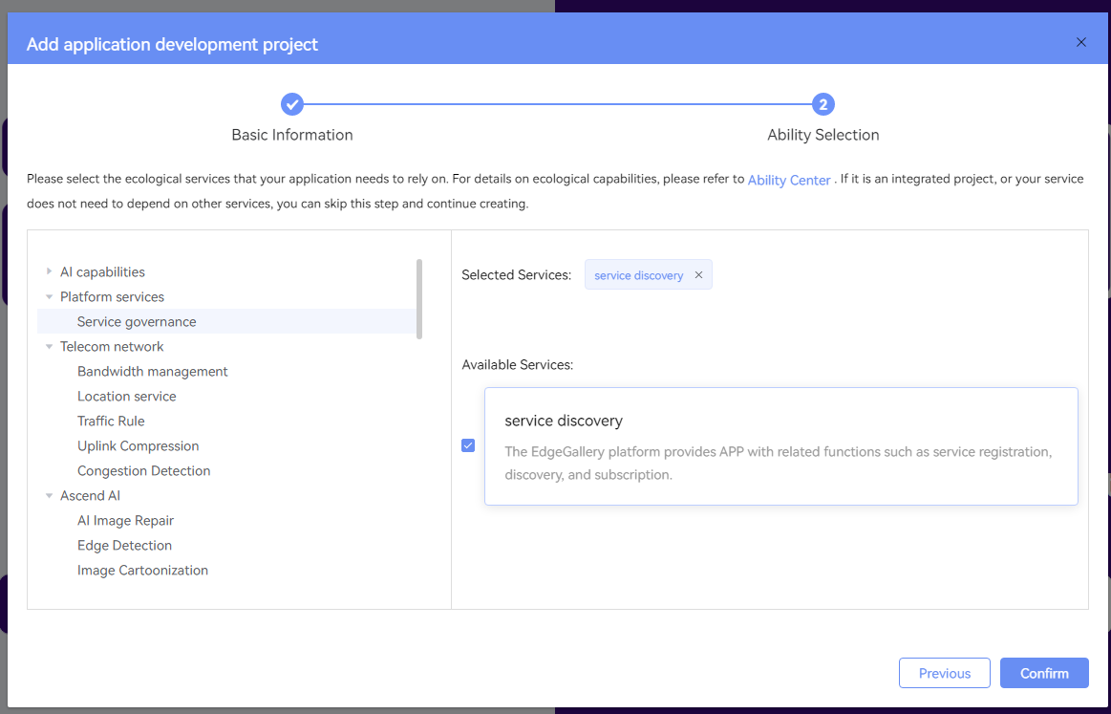

Click Confirm to add the project successfully.

#### Deplyment Test

Upload APP Image

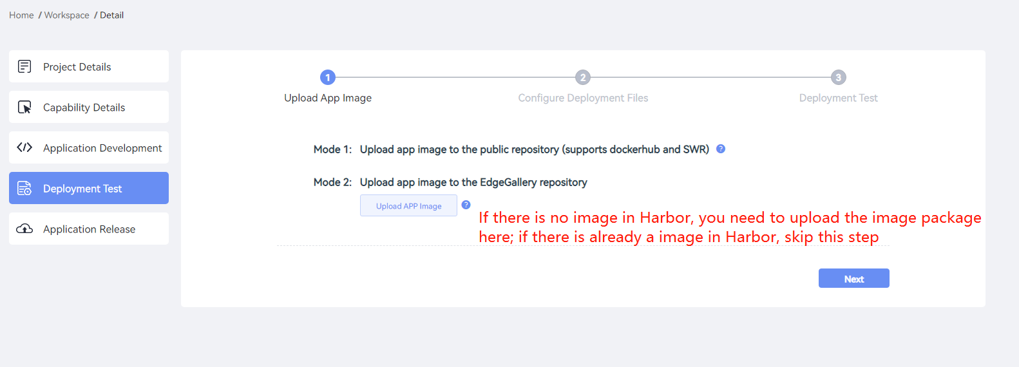

Click Next to Configure Deployment Files (select Import File here, you can also choose Visual Configuration)



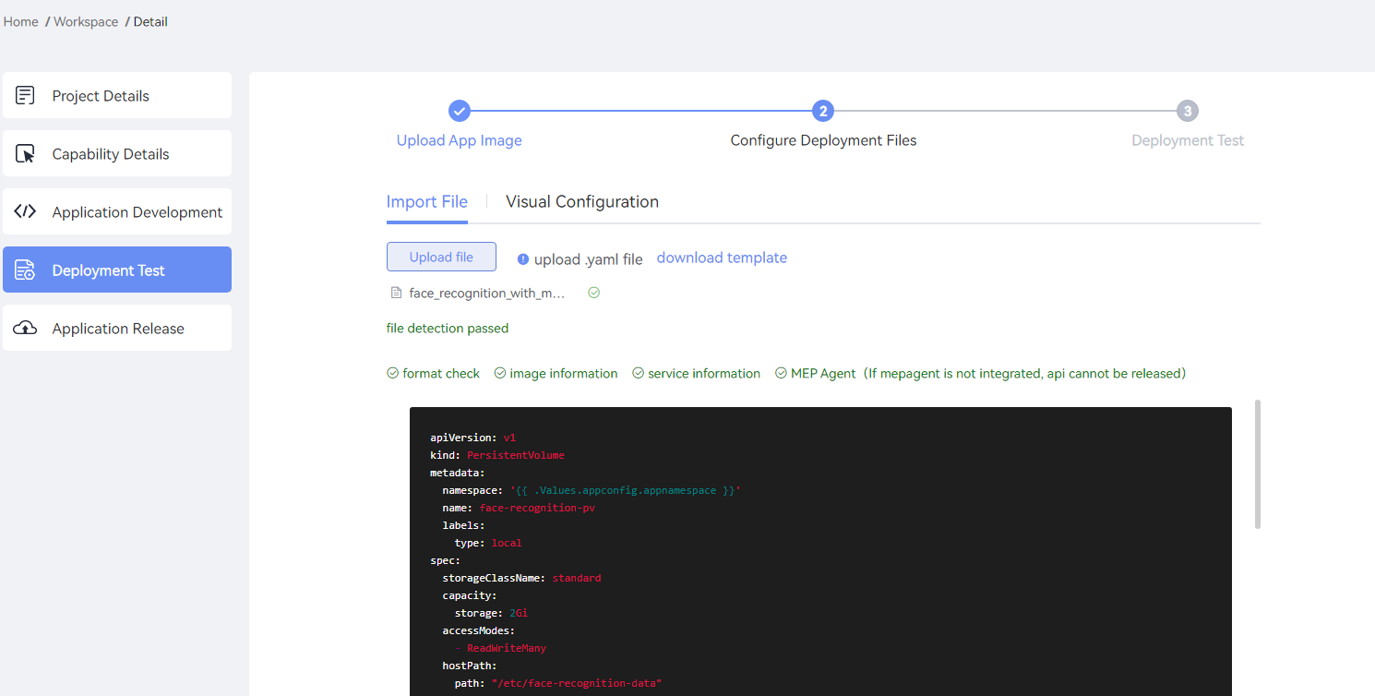

Click Next to perform Deployment Test. After Deployment Test pass, Release Resources before clicking the application release to avoid resource occupation

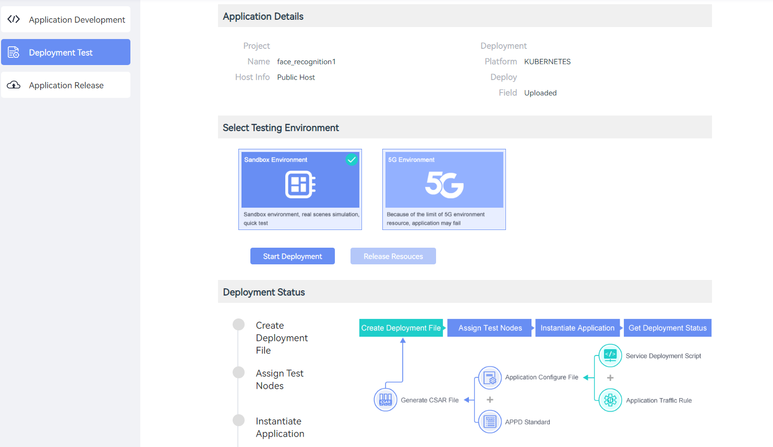

#### Application Release

In the Project Details, the Appcation Description File must be uploaded; in the Service Publishing Configuration, the service to be published must be added

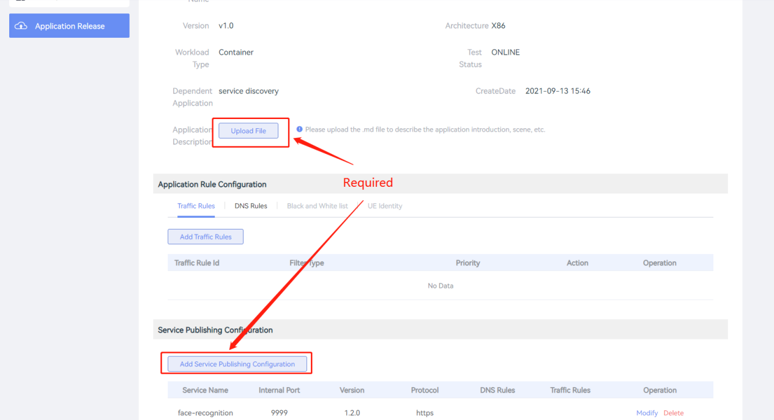

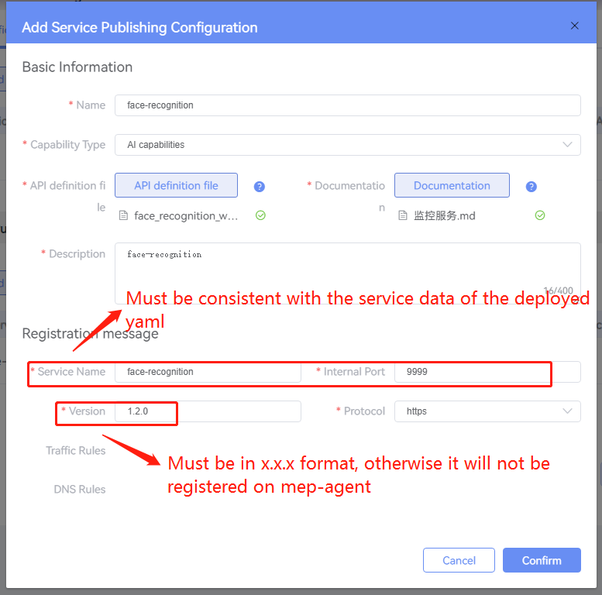

After the configuration is completed, you must click Save Config, otherwise the configuration will not take effect, click Next to proceed with the Application Certification Test

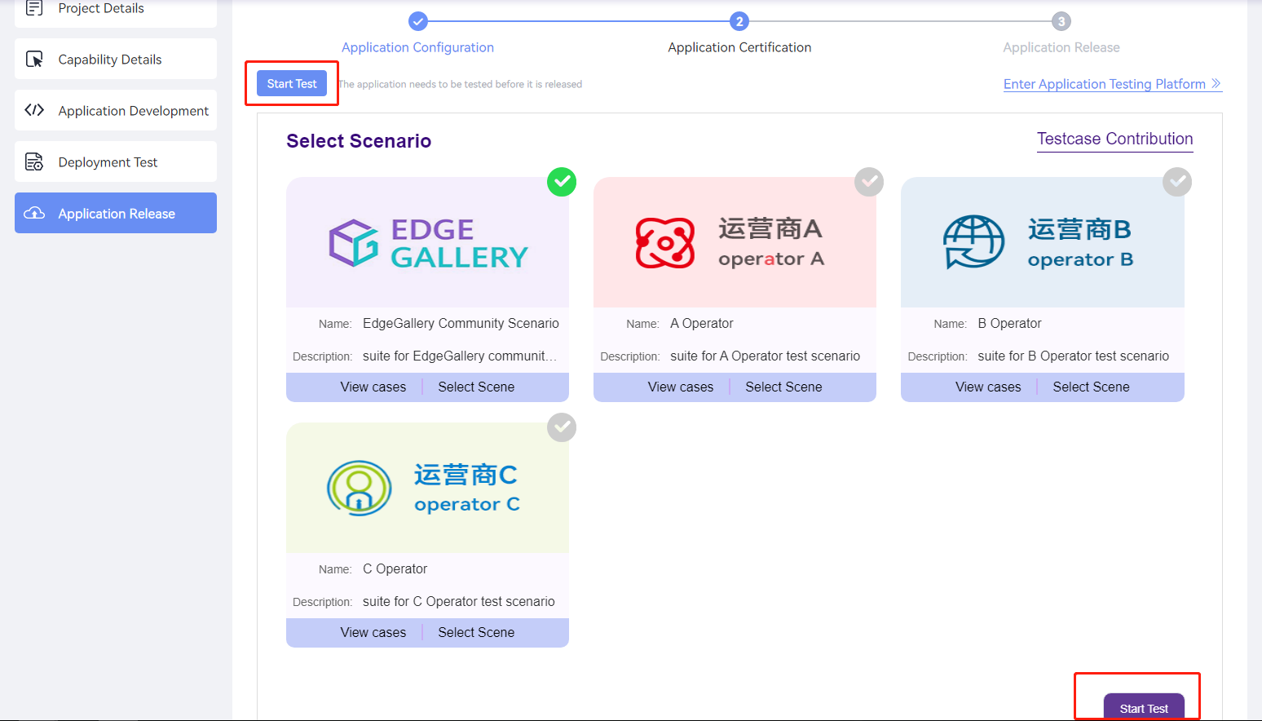

To be tested successfully, click Next to release the application

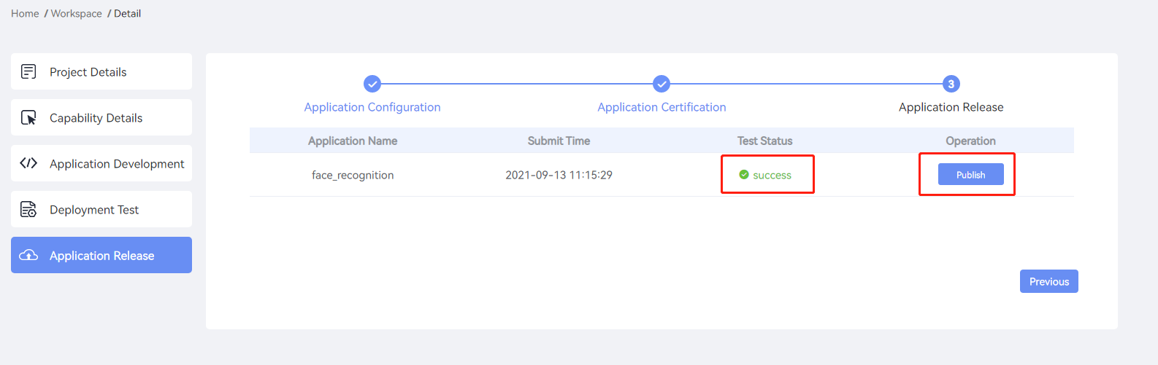

Successfully Publish, not only can you see the application in the AppStore, but also the released capabilities in the competence center

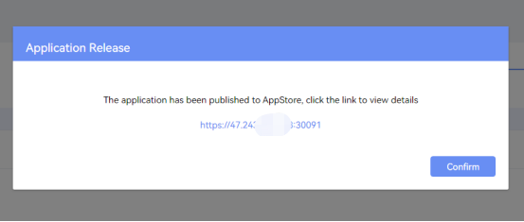

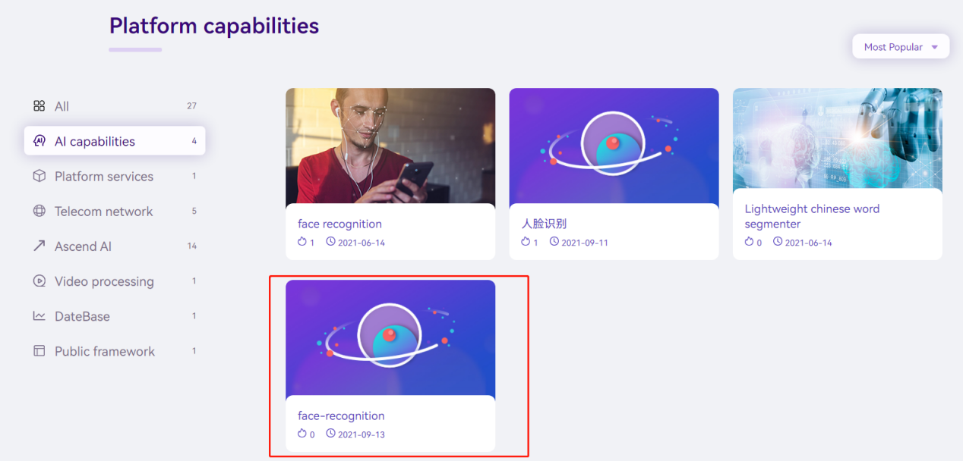

### MECM Instantiation Application

#### 1.Sync application

APP Management->Package List->Sychronize From App Store,Select application,click Confirm

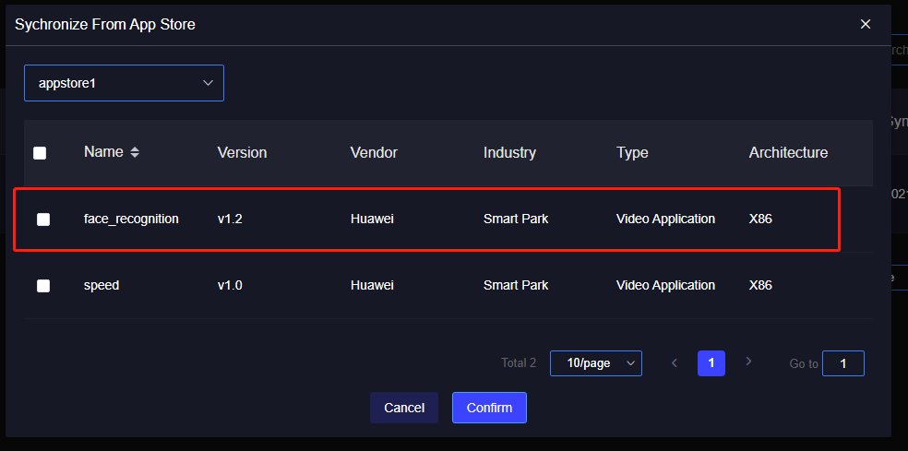

#### 2.Distribute to edge nodes

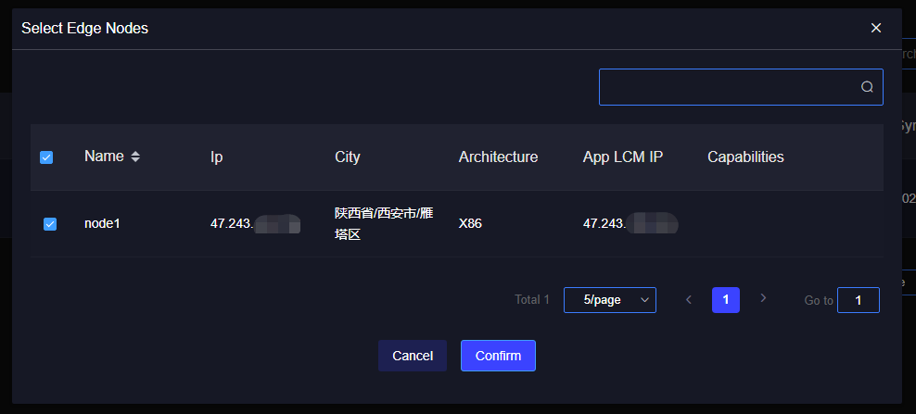

#### Deploy

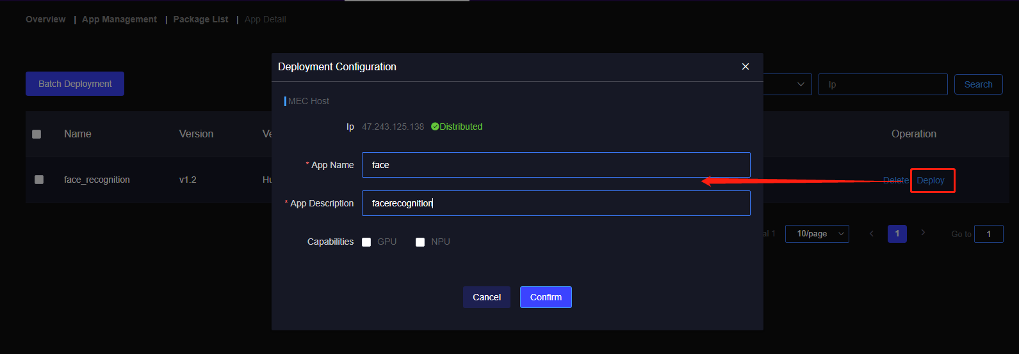

Successful deployment

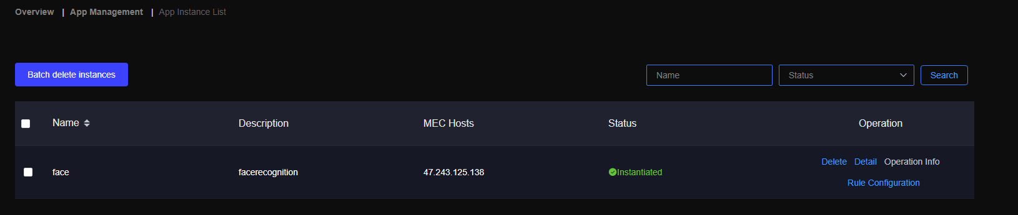

### Difference

In the process of creating the Monitor application on the Developer platform, you need to select the service discovery and previously released face-recognition capabilities, and you do not need to upload the service release configuration.

The other steps are exactly the same.

