Regex

## Flag

<https://javascript.info/regexp-introduction#flags>

Regular expressions may have flags that affect the search.

There are only 6 of them in JavaScript:

**i**

With this flag the search is case-insensitive: no difference between A and a (see the example below).

**g**

With this flag the search looks for all matches, without it – only the first match is returned.

## 重复修饰符

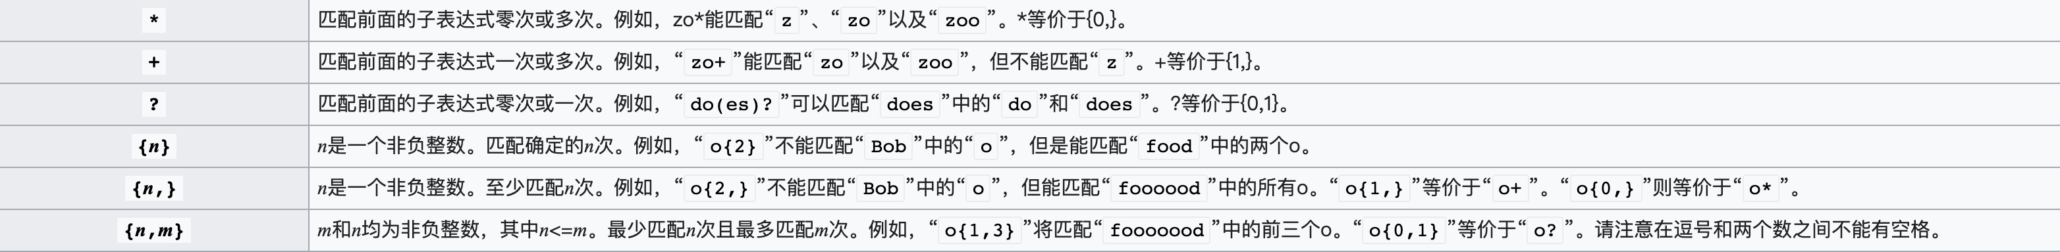

贪婪匹配会尽量从高往低进行匹配，

而非贪心量化则会从低往高进行匹配

<https://stackoverflow.com/questions/21289027/java-regular-expression-two-question-marks>

## 模式匹配

只有第一种可以拿到匹配后的内容， 注意，只能使用$0…$9，其余数字容易引起歧义