**Introduction**

This document outlines the design, development, and implementation of a full-stack eCommerce web application using the MERN stack (MongoDB, Express.js, React.js, and Node.js). The project includes an admin panel for product management and a user-friendly interface for customers to browse, add to cart, and purchase products.

## ****Project Overview****

### ****Features****

* **User Authentication:** Registration, login, and authentication using JWT.
* **Admin Panel:** Add, update, and delete products.
* **Product Management:** View product details, categories, and search functionality.
* **Shopping Cart:** Add/remove items, adjust quantity.
* **Checkout & Payment:** Payment gateway integration (e.g., Stripe, PayPal).
* **Order Management:** Track orders, view order history.
* **User Profile:** Update user details, view order history.
* **Product Reviews & Ratings:** Users can leave feedback on products.
* **Wishlist Functionality:** Users can save products for future purchases.
* **Email Notifications:** Order confirmation and status updates.
* **Responsive UI:** Mobile-friendly design using React.js.
* **Search and Filtering:** Enhanced product discovery using search and category filters.

## ****Technology Stack****

### ****Frontend:****

* React.js
* Redux (for state management)
* Tailwind CSS / Bootstrap
* Axios (for API calls)

### ****Backend:****

* Node.js
* Express.js
* MongoDB with Mongoose
* JWT for authentication
* Bcrypt.js for password hashing

### ****Other Tools & Services:****

* Cloudinary (for image storage)
* Stripe / PayPal (for payments)
* Redux Toolkit (for global state management)
* Postman (API testing)
* Git & GitHub (version control)
* Nodemailer (for sending emails)

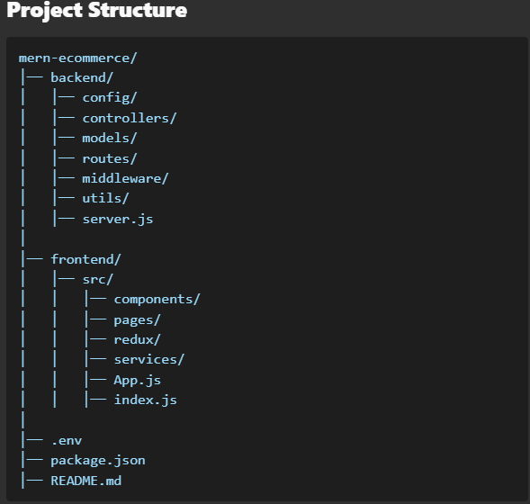

## ****Installation & Setup****

### ****1. Clone the Repository****



### ****2. Install Dependencies****

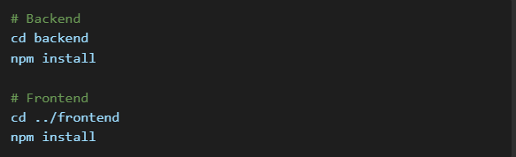

### ****3. Configure Environment Variables****

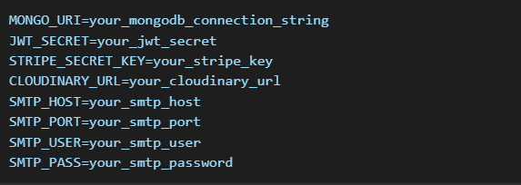

### ****4. Run the Project****

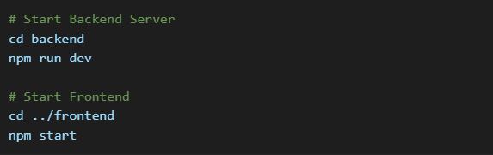

## ****API Endpoints****

### ****User Authentication****

* POST /api/users/register - Register a new user
* POST /api/users/login - Authenticate user & get token
* GET /api/users/profile - Get user profile (protected route)
* PUT /api/users/profile - Update user details

### ****Product Management****

* GET /api/products - Fetch all products
* GET /api/products/:id - Fetch single product
* POST /api/products - Add new product (admin only)
* PUT /api/products/:id - Update product (admin only)
* DELETE /api/products/:id - Delete product (admin only)
* POST /api/products/:id/review - Add product review

### ****Orders & Cart****

* POST /api/orders - Create an order
* GET /api/orders/:id - Get order details
* GET /api/orders/user/:id - Get user order history
* PUT /api/orders/:id/pay - Mark order as paid
* PUT /api/orders/:id/deliver - Mark order as delivered

### ****Wishlist****

* POST /api/wishlist - Add item to wishlist
* GET /api/wishlist - Get wishlist items
* DELETE /api/wishlist/:id - Remove item from wishlist

### ****Email Notifications****

* POST /api/notifications/order-confirmation - Send order confirmation email
* POST /api/notifications/order-status - Send order status update

## ****Deployment****

### ****1. Backend Deployment (Heroku/Vercel)****

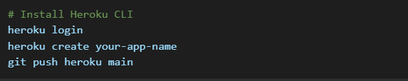

### ****2. Frontend Deployment (Vercel/Netlify)****

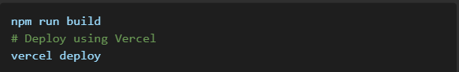

## ****Security Considerations****

* Use environment variables to store sensitive data.
* Implement proper validation for user inputs.
* Secure authentication with JWT and password hashing.
* Use HTTPS for secure communication.
* Implement role-based access control (RBAC) for admin users.

## ****Future Enhancements****

* Implement AI-based product recommendations
* Add real-time order tracking
* Implement a live chat feature for customer support
* Introduce discount coupons and promotional offers
* Enhance SEO optimization for better search visibility

## ****Conclusion****

This eCommerce project provides a scalable and efficient shopping experience. The combination of the MERN stack ensures seamless performance and flexibility for further enhancements. With features such as authentication, product management, shopping cart, and payment integration, this platform serves as a solid foundation for an online marketplace.