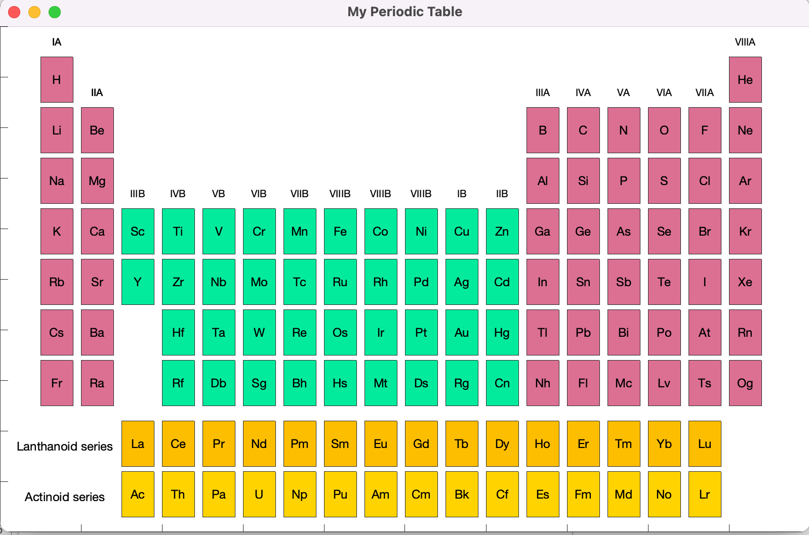

After “Sg” was clicked, in the command window:

---------------------------------------------------------------------------------------------------------------

Element: Seaborgium

Symbol: Sg

Atomic number: 106.

Atomic weight: 268.1u.

There's no data found for negativity of element Seaborgium

Description: Seaborgium is a radioactive element that is short-lived.

Group: VIB.

Period:7.

After “Ag” was clicked, in the command window:

---------------------------------------------------------------------------------------------------------------

Element: Silver

Symbol: Ag

Atomic number: 47.

Atomic weight: 107.9u.

Electronegativity: 1.93.

Description: Silver is a soft, shiny metal that is the best electrical conductor.

Group: Lanthanide Series.

Period:5.