New color:

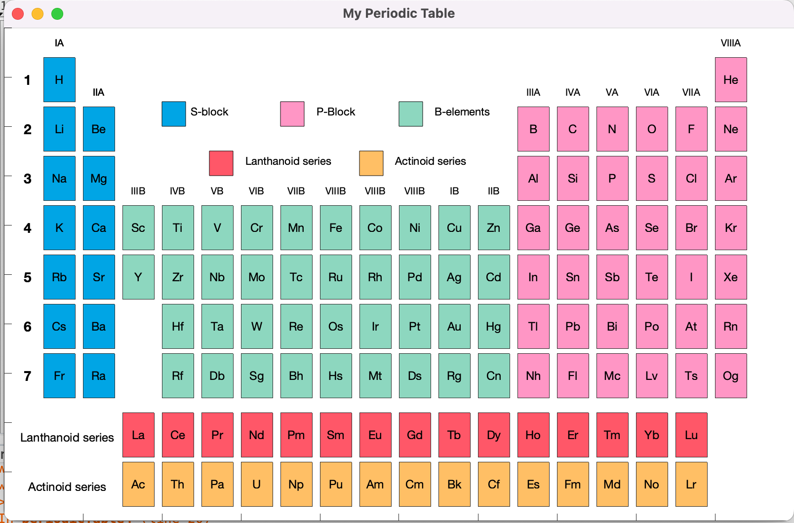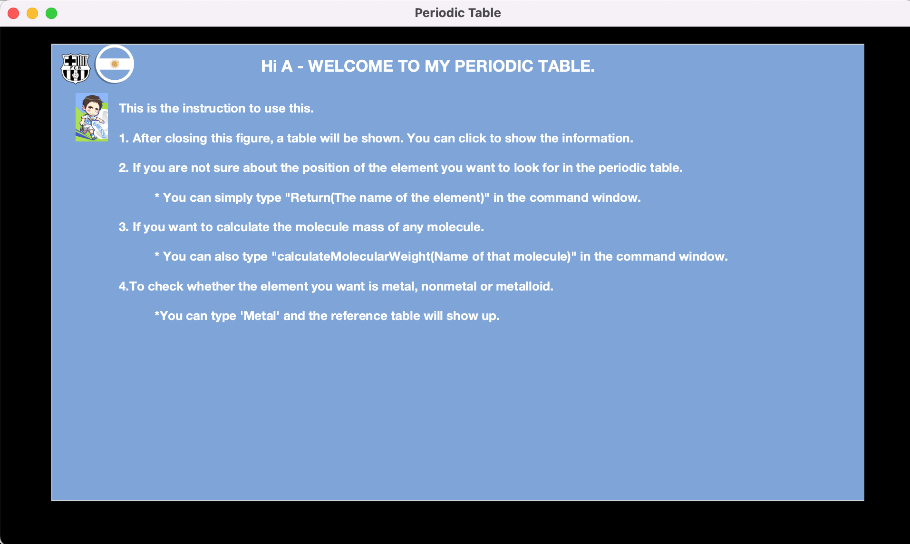

After typing, a, a figure will be showed to instruct how to use the periodic Table.

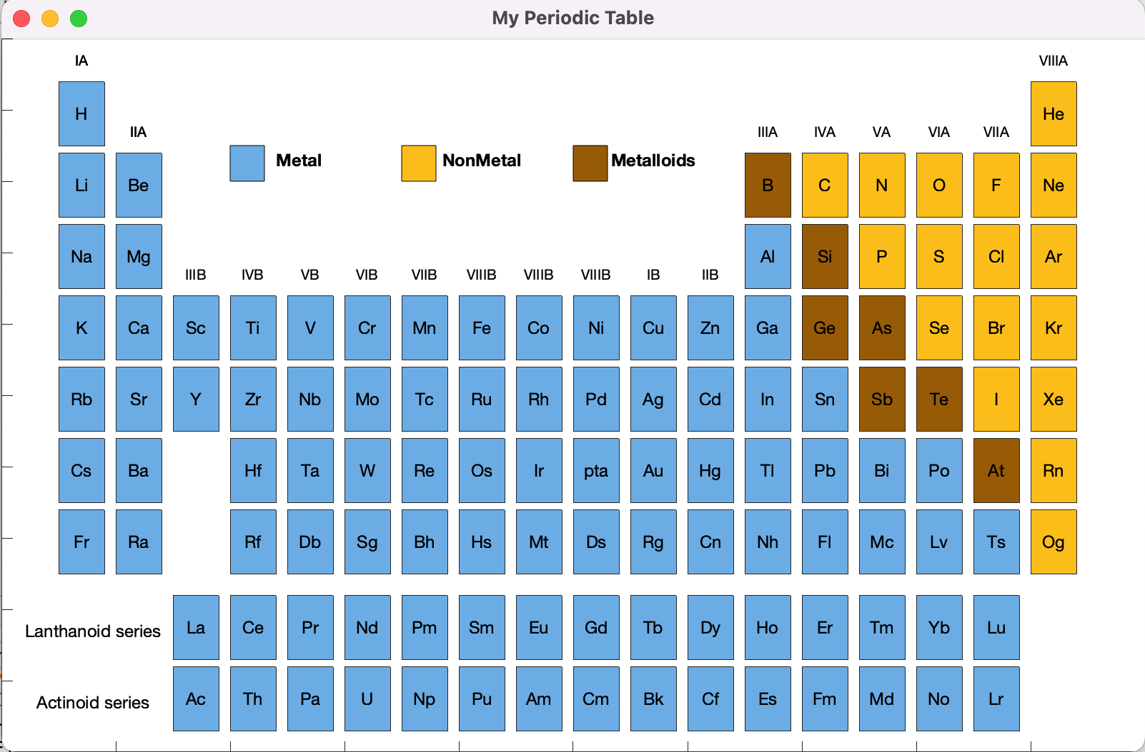

Also, add the new function Metal, a figure will be showed to check if the element is a metal, nonmetal or a metalloid.