NUME___L2 - Lața Eduard________________________________

The digital infrastructure of a company consists of a computing server and a storage server equipped with two large disks arrays. The user requirements are homogeneous and the workload generated may be considered as a single class. The layout of the digital infrastructure is shown in Figure

- The customer class, referred to as ClosedClass, has a population of N = 3 customers. There are four stations (CPU, Diskl and Disk2), three are of queueing type load independent and one is of delay type (Users)

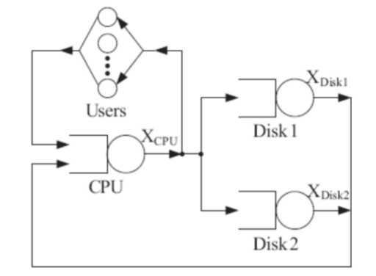

Figure 1: The system of Example 2.

Users delay station represents user's think time (Z = 16s) between interaction with the system. Service times, distributed exponentially, and the visits at the stations are reported in Table 1.

 | CPU | Disk1 | Disk2 | Users
Service time [sec] | 0.006 | 0.038 | 0.030 | 16
Visits | 101 | 60 | 40 | 1

Table 1: The parameters for the single class model of Example 2.

Drawing the graph
- The graph should look like Figure 2
- The default Selected Distribution should be Exponential.
- As there are 3 outgoing links from CPU, we have to set a job’s probability to choose each of these paths. This is done by setting the probabilities of Disk1, Disk2 and Users as 60, 40 and 1 respectively . Note that the values of the Probabilities are automatically adjusted by the tool.

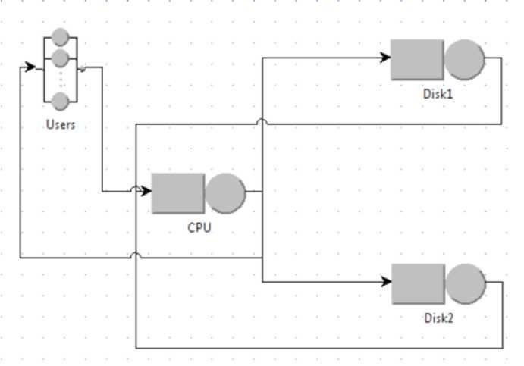

Figure 2: The system

- Set Defining the Performance Indices
Before start the simulation we must select the performance indices to analyze. In Example 1 we want to study the following indices:
 | Queue time  [sec] | Throughput [jobs/sec] | Residence time [sec] | System Response Time [sec] | - Utilization
CPU | 0.000361 | 14.358 | 0.595 | 20.810 | 0.085

- Running the Simulation

Example 3 - A model with a load dependent station

The network is shown in Figure 2. It comprises only two stations: one is of delay type (named Users) and the other is a load dependent station (named Station). This model has one closed class only with N = 8 customers. The user's think time is Z = 21 s, while the service demands for the load dependent Station, shown in Table 4, are function of n: number of customers in the station (D(n) = n + 1/n).
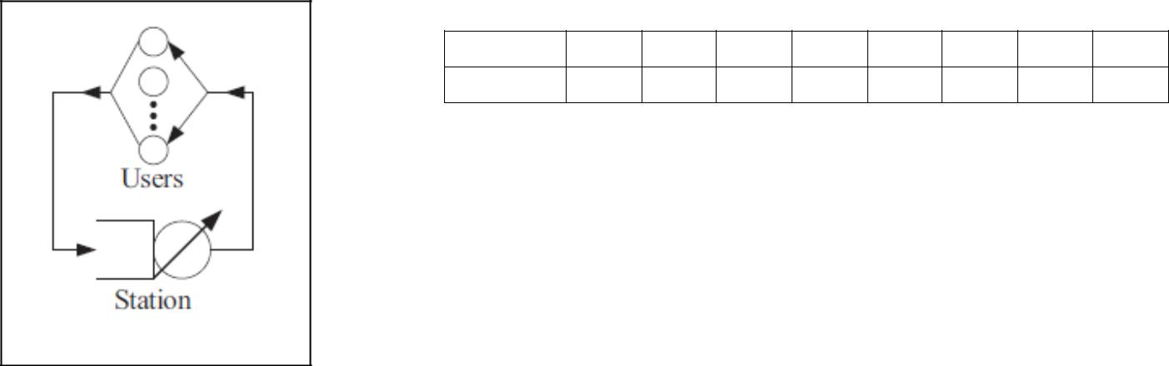

n 1 2 3 4 5 6 7 8

D(n) [s] 2.00 2.50 3.33 4.25 5.20 6.17 7.14 8.13

Table 4: Example 3 - service demands for Station, a load-dependent service center

Figure 2 : Example 3 - network topology

In Example 3 we want to study the following indices:

 | Station | Users
Throughput [job/s] | 0.280 | 0.283
Queue Time[sec] | 4.695 | 0.00
Residence Time [s] | 7.234 | 21.038
Utilization | 0.717 | 6.050

