Developing Sword of Time: A Thesis in Gameplay Mechanics and Systems Design
Candidate: Eduard Iorga
Scientific coordinators: Assistant Professor eng. Alexandru GROSU
Lect. Dr. eng. Stelian NICOLA
Session: June 2025

Table of Contents
1. INTRODUCTION 6
1.1 Context 6
1.2 General Information 6
1.3 Theme and Game Name 6
1.4 Target Audience, Game Type and Player Objectives 6
1.5 Motivation and Objectives 7
2. DOMAIN STUDY 8
2.1 Selected Games for Analysis 8
2.2 Comparative Analysis of proposed games and Sword of Time 10
2.3 Analysis Table 11
3. THEORETICAL FOUNDATIONS 13
3.1 Technologies Used 13
3.2 Key Systems and Libraries 15
4. Proposed Solution and Design Methodology 18
4.1 General Game Design Overview 18
4.2 Core Mechanics (Functional Overview) 18
4.3 Progression System 19
4.4 Difficulty and Balancing 19
4.5 Algorithm Schematics 20
4.6 Player Attack System 22
5. Implementation Analysis 24
5.1 Code Implementation Analysis 24
5.1.1 Player Movement 24
5.1.2 Player Attack 28
5.1.3 Enemy Patrol 31
5.1.4 Boss Enemy 32
5.1.5 Melee and Ranged Enemies 34
5.1.6 Procedural Room Generation 36
5.1.7 Enemy Damage 40
5.1.8 Enemy Movement 41
5.1.9 Spike Head 42
5.1.10 Health System 43
5.1.11 Ability System 45
5.1.12 Time Rewind Mechanic 47
5.1.13 Camera 49
5.1.14 UI System 50
5.1.15 Game Stats Tracker System 52
5.2 Narrative, Used Assets and Animations 53
6. Game Testing and Experimental Results 56
6.1 Data Collection Methods 56
6.1.1 Gameplay Statistics via Google Sheets 56
6.1.2 Gameplay Statistics via Google Forms 56
6.2 Analysis of Results 56
6.2.1 Gameplay Stats Overview 56
6.2.2 Feedback Highlights 58
7. Conclusion 62
8. References 63

ABSTRACT

Sword of Time este un joc video 2D platformer rogue-like realizat ca parte a lucrarii mele de licența, explorând mecanici de gameplay și design-ul sistemelor. Principalul obiectiv al acestei lucrări a fost crearea unui joc dinamic și generat procedural care prezintă o provocare pentru jucători prin mecanici legate de manipularea timpului și a formei jucătorului precum și generarea aleatorie de niveluri. Toate aceste elemente îl provoacă pe jucător să gândească atât creativ cât și strategic pentru a completa obiectivul jocului. Sword of Time combină platforming-ul cu elemente de progress de tip rogue-like, ce crează o buclă de repetiție unică la fiecare încercare.

Procesul de dezvoltare a avut loc în Game Engine-ul Unity, punând accent pe algoritmi de generare procedurală, abilități controlate de jucător și un sistem de combat. Elemente cheie de design ce au prezentat o provocare sunt cele precum crearea unui mediu de joc și a unor mecanici balansate, astfel asigurând ca fiecare parcurgere a jocului este atât provocatoare cât și plină de recompensă. Jocul prezintă mecanici precum wind-dashing, derularea înapoi a timpului, varietate în inamici, obiecte și niveluri ce devin progresiv mai grele și necesită o adaptare strategică.

Rezultatul acestui proiect este un demo Sword of Time, unde jucătorii pot naviga prin niveluri generate procedural, învingând inamicii și depășind obstacolele din cale folosind abilități și obiecete pe care le obțin. Această lucrare concluzionează prin o analiză a eficienței sistemelor de jocuri, precum și sugestii pentru dezvoltarea viitoare ce va extinde narativa cât și raza de interacțiune a jucătorului.

ABSTRACT

Sword of Time is a 2D platformer rogue-like video game developed as part of my thesis exploring gameplay mechanics and systems design. The primary objective of this research was to create a dynamic and procedurally generated game experience that challenges players with time-based mechanics, randomly generated levels that challenge the player to think both creatively and strategically. Sword of Time combines the thrill of platforming with rogue-like progression elements, creating a unique loop of discovery and challenge.

The development process utilized the Unity game engine, focusing on procedural generation algorithms, player-controlled abilities and combat systems. Key design challenges included creating a balanced game environment and mechanics, thus ensuring that each playthrough is both challenging and rewarding. The game features mechanics such as wind-dashing, enemy variety, items and progressively harder environments that require adaptive strategies.

The outcome of this project is a playable demo of Sword of Time, where players can navigate through procedurally generated levels, overcoming enemies and environmental obstacles using the abilities or items they acquire. This thesis concludes with an analysis of the effectiveness of the game systems and suggestions for future development to expand the scope of player interaction and narrative depth.

INTRODUCTION

Context
Nowadays, the video game industry has become one of the most significant sectors in digital entertainment[1]. Modern technologies and game engines allow for the creation of complex and immersive interactive experiences. In this current context, developing a video game is more of a technological and creative challenge that combines knowledge from a wide range of areas such as programming, graphic design and user psychology.

General Information
This thesis presents the development and design process of the video game Sword of Time, a 2D platformer with action elements that also combines key particularities from the rogue like genre[2]. The video game is developed in the Unity Engine and the programming language used for the scripting being C#. The game follows a warrior who must pass through different levels that are riddled with obstacles and enemies in order to get the swords of time. The warrior collects the swords of time by defeating the boss of each world. Once he completes the world by defeating the boss, he moves on to the next one trying to pass through that world’s specific obstacles. The gameplay emphasizes precise movement control, a time rewinding mechanic, intelligent enemy interactions and a wind-dashing mechanic that allows you to pass through enemies and objects.

Theme and Game Name
The theme of this thesis is Developing Sword of Time: a deeper dive in Gameplay Mechanics and Systems Design. The central focus is the creation of a 2D platformer that mixes with elements of the rogue-like genre, while also exploring how different gameplay mechanics and procedural systems can enhance platforming gameplay.

Target Audience, Game Type and Player Objectives
The game is aimed at players aged between 16 to 35 who enjoy challenging, strategic and skill-based games with high replay value. Fans of games like Dead Cells, Hollow Knight and Hades, who appreciate fast-paced combat, progression systems and unique mechanics will find Sword of Time engaging.
As the previously mentioned games, Sword of Time falls in the spectre of a 2D rogue-like platformer genre. It integrates action-oriented platforming with procedural generation and time-based mechanics such as rewinding, dashing and combat interactions.

Players are tasked with surviving as long as possible while progressing through procedurally generated levels. They must defeat enemies, avoid traps and collect items that give them access to unique abilities. The player’s ultimate goal is to master the game’s systems, learning to make use of the powers they obtain and overcome the challenges presented their way.

Motivation and Objectives
The motivation behind this project stems from the desire to realize my own creativity in this part of the industry. A hobby of mine is playing video games, so taking into account the multitude of games I have played, I know what I enjoyed seeing in such a project. Thus, I wanted to make my own creation and ensure I could develop a video game that I would enjoy playing anytime. This thesis also aims to bridge theoretical research and practical implementation by using Sword of Time as a case study in system-driven game design. Key objectives included building a cohesive game loop, balancing the procedural randomness with fairness and designing mechanics that reward both reflexes and strategy.

Domain Study

Selected Games for Analysis
Dead Cells is a video game made by Motion Twin which features mechanics such as the procedural generation of levels, fluid melee combat, permadeath as well as upgrades/unlocks across runs[3]. The engine used for developing this game was a custom one, made by the developers themselves, named Heaps. A key technology that the developer made use of was the pixel art pipeline, namely they started the designs of characters and animations with 3D models, which are further rigged and animated using Spine, thus making them 2D. The pixel art alone sets them apart from other games’ designs, simply by the fluidity and smoothness of the animations as well as by the responsive and aesthetically pleasing colours. Apart from these, some other notable features would be its high replayability through a well put together weapon system and randomized level layout.
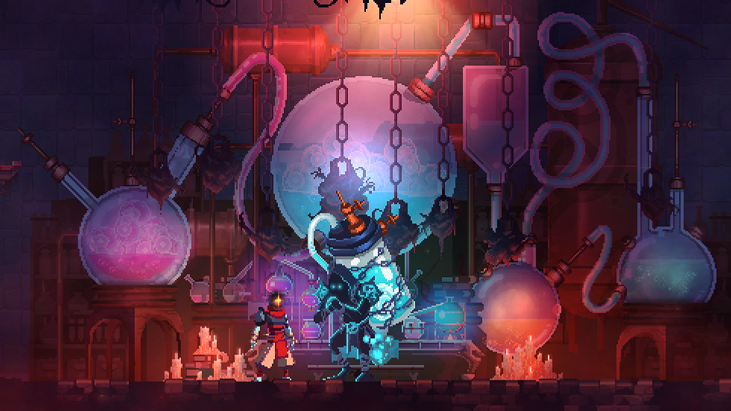
Figure 2.1.1 - Showcase of Dead Cells’ unique aesthetic (source: Retronator)
Hollow Knight is a 2D platformer video game developed by Team Cherry which sets itself apart with mechanics such as precision platforming, unlockable abilities (e.g. double jump, dash)[4]. This game, stands apart from the others through its metroidvania elements; this implies that Hollow Knight isn’t your typical platformer where the player has a clear path to go through. In this game, you can explore different areas with different levels of difficulties, some may even need you to unlock new abilities in order to access them. The game was developed in Unity using hand-drawn animations, another feature that makes it remark itself by its aesthetically pleasing visuals. Although it doesn’t fall in the rogue-like genre, the movement and combat design inspired Sword of Time.
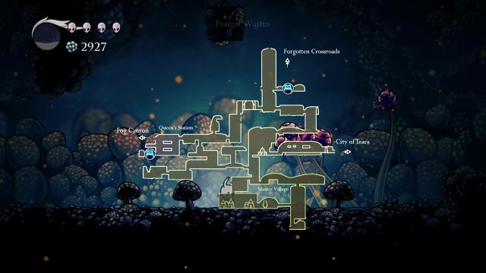
Figure 2.1.2 - Showcase of Hollow Knight’s Metroidvania aspect (source: VGChartz)
Hades is a rogue-lite video game developed by SuperGiant Games and similar to Dead Cells, it features procedural dungeon generation, boss encounters, but adds its own touch through ability combos that are unlocked via boons, hub world, as well as rich voice-acted narrative[5]. Hades sets itself apart through its rich and captivating story, encouraging replayability in order to finish the game. It is also well received due to its fluid and beautiful graphics that fit well the Greek Mythology theme it approaches. The boon system is something unique, even though it could be argued that a boon is just a simple item, in reality through a boon you gain different combos and abilities that impact your gameplay. It is worth mentioning that it has a more complex system of items, since there are different types of boons, that can randomly give you different side effects.
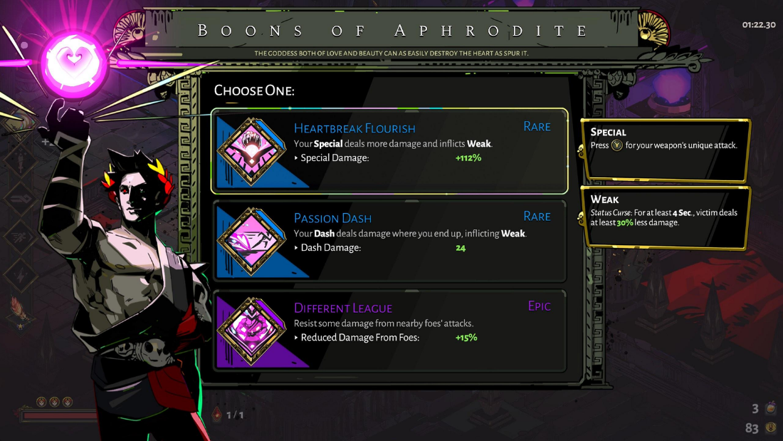

Figure 2.1.3 - Showcase of Hades’ Boon System (source:Boons )
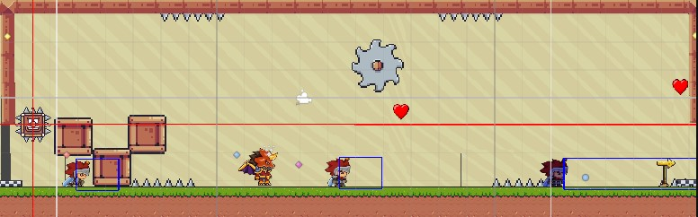
Sword of Time is the game I developed using the Unity Engine, C# scripting and different assets from the Unity Asset Store. It features mechanics such as procedurally generated levels, player abilities such as time rewinding and wind dashing, which are obtained through picking up items[6]. The enemies are of different types, namely there are melee and ranged enemies and each enemy from these categories can either patrol or stay in place. Last but not least, the game features a Boss enemy, which is a more difficult and also a mixture of the melee and ranged enemies, meaning that it can use both types of attacks and is constantly on the lookout for the player. This enemy, activates once you enter its specific room, namely the Boss Room. The procedurally generated rooms, are riddled with enemies, traps, items (that could be the ones that unlock abilities or simply health pickups that give your health back) and also different types of decorations, that can help ease your playthrough.
Figure 2.1.4 - Showcase of one such procedurally generated room (source: screenshot)

Comparative Analysis of proposed games and Sword of Time
We will start by comparing key mechanics and moving our way to what distinct features set them apart from one another.
Movement and Mobility in all three games (Dead Cells, Hollow Knight and Sword of Time) is fast-paced and based on responsiveness. The player can jump, roll, double jump, wall jump, as well as make use of their abilities to improve traversal. In this aspect, Hades has a different approach, the movement is based on isometric dashes and fast reaction timing, that is due to the fact that in this game you use the movement as a means to dodge attacks and move faster, having no need to interact with the environment. While both Sword of Time and Hades share this dash mechanic, in the case of Sword of Time it is not that as dependent on it as Hades.
The Combat System sees some similarities between Sword of Time and Dead Cells, both games having melee and ranged combat, while also bringing to the table unique abilities. Hades and Hollow Knight focus more on melee combat, spells and each game’s respective “item” system, namely Hades with the Boons and Hollow Knight with charms. While these games may take a more complex approach to their combat system, Sword of Time follows a more simplistic approach, that forces the player to be efficient and precise with their movement and attacks.
Progression System functions on the same principle for Dead Cells, Hades and Sword of Time, all three being rogue-likes. Meaning that if you die during one of the playthroughs and you have items on yourself, all the progress is lost and you must start from the beginning with nothing that you had on the previous run present on you. This ensures a challenging experience, making every action matter, even though at time it can be frustrating, it brings novelty to each playthrough. Hollow Knight on the other hand, takes the metroidvania genre approach, upon death, the player may lose some currency, but whatever items he had previously on him, stay even after death. Furthermore, Hollow Knight has checkpoints system, meaning you don’t have to start from the beginning every time you die.
When it comes to Visual Style, Sword of Time and Hollow Knight are very similar, both embracing a stylish and minimalist 2.5D art. Sword of Time also makes use of things such a particle system and grayscaling, that activate upon using the Rewinding Time ability, making the experience overall more immersive. Dead Cells on the other hand fully embraces pixel art, well mixing the 2D and 3D aspects of it, while Hades sets the tone with vibrant animations that make for an enjoyable visual experience.

Analysis Table

Table 2.3.1- Showcase of selected games comparison

Game Name | Movement & Mobility | Combat System | Progression System | Visual Style
Dead Cells | Fast-paced, responsive, jump, double jump, dodge roll | Fluid melee/ranged combat and weapon variety | Rogue-like, unlock new gear over runs | Pixel art with dynamic lighting
Hollow Knight | Tight 2D movement, wall jump, dash | Melee combat, spells and charms | Metroidvania, ability-based map access | Hand-drawn atmospheric and minimalist UI
Hades | Isometric dashes, fast reaction timing | Multiple weapons, melee combat, boons | Rogue-like, permanent upgrades via mirror | Stylized and vibrant animation
Sword of Time | Wind-dashing, double-jump, platformer style traversal | Melee and Ranged combat, unique abilities | Rogue-like | Pixel art, grayscale and particle effects during abilities

Theoretical Foundations

Technologies Used
The development of Sword of Time was realized using the Unity Engine, chosen for its support for 2D development, wide and active community that makes its presence known through the Asset Store, as well as Unity’s powerful tooling. As it is custom for Unity, the C# programming language was used to implement the scripts that affect the gameplay mechanics and systems.

The engine used for development is Unity 6.0, thus Unity specific features have been used in the development of the game, such as URP, the URP Post-Processing Stack and the Unity Asset Store[6]. The URP is used for scene management, rendering, physics and animations. The URP Post-Processing Stack is used to create visual effects such as the grayscale filter applied during time rewind[7]. Through the Asset Store, sprites, level design elements and systems have been imported[8].
Figure 3.1.1 – Showcase of Unity (source: Unity)

As previously mentioned, the programming is done in C#, a language used for all gameplay scripts, that includes the enemy patrol AI, time rewinding mechanic, player control and procedural level generation[9]. The code is ran and compiled through Visual Studio, an IDE developed by Microsoft, that allows editing, debugging, building and deploying the code[10].
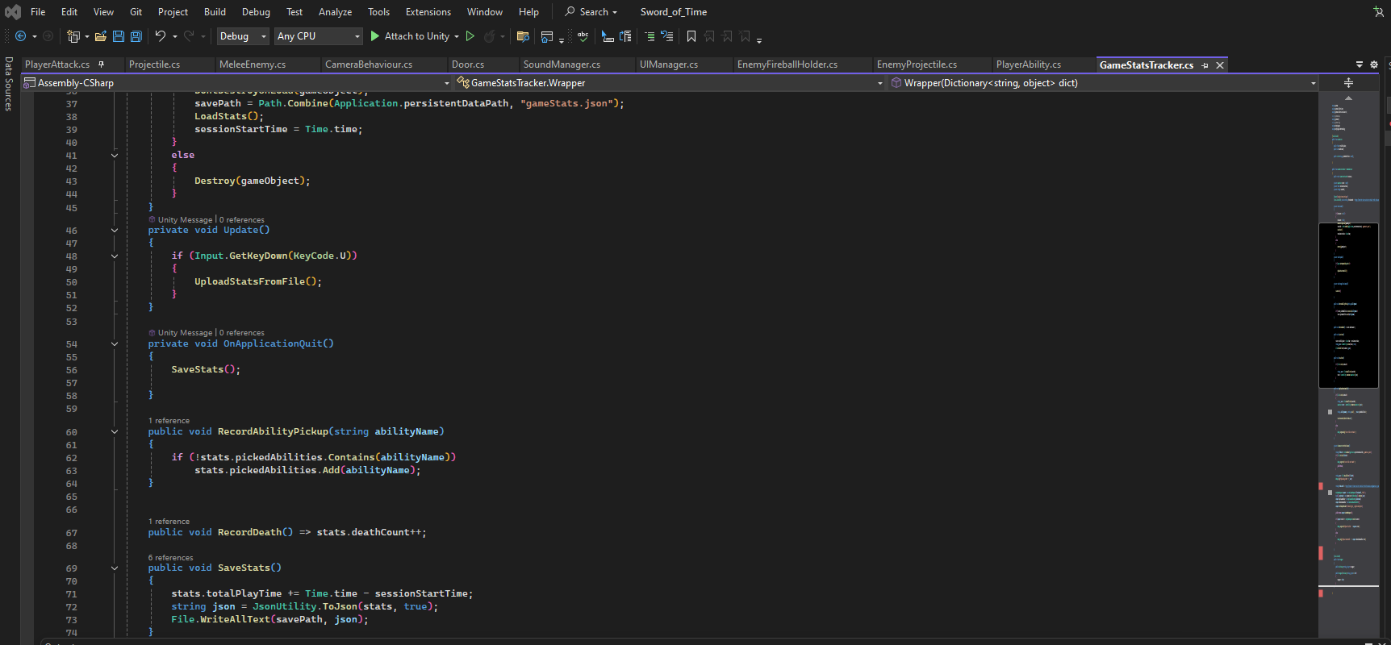
Figure 3.1.2 - Showcase of Visual Studio interface (Source: screenshot)


Through C# I make use of Component-Based Design, whose purpose is to modularize functionality into reusable scripts, such as EnemyPatrol.cs and HealthSystem.cs scripts, that don’t have only one single purpose.
Figure 3.1.3 - Showcase of C# (source: C#)

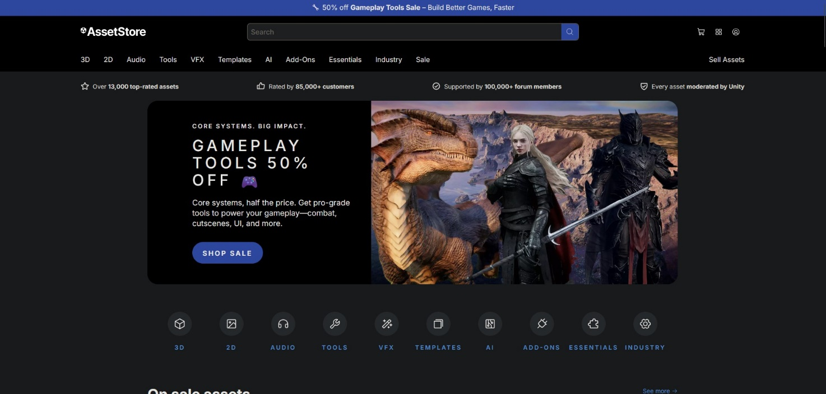
The Art Pipeline uses Unity specific tools such as the Animator Controller system, Sprite Editor and as mentioned above the Asset Store, through which everything related to animations and level designing was imported[11]. Unity’s Animator Controller system is used in order to manage transitions between states, such as idle, run, attack. Furthermore, Unity’s Sprite Editor is used in order to enable an efficient animation workflow on the sprite sheets.
Figure 3.1.4 -Showcase of Unity Asset Store (source: Screenshot)

Key Systems and Libraries
Enemy Patrol System is done through direct manipulation of the enemy’s Transform.position, without making use of a pathfinding algorithm. The patrol area is defined by two edges, the enemy flipping direction when colliding with them. The sprite’s scale is flipped on the x-axis to mirror direction and animations are toggle via the Unity Animator. The moment the enemy reaches the edge, he remains idle for a few seconds before changing direction of his patrol; this is due to the fact that I wanted to take a realistic approach to the way an enemy patrols. The animator triggers in order to sync movement with visual state.

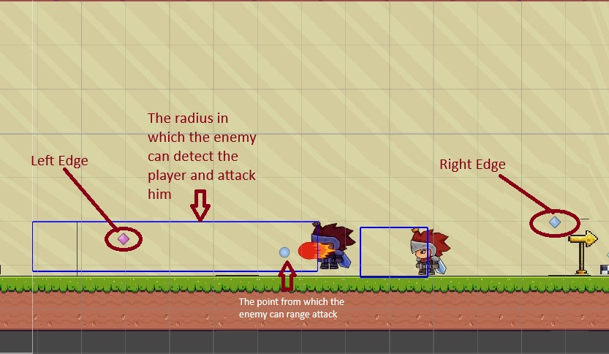
Figure 3.2.1 -Explanation of Enemy Patrol System (source: Screenshot)

Time Rewind System brings a unique take on the gameplay depth. Through it players can correct mistakes, escape traps or plan attacks in a strategic way. Time Rewind affects both the player and environment, making the player immune to damage while rewinding and the enemies immobilized, allowing for breathing room. The way this mechanic works is that it stores the positions and rotations in a buffer, and when triggered, time is reversed by restoring the previous positions/rotations frame-by-frame.

The Rigidbody2D component is set to Kinematic in order to prevent physics conflicts. The other objects such as traps also include a TimeRewind component that manages their own recorded state. This way, it allows for reusable rewind behaviour across multiple object types, making them affected by this ability. In order to create an immersive experience, Unity’s Volume system comes into play, through enabling the grayscale effect and particles during the use of the ability.

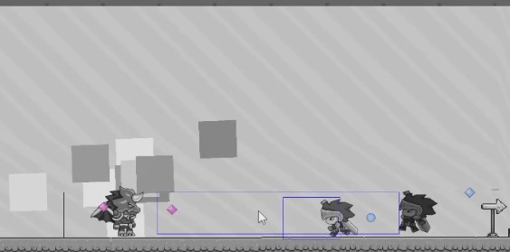

Figure 3.2.2 - Showcase of Time Rewind Ability (source: Screenshot)

Proposed Solution and Design Methodology

General Game Design Overview
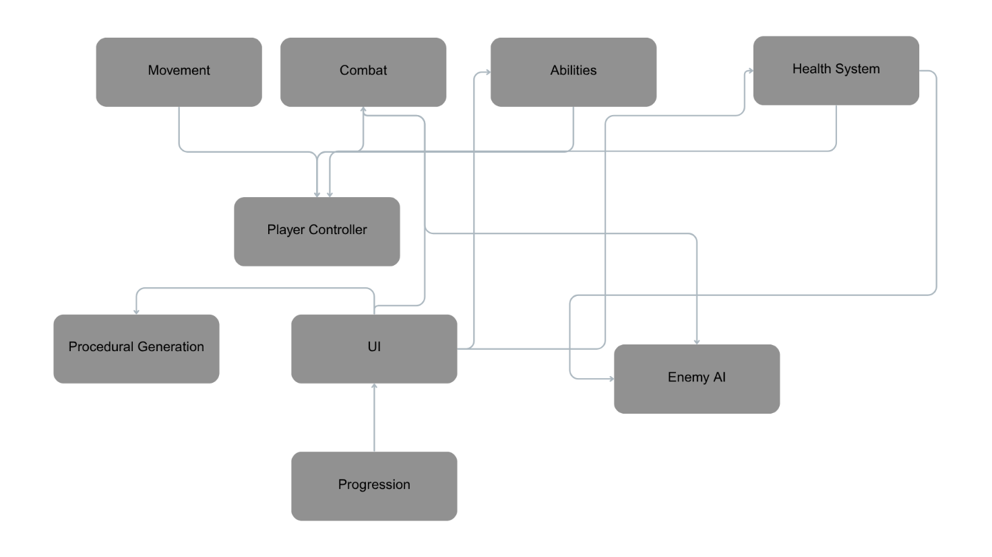
The game Sword of Time is centered around rogue-like mechanics in a procedurally generated 2D platformer environment. The player explores rooms, battles enemies and makes use of his abilities strategically to overcome obstacles. The overall game architecture is designed in a modular, component-based manner, allowing systems like combat, movement and enemy AI to function independently yet interact seamlessly.
Figure 4.1.1 - Block Diagram of main mechanics (source: own diagram)

Core Mechanics (Functional Overview)
The movement is a standard 2D movement with running and jumping. The player can also hang on to the wall or jump from it. He can have a normal jump or double jump. The combat is made out of ranged attacks with a fireball when it comes to the player’s perspective. When it comes to the enemies they can have melee attacks with swords or ranged attacks with fireballs. The boss has a mix of ranged and melee attacks, making him more unpredictable then the rest of the enemy NPCs.
Abilities can be of several types. The most important ones would be the time rewind and wind dashing abilities. Through time rewind the player goes back in time a few seconds, enemies and traps stop from moving, and he is immune during the rewind. Wind Dash provides the player the ability to transform into wind and pass through objects, traps or even enemies in order to avoid combat. There can also be abilities such as jump enhancing, where the player can double jump or even triple jump, or even abilities that enhance the player’s attack. Interaction is based on the fact that the player can take health pickups from the ground that give him more health or even take items that grant abilities such as the ones listed above.

Progression System
Level Advancement is done through the player completing the rooms he has in front of him, namely surviving the room and reaching the next one, until he reaches the boss room. After the boss is defeated, the game is completed

Difficulty and Balancing
Difficulty ramps up through increased enemy count and patrolling, but also through environmental hazards such as traps and obstacles. The balancing is done through the finding of items, that boost player abilities or even grant him new ones.

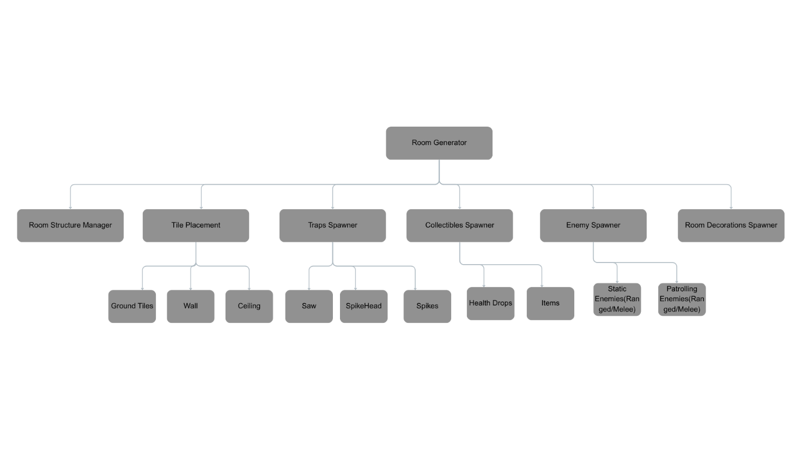
Algorithm Schematics
Figure 4.5.1 - Block Diagram of Room Generation (source: own diagram)

As shown in the Figure 4.5.1, it is presented the diagram for how Procedural Level Generation works on a larger scale. Room Generator’s purpose is to be the central system for generating all room components such as tiles, obstacles, decorations and enemies. Tile Placement has components such as ground, ceiling and wall tiles and is responsible for placing them in the right position. Ground and ceiling tiles are placed using roomSize.x for horizontal layout, while the wall is placed once per room.
Traps Spawner’s responsibility is to spawn traps between an input given interval. The traps can be SpikeHeads, Saws or Spikes. Collectible Spawner is responsible for spawning a number of collectibles given as input. It chooses them from a collectible array and they can be health pickups or even items.
Enemy Spawner has 2 types of enemies it can select from: static and patrolling enemies. Static enemies are taken from an array called EnemyPrefab and it contains both melee and ranged enemies. In a similar manner the ranged and melee patrolling enemies are handled. There is a 50% chance to spawn a patrolling enemy, its type being randomly chosen.
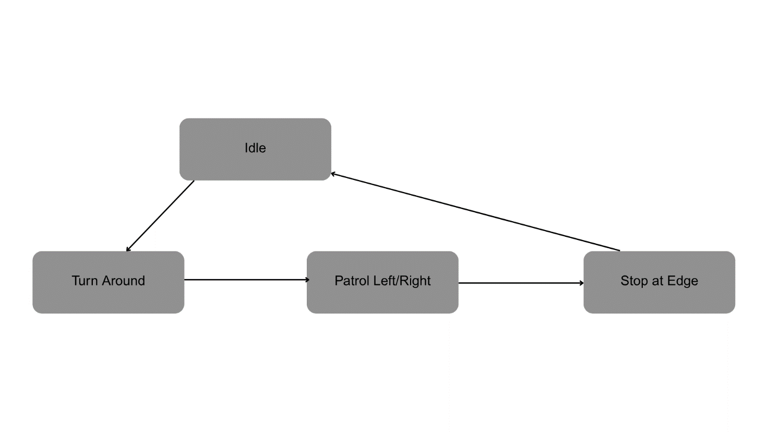
Through Room Structure Manager each room is created as a child of the generator, even more all tiles, obstacles, enemies and collectibles are instantiated as children of the room object.
Figure 4.5.2- Block Diagram of Enemy Patrol mechanic (source: own diagram)
As shown in Figure 4.5.1, it is presented the Enemy Patrol mechanic as a general overview of the patrolling enemies whole behaviour cycle. Thus, Idle’s purpose is to make the enemy take a short break from the patrol the moment he reaches the edge, thus challenging the player to wait until the area is safe to enter. Turn Around happens after the enemy has reached the edge and exits the idle state, thus setting the movement direction to the other edge.
Patrol Left/Right simply implies that the enemy is in a constant movement between those edges, while Stop at Edge occurs when the enemy has reached the edge

Player Attack System
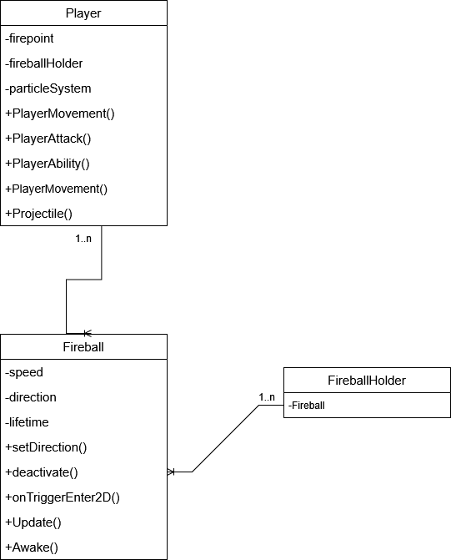

Figure 4.6.1 – UML Diagram that showcases how the Player Attack Works (source: own diagram)
As shown in Figure 4.6.1, Player class contains GameObjects such as firepoint, fireballHolder and particleSystem. The latter is used for the Rewind ability, with the purpose of giving rewind a more immersive aesthetic. PlayerMovement, PlayerAttack, PlayerAbility, PlayerMovement, Projectile are scripts linked to the player GameObject. For our purpose we will focus on how the PlayerAttack works. The Player object can have access to multiple Fireball objects. A fireball has attributes such as speed, direction and lifetime. They are used in order to make sure the gameplay is well balanced, but their values can be modified through items. Namely, the speed and direction can be modified. Once a fireball reaches its lifetime limit, it will deactivate through deactivate() function. Update() is used for the general behaviour of the fireball and Awake() is used in order to initialize variables. The function onTriggerEnter2D() has the purpose of handling the behaviour of a fireball once it collides with an object, more specifically set the animator and call deactivate after the collision
FireballHolder has the simple purpose of holding multiple fireballs. It acts as an array of fireballs from which the player can access the projectile.
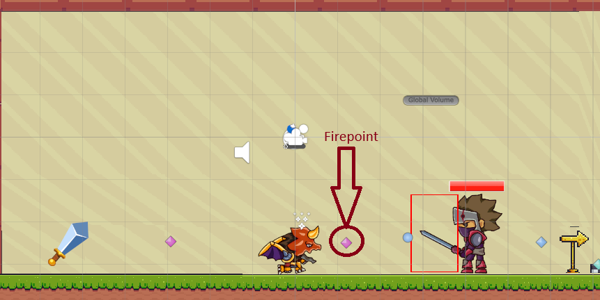

Figure 4.6.2 – Showcase of Firepoint importance (source: screenshot)

Implementation Analysis

Code Implementation Analysis

Player Movement
The player makes use of Unity’s Rigidbody2D for physics-based movement. The movement input is captured using Input.GetAxis(“Horizontal”), which further controls the RigidBody2D’s velocity, allowing for smooth and responsive movement. The player’s orientation is flipped using transform.localScale based on input direction.
Figure 5.1.1.1 - Showcase of horizontal movement implementation (Source: screenshot)

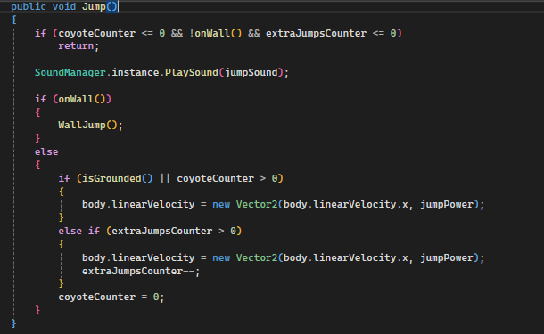
The player can jump using the spacebar, the jumping system having three enhancements. The first one being the Coyote Time, which allows players to jump shortly after walking off a platform. The second one is Multiple Jumps and as the name suggests it allows for setting double jumping or more, in our case we at most can have only have double jumping if the player picks up a certain item. Lastly, there is Variable Jump Height, which in the case that the player releases the jump key early, the jump is cut short by halving the upward velocity. Asides from these enhancements the player can also jump on walls and stick there for strategic purposes.
Figure 5.1.1.2- Showcase of jump mechanic (Source: screenshot)
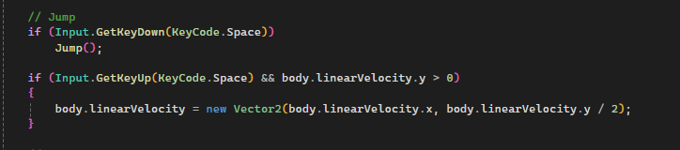

Figure 5.1.1.3 - Showcase of how jumping input is handled (Source: screenshot)

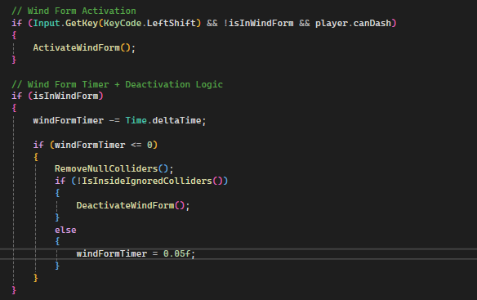
Wind Form Dashing is activated using L-Shift and if the PlayerAbility.canDash flag is true. Through this ability the player temporarily changes his physics layer so that he can pass through enemies, traps and boxes. While in Wind Form, a timer counts down and the player becomes intangible by using Physics2D.IgnoreCollision. Upon the timer’s expiration, the system checks if the player is inside any ignored collider before reverting back to the original layer and player shape. This mechanic is used in order to ease traversal in difficult situations and escape tight spaces. The player’s visual transformation from its original form to that of the wind is done using the Animator Controller component attached to the player, which can be set on and off through a trigger.
Figure 5.1.1.4 - Showcase of how jumping input is handled (Source: screenshot)

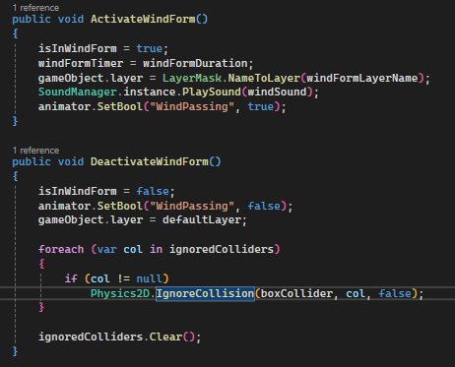

Figure 5.1.1.5 - Showcase of Animator Controller interaction (Source: screenshot)

Crouching is done using the L-CTRL button, thus changing accordingly the player’s BoxCollider2D size and offsetting in order to simulate crouching. The collider resizing is animated using a Boolean isCrouching in the animator.
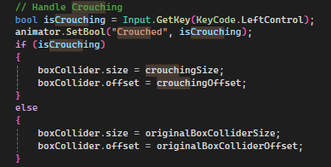

Figure 5.1.1.6 - Showcase of Crouching Mechanic (Source: screenshot)

As stated for the Wind Form Dashing, I am making use of the animator controller, thus not only the dash uses it, but the run, crouching and grounded checker are using in order to ensure smooth transitions. The way the animator is controlled can be seen through Figure 5.1.1.5 and Figure 5.1.1.6 In a similar manner running is handled, using animator. SetBool and making sure the player is grounded while running, through the grounded Boolean.

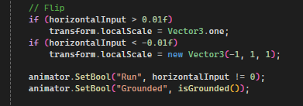

Figure 5.1.1.7- Showcase of Animator for Running (Source: screenshot)

Collision Management for Wind Form Dash is done using collision ignoring logic thus dynamically allowing passing through specific tagged objects such as enemies, traps, boxes and the boss. When Wind Form ends, all ignored collisions are restored and null references are cleaned up to avoid memory issues from any destroyed objects.
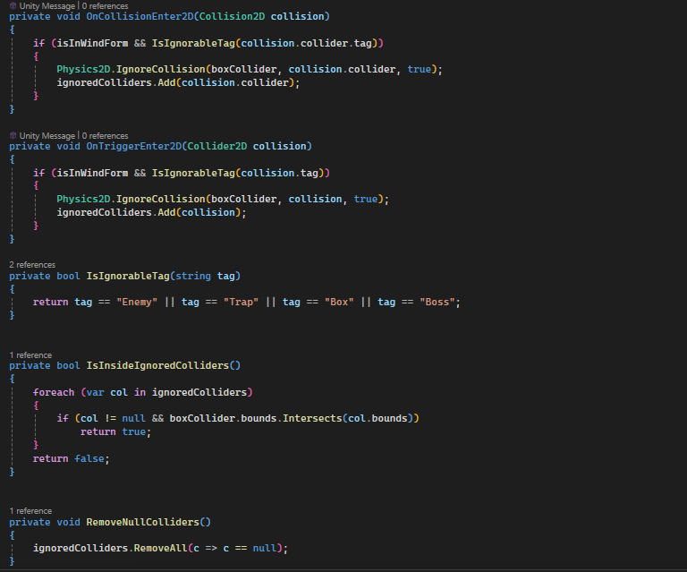

Figure 5.1.1.8 - Showcase of how collisions are handled (Source: screenshot)

Player Attack
The PlayerAttack script handles all player combat logic, that includes attack cooldowns, fireball spawning, animation triggering and modification of the player attack that come from different items.
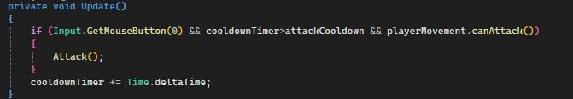
The attack is triggered by the player pressing the left mouse click, namely Input.GetMouseButton(0) as Unity interprets it. The attack is followed by a cooldownTimer variable that prevents spamming and can have a lower value if a certain item is picked up. Attacking is allowed only if the cooldown has passed and the player is grounded, the latter being checked in the method canAttack() from the PlayerMovement script.
Figure 5.1.2.1- Showcase of Attacking logic (Source: Screenshot)

In the event that the player is in Wind Form Dash, there is a checker in the Attack script that ensures Wind Form remains a non-combat and traversal only ability, by disabling the attack as long as the player is in that shape. There can be two types of attacks, crouch attack and normal attack. The crouch attack is triggered by holding L-CTRL button and pressing L-Click.
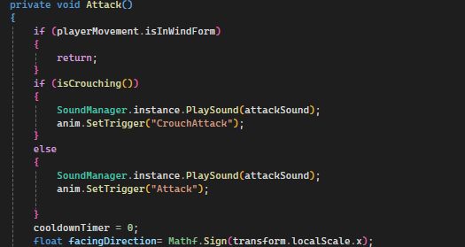

Figure 5.1.2.2- Showcase of handling logic for attacks (Source: Screenshot)

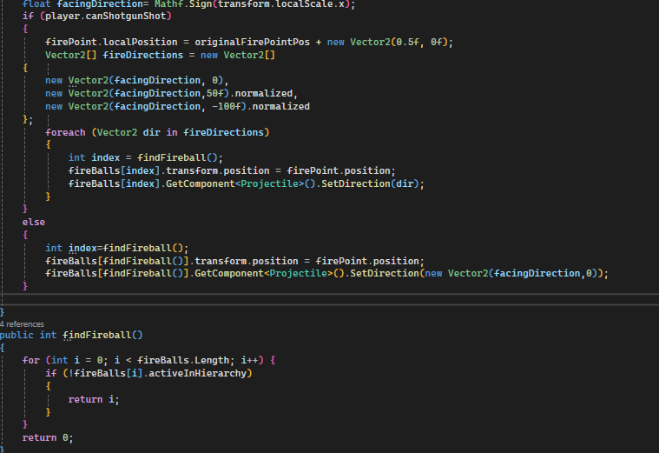
Projectiles, namely the fireballs are stored in an array and reused via object pooling to optimize performance and ensure smooth gameplay. The method findFireball() returns the index of the next active fireball, while the projectile is repositioned to the firePoint object and activated with the specific direction. If the player picks up the ShotgunShot item, then the canShotgunShot flag is enabled in PlayerAbility and the attack becomes a spread shot, more precisely the player fires three projectiles at slightly different angles, thus when hitting an enemy together they deal three damage. This mechanic is useful for high damage bursts and escaping combat faster.

Figure 5.1.2.3- Showcase of using the fireball and ShotgunShot mechanic (Source: Screenshot)

The Projectile script controls the movement, collision and visual effects of the player’s ranged attacks. It is integrated within the PlayerAttack script and as previously mentioned above and shown in Figure 5.1.2.3, it makes use of object pooling. In this script, several aspects of the fireball projectile are handles, such as the speed of the projectile, damage, ensuring the correct direction for the projectile, as well as handling collisions and triggering animations. The script also includes a Deactivate() method that when a fireball’s collider hits another specific tag’s collider, it deactivates upon explosion, ensuring optimization. Direction of the fireball is set through setDirection() method. In this method, the direction is normalized for consistent speed regardless of the angle from where the projectile shoots, while also flipping the sprite based on direction to match facing. There are several targets that the fireball can damage, them being Boss, Enemy and Box, for the former dealing five damage since the Boss has bigger health than the rest of characters. Each normal enemy takes one damage and the boxes simply deactivate upon collision, their purpose being to hide items, be obstacles or depending on usage help the player traverse the rooms. After five seconds upon activation, the projectile is deactivated through the Deactivate() method.
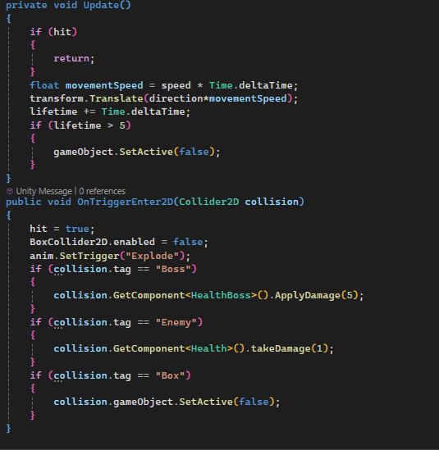
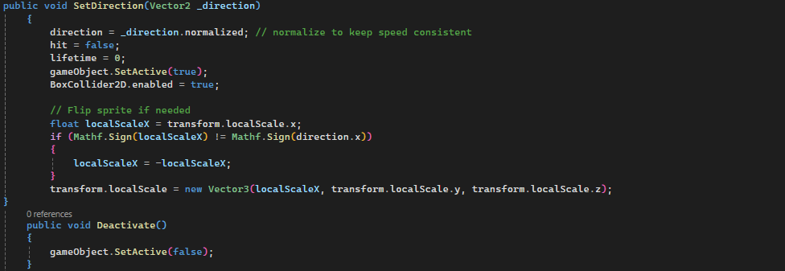
Figure 5.1.2.4- Showcase of Projectile logic and collision handling (Source: Screenshot)
Figure 5.1.2.5- Showcase of how the direction is set (Source: Screenshot)

Enemy Patrol
The Enemy Patrol script controls the movement of enemies, making them patrol from two points, namely leftEdge and rightEdge. Once the enemy reaches one of the edges, the ChangeDirection() method is called where the idleTimeCounter starts. Once the counter value becomes bigger than the value given to idleTime, the enemy changes the facing direction and resumes patrol until reaching the opposing edge through MoveInDirection() method as showcased in Figure 5.1.3.2.
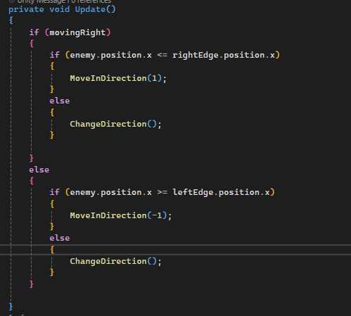

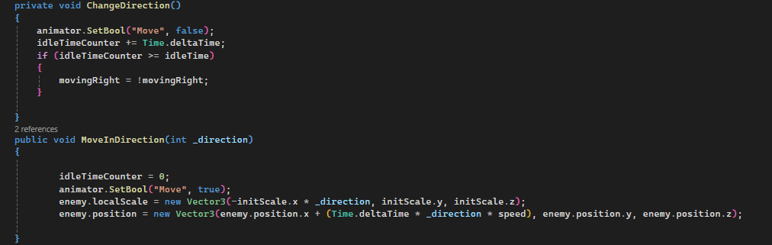
Figure 5.1.3.1- Showcase of patrolling logic (Source: Screenshot)
Figure 5.1.3.2- Showcase of changing direction (Source: Screenshot)

Boss Enemy
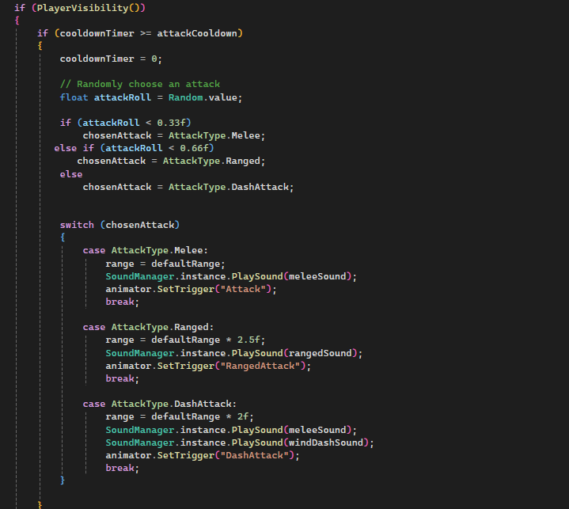
The BossEnemy script handles the boss’s behaviour, this includes the range of attacks he can choose from, ranged projectiles, dashing to the player and detecting the player. There are three possible attack types the boss randomly chooses between: Melee Attack, Ranged Attack and Dash Attack. Each of them has a different probability of being chosen, thus being randomly selected every time the boss’s attack cooldown ends. In order for the boss to attack the player, firstly it needs to detect him through PlayerVisibility() method and secondly the cooldown needs to expire, then a random attack type is chosen via Random.value, the animation being executed through animator.SetTrigger().
Figure 5.1.4.1- Showcase of Boss’s Attack logic (Source: screenshot)

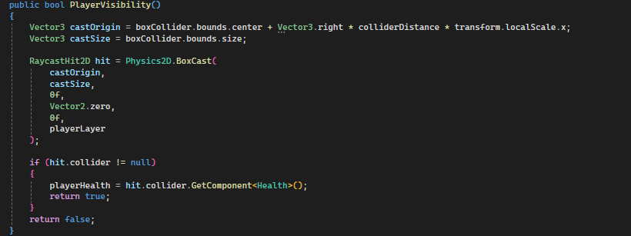
The PlayerVisibility() method uses a BoxCast which is based on the boss’s collider to detect the player. The direction of detection is influence by the boss’s transform.localScale.x variable as well as a colliderDistance variable which has the purpose to determine how far should the boss look in order to detect the player. As it can be seen from Figure 5.1.4.1, the range variable is modified depending on the attack, the idea for this being that the boss can have a larger detection box if he chooses to use ranged attack, because such an attack can reach the player from a further distance.
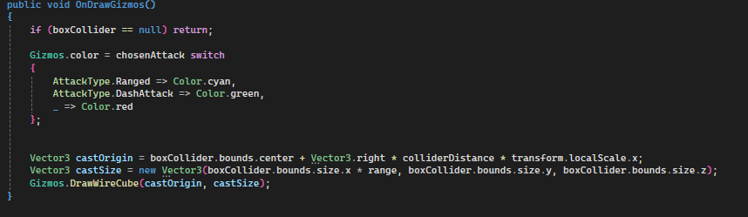
Figure 5.1.4.2- Showcase of Boss’s method for detecting the player (Source: screenshot)
Figure 5.1.4.3- Showcase of how range affects the size of the box responsible for detection (Source: screenshot)

As it can be seen in Figure 5.1.4.2 the player’s Health component is kept in a variable in order to apply damage, once the attack animation is triggered. The damage is dealt to the player through the DamagePlayer() method that calls the takeDamage() method from the Health script.
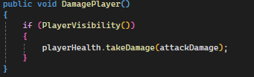

Figure 5.1.4.4- Showcase of DamagePlayer() method (Source: screenshot)

The ranged attack for the boss is done in the same manner, as it is done for the player and the other enemies, namely it uses pooling for fireballs and once they are active it calls the ActivateProjectile() method from the Enemy Projectile script. The Enemy Projectile script functions the same as the Projectile script destined for the player, the only difference being that it doesn’t need to adapt to the enemy’s direction, thus the method setDirection() is not present in the Enemy Projectile script. On top of that, instead of looking for collisions with other types of objects, the Enemy Projectile script looks only for collisions with objects that have the “Player” tag. The PerformDash() method moves the boss behind the player’s position with an offset. It makes use of Raycast downwards to make sure the boss is on the ground after dashing.
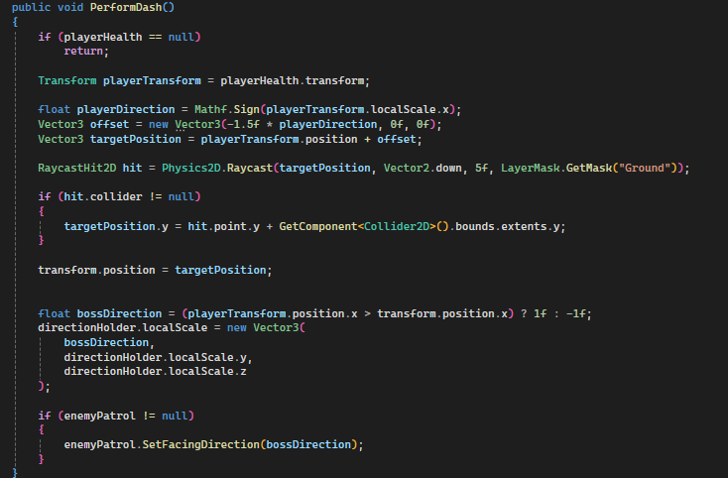
Figure 5.1.4.5- Showcase of PerformDash logic (Source: screenshot)

Melee and Ranged Enemies
Both Melee and Ranged Enemy scripts take the same approach and are quite similar to the BossEnemy script, the only difference being what animations they trigger when detecting the player. Melee Enemy checks if the playerHealth is above zero before attacking in order not to attack an empty area and then triggers the melee attack animation. Ranged Enemy doesn’t need to check for playerHealth, since the fireball which has the projectile script on it is the one that hits the player.
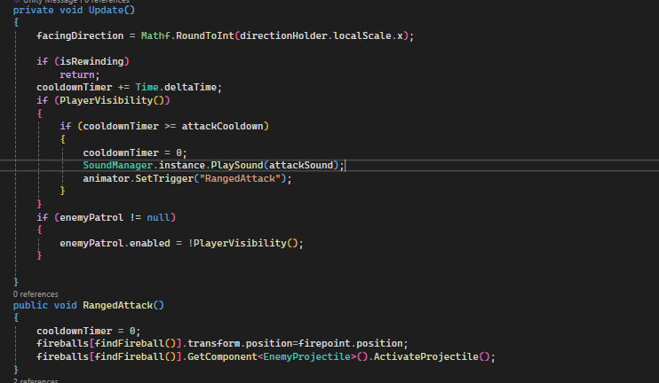
Figure 5.1.5.1- Showcase of how Ranged Enemy attack works (Source: screenshot)
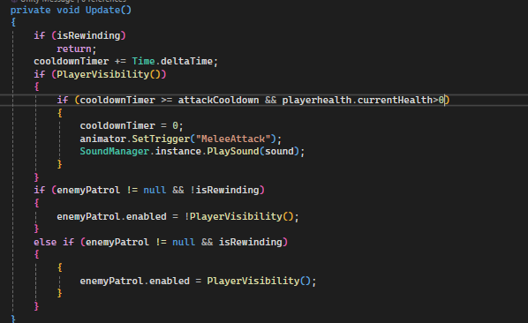
Figure 5.1.5.2- Showcase of how Melee Enemy attack works (Source: screenshot)

All three scripts, namely BossEnemy, Melee Enemy and Ranged enemy, make use of the interface IEnemy. The purpose of the interface is to let each script tailor PlayerVisibility() and OnDrawGizmos() methods to their own usage since each of them needs to use them in a way that is specific to the enemies and also make them distinguishable during testing through different colours.
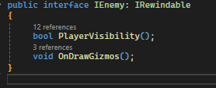

Figure 5.1.5.3- Showcase of IEnemy interface (Source: screenshot)
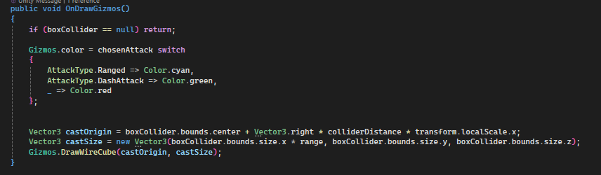
Figure 5.1.5.4- Showcase of how OnDrawGizmos is specifically tailored for the boss based on his attacks (Source: screenshot)

Procedural Room Generation
The RoomGeneration script procedurally generates rooms, beginning from an empty object that represents the startPoint variable. The rooms are filled with floor, wall and ceiling tiles that represent the main structure of a room. Inside the rooms are randomly generated and placed spikes, traps, boxes in different shapes, enemies that can either patrol or be static, health collectibles and items.
The GenerateRooms() method starts with placing the floor on x axis based on the given size on the X axis. Ceiling generation works the same, but it positions itself based on the value given to Y axis length and from there keeps generating on the x axis until the values are met. The right wall is a prefab instantiated at the bottom right-edge, since the it is made out of two assets, a start sign and a wall, that together make the right wall prefab. On the floor and ceiling, spikes can be placed in order to make traversal more difficult. They are spawned based on their chance of spawning which can be toggled from the Unity Inspector. Furthermore, their spacing can also be toggled from the Unity Inspector in order to make balanced generated rooms. These aspects are handled in the code segments where spikes can be placed, namely floor and ceiling.
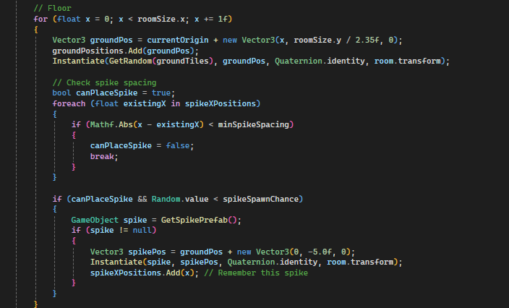
Figure 5.1.6.1- Showcase of floor generation and spike positioning logic (Source: screenshot)

The RoomGeneration script can spawn a random number of obstacles, excluding those tagged “Spike” since they are handled separately as shown in Figure 5.1.6. Those other obstacles can be saws that traverse and spin left to right or spikeheads that once in their detection range follow the player and damage him. They are placed within the room bounds, which as mentioned above are the given x and y.
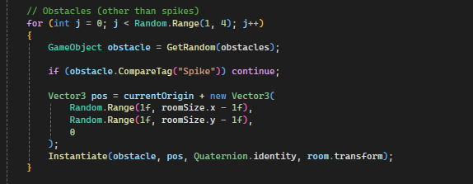
Figure 5.1.6.2- Showcase of obstacles logic handling (Source: screenshot)

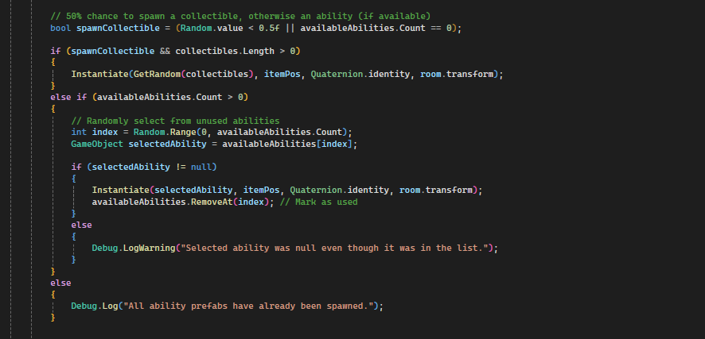
When it comes to collectibles there is a 50% chance of spawning a health collectible or an unused ability, more specifically an item. There can only be only one item per room and it can spawn together with a health collectible. Items that are spawned in a room are removed from availableAbilities once used.
Figure 5.1.6.3- Showcase of items and collectibles logic (Source: screenshot)

When it comes to enemies the script can generate up to two enemies that are static, thus don’t patrol, per room. It handles height offsets for ranged and melee enemies and avoids overlapping when spawning via IsEnemyOverlappin() method. The enemies that can patrol are spawned based on randomness, they have a 50% chance of spawning and can be only one per room. If the patrol enemy gets spawned, there is another 50% chance of spawning either a melee patrolling one or a ranged patrolling one. Similar to how the static ones were handled, the method IsEnemyOverlapiing() is being used to ensure no overlaps are made during generation.
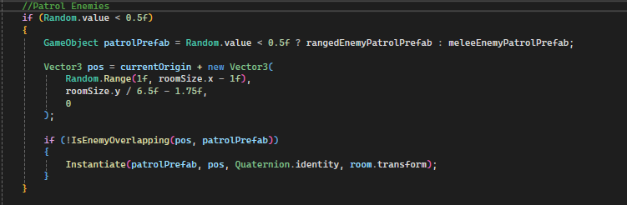
Figure 5.1.6.4- Showcase of Patrol Enemy spawning logic (Source: screenshot)

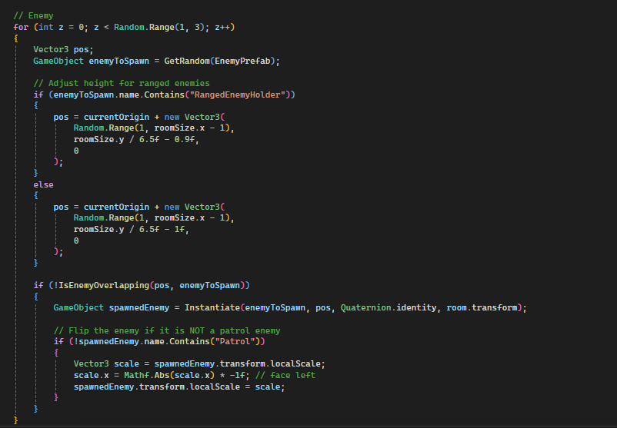
Figure 5.1.6.5- Showcase of Static Enemies spawning logic (Source: screenshot)

Decorations are limited as maximum one such object spawn per room and can come in different shapes based on what prefab is chosen from the DecorationPattern array. The spawn chance is given as variable in the DecorationPattern class and can be adjusted from the Unity Inspector as it can be seen from Figure 5.1.6.6. The position and depth of each decoration is adjusted based on the name, since they have different shapes, they need to be adjusted accordingly. The method IsOverlapping() is used in order to avoid clutter and make sure no other objects could spawn and overlap with the decoration.

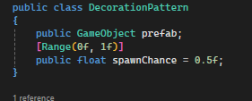

Figure 5.1.6.6- Showcase of DecorationPattern class (Source: screenshot)

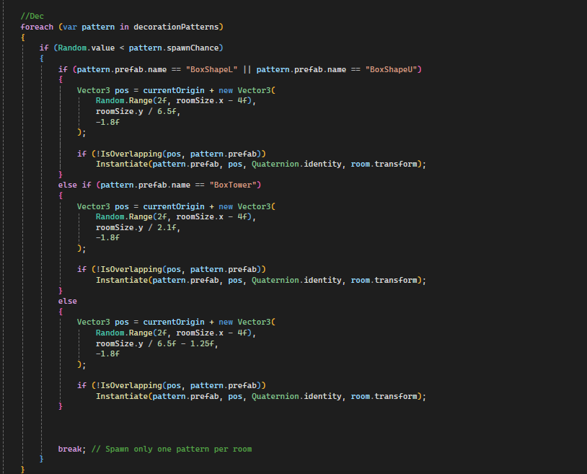
Figure 5.1.6.7- Showcase of Decoration spawning logic (Source: screenshot)

Enemy Damage
The Enemy Damage script is used by a number of objects. It is a script crucial for traps, such as spikehead, saw and spikes, but it is also used by melee and ranged enemies, be them patrolling or static and lastly the boss. It has the same purpose for all its objects, if the player collides with the enemy then he takes damage.
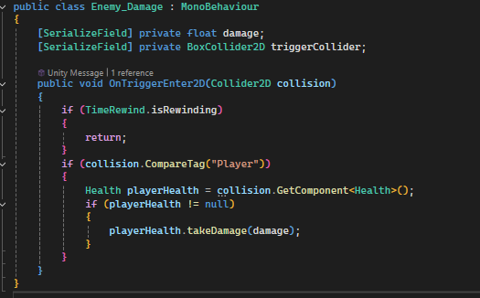

Figure 5.1.7.1- Showcase of Enemy Damage script (Source: screenshot)
As it can be seen from Figure 5.1.7.1, the only time objects with this script on them don’t deal damage is when the player rewinds time, since he is invincible during rewind in order to balance the mechanic.

Enemy Movement
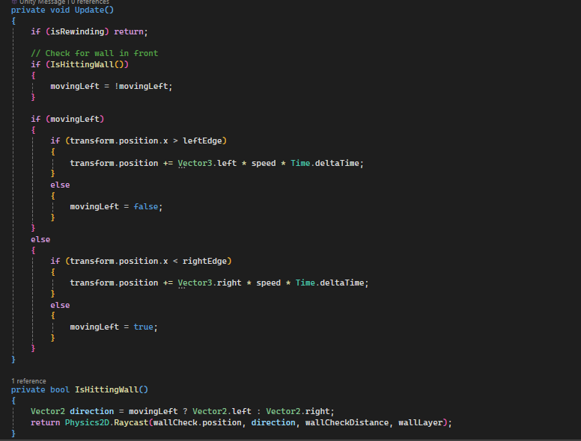
The Enemy Movement script is used for traps, more specifically for the saw trap. The saw only moves left and right based on the movement distance variable. Left edge is computed as the difference between the saw’s initial position and the movementDistance variable, while the right edge is computed as the sum of those two. Based on those variables, the script checks if the saw’s position on the x axis has reached the edges and in case it does, it simply sets the Boolean variable movingLeft to either false if left edge has been reached and true if the opposite has occurred. The script also checks for wall collisions, in the event that they spawn close to walls and need to be adjusted in order not to pass through them. An empty object is placed on the saw and it uses raycast in order to figure out if it reaches the layer named “Wall”. Based on that, it controls whether the trap should change direction or not.
Figure 5.1.8.1- Showcase of Saw moving logic (Source: screenshot)

Spike Head
The SpikeHead enemy is a reactive trap with the purpose of pressuring the player through following and attacking him. It remains stationary until it detects the player through one of its four rays obtained through the use of Physics2D.Raycast. The direction of the rays is that of the four cardinal directions, namely left, right, up and down. Upon detecting the player it moves fast towards him trying to deal damage by colliding with him. It stops chasing upon collision or if the player moves out of its range. This trap was designed in order to make the player take fast decisions and have spatial awareness.
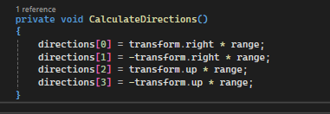

Figure 5.1.9.1- Showcase of how directions are computed (Source: screenshot)

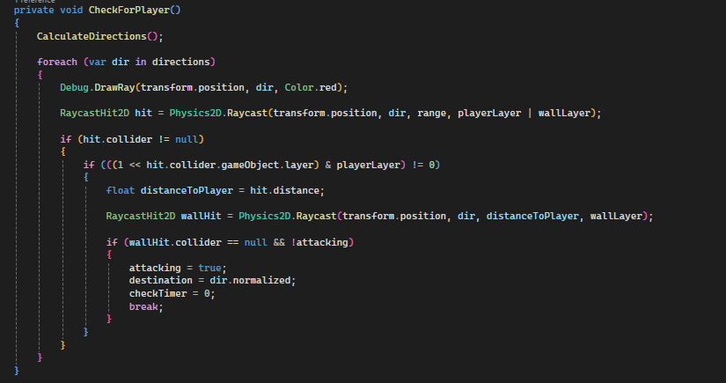
Each raycast checks for both the player and the wall layer, thus if a player is seen without a wall obstructing the line of sight, it locks onto him and starts a chase by setting the Boolean attacking to true.
Figure 5.1.9.2- Showcase of SpikeHead checking for player logic (Source: screenshot)

Health System
The Health System plays a crucial part in how the game plays, because it has the purpose of managing the survivability of both the player and enemies, helping make a balanced environment when it comes to this aspect. It handles everything from damage intake, healing to invincibility frames and game-over conditions.
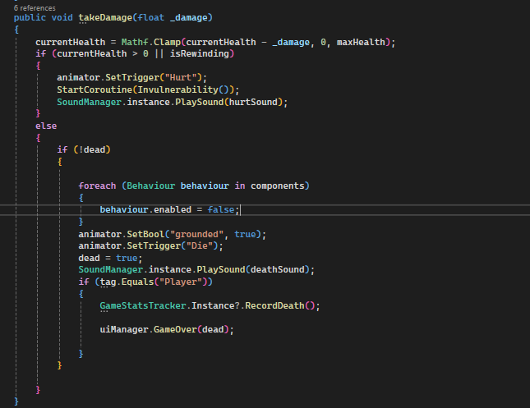
The takeDamage() method is used when an entity takes damage thus needing to have their health reduced. In order to avoid negative values Mathf.Clamp() is used. Further, the script checks if the entity is still alive; in this case triggering the “Hurt” animation, playing the specific sound for hurt and starting an invulnerability coroutine that gives the said entity a customizable number of seconds of invulnerability. The moment the health reaches zero and the entity is not dead, the “Die” animation is triggered, the other behaviour scripts attached to that object are disabled and a death sound is played. If the entity that died is tagged as “Player” then a call to the GameOver() method from the UIManager script is made and the death is logged in the GameStatsTracker.
Figure 5.1.10.1- Showcase of takeDamage() method (Source: screenshot)

Methods such as getHealth() and addHealth() are responsible for managing health pickups and respectively modifying maxHealth permanently through picking up a specific item. Invulnerability() method disables collisions between the “Player” layer and “Enemy” layer through IgnoreLayerCollision() method from Physics2D class. After disabling collisions it makes use of the coroutine to flicker the sprite colour between red and white and visually show invulnerability. After the invulnerability time expires, the collisions are re-enabled by simply setting IgnoreLayerCollision() to true. It is a crucial aspect of the health system since it prevents unfair consecutive hits after taking damage.
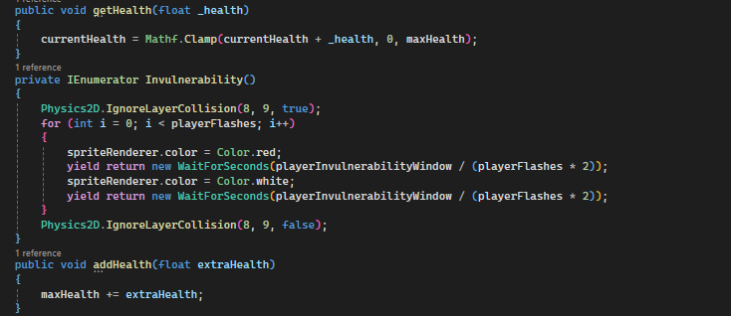

Figure 5.1.10.2- Showcase of Invulnerability coroutine and health managing methods (Source: screenshot)

The player can also see his current health thanks to the HealthBarFunctionality script. Through this script the maximum health, current health and modifications that come from picking up health upgrade are visually represented. The playerHealth object is the actual Health component storing the values, while totalHealthBar and currentHealthBar are images that visually represent the health status. In the event that the player has picked up the ability to increase his health, the total bar will expand, but the added health won’t modify the current health since the player needs to get health pick-ups in order to increase it to its full amount.
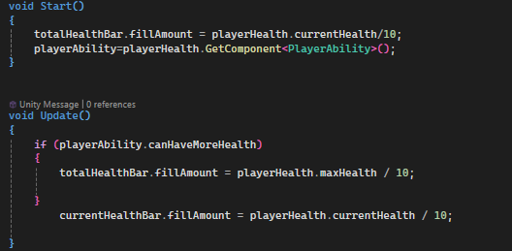

Figure 5.1.10.3- Showcase of HealthBarFunctionality logic (Source: screenshot)

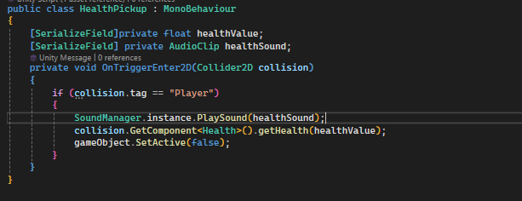
The last component of the whole health system is the HealthPickup script, where the health pickups logic is handled. In order to pick up such an item the script checks for the “Player” tag, thus if the player collides with the health pickup a specific sound is played, and the value of the pickup is given to the player’s Health component thus updating everything.
Figure 5.1.10.4- Showcase of HealthPickup logic (Source: screenshot)

Ability System
The Ability System controls which powers or mechanics the player has access to during the game. It allows for progressive unlocking, making the player adapt and create strategies based on what he has access to during that run.
In the PlayerAbility script are stored Boolean flags that represent each ability the player has unlocked or not, thus each ability has a corresponding method that enables it and logs the event. This script affects other scripts such as PlayerMovement, Dash being an ability that has the core logic implemented in that script, as mentioned in chapter 5.1.1. The same thing can be said about the PlayerAttack script, since ShotgunShot changes the way the player attacks, this mechanic being discussed in chapter 5.1.2.
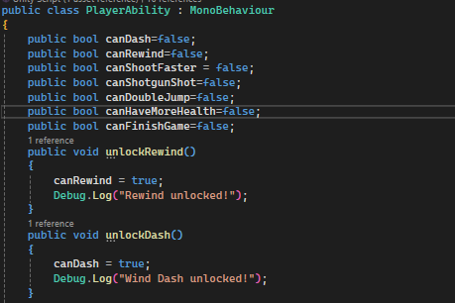

Figure 5.1.11.1- Showcase of PlayerAbility logic (Source: screenshot)

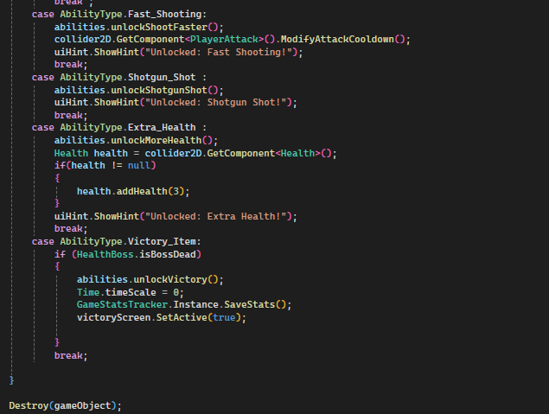
The AbilityUnlockItem script is attached to items that can be picked up, thus handling the logic when the player collides with them. Each unlockable ability is put into an enum named AbilityType in order to distinguish which ability pickup unlocks. Afterwards, it calls the appropriate method on PlayerAbility and shows and unlock hint via ItemUnlockedHint. A sound specific for the pickup of abilities is played upon collision and the ability is logged via GameStatsTracker. There are two special cases that are handled in this script, one being the Extra_Health ability, where it is needed to specify the Health component in order to add three health to the player. The other case is for the Victory_Item which triggers the end of the game if the boss is dead, thus showing a victory screen and pausing time.
Figure 5.1.11.2- Showcase of the unlock logic (Source: screenshot)

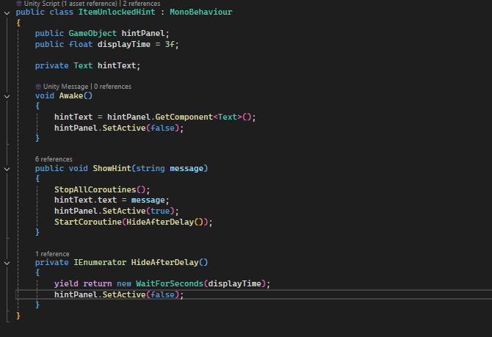
The last component of the whole system is the ItemUnlockedHint script which is responsible for notifying the player when an ability has been unlocked. The ShowHint method takes a string named message and updates the UI with the said string, using a coroutine to temporarily display the hint panel for the number of seconds given through displayTime variable. In the event that a new hint is triggered while one is still showing, it cancels the previous coroutine in order to avoid overlap. The purpose of this script is to make unlocking feel rewarding and immediate, providing the player info on what has happened upon his action of picking up. It is also important to provide information about what certain items do, since in some cases it may not be obvious.

Figure 5.1.11.3- Showcase of ItemUnlockedHint logic (Source: screenshot)

Time Rewind Mechanic
The Time Rewind system allows the player to rewind their movement and state, thus travelling backwards through time for a short duration. This mechanic also pauses the behaviour of nearby enemies, reinforcing the game’s temporal theme. It makes use of two scripts, PointInTime and TimeRewind. The former has the purpose of storing the positions and rotations of the player, being further used in handling the whole logic of the mechanic in the main script TimeRewind.
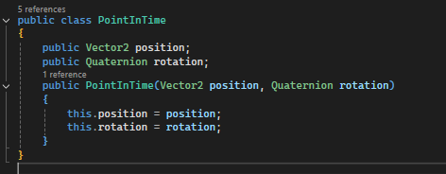

Figure 5.1.12.1- Showcase of PointInTime script (Source: screenshot)

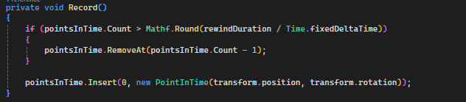
The TimeRewind script is responsible for tracking and applying time rewind mechanics, visuals and logic across the affected objects. Making use of the script presented in Figure 5.1.12.1, it stores the player’s position and rotation in a list of PointInTime. The moment isRewinding is set to true, the Rigidbody2D component of the player is set to Kinematic in order to make it controlled only by the script and no external input during rewind. The stored states are applied in reverse until all the states are exhausted, thus stopping when out of recorded data.
Figure 5.1.12.2- Showcase of how states are recorded (Source: screenshot)
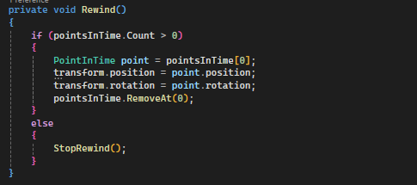

Figure 5.1.12.3- Showcase of state handling (Source: screenshot)

In order to activate time rewind the player must meet two requirements, have the rewind ability and hold the “R” key. There are also visual and sound effects that make the rewind more immersive, such as the grayscale post-processing which is enabled through URP Volume, particle effects object and the specific sound for the rewind mechanic. Upon release of the said key, the rewind is stopped, the Rigidbody2D component is set back to dynamic, every object affected by the rewind resumes normal behaviour and the screen is back to normal. As mentioned, the script searches all the objects that have the tag “Enemy”,
switching their Rigidbody2D component to kinematic too during rewind. The handling for the enemies is done through the IRewindable interface that passes two methods onRewindStart() and onRewindStop(). Through these methods resuming and pausing of animations, movement and behaviour is done.

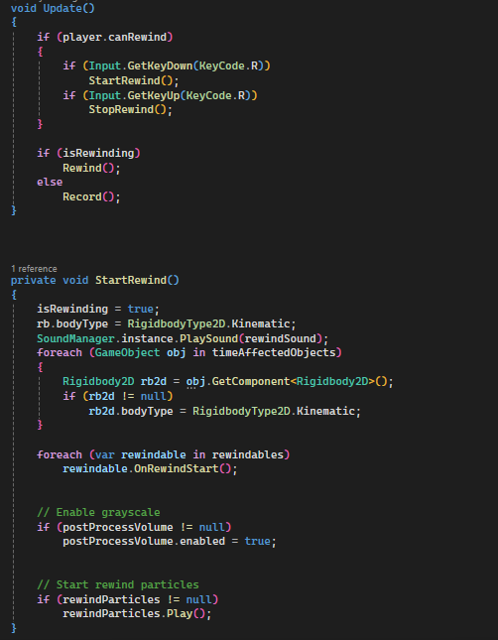

Figure 5.1.12.4- Showcase of rewind logic (Source: screenshot)

Camera
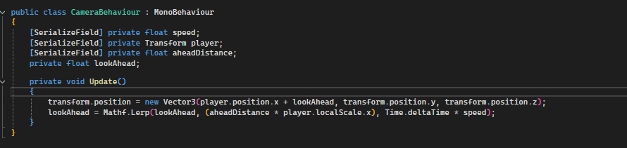
The camera mechanic is pretty straightforward, it follows the player by making use of his position, the lookAhead variable working as a forward offset based on the direction the player is facing. With the use of Mathf.Lerp, a smooth transition is created for the offset in order to provide a natural feeling camera shift.
Figure 5.1.13.1- Showcase of CameraBehaviour script (Source: screenshot)

UI System
The UI System provides gameplay interfaces such as pause menu, game over screen, victory screen, responsive feedback upon picking up items and the possibility to submit feedback for the game.
The Pause Menu is triggered upon pressing the “ESC” key, thus when pausing the Time.timeScale variable is set to 0, freezing all in-game activity. Unpausing resumes the game at normal speed. Similarly this is how the Game Over Screen works, freezing all activity, excepting the fact that it is triggered once the health of the player drops below zero In the Pause Menu players have several buttons they can access, such as resume, change music and sound volume, return to the main menu or simply quit the game.
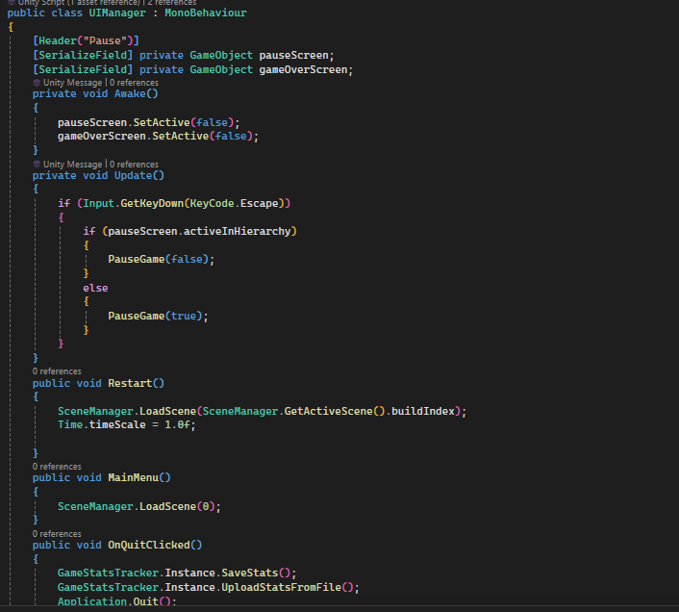
Figure 5.1.14.1- Showcase of UIManager logic Part 1 (Source: screenshot)
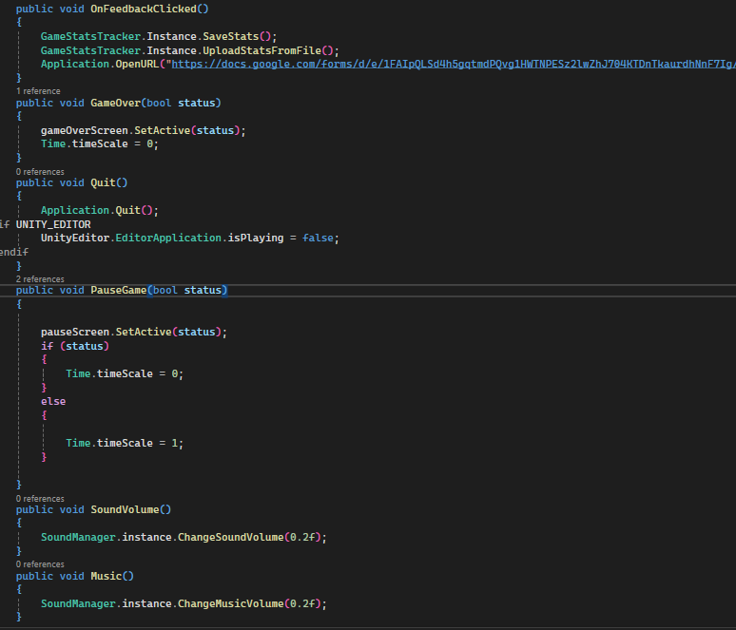

Figure 5.1.14.2- Showcase of UIManager logic Part 2 (Source: screenshot)

As it can be seen from Figure 5.1.14.2 through two methods, SoundVolume() and Music(), the player can tweak the audio by a value of 0.2 on each key press. As it also turns out from Figure 5.1.14.2 there is also an integration for uploading gameplay statistics to a Firebase database and also allowing the player to submit feedback via a Google Forms. Thus, it encourages player-driven feedback and data collection for balancing and improvements.
In order to complement the UI system, Sword of Time features a sound management system that handles both gameplay sound effects and background music. This is achieved through the singleton pattern, having one instance that persists across scenes. This way, UI buttons and gameplay events are allowed to call audio functions globally without needing direct references or scene specific setup.
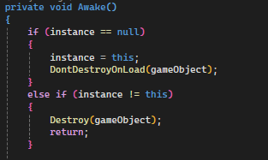

Figure 5.1.14.3- Showcase of singleton usage (Source: screenshot)

The SoundManager script initializes two audio sources, m_AudioSource meant for SFX such as attacks, abilities and UI navigation, while musicSource is used for the looping background music. Volume levels are saved and loaded using PlayerPrefs, thus the player prefrences are retained across different play sessions. As previously mentioned, the sound management system complements the UI system, this way the player can have control over in-game audio directly from the pause menu.
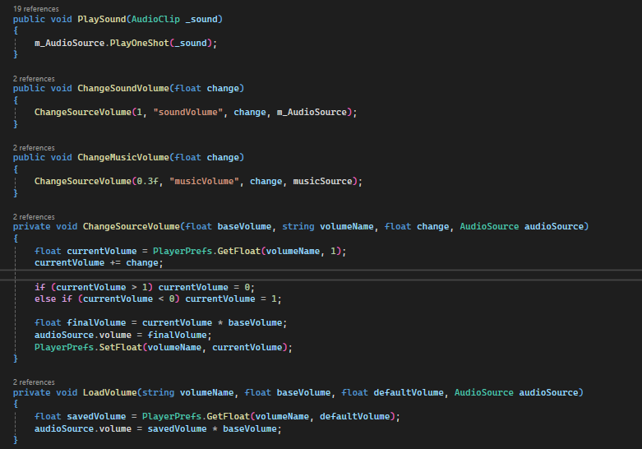

Figure 5.1.14.4- Showcase of sound logic (Source: screenshot)

Game Stats Tracker System
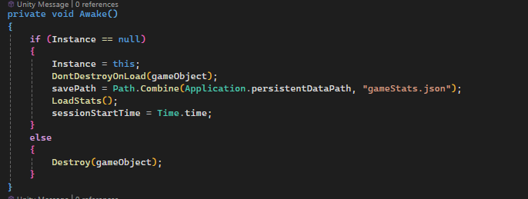
Lastly, in order to get feedback on the player experience and adjust the balance of the game accordingly, Sword of Time includes a Game Stats Tracker system that is another complement of the UI. Through this system, gameplay metrics such as deaths count, picked items and total playtime are tracked, while there is also the possibility of players accessing the feedback form, offering insights into how the mechanics worked and what would they like added. Similarly, to the sound system, the GameStatsTracker script makes use of the singleton design pattern.
Figure 5.1.15.1- Showcase of singleton use (Source: screenshot)

As previously mentioned, the tracker focuses on three key gameplay stats, them being the death count, picked items and total playtime. The death count is updated every time the player dies while the play time is automatically accumulated every time the game is played and saved upon quitting it. These stats are saved locally in a .json file by making use of Unity’s JsonUtility class. Furthermore, those stats are uploaded to a Firebase database by making a POST request through UnityWebRequest. This system is integrated within the UI through the fact that upon finishing the game, if the player presses the Feedback button, it uploads his stats and sends him to a Google Form in order to get further input. The Quit button automatically saves and uploads the stats before exiting the application.
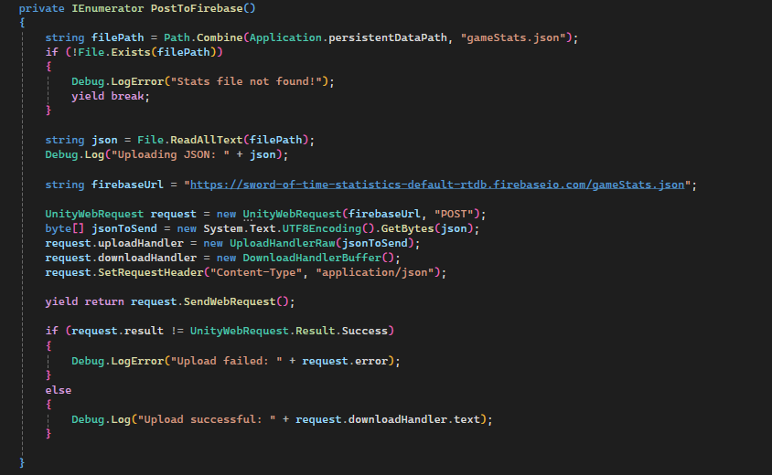

Figure 5.1.15.2- Showcase of POST logic (Source: screenshot)

Narrative, Used Assets and Animations
The narrative of the game is represented by the main character’s quest to collect all the swords of time by defeating the bosses of each world he encounters in order to bring balance to the universe and make sure the swords are in the hands of the good. It is a difficult task since in order to reach a boss, the player must pass through different rooms riddled with obstacles and enemies. Through the first abilities that the player picks up, namely the time rewind and wind dash scroll, and his appearance, it can be stated that he is a sort of guardian responsible for these swords that he seeks, thus tying into the game’s theme, time. Through defeating bosses, the player gains more control over time, becoming the guardian he needs to be in order to keep the world safe.
The sprites for the characters such as the main character, enemies, traps and the boss are assets accessed from the Unity Asset Store. Furthermore, the design of the levels was done by making use of level designing assets from the Store. Apart from these, the assets also helped make the boss health system more representative, since he doesn’t use the same system as the one I implemented. The main difference between the health system from the Unity Store and mine is the visual representation since the boss’s health can be seen represented as a bar on top of his head that follows him through his whole behaviour. This approach was taken in order to give the player a good and immersive feeling when it comes to battling the boss since it represents a crucial part in the game.
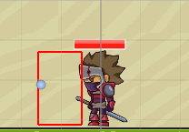

Figure 5.2.1- Showcase of boss’s health bar (Source: screenshot)

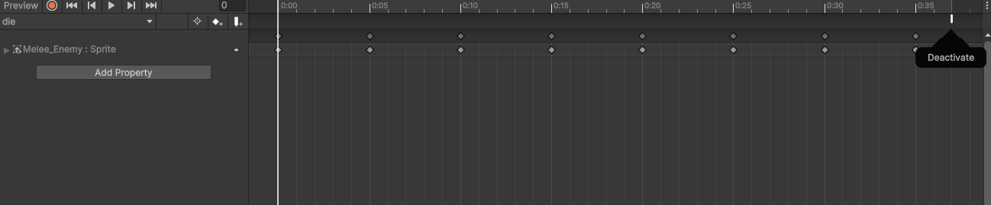
The animations were done using Unity’s Animation and Animator tools. In the Animation tool, the sprites were put together in order to form an animation, thus obtaining a character’s state. Furthermore, for some animations, events where added, such being the case for the death animation, were the object must be deactivated.
Figure 5.2.2- Showcase of die animation Deactivate event (Source: screenshot)

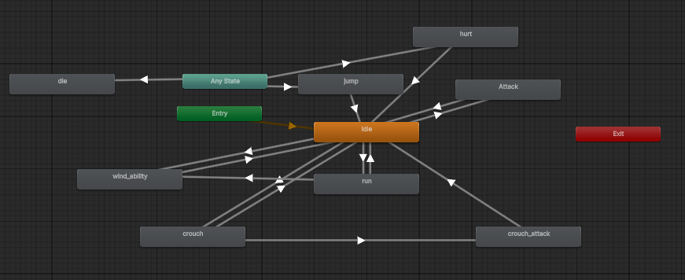
The Animator tool was also a very useful tool, since through it, transitions from states could be made, thus deciding the way the game mechanics work together. A transition from a state can have a trigger that enables it, a Boolean value that makes it true, an integer or a float. For Sword of Time, only triggers and Booleans were needed.
Figure 5.2.3- Showcase of state diagram for the player (Source: screenshot)

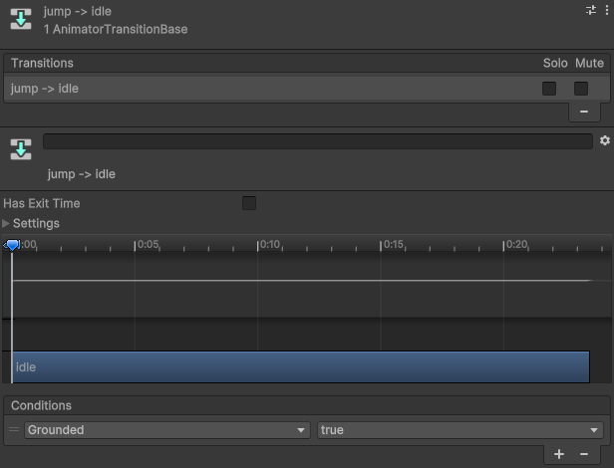

Figure 5.2.4- Showcase of transition from jump to idle (Source: screenshot)

Game Testing and Experimental Results

Data Collection Methods

Gameplay Statistics via Google Sheets
A custom game statistic as mentioned in Chapter 5.1.15 was implemented was implemented in order to log player data at the end of each session. This information is exported automatically to a Firebase database which are further synchronized with Google Sheets for analysis[12]. As previously mentioned the tracked data contains the total playtime per session, the number of deaths and the collected abilities[13]. This data allows for valuable insight into gameplay patterns and player progress since rooms, along with items are randomly spawned, except for the wind dash and rewind scroll which were given at the beginning in order to balance the difficulty and make the player want to engage further with the game despite its difficulty.

Gameplay Statistics via Google Forms
In order to complement the gameplay data obtained via Google Sheets, a Google Forms questionnaire was shared with the players. The form collected feedback about the clarity and usability of game mechanics, the perceived difficulty of levels, enjoyment of the art style and animations, as well as an overall satisfaction the game gives and naturally suggestions for future improvements.

Analysis of Results

Gameplay Stats Overview
Through the Google Sheets, specific cases were analyzed, such as the corelation between play time and death count, the collected abilities frequency and the ability collection distribution, all of those being taken into consideration in order to get insights on what could be further balanced and improved directly from gameplay data.

Figure 6.2.1.1 - Showcase of Bar Chart for Play Time vs Death Count (Source: screenshot)

Through Figure 6.2.1.1 key insights are gained. This bar chart has represented on the horizontal axis the total play time and its variations, while on the vertical axis it has the death counts, thus each bar represents a player’s session of the game. Through this chart we can deduce that most sessions average around a moderate playtime with moderate deaths, very few being under 5 minutes with few death counts. On the other hand there are a good number of longer sessions with higher deaths, with playtimes over thirty minutes that correspond with much higher death counts. This data suggests a sustained player engagement, but at the same time imply challenging game-segments or even players struggling through multiple failures in order to reach the ending of the game. Thus, it is worth taking into consideration for future enhancements a little more tuning around the balancing of enemy AI and boss fight, in order to avoid frustration for players being more casual.

Figure 6.2.1.2- Showcase of the proportion of collected abilities through all sessions (Source: screenshot)
The pie chart from Figure 6.2.1.2 presents the efficiency of the procedural room generation and the ability system, because of the fact that items that grant abilities are randomly spawned through the procedural room generation as explained in Chapter 5.1.6. It is worth mentioning that the players were granted in the beginning the item that grants the wind dash and the rewind scroll in order to have a pleasant experience and enjoy those key features since they were playing the first version of the game. Also, the Victory_Item is present at all the players since in order to submit this data, they would have to pick it up after beating the boss, thus finishing the game. Taking this into account the slices are evenly distributed indicating the fact that the players got to use every item implemented throughout their play sessions.

Figure 6.2.1.3- Showcase of Collected Abilities Frequency chart (Source: screenshot)

Figure 6.2.1.3 takes a more detailed look at the number of times each ability has been picked up. Here we can see clearly that the most picked ones, each picked 17 times are Dash, Rewind and Victory_Item. As explained above, the reasoning being that every player has access to the first two and needs the latter in order for their statistics to be submitted. Very close to them are the Shotgun_Shot which was picked a total of 16 times and next to it is the Fast_Shooting being picked a total of 15 times. The least picked ones are Double_Jump and Extra_Health being picked 13 times each, suggesting that either these abilities were harder to reach, not spawned that often or even less attractive to the players. This could suggest a small rebalancing in their overall usefulness in order to make them feel equally impactful to the most picked ones.

Feedback Highlights
From the Feedback form several trends and key suggestions were gathered. The things players agreed on the most being the visual style and animations along with the sounds and music, both of them being rated a total of 4.26/5 as shown below in Figure 6.2.2.1. Furthermore 94.7% of the form takers agreed that the visuals and particles for the Rewind Time mechanic add to its immersivity suggesting that from the aesthetic aspect of the game, it is very well put together and pleasant to the users.

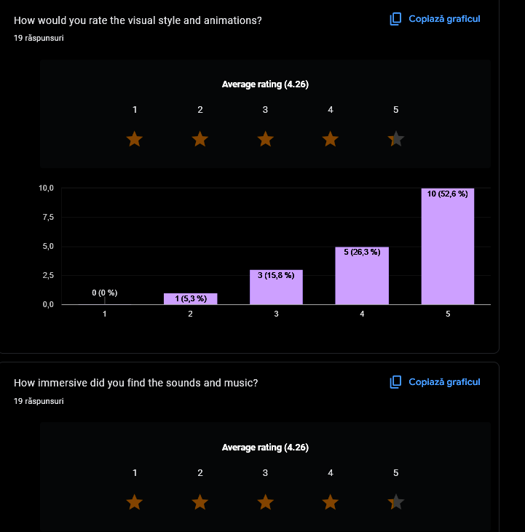

Figure 6.2.2.1 - Showcase of Animations and Music ratings (Source: screenshot)

The Rewind Time mechanic and Wind Dash Mechanic were well received, the latter being the better rated one with a total rating of 4.16/5. The reason for this being the fact that most players didn’t find the same usefulness for the former as they did for the latter, as it is further emphasized in some feedback answers. An anonymized quote from a player reads “Rewind is interesting but some tweaks should be done to it in my opinion, to make it even more useful”. When asked what feature stood out most users praised either the wind dash or the rewind time as shown in Figure 6.2.2.2.
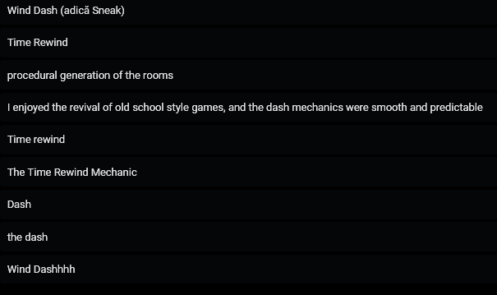
Figure 6.2.2.2 -Showcase of what feature stood out to people (Source: screenshot)

The Enemy Patrol Combat AI, Room Procedural Generation and Difficulty balance were all rated similarly. As stated in Chapter 6.2.2.2, there was a tendency for the players that had a higher play time to have more deaths, suggesting that some balancing was needed in order to make the game accessible even to the casual player. An anonymized quote from a player’s feedback when asked about future improvements reads “Difficulty can be a problem, especially for a player like me who doesn't play games like these that much. This being said, maybe tweaking the difficulty or making different game difficulty modes, such as easy, medium or hard”. This suggestion is a really good one, since the players could be asked to decide in the beginning what kind of experience they would like to have, enjoy the game the way it was meant to play, with a high level of difficulty or simply choose an easy mode meant for players who just want to enjoy the story and be satisfied throughout the whole playthrough. Further feedback upon what improvements could be made include things such as adding cooldowns and an energy system to abilities like dash and rewind time, making them be used more strategically considering the fact that they are limited by such constraints. A percentage of 89.5% people said they would like to replay the game if it was further expanded, indicating a positive outcome on their experience with the Sword of Time. This positive outcome is also reflected in the overall rating of the game, getting a total rating of 4/5 for the overall evaluation, as shown in Figure 6.2.2.3.
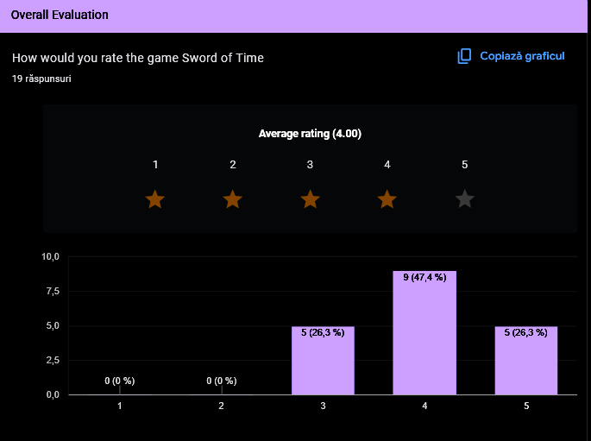
Figure 6.2.2.3- Showcase of overall evaluation rating (Source: screenshot)

Conclusion

Throughout this thesis, the 2D rogue-like platformer Sword of Time was developed featuring procedurally generated levels, a well put together ability system, a complete gameplay loop, enemy AI and an aesthetically pleasing level design. Player testing data and feedback were collected through Firebase integration and respectively Google Forms.
Several technical challenges were encountered during development. One persisting challenge was applying the rewind time mechanic correctly and efficiently to all the affected objects during rewind. Initially, some entities, especially the patrolling enemies, did not fully stop patrolling during rewind due to the reliance on Transform.position and their OOP hierarchy, thus having to be careful to apply the rewind on the correct object in the hierarchy. This issue was resolved by implementing an IRewindable interface to correctly freeze behaviour among the right objects in the hierarchy, making sure every affected entity implements the rewind time methods. Another challenge was the procedural level generation and logical trap placement. A grid-based approach was adopted, placing objects effeciently based on neighbouring walls and limits.
Compared to the titles analyzed in Chapter 2, namely Dead Cells and Hollow Knight, Sword of Time brings forth the procedural level generation, which ensures high replayability while also presenting an ability collection system that encourages exploration and further progression. On top of that, the rewind mechanic is creatively implemented, adding to the games strategic and efficiency-based aspect. While it is clear further improvements are needed in order to make an even better experience, as suggested from the game stats and forms data collected, Sword of Time was received positively by its players.
Future development directions are based both on the feedback received from players and the vision I have for this game. Firstly, at this moment there is only one level, thus more levels should be added in order to match the path envisioned and the narrative. More bosses and levels need to be added, since the main character needs to secure all swords of time and reach his full potential. The future levels and bosses that will be added will have their own specific theme, since the player travels different worlds, thus further uniqueness will be encouraged when it comes to level and enemies designing, as well as their mechanics. Future levels imply more items and as it resulted from the forms feedback, a more complex system of how abilities work will be implemented, making them have cooldowns that can be reduced through eliminating enemies. Another improvement would be to add a difficulty system as mentioned in Chapter 6.2.2.2, where the game would be also fit for casual players that just want to enjoy the narrative of the game and its unique features. One last improvement would be the addition of some mini-boss fights and puzzles, increasing gameplay variety and creating more unpredictable scenarios that make the player strategize.
The feedback and test results, show strong user engagement, while at the same time highlighting the need to fix some key aspects of a few mechanics, improving features by adding more complexity to them, balancing the game for every type of player in order to enhance the overall player experience and make an even more pleasant game.

References

[1] M. Sood, “Studying the Factors Leading to Revenue and Profitability Growth in the Toy, and Gaming and Esports Sectors,” Int. J. Econ. Manag. Stud., vol. 11, no. 10, pp. 1–12, Oct. 2024, doi: 10.14445/23939125/IJEMS-V11I10P101.
[2] J. Schell, The art of game design: a book of lenses, Reprinted. Amsterdam Heidelberg: Elsevier, 2010.
[3] “Dead Cells - The rogueVania from Motion Twin.” Accessed: Jun. 25, 2025. [Online]. Available: https://dead-cells.com
[4] “Hollow Knight,” Hollow Knight. Accessed: Jun. 25, 2025. [Online]. Available: https://www.hollowknight.com
[5] “Supergiant Games.” Accessed: Jun. 25, 2025. [Online]. Available: https://www.supergiantgames.com/games/hades
[6] A. Gellel and P. Sweetser, “A Hybrid Approach to Procedural Generation of Roguelike Video Game Levels,” in International Conference on the Foundations of Digital Games, Bugibba Malta: ACM, Sep. 2020, pp. 1–10. doi: 10.1145/3402942.3402945.
[7] U. Technologies, “Unity - Manual: Unity 6.0 User Manual.” Accessed: Jun. 25, 2025. [Online]. Available: https://docs.unity3d.com/6000.0/Documentation/Manual/UnityManual.html
[8] U. Technologies, “Unity - Manual: Rendering.” Accessed: Jun. 25, 2025. [Online]. Available: https://docs.unity3d.com/6000.0/Documentation/Manual/rendering-and-post-processing.html
[9] “Unity Asset Store.” Accessed: Jun. 25, 2025. [Online]. Available: https://assetstore.unity.com
[10] BillWagner, “C# Guide - .NET managed language.” Accessed: Jun. 25, 2025. [Online]. Available: https://learn.microsoft.com/en-us/dotnet/csharp/
[11] ghogen, “Visual Studio documentation.” Accessed: Jun. 25, 2025. [Online]. Available: https://learn.microsoft.com/en-us/visualstudio/windows/?view=vs-2022
[12] U. Technologies, “Unity - Manual: Unity’s Asset Store.” Accessed: Jun. 25, 2025. [Online]. Available: https://docs.unity3d.com/6000.1/Documentation/Manual/AssetStore.html
[13] “Firebase Realtime Database,” Firebase. Accessed: Jun. 25, 2025. [Online]. Available: https://firebase.google.com/docs/database
[14] “Extending Google Sheets | Apps Script,” Google for Developers. Accessed: Jun. 25, 2025. [Online]. Available: https://developers.google.com/apps-script/guides/sheets

Annexes:

- Figure 2.1.1 - Showcase of Dead Cells’ unique aesthetic …………………………….8
- Figure 2.1.2 - Showcase of Hollow Knight’s Metroidvania aspect …………………...9
- Figure 2.1.3 - Showcase of Hades’ BoonSystem ………………………………………9
- Figure 2.1.4 - Showcase of one such procedurally generated room………………. 10
- Table 2.3.1- Showcase of selected games comparison.......................................... 11
- Figure 3.1.1 – Showcase of Unity ………………………………………………….......13
- Figure 3.1.2 - Showcase of Visual Studio interface …………………………………..14
- Figure 3.1.3 - Showcase of C#.................................………………………………….14
- Figure 3.1.4 - Showcase of Unity Asset Store ………………………………………..15
- Figure 3.2.1 - Explanation of Enemy Patrol System …………………………………16
- Figure 3.2.2 - Showcase of Time Rewind Ability ……………………………………..17
- Figure 4.1.1 - Block Diagram of main mechanics …………………………………… 18
- Figure 4.5.1 - Block Diagram of RoomGeneration ……………………………….......20
- Figure 4.5.1- Block Diagram of Enemy Patrol mechanic …………………………….21
- Figure 4.6.1 - UML Diagram that showcases how the Player Attack Works .……...22
- Figure 4.6.2 - Showcase of Firepoint importance …………………………………….23
- Figure 5.1.1.1 - Showcase of horizontal movement implementation.……………….24
- Figure 5.1.1.2 - Showcase of jump mechanic.………………………………………...24
- Figure 5.1.1.3 - Showcase of how jumping input is handled …………….….………25
- Figure 5.1.1.4 - Showcase of how jumping input is handled ………………………..25
- Figure 5.1.1.5 - Showcase of Animator Controller interaction ………………………26
- Figure 5.1.1.6 - Showcase of Crouching Mechanic ………………………………….26
- Figure 5.1.1.7 - Showcase of Animator for Running …………………………………27
- Figure 5.1.1.8 - Showcase of how collisions are handled …………………………...27
- Figure 5.1.2.1 - Showcase of Attacking logic …………………………………………28
- Figure 5.1.2.2 - Showcase of handling logic for attacks ……………………………..28
- Figure 5.1.2.3 - Showcase of using the fireball and ShotgunShot mechanic ……...29
- Figure 5.1.2.4 - Showcase of Projectile logic and collision handling …………........30
- Figure 5.1.2.5 - Showcase of how the direction is set ………………………….........30
- Figure 5.1.3.1 - Showcase of patrolling logic ……………………………………........31
- Figure 5.1.3.2 - Showcase of changing direction ……………………………….........31
- Figure 5.1.4.1 - Showcase of Boss’s Attack logic ………………………………........32
- Figure 5.1.4.2 - Showcase of Boss’s method for detecting the player ……………..33
- Figure 5.1.4.3 - Showcase of how range affects the size of the box responsible for detection ………………………………………………………………………...............33
- Figure 5.1.4.4 - Showcase of DamagePlayer() method ……………………….........33
- Figure 5.1.4.5 - Showcase of PerformDash logic …………………………………….34
- Figure 5.1.5.1 - Showcase of how Ranged Enemy attack works …………………..35
- Figure 5.1.5.2 - Showcase of how Melee Enemy attack works ……………………..35
- Figure 5.1.5.3- Showcase of IEnemy interface ……………………………………….36
- Figure 5.1.5.4- Showcase of how OnDrawGizmos is specifically tailored for the boss based on his attacks …………………………………………………………................36
- Figure 5.1.6.1 - Showcase of floor generation and spike positioning logic ………..37
- Figure 5.1.6.2 - Showcase of obstacles logic handling…………………………........37
- Figure 5.1.6.3 - Showcase of items and collectibles logic……………………….......38
- Figure 5.1.6.4 - Showcase of Patrol Enemy spawning logic………………………....38
- Figure 5.1.6.5 - Showcase of Static Enemies spawning logic……………………….39
- Figure 5.1.6.6 - Showcase of DecorationPattern class……………………………….39
- Figure 5.1.6.7 - Showcase of Decoration spawning logic………………………........40
- Figure 5.1.7.1- Showcase of Enemy Damage script………………………………….40
- Figure 5.1.8.1- Showcase of Saw moving logic……………………………………….41
- Figure 5.1.9.1- Showcase of how directions are computed………………………….42
- Figure 5.1.9.2- Showcase of SpikeHead checking for player logic………………….42
- Figure 5.1.10.1- Showcase of takeDamage() method………………………………..43
- Figure 5.1.10.2 - Showcase of Invulnerability coroutine and health managing methods……………………………………………………………………………………44
- Figure 5.1.10.3 - Showcase of HealthBarFunctionality logic……………………......45
- Figure 5.1.10.4 - Showcase of HealthPickup logic……………………………….......45
- Figure 5.1.11.1 - Showcase of PlayerAbility logic…………………………………….46
- Figure 5.1.11.2 - Showcase of the unlock logic ………………………………………46
- Figure 5.1.11.3 - Showcase of ItemUnlockedHint logic ……………………………..47
- Figure 5.1.12.1- Showcase of PointInTime script ……………………………………48
- Figure 5.1.12.2 - Showcase of how states are recorded ……………………….......48
- Figure 5.1.12.3 - Showcase of state handling ………………………………………..48
- Figure 5.1.12.4 - Showcase of rewind logic ……………………………………….....49
- Figure 5.1.13.1 - Showcase of CameraBehaviour script ……………………………49
- Figure 5.1.14.1 - Showcase of UIManager logic Part 1 ……………………………..50
- Figure 5.1.14.2 - Showcase of UIManager logic Part 2 ……………………………..51
- Figure 5.1.14.3 - Showcase of singleton usage ……………………………...………51
- Figure 5.1.14.4 - Showcase of sound logic ……………………………………..........52
- Figure 5.1.15.1 - Showcase of singleton use …………………………………..…….52
- Figure 5.1.15.2 - Showcase of POST logic ………………………………………......53
- Figure 5.2.1 - Showcase of boss’s health bar …………………..……………………54
- Figure 5.2.2 - Showcase of die animation Deactivate event ………………...……..54
- Figure 5.2.3 - Showcase of state diagram for the player ………………………...... 54
- Figure 5.2.4 - Showcase of transition from jump to idle ……………………….........55
- Figure 6.2.1.1 - Showcase of Bar Chart for Play Time vs Death Count ……...……57
- Figure 6.2.1.2 - Showcase of the proportion of collected abilities through all
sessions ………………………………………………………………………………….57
- Figure 6.2.1.2 - Showcase of Collected Abilities Frequency chart ………………….58
- Figure 6.2.2.1 - Showcase of Animations and Music ratings ………………………..59
- Figure 6.2.2.2 - Showcase of what feature stood out to people ………………........60
- Figure 6.2.2.3 - Showcase of overall evaluation rating ………………………….......61
