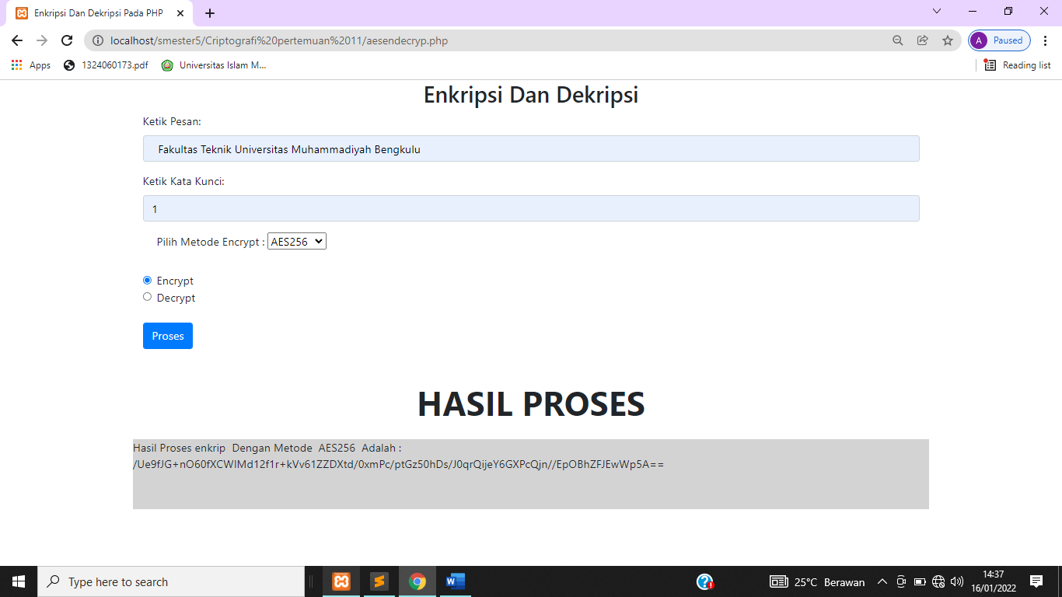

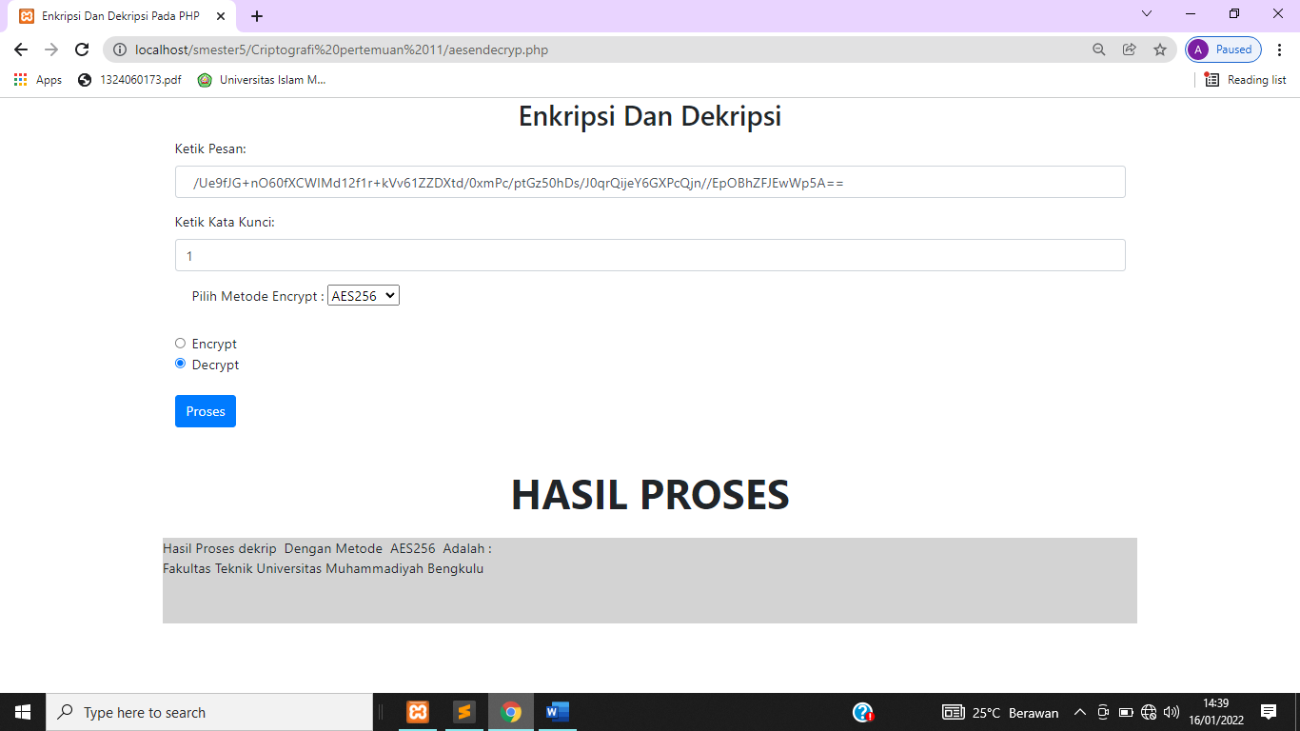

**Source Code Program**

<!DOCTYPE html>

<html lang="en">

<head>

<title>Enkripsi Dan Dekripsi Pada PHP</title>

<meta charset="utf-8">

<meta name="viewport" content="width=device-width, initial-scale=1">

<link rel="stylesheet" href="https://maxcdn.bootstrapcdn.com/bootstrap/4.5.2/css/bootstrap.min.css">

<script src="https://ajax.googleapis.com/ajax/libs/jquery/3.5.1/jquery.min.js"></script>

<script src="https://cdnjs.cloudflare.com/ajax/libs/popper.js/1.16.0/umd/popper.min.js"></script>

<script src="https://maxcdn.bootstrapcdn.com/bootstrap/4.5.2/js/bootstrap.min.js"></script>

</head>

<body>

<div class="container">

<h2><center> Enkripsi Dan Dekripsi</center></h2>

<form method="POST" action="">

<div class="form-group">

<label for="tekspesan" >Ketik Pesan:</label>

<input type="text" class="form-control" id="tekspesan" placeholder="Ketik Pesan" name="tekspesan" required value=" <?php if(!empty($_tekshasil))echo $tekshasil; ?> ">

</div>

<div class="form-group">

<label for="kunci">Ketik Kata Kunci:</label>

<input type="text" class="form-control" id="kunci" placeholder=" Ketik Kata Kunci" name="kunci" required>

</div>

<div class="form-group form-check">

<label class="form-check-label">Pilih Metode Encrypt :</label>

<select class="form-group" name="metodeendec">

<option value="AES128">AES128</option>

<option value="AES192">AES192</option>

<option value="AES256">AES256</option>

<option value="blowfish">blowfish</option>

<option value="idea">idea</option>

</select>

</div>

<div class="form-check">

<label class="form-check-label">

<input type="radio" class="form-check-input" name="optradio" value="enkrip" required>Encrypt

</label>

</div>

<div class="form-check">

<label class="form-check-label">

<input type="radio" class="form-check-input" name="optradio" value="dekrip" required>Decrypt

</label>

</div>

<br>

<button type="submit" class="btn btn-primary" name="bproses">Proses</button>

</form>

</div><br>

<p ><font size="30"><b><center> HASIL PROSES</p></center></b></font>

<div style="height: 100px; width: 75%; margin-left: 12.5%;margin-right: 12.5%; background-color: lightgray;">

<?php

if(isset($_POST['bproses'])){

$tekspesan=$_POST['tekspesan'];

$kunci=$_POST['kunci'];

$metodeendec=$_POST['metodeendec'];

$pilencode=$_POST['optradio'];@$tekshasil="";

if($pilencode=='enkrip'){

@$tekshasil=openssl_encrypt($tekspesan,$metodeendec,$kunci);

}

if($pilencode=='dekrip'){

@$tekshasil=openssl_decrypt($tekspesan,$metodeendec,$kunci);

}

echo "Hasil Proses&nbsp;".$pilencode."&nbsp; Dengan Metode &nbsp;".$metodeendec."&nbsp; Adalah : <br>"; print_r($tekshasil."");

}

?>

</div>

</body>

</html>