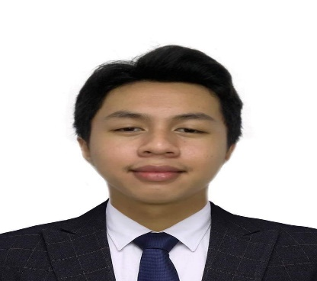

* IMMERSION/On-the-Job Training

**Department of Trade and Industry**

Lucena Grand Central, Lucena Quezon

* INTERNSHIP

XYZ Tech Solutions in Pasig

June 2024 - August 2024

***I hereby certify that all the information above is true and correct to the best of my knowledge and belief.***

**EDIZON G. PEREZ**

Applicant

**WORK EXPERIENCE**

**2023-2027**

**TERTIARY EDUCATION**

CSTC College of Sciences Technology and Communications Inc.

**2021-2023**

**TERTIARY EDUCATION**

**College of Sciences Technology and Communications Inc.**

Brgy.10, Lucena City Quezon

**2017-2021**

**SECONDARY EDUCATION**

**Lucena Dalahican National High School**

Brgy. Dalahican, Lucena City Quezon

**2011-2017**

**PRIMARY**

**Dalahican Elementary School**

Brgy. Dalahican, Lucena City Quezon

**EDUCATIONAL ATTAINMENT**

**AGE** : 19

**DATE OF BIRTH** : December 28, 2004

**PLACE OF BIRTH** : Lucena City

**NATIONALITY** : Filipino

**CIVIL STATUS** : Single

**RELIGION** : Roman Catholic

**LANGUAGE SPOKEN**: English and Tagalog

**SKILLS**

**•Computer Literate**

**•Knowledgeable in working on**

Microsoft Office Suites (Word.

PowerPoint. Excel)

Computer Programming (Visual

Basic.NET, Java)

Multimedia Applications

(Windows Movie Maker, Adobe Photoshop)

Web Development (HTML)

**• Oriented in Windows Operating**

System (XP, 7, 8, 8.1, 10)

**REFERENCES**

**NINO JOSEPH A. BALLARES**

**SHS Principal**

**CSTC Sariaya**

**Jorge T Jader, MIT**

**Acting Dean, School of Information Technology Sariaya, Quezon**

**TEODY REYES**

**Professional Photographer**

**Tayabas City**

**CAREER OBJECTIVES**

**EDIZON G. PEREZ**

*Brgy. Dalahican Lucena City Purok 3B*

*09701834905 | edizonperez0@gmail.com*

(Selfies are not allowed)

2x2

To secure a challenging position in a reputable organization to expand and utilize my learning, knowledge, and skills while making a significant contribution to the success of the company.

**PERSONAL DATA**