**Bases de Datos. 2022-30**

**Taller SQL No. 1**

**Integrantes:**

Michelle Polo

Edilberto Rodriguez

**Questions about SalesDB:**

Pick 5 questions and paste your answers (sql script and the result using screenshot)

1. Select all the information about the clients who have purchased the product with ID=1.

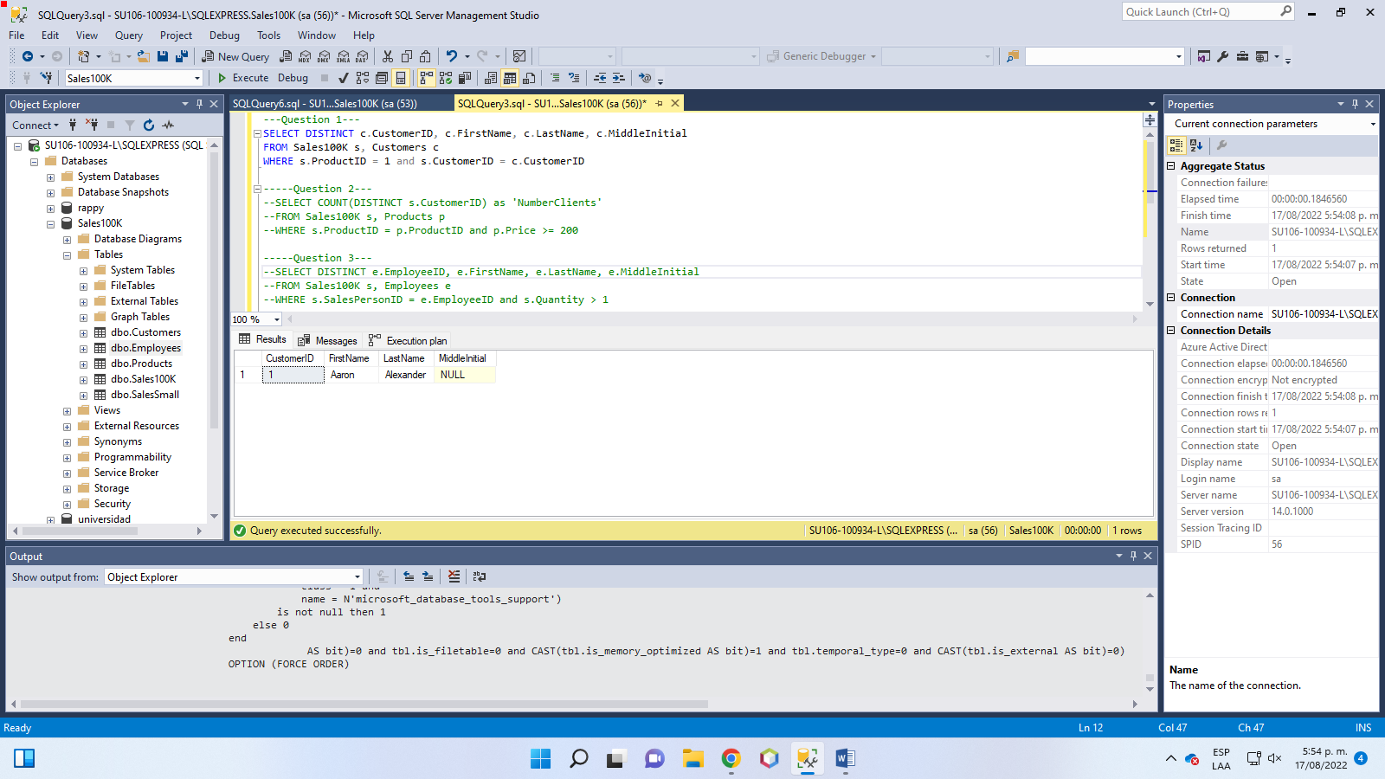

1. Count how many clients have purchased products with prices greater than $200

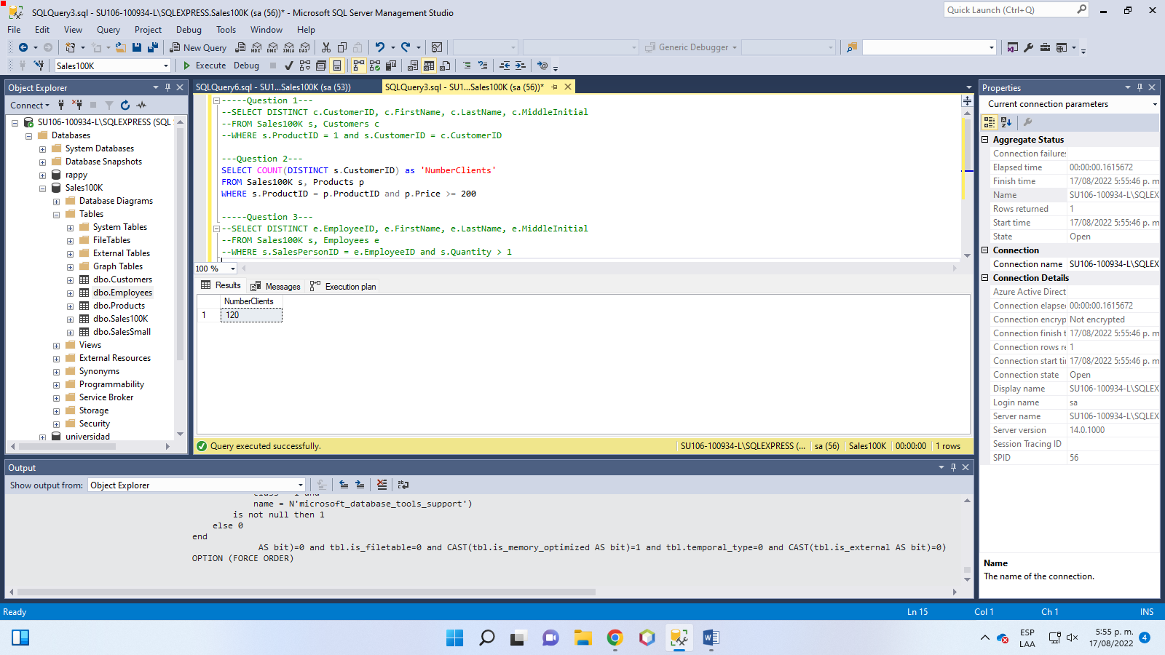

1. Show the information about the employees that have sold more than 1 items of the same product on a single transaction (each represented by a row in the Sales table).

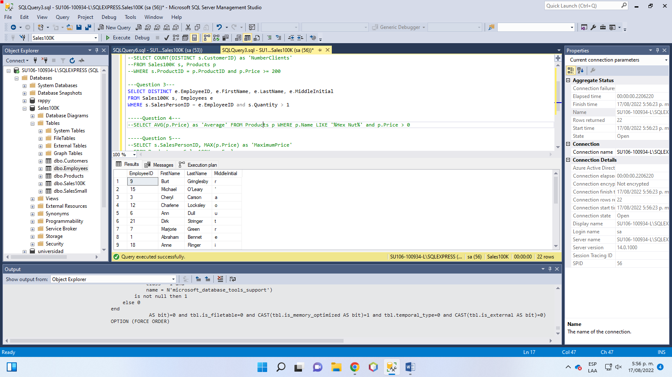

1. Calculate the average price of products containing “Hex Nut” in the name, for all the products with a price different than cero.

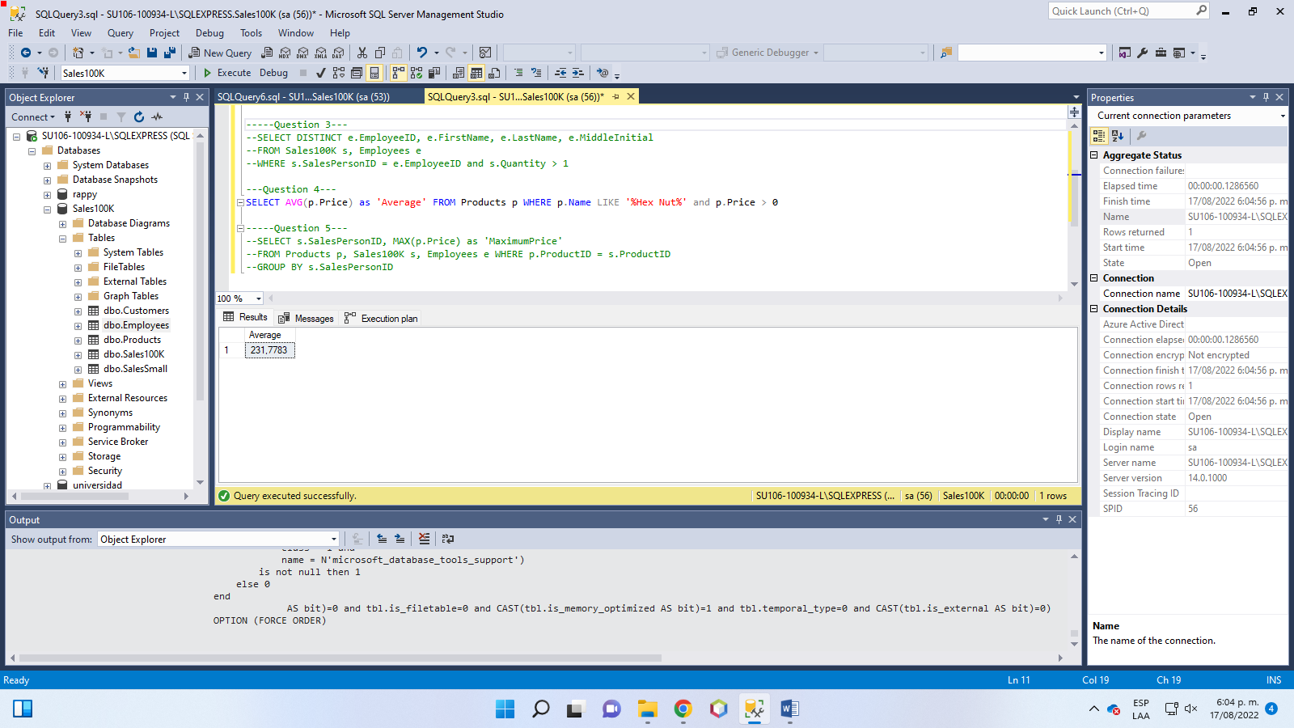

1. Calculate the maximum price of the products sold by each employee

