LAB: MONGO DB

STUDENT NUMBER: 145491

1.Install MongoDB

2.Start MongoDB

b)

3. Create configuration file

4. Connect to MongoDB

5. Execute the following commands and in a table explain what each one is for

|  |  |
| --- | --- |
| Show dbs | Shows databases available |
| Use analisisProveedores | Switch to database named ‘analisisProveedores’ |

6. Read the reference manual and write down the function of the following sentences:

|  |  |
| --- | --- |
| Aggregate | Aggregation operations process the data records/documents and return computed results. It collects values from various documents and groups them together and then performs different types of operations on that grouped data like sum, average, minimum, maximum, etc |
| Count | Counts the number of documents in a collection or a view. Returns a document that contains this count and as well as the command status. |
| Distinct | The distinctmethod finds the distinct values for a given field across a single collection and returns the results in an array. |
| Group | It is used to group documents based on some value, ‘group key’. A group key is often a field, or group of fields. |
| mapReduce | map-reduce is a data processing programming model that helps to perform operations on large data sets and produce aggregated results. |
| Find | The find function is used to find data from the MongoDB database. |
| Insert | the insert method inserts a document or documents into the collection. |
| Update | Theupdate method updates the values in the existing document in the collections of MongoDB. |
| Delete | The delete function is used to delete a document that is from the collection. |
| findAndModify | The findAndModify method modifies and return a single document that matches the given criteria. |
| parallelCollectionScan | Allows applications to use multiple parallel cursors when reading all the documents from a collection, thereby increasing throughput. It returns a document that contains an array of cursor information. |
| Logout | Ends the current authentication session. |
| Authenticate | It enables authentication. Authentication is enforced when access control is enabled on a MongoDB deployment, requiring users to identify themselves. |
| createUser | create new users for the database. |
| dropUser | Removes the user from the current database. |
| grantRolesToUser | Grants additional roles to a user. |
| usersInfo | Returns information about one or more users. |
| renameCollection | Renames a collection. |
| Copydb | copies a database from a remote host to the current host. |
| dropDatabase | Removes the current database, deleting the associated data files. |
| listCollections | Retrieve information, i.e., the name and options, about the collections and [views](https://www.mongodb.com/docs/manual/core/views/) in a database. |
| drop | The drop method removes collections from the database. |
| create | Database is created using this function |
| clone | It create a copy of the collection |
| createIndexes | The createIndexes method creates one or more indexes on the specified collection. |
| dropIndexes | This method drops the specified index or all index from the given collection. |
| shutdown | The [shutdown](https://www.mongodb.com/docs/manual/reference/command/shutdown/#mongodb-dbcommand-dbcmd.shutdown) command cleans up all database resources and then terminates the process |

Lab 2: Importing a collection and exploring a database

Lab 3: Querying providers

7) For querying array fields: Get the providers with grade B

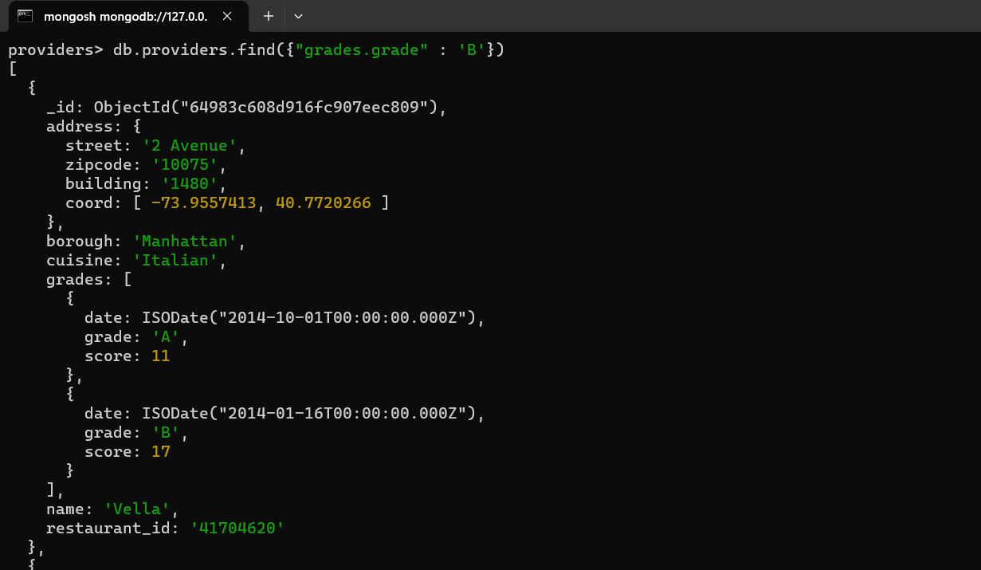

8)

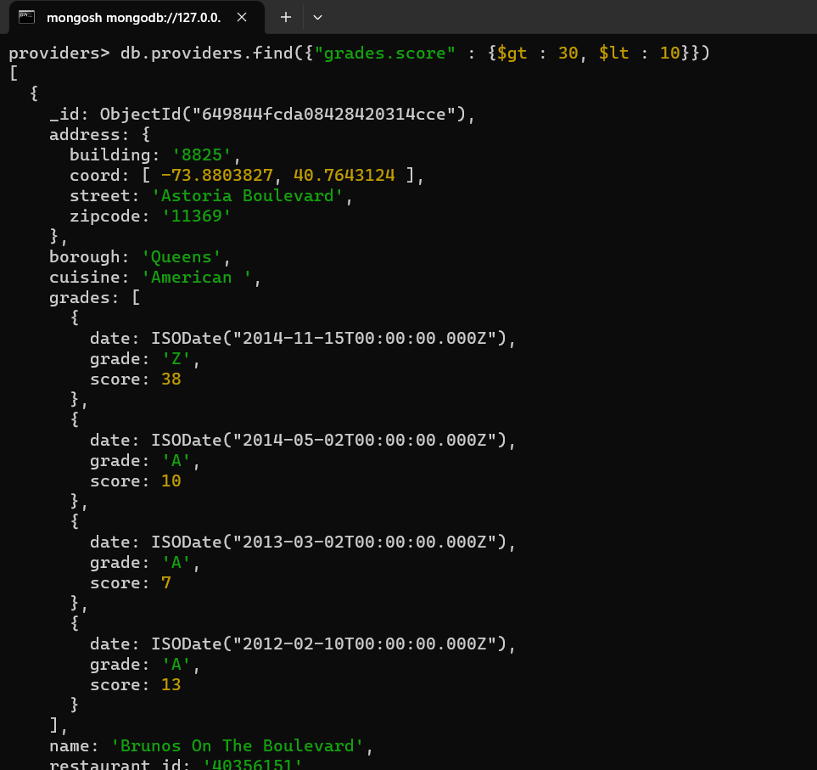

9)

