Title Of Your Report

Your Name student number

31 January 2025

# Abstract

Max. 150 words.

Provide a concise summary of your work. It should be understandable as a standalone piece, without the need to read the whole report.

Briefly describe the problem. What did you investigate, which approach did you use, and what were the key findings and observations? What is the importance of this study?

# Introduction

Max. 150 words.

Give a brief motivation for your work.

# Methodology

The total for this section should be approximately 500 words.

Describe all key steps you took to prepare, run and analyse the simulation in a condensed form. Another scientist should be able to repeat your simulation based on the information given in this section.

## System Setup

Describe where you obtained the structure(s), how you manipulated them to obtain the model used in the simulation, which forcefield(s) you used, and the system size.

Make sure you write out your chemical formulae, such as – Na2SO4 or Ca2+. The shortcut for subscript is **Ctrl** + **=** and for superscript **Ctrl** + **Shift** + **=**.

While for short documents, like this one, you can manage citations through the inbuilt Word tool, we recommend using Mendeley or other referencing software. To use Mendeley you will need to:

1. Install Mendeley Desktop – see guide [here](https://www.mendeley.com/guides/desktop/);
2. To insert a citation into this document, bring cursor to the text you want to be referenced;
3. Go to Word menu “References”, click “Insert or edit citation”;
4. Into the field start typing the name of the author, a suggestion will come up, click OK;
5. You should get something like this: "GROMACS1 molecular simulation package was used";
6. In this document bring cursor under section **References**, then in Word menu “References” press “Insert Bibliography” and the bibliography will be generated.

## Simulation Protocol

Include relevant run information for energy minimization, equilibration, and production runs. Provide details such as run type algorithm, time step, temperature, pressure, simulation length, etc.

## Analysis

Explain how you ensured system equilibration within the analyzed time frame. Describe the analysis performed on trajectories, including software used, tools, parameters, and preparation of plots or renderings.

You may find yourself needing to write an equation, which can either be written in-line $ρ=m⁄V$; or displayed with a number, like (Eqn. 1). The density  
($ρ$) is defined as the mass ($m$) divided by the volume ($V$), and it can be  
expressed mathematically as:

$$\begin{aligned}ρ=\frac{m}{V}\#\left(1\right)\end{aligned}$$

where $ρ$ is density in kg m−3, is mass in kg, and is volume in m3.

Remember that units, such as g, cm, s, keV are set in roman font, while  
physical constants, such as $m$, $V$, $ρ$ are in italics. This means that the units  
involving constants are mixed roman-italics, e.g., GeV/*c* (with the *c* in italic  
because it symbolizes the speed of light, a constant).

# Results and Discussion

Approximately 500 words including tables and captions.

Describe your result data with a plot that illustrates your findings and a rendering of the system.

Here is an example of how to include and reference the plot (**Figure 1**) or a  
**Figure 2** to illustrate your results. You may want to include a table (**Table 1**) summarising your results. Note that typically figures have captions below and tables above.

**Figure 1**: An example plot, showing linear density profile for apigenin (API) – clay (MMT) system containing Na+, Ca2+ and Cl– ions. Water is present but not shown.

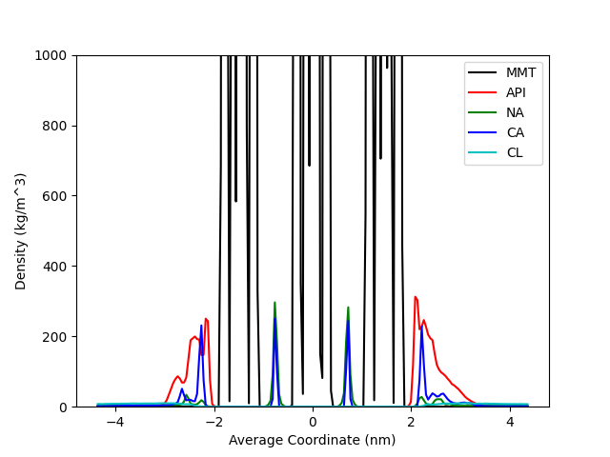

**Table 1**: This is an example table, showing Parameter 1 and Parameter 2 for  
the Set I and Set II.

|  |  |  |
| --- | --- | --- |
| Name | Parameter 1 (km m-3) | Parameter 2 (m3) |
| Set I | 11 ± 3 | 0.34 |
| Set II | 33 ± 4 | 0.56 |

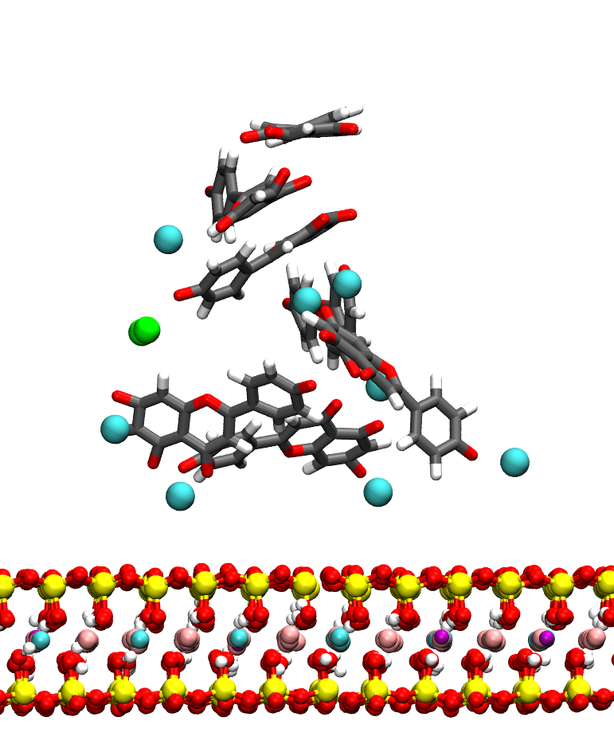

**Figure 2**: This is an example rendering, showing an interaction between apigenin molecules and clay surface in the presence of ions. Colours are as follows: C - grey, H - white, O – red, Si – yellow, Al - cyan, Mg – pink, Fe – purple, Ca2+ - large cyan spheres, Cl− - green spheres. Water is not shown for clarity.

# Conclusions

Approximately 100 words.

Outline the key conclusions from your study.

Overall, your report should be about 1500 words and include a figure of the system, an analysis plot and possibly a table.

# References

1. Berendsen, H. J. C., van der Spoel, D. & van Drunen, R. GROMACS: A message-passing parallel molecular dynamics implementation. *Comput. Phys. Commun.* **91**, 43–56 (1995).