Title Of Your Report
Your Name student number
6 February 2024

Overview
Max. 100 words.
Briefly describe the problem. What did you investigate, which approach did you use, and what were the key findings and observations?

Methodology
Max. 500 words.
Describe all key steps in a condensed form.

System Setup
Describe where you obtained the structure(s), how you manipulated them to obtain the model used in the simulation, which forcefield(s) you used, and the system size.
Make sure you write out your chemical formulae, such as – Na₂SO₄ or Ca²⁺. The shortcut for _{subscript} is Ctrl + = and for ^{superscript} Ctrl + Shift + =.
While for short documents, like this one, you can manage citations through the inbuilt Word tool, we recommend using Mendeley or other referencing software. To use Mendeley you will need to:
- Install Mendeley Desktop – see guide here;
- To insert a citation into this document, bring cursor to the text you want to be referenced;
- Go to Word menu “References”, click “Insert or edit citation”;
- Into the field start typing the name of the author, a suggestion will come up, click OK;
- You should get something like this: "GROMACS¹ molecular simulation package was used";
- In this document bring cursor under section References, then in Word menu “References” press “Insert Bibliography” and the bibliography will be generated.

Simulation Protocol
Include relevant run information for energy minimization, equilibration, and production runs. Provide details such as run type algorithm, time step, temperature, pressure, simulation length, etc.

Analysis
Explain how you ensured system equilibration within the analyzed time frame. Describe the analysis performed on trajectories, including software used, tools, parameters, and preparation of plots or renderings.
You may find yourself needing to write an equation, which can either be written in-line $ρ=m⁄V$; or displayed with a number, like (Eqn. 1). The density
($ρ$) is defined as the mass ($m$) divided by the volume ($V$), and it can be
expressed mathematically as:
$$\begin{aligned}ρ=\frac{m}{V}\#\left(1\right)\end{aligned}$$
where $ρ$ is density in kg m⁻³, $m$ is mass in kg, and $V$ is volume in m³.
Remember that units, such as g, cm, s, keV are set in roman font, while
physical constants, such as $m$, $V$, $ρ$ are in italics. This means that the units
involving constants are mixed roman-italics, e.g., GeV/c (with the c in italic
because it symbolizes the speed of light, a constant).

Results
Max. 400 words including tables and captions.
Describe your result data with a plot that illustrates your findings and a rendering of the system.
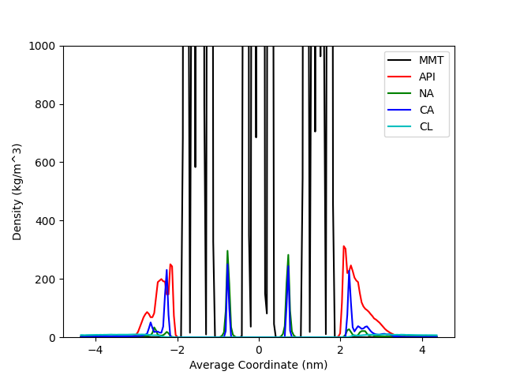
Here is an example on how to include and reference the plot (Figure 1) or a
Figure 2 to illustrate your results. You may want to include a table (Table 1) summarising your results. Note that typically figures have captions below and tables above.
Figure 1: An example plot, showing linear density profile for apigenin (API) – clay (MMT) system containing Na⁺, Ca²⁺ and Cl– ions. Water is present but not shown.
Table 1: This is an example table, showing Parameter 1 and Parameter 2 for
the Set I and Set II.
Name | Parameter 1 (km m⁻³) | Parameter 2 (m³)
Set I | 11 ± 3 | 0.34
Set II | 33 ± 4 | 0.56

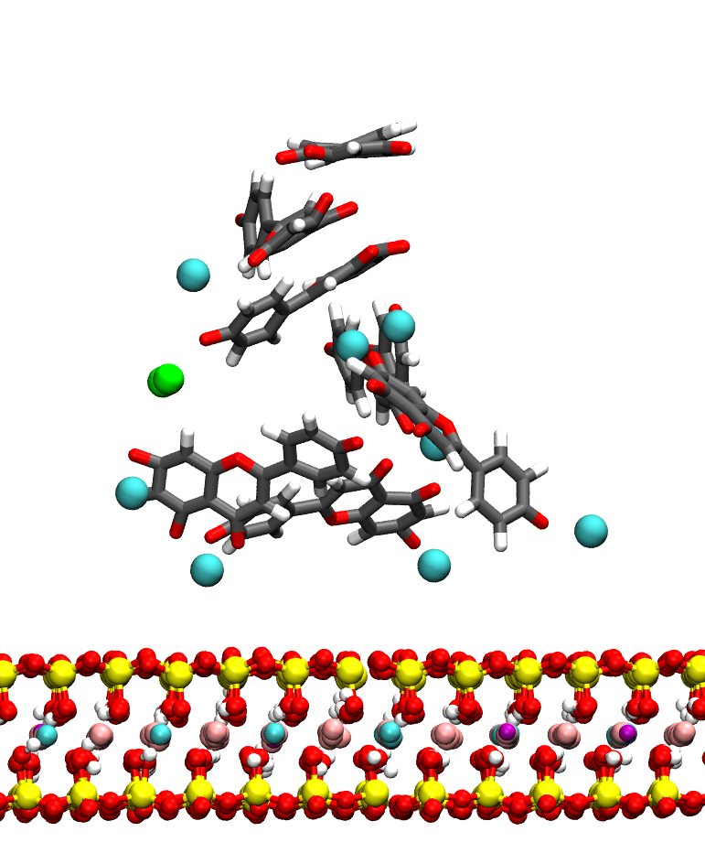
Figure 2: This is an example rendering, showing an interaction between apigenin molecules and clay surface in the presence of ions. Colours are as follows: C - grey, H - white, O – red, Si – yellow, Al - cyan, Mg – pink, Fe – purple, Ca²⁺ - large cyan spheres, Cl⁻ - green spheres. Water is not shown for clarity.

References
1. Berendsen, H. J. C., van der Spoel, D. & van Drunen, R. GROMACS: A message-passing parallel molecular dynamics implementation. Comput. Phys. Commun. 91, 43–56 (1995).

