*Olaf Stapledon*

# Life

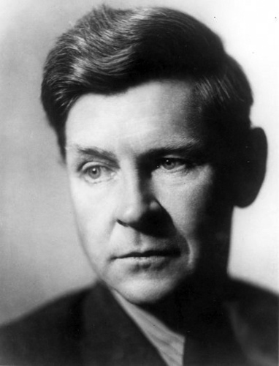

Stapledon was born in Seacombe, Wallasey, on the Wirral Peninsula near Liverpool, the only son of William Clibbert Stapledon and Emmeline Miller. The first six years of his life were spent with his parents at Port Said. He was educated at Abbotsholme School and Balliol College, Oxford, where he acquired a BA in Modern History in 1909 and a MA in 1913. After a brief stint as a teacher at Manchester Grammar School he worked in shipping offices in Liverpool and Port Said from 1910 to 1913.

During World War I he served as a conscientious objector with the Friends' Ambulance Unit in France and Belgium from July 1915 to January 1919. On 16 July 1919 he married Agnes Zena Miller (1894-1984), an Australian cousin. They had first met in 1903, and later maintained a correspondence throughout the war. They had a daughter, Mary Sydney Stapledon (1920-), and a son, John David Stapledon (1923-). In 1920 they moved to West Kirby.

Stapledon was awarded a PhD in philosophy from the University of Liverpool in 1925 and used his thesis as the basis for his first published prose book, A Modern Theory of Ethics (1929). However, he soon turned to fiction in the hope of presenting his ideas to a wider public. The relative success of Last and First Men (1930) prompted him to become a full-time writer. He wrote a sequel and followed it up with many more books of both fiction and philosophy.

In 1940 the family built and moved into Simon's Field, in Caldy. After 1945 Stapledon travelled widely on lecture tours, visiting the Netherlands, Sweden and France, and in 1948 he spoke at the World Congress of Intellectuals for Peace in Wrocław, Poland. He attended the Conference for World Peace held in New York in 1949, the only Briton to be granted a visa to do so. In 1950 he became involved with the anti-apartheid movement. After a week of lectures in Paris, he cancelled a projected trip to Yugoslavia and returned to his home in Caldy, where he died very suddenly of a heart attack.

Stapledon was cremated at Landican Crematorium, and then his widow and their children scattered his ashes on the sandy cliffs overlooking the Dee Estuary, a favourite spot of his that features in more than one of his books.

# Works

Stapledon's writings directly influenced Arthur C. Clarke, Brian Aldiss, Stanislaw Lem, C. S. Lewis and John Maynard Smith and indirectly influenced many others, contributing many ideas to the world of science fiction. The "supermind" composed of many individual consciousnesses forms a recurring theme in his work. Star Maker contains the first known description of what are now called Dyson spheres. Freeman Dyson credits the novel with giving him the idea. Last and First Men features early descriptions of genetic engineering and terraforming. Sirius describes a dog whose intelligence is increased to the level of a human being's.

Stapledon's fiction often presents the strivings of some intelligence that is beaten down by an indifferent universe and its inhabitants who, through no fault of their own, fail to comprehend its lofty yearnings. It is filled with protagonists who are tormented by the conflict between their "higher" and "lower" impulses.

Last and First Men, a "future history" of 18 successive species of humanity, and Star Maker, an outline history of the Universe, were highly acclaimed by figures as diverse as Jorge Luis Borges, J. B. Priestley, Virginia Woolf and Winston Churchill (Stapledon maintained a long correspondence with Woolf). In contrast, Stapledon's philosophy repelled C. S. Lewis, whose Cosmic Trilogy was written partly in response to what Lewis saw as amorality, although Lewis admired Stapledon's inventiveness and described him as "a corking good writer". In fact Stapledon was an agnostic who was hostile to religious institutions, but not to religious yearnings, a fact that set him at odds with H. G. Wells in their correspondence.

None of Stapledon's novels or short stories has been adapted for film or television, although George Pal bought the rights to Odd John. Castle of Frankenstein magazine reported in 1966 that David McCallum would play the title role.[1]

Together with his philosophy lectureship at the University of Liverpool, which now houses the Olaf Stapledon archive, Stapledon lectured in English literature, industrial history and psychology. He wrote many non-fiction books on political and ethical subjects, in which he advocated the growth of "spiritual values", which he defined as those values expressive of a yearning for greater awareness of the self in a larger context ("personality-in-community").

# And more

